Software Application Name: Gym Management
Version: 2.2
Date: June 23-th 2024

Contents
Summary 1
Technology 1
Business Cases 1
Database 1

Summary
The Gym Membership Management Application is designed to help gyms effectively manage their members and subscriptions. It provides functionalities for member registration, subscription management, attendance tracking, and reporting.

Technology
Chosen Application Architecture: Model-View-Controller (MVC):
Technology: .NET 8.0, Microsoft SQL Server0
Entities:
- Receptionist (Users) You can consider using identity provided by dotnet core or create your own login system.

Business Cases
- Member Registration: Ability to register new members with personal details.
- Subscription Management: Allow members to choose subscription plans and manage their subscriptions.
- Attendance Tracking: Keep track of member attendance for classes or gym sessions.
- Reporting: Generate reports on member demographics, subscription trends, and attendance.
- Users which will be admins will be able to add/update/remove users, subscription, classes etc.

Database

Members Id (int -> pk)
First Name (string)
Last Name (string)
Age (int)
Gender (string)
Id Card Number (string) unique
Email (string)
Registration Date (dateTime)
Is Deleted (bool) (If this field is true, it means that the member is no longer a member)

Subscriptions Id (int -> pk)
Code (string) unique
Description (string)
Number of months (int)
Week Frequency (int) (3dd/week, 4dd/week, 5dd/week, all week)
Total Number of Sessions (int)
Total Price (decimal)
Is deleted (bool) (If this field is true, it means that the subscription is no longer available)

Operations: A subscription can be only soft deleted?

Member Subscription Id (int -> pk)
SubscriptionsId (int -> fk)
MemberId (int -> fk -> unique)
Original Price (decimal)
Discount Value (decimal)
Paid Price (decimal)
Start Date (dataTime)
EndDate (dataTime)
Reamining Sessions (int)
Is deleted (bool) (If this field is true, it means that the member is no longer associated with this subscription)

Admin Panel
Consider creating an administrative panel to manage users.
Operations
● Create new users
● View o View details of a user o List/Search a user
● Update o Change the user password o Change user profile data
● Soft delete user

Discounts Id (int -> pk)
Code (string)
Value (decimal)
Start Date (dateTime)
End Date (dateTime)
Deactivation Date (bool) (If this field is true, it means that the discount is no longer available)

Discounted Member Subscriptions Id (int -> pk)
MemberSubscriptionId (int -> fk)
DiscountId (int -> FK)

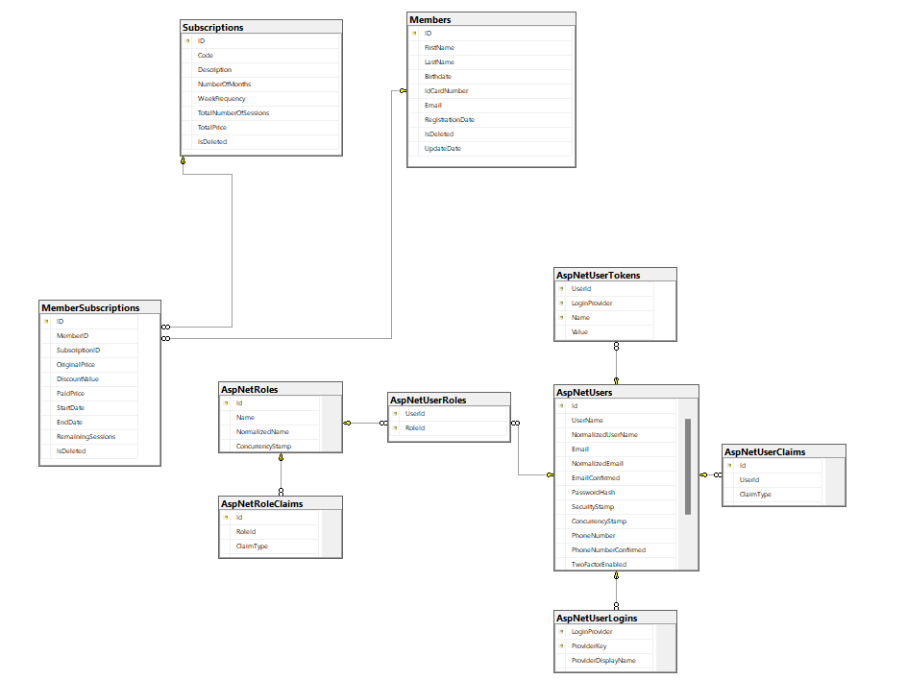

Business Rules
- Users must be authenticated to add/delete or view members, subscriptions etc.
- Members must not have a subscription more than once at a time.
- If gym has reached maximum capacity there should be prohibited to add a new member.

Application Architecture
Console Application, Monolithic Architecture. Repository Pattern. Code First.



