A Minor Project Report on
EXPLAINABLE AND RELIABLE TRAFFIC-SIGN RECOGNITION ON GTSRB
(ES-451: Minor Project)
submitted in partial fulfilment of the requirements for the award of the degree of
Bachelor of Technology
in
Information Technology
Submitted by
AKSHIT MEHTA
Enrolment No.: 00314803123
SHASHWAT KUMAR
Enrolment No.: 00414803123
Under the supervision of
Mr. Ajay Kumar Kaushik
Assistant Professor

DEPARTMENT OF INFORMATION TECHNOLOGY
MAHARAJA AGRASEN INSTITUTE OF TECHNOLOGY
PSP Area, Plot No. 1, Sector-22, Rohini, Delhi-110086, India
December 2026
DECLARATION
This is to certify that the material embodied in this Minor Project titled “EXPLAINABLE AND RELIABLE TRAFFIC-SIGN RECOGNITION ON GTSRB”, being submitted in partial fulfilment of the requirements for the award of the degree of Bachelor of Technology in Information Technology, is based on our original work. It is further certified that this Minor Project work has not been submitted in full or in part to this university or any other university for the award of any other degree or diploma. Our indebtedness to other works has been duly acknowledged at the relevant places.

(Akshit Mehta)
Enrolment No.: 00314803123
(Shashwat Kumar)
Enrolment No.: 00414803123
Date: ____________________
Place: Delhi
Department of Information Technology
CERTIFICATE
This is to certify that the work embodied in this Minor Project titled “EXPLAINABLE AND RELIABLE TRAFFIC-SIGN RECOGNITION ON GTSRB”, being submitted in partial fulfilment of the requirements for the award of the degree of Bachelor of Technology in Information Technology, is original and has been carried out by Akshit Mehta (Enrolment No. 00314803123) and Shashwat Kumar (Enrolment No. 00414803123) under my supervision and guidance.
It is further certified that this Minor Project work has not been submitted in full or in part to this university or any other university for the award of any other degree or diploma to the best of my knowledge and belief.

Mr. Ajay Kumar Kaushik
Assistant Professor
Department of Information Technology
Maharaja Agrasen Institute of Technology
Prof. (Dr.) Amita Goel
Head, Department of Information Technology
Maharaja Agrasen Institute of Technology
ACKNOWLEDGEMENT
We express our sincere gratitude to our mentor and faculty supervisor, Mr. Ajay Kumar Kaushik, Assistant Professor, Department of Information Technology, Maharaja Agrasen Institute of Technology, for the guidance, encouragement and feedback received throughout this project.
We thank the Project Convenors, Dr. Shallu Bashambu and Mr. Vibhor Sharma, for organising the project reviews and defences and for the clear guidelines that helped us prepare this report. We are grateful to Prof. (Dr.) Amita Goel, Head of the Department of Information Technology, and to the Maharaja Agrasen Institute of Technology for providing an environment in which students are encouraged to carry out independent technical work.
We acknowledge the creators of the German Traffic Sign Recognition Benchmark, whose openly available dataset made this study possible, and the maintainers of the open-source tools on which we relied: TensorFlow and Keras, scikit-learn, NumPy, pandas, Matplotlib, Pillow and OpenCV. We also thank the Google Colaboratory service for the GPU runtime used to train the models.
Finally, we thank our families and friends for their constant encouragement, and our classmates for the many discussions that sharpened our ideas.

(Akshit Mehta)
Enrolment No.: 00314803123
(Shashwat Kumar)
Enrolment No.: 00414803123
MAHARAJA AGRASEN INSTITUTE OF TECHNOLOGY

VISION OF THE INSTITUTE
To attain global excellence through education, innovation, research, and work ethics with the commitment to serve humanity.
MISSION OF THE INSTITUTE
M1. To promote diversification by adopting advancement in science, technology, management, and allied discipline through continuous learning.
M2. To foster moral values in students and equip them for developing sustainable solutions to serve both national and global needs in society and industry.
M3. To digitize educational resources and process for enhanced teaching and effective learning.
M4. To cultivate an environment supporting incubation, product development, technology transfer, capacity building and entrepreneurship.
M5. To encourage faculty-student networking with alumni, industry, institutions, and other stakeholders for collective engagement.
DEPARTMENT OF INFORMATION TECHNOLOGY
VISION OF THE DEPARTMENT
To establish a center of excellence promoting Information Technology related education and research for preparing technocrats and entrepreneurs with ethical values.
MISSION OF THE DEPARTMENT
M1. To excel in the field by imparting quality education and skills for software development and applications.
M2. To establish a conducive environment that promotes intellectual growth and research.
M3. To facilitate students to acquire entrepreneurial skills for innovation and product development.
M4. To encourage students to participate in competitive events and industry interaction with a focus on continuous learning.
MAHARAJA AGRASEN INSTITUTE OF TECHNOLOGY
PROGRAM OUTCOMES (POs)
PO1 Engineering knowledge: Apply knowledge of mathematics, natural science, computing, engineering fundamentals and an engineering specialization as specified in WK1 to WK4 respectively to develop to the solution of complex engineering problems.
PO2 Problem analysis: Identify, formulate, review research literature and analyze complex engineering problems reaching substantiated conclusions with consideration for sustainable development. (WK1 to WK4)
PO3 Design/Development of Solutions: Design creative solutions for complex engineering problems and design/develop systems/components/processes to meet identified needs with consideration for the public health and safety, whole-life cost, net zero carbon, culture, society and environment as required. (WK5)
PO4 Conduct Investigations of Complex Problems: Conduct investigations of complex engineering problems using research-based knowledge including design of experiments, modelling, analysis & interpretation of data to provide valid conclusions. (WK8).
PO5 Engineering Tool Usage: Create, select and apply appropriate techniques, resources and modern engineering & IT tools, including prediction and modelling recognizing their limitations to solve complex engineering problems. (WK2 and WK6)
PO6 The Engineer and The World: Analyze and evaluate societal and environmental aspects while solving complex engineering problems for its impact on sustainability with reference to economy, health, safety, legal framework, culture and environment. (WK1, WK5, and WK7).
PO7 Ethics: Apply ethical principles and commit to professional ethics, human values, diversity and inclusion; adhere to national & international laws. (WK9)
PO8 Individual and Collaborative Team work: Function effectively as an individual, and as a member or leader in diverse/multi-disciplinary teams.
PO9 Communication: Communicate effectively and inclusively within the engineering community and society at large, such as being able to comprehend and write effective reports and design documentation, make effective presentations considering cultural, language, and learning differences.
PO10 Project Management and Finance: Apply knowledge and understanding of engineering management principles and economic decision-making and apply these to one's own work, as a member and leader in a team, and to manage projects and in multidisciplinary environments.
PO11 Life-Long Learning: Recognize the need for, and have the preparation and ability for i) independent and life-long learning ii) adaptability to new and emerging technologies and iii) critical thinking in the broadest context of technological change. (WK8)
MAHARAJA AGRASEN INSTITUTE OF TECHNOLOGY
DEPARTMENT OF INFORMATION TECHNOLOGY
PROGRAM SPECIFIC OUTCOMES (PSOs)
PSO1 Students are equipped with programming technologies applied in the industry.
PSO2 Students are able to provide efficient solutions for emerging challenges in the computation domain such as Artificial Intelligence, Data Science, Web Technologies.
PSO3 Students are able to apply domain knowledge and expertise in the field of Information Technology for enhancing research capability to transform innovative ideas into reality.
PROGRAM EDUCATIONAL OBJECTIVES (PEOs)
PEO1 The graduates will utilize their professional skills in Information Technology to address real-world and societal challenges.
PEO2 The graduates would become successful entrepreneurs and motivators.
PEO3 The graduates would pursue research globally and engage in producing novel products to serve humanity.
PEO4 The graduates would exhibit collaborative abilities with adherence to professional ethics.
SUSTAINABLE DEVELOPMENT GOALS (SDGs) ADDRESSED
SDG addressed: SDG 9 (Industry, Innovation and Infrastructure); SDG 11 (Sustainable Cities and Communities); SDG 3 (Good Health and Well-being).
How the project contributes towards the above SDGs:
SDG 11 (target 11.2) and SDG 3 (target 3.6). Road traffic injuries are a major cause of death worldwide [1]. Driver-assistance systems that recognise traffic signs reliably can reduce errors caused by missed or misread signs. This project studies, on a public benchmark, how to build such a classifier so that its measured accuracy is honest, its decisions can be inspected, and it can say when it is unsure, which are the properties a safety-relevant component needs before any further validation.
SDG 9 (targets 9.5 and 9.c). The work promotes innovation and access to technology: it delivers a small model (116,203 parameters) that runs entirely in a web browser without a server, so the technique can be examined and reused on low-cost devices and in education without specialised infrastructure. All code, results and the interactive demonstration are released openly.
The project does not claim to be a certified driving system; its limitations are discussed in Chapter 11.
MINOR PROJECT RUBRICS
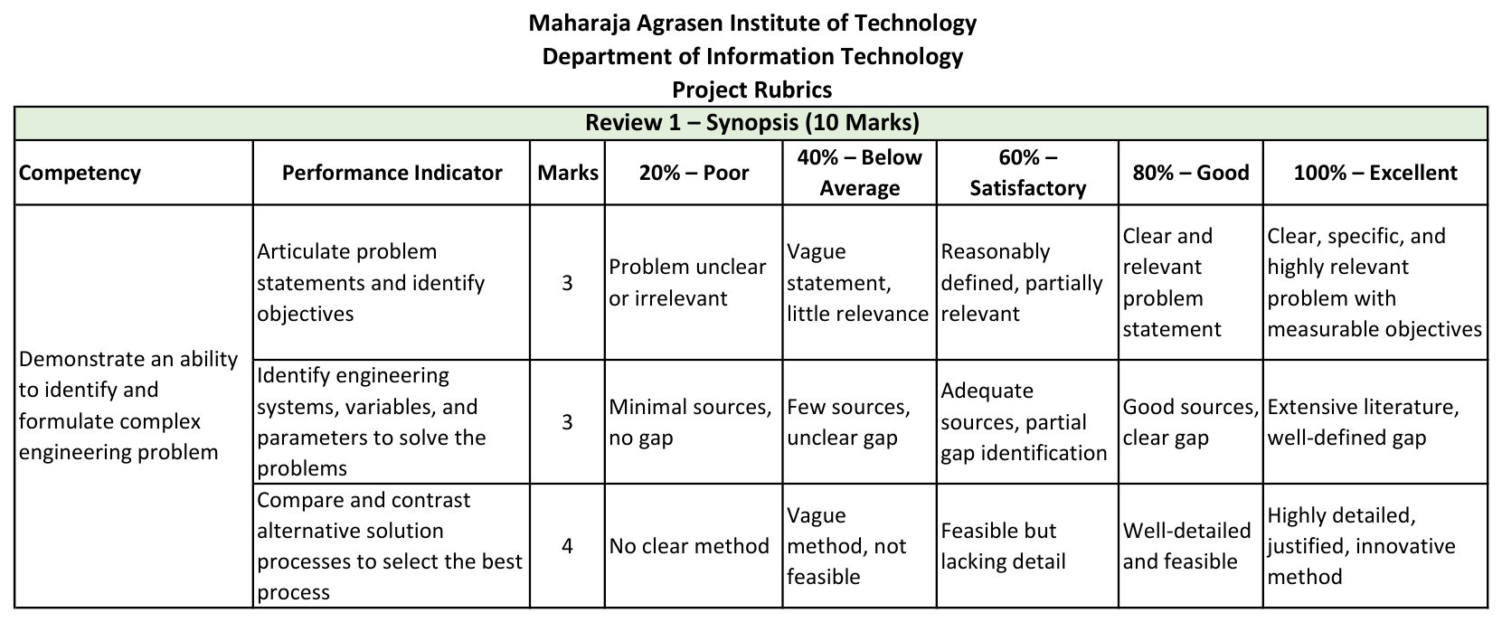
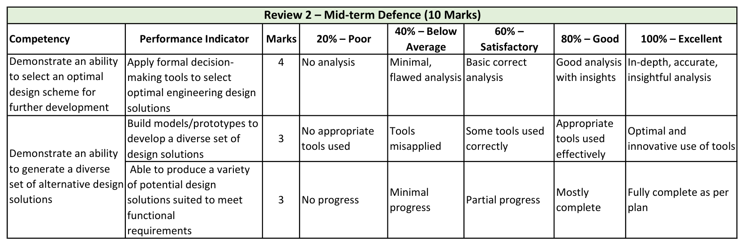
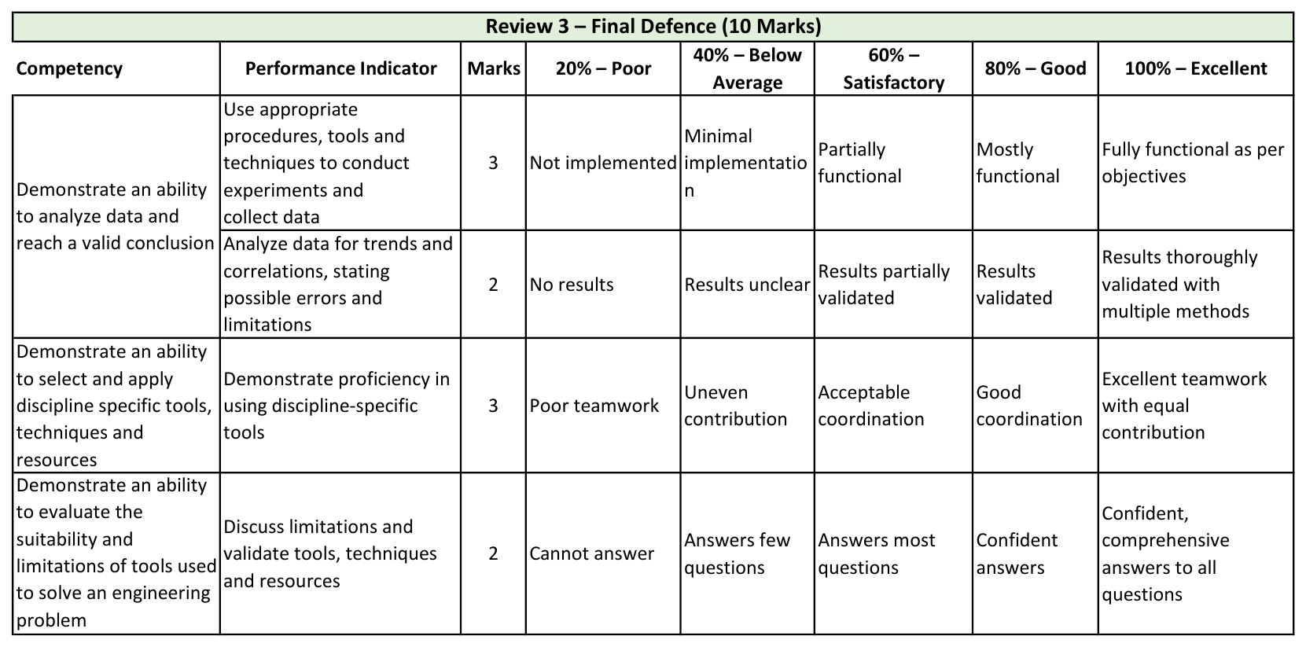
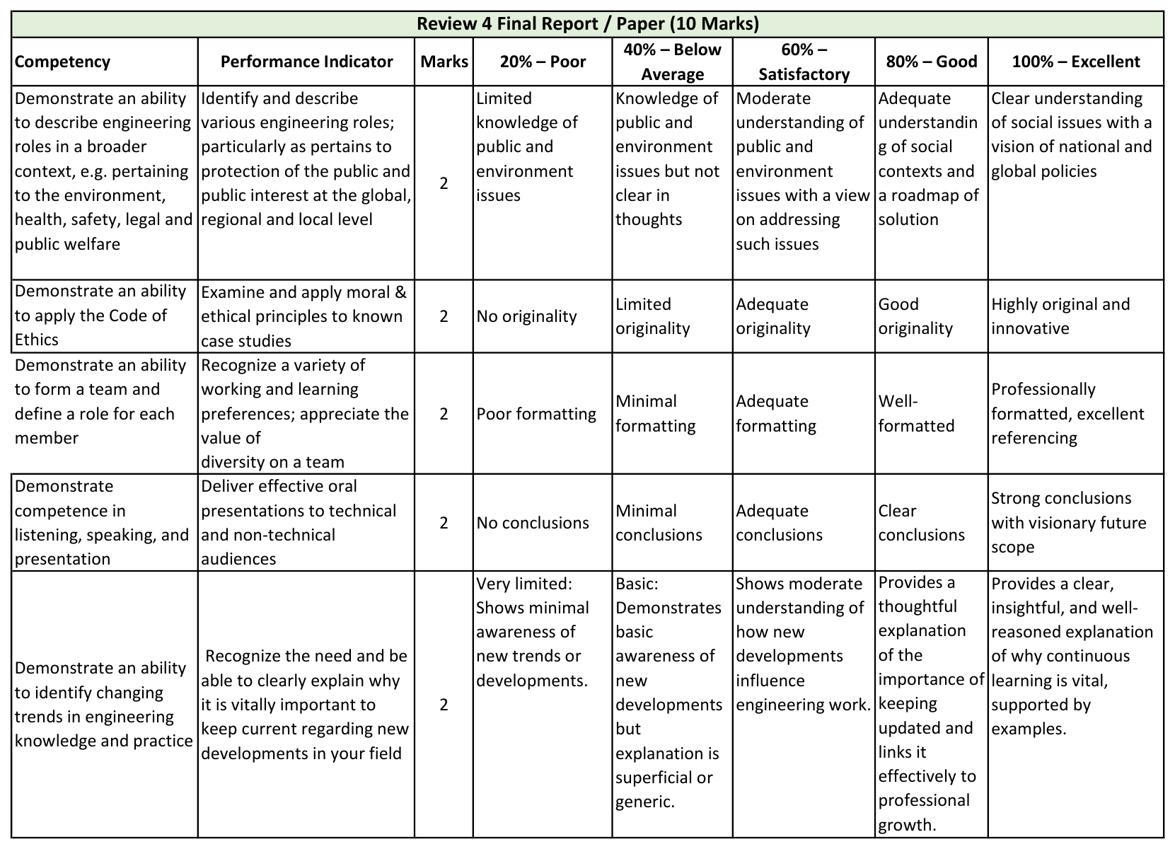
ABSTRACT
Reliable recognition of traffic signs is a building block of driver-assistance systems, but published accuracy figures on the German Traffic Sign Recognition Benchmark (GTSRB) say little about how a model behaves on unseen signs, why it errs, or when it should not be trusted. This project builds and evaluates a complete, reproducible traffic-sign classification pipeline that treats these questions as first-class goals.
The 39,209 training images of GTSRB were shown to come from only 1,307 physical signs photographed about 30 times each. A random validation split places 1,291 of those signs on both sides and inflates validation scores, so a per-class, track-grouped split with zero shared signs was used instead. Two models were compared: a compact 116,203-parameter convolutional network trained from scratch and MobileNetV2 transfer learning in two stages. Each design decision was measured on a progress ladder from a trivial baseline (5.9 % validation accuracy) to the final network (97.6 %), a 39-fold reduction in error.
On the official test set, scored once, the custom CNN reached 96.96 % accuracy and 95.21 % macro-F1, ahead of fine-tuned MobileNetV2 (91.26 %) and an ensemble of both (96.88 %). Grad-CAM, calibration (expected calibration error 0.0105), selective prediction (99 % accuracy while answering 95.5 % of images) and corruption tests showed that the network tolerates blur, darkening and glare but is fragile to noise, occlusion and large rotation, and that its most confident errors are very dark speed-limit signs. Two runs of the pipeline differed by about half a point, which bounds what small differences can be trusted.
The trained network was re-implemented in dependency-free JavaScript and verified against Keras (largest probability difference 3.2 x 10⁻⁶ over 116 images), and is published as a static website that classifies test images, uploads and camera frames locally, explains each prediction and stress-tests it. The report documents the methodology, implementation, testing, results and limitations, including that the system handles only cropped signs from one country and is not safety-certified.
Keywords: traffic-sign recognition, GTSRB, convolutional neural network, transfer learning, Grad-CAM, calibration, robustness, data leakage.
TABLE OF CONTENTS
Declaration ii
Certificate iii
Acknowledgement iv
Vision and Mission of the Institute and the Department v
Program Outcomes, Program Specific Outcomes and Program Educational Objectives vi
Sustainable Development Goals (SDGs) Addressed viii
Minor Project Rubrics ix
Abstract xiii
List of Figures xviii
List of Tables xx
Chapter 1: Introduction 1
1.1 Background and Motivation 1
1.2 Need of the Study 1
1.3 Scope of the Study 2
1.4 Objectives of the Study 3
1.5 Contributions 3
1.6 Organisation of the Report 4
Chapter 2: Problem Statement 6
2.1 Problem Definition 6
2.2 Objectives 6
2.3 Research Questions 7
2.4 Evaluation Protocol 7
2.5 Success Criteria 7
Chapter 3: Literature Review 9
3.1 Traffic-Sign Recognition and the GTSRB Benchmark 9
3.2 Convolutional Networks and Their Components 9
3.3 Transfer Learning and MobileNetV2 10
3.4 Evaluation Pitfalls: Leakage, Dataset Bias and Imbalance 10
3.5 Explainability: Grad-CAM and Embedding Visualisation 11
3.6 Calibration and Selective Prediction 11
3.7 Robustness to Corruptions 11
3.8 Detection, Datasets and Safety Standards 12
3.9 Summary and Research Gap 12
Chapter 4: Analysis 14
4.1 Software Requirement Specifications 14
4.1.1 Functional Requirements of the Project 14
4.1.2 Non-functional Requirements of the Project 15
4.2 Feasibility Study of the Project 15
4.3 Tools, Technologies and Platform Used 16
4.4 Use Case Diagrams and Data Flow Diagrams 17
Chapter 5: Research Methodology 20
5.1 Methodology Used 20
5.1.1 Principles 20
5.1.2 Evaluation Metrics 20
5.1.3 Experimental Design 21
5.2 Data Collection and Analysis 22
5.2.1 Dataset and Acquisition 22
5.2.2 Exploratory Data Analysis 22
5.2.3 Leakage Analysis 24
5.3 Tools and Technology Used 25
Chapter 6: Design and Architecture 26
6.1 Structure Chart and Work Breakdown Structure 26
6.2 Explanation of Modules 27
6.3 Flow Chart and Activity Diagram 27
6.4 ER Diagram and Class Diagram 29
6.5 Model Architectures and Algorithms 30
6.5.1 Custom CNN 30
6.5.2 MobileNetV2 Transfer Learning 31
6.5.3 Algorithms 32
Chapter 7: Implementation 34
7.1 Data Presentation and Preparation 34
7.1.1 Loading and Verification 34
7.1.2 The Validation Split 34
7.1.3 Caching and Augmentation 35
7.1.4 Hyper-parameters 36
7.2 Implementation of the Work 36
7.2.1 Models and Training 36
7.2.2 The Progress Ladder 37
7.2.3 Evaluation, Explanation and Reliability Code 37
7.2.4 Export and Parity Checks 37
7.2.5 The Browser Implementation 38
7.3 Analysis and Interpretation of Training 38
7.4 Screenshots 40
7.5 Source Code of Some Modules 42
Chapter 8: Testing 44
8.1 Test Strategy 44
8.2 Checks Embedded in the Pipeline 44
8.3 Numerical Verification of the Browser Network 45
8.4 Functional Test Cases for the Website 45
8.5 Defects Found and Fixed 46
8.6 Limitations of the Testing 47
Chapter 9: Results and Discussion 48
9.1 Results 48
9.1.1 Model Comparison 48
9.1.2 Progress Ladder 49
9.1.3 Per-Class Performance 50
9.1.4 Confusion Analysis 51
9.1.5 Explainability 52
9.1.6 Calibration and Selective Prediction 53
9.1.7 Robustness to Corruptions 54
9.1.8 Export and Deployment 55
9.2 Discussion 56
9.2.1 Merits and Demerits of the Approach 56
9.2.2 Comparison with Published Results 56
9.2.3 Why Did the Small CNN Beat MobileNetV2? 56
9.2.4 Grad-CAM at Saturation 57
9.2.5 Run-to-Run Variation 57
9.3 Findings 58
Chapter 10: Summary and Conclusion 60
10.1 Summary of the Work 60
10.2 Conclusions 61
10.3 Learning Outcomes 61
Chapter 11: Limitations of the Project and Future Work 62
11.1 Limitations 62
11.2 Future Work 63
11.3 Ethical and Safety Considerations 63
References 64
Appendix A: Source Code of Selected Modules (Annexure 1) 67
Appendix B: Per-Class Results of the Custom CNN 69
Appendix C: Reproducing the Work 71
C.1 Running the Experiments 71
C.2 Rebuilding the Website Data 71
C.3 Repository Layout 71
Appendix D: Research and Publication Status (Annexure 2) 73
LIST OF FIGURES
Figure No. and Title Page No.
Figure 4.1: Use case diagram of the traffic-sign recognition system 17
Figure 4.2: Data flow diagram, level 0 (context diagram) 18
Figure 4.3: Data flow diagram, level 1 19
Figure 5.1: End-to-end workflow of the study 20
Figure 5.2: Number of images per class in the training and official test sets 23
Figure 5.3: One random training example per class 23
Figure 5.4: Distribution of image width, size and aspect ratio in the training images 24
Figure 5.5: Brightness distribution of the training images with the darkest and brightest examples 24
Figure 5.6: Frames of a single physical Stop sign (one training track) 24
Figure 5.7: Random image split versus the track-grouped split used in this study 25
Figure 6.1: Work breakdown structure of the project 26
Figure 6.2: Flow chart of the experiment pipeline 28
Figure 6.3: Data and control flow of the website 28
Figure 6.4: Entity-relationship diagram of the data and results 29
Figure 6.5: Class and module diagram of the code 30
Figure 6.6: Architecture of the custom CNN 31
Figure 6.7: Two-stage training of the MobileNetV2 model 32
Figure 7.1: Original image and random augmentations (training only) 36
Figure 7.2: Training and validation curves of the custom CNN 39
Figure 7.3: Training and validation curves of MobileNetV2 across the two stages (the dashed line marks the start of fine-tuning) 39
Figure 7.4: Website home view with the live prediction panel and headline results 40
Figure 7.5: Live demonstration of a misclassified test image with Grad-CAM 41
Figure 7.6: Noise applied to a test image; the model would defer 41
Figure 7.7: Stress lab with presets, sliders and a noise sweep 42
Figure 7.8: Results dashboard: the progress ladder and training curves 42
Figure 9.1: Test accuracy and macro-F1 of the models, and accuracy versus latency 49
Figure 9.2: Progress ladder: validation accuracy at each step (left) and the same data as error rate on a logarithmic scale (right) 49
Figure 9.3: F1 score of every class (left) and F1 against class size (right) 51
Figure 9.4: Row-normalised confusion matrix of the custom CNN on the test set 52
Figure 9.5: The twelve most confident errors on the test set 52
Figure 9.6: Grad-CAM for the custom CNN (middle row) and MobileNetV2 (bottom row): five correct predictions (left) and five confident errors (right) 53
Figure 9.7: t-SNE projection of the penultimate-layer embedding, coloured by sign family and by class 53
Figure 9.8: Confidence of correct and wrong predictions, reliability diagram and coverage-accuracy curve 54
Figure 9.9: Accuracy of the custom CNN under increasing corruption severity 55
Figure 9.10: Examples of the corruptions at the three severities 55
LIST OF TABLES
Table No. and Title Page No.
Table 1.1: Mapping of the required report headings to the chapters of this report 4
Table 2.1: Objectives and the evidence that shows each has been met 6
Table 3.1: Summary of the reviewed work and its relevance to this project 12
Table 4.1: Functional requirements 14
Table 4.2: Non-functional requirements 15
Table 4.3: Feasibility analysis 16
Table 4.4: Tools, technologies and platform 16
Table 4.5: Principal use cases 17
Table 5.1: Training budgets of the notebook run modes (epochs are upper limits) 22
Table 5.2: Dataset facts measured by the notebook 22
Table 6.1: Work packages and deliverables 26
Table 6.2: Modules and their responsibilities 27
Table 6.3: Layers and parameters of the custom CNN 31
Table 7.1: Random split versus the track-grouped split used 35
Table 7.2: Augmentation settings (training only) 35
Table 7.3: Hyper-parameters and training settings of the reported run 36
Table 7.4: Definition of the progress-ladder steps 37
Table 7.5: Training cost of the reported run 39
Table 8.1: Levels of testing used 44
Table 8.2: Automated checks in the notebook and their outcome in the reported run 44
Table 8.3: Agreement between the JavaScript network and Keras on 116 test images 45
Table 8.4: Functional test cases for the website 45
Table 8.5: Defects found during development and testing 46
Table 9.1: Performance of the four models on the official test set (12,630 images) 48
Table 9.2: Progress ladder: validation accuracy and macro-F1 at each step 49
Table 9.3: The eight classes with the lowest F1 on the test set 50
Table 9.4: The ten most frequent confusions on the test set 51
Table 9.5: Selective prediction of the custom CNN on the test set 54
Table 9.6: Accuracy of the custom CNN under corruptions (6,000 test images; clean accuracy 96.97 %) 54
Table 9.7: Merits and demerits of the proposed approach and pipeline 56
Table 9.8: Test accuracy in the two full runs 57
Table 10.1: Answers to the research questions 61
Table 11.1: Proposed future work and the evidence that motivates it 63
Table B.1: Per-class test results of the custom CNN 69
Table C.1: Layout of the project repository 71
Table D.1: Research and publication status 73

CHAPTER 1: INTRODUCTION

1.1 Background and Motivation
Road traffic crashes remain one of the leading causes of death and injury worldwide [1]. Many crashes involve a driver who failed to notice, or misread, a traffic sign: a speed limit passed unseen, a stop sign hidden by glare, a warning obscured by vegetation. Advanced driver-assistance systems (ADAS) and, in the longer term, automated vehicles therefore need a component that recognises traffic signs automatically and reliably.
Recognising a traffic sign from a camera image is a classic image-classification problem. It looks easy for a person, but it is demanding for a machine. Signs are photographed at different distances, so the same sign may occupy fewer than thirty or more than two hundred pixels. Lighting ranges from direct sun to dusk. Signs are tilted, dirty, partly covered, motion-blurred and surrounded by clutter. Many signs also differ only in a small detail: a speed limit of 60 km/h and one of 80 km/h share the same shape, colour and layout and differ by a single digit.
Deep convolutional neural networks (CNNs) have made this problem largely tractable. On the German Traffic Sign Recognition Benchmark (GTSRB), the dataset used in this project, published committees of CNNs exceed the measured accuracy of human participants [2], [3]. A reader might therefore conclude that traffic-sign classification is a solved problem. This project starts from a different observation: a high number on a benchmark leaves several practical questions unanswered. Was the number measured honestly? On which signs does the model fail, and why? Does it look at the sign or at the background? Does it know when it is unsure? What happens when the image is darker, noisier or partly covered than anything seen in training? And can the result be reproduced and inspected by someone else?

1.2 Need of the Study
The study is motivated by five gaps between benchmark accuracy and trustworthy deployment.
- Evaluation can be optimistic through data leakage. Leakage occurs when information from the evaluation data reaches the training process [4]. GTSRB training images are frames taken from short sequences of the same physical sign. If a validation set is drawn at random from these frames, near-duplicates of training images appear in it and validation accuracy overstates performance on new signs. Whether this matters for GTSRB, and by how much, should be measured rather than assumed.
- Accuracy alone hides class-level behaviour. The 43 classes are strongly imbalanced (about 10.7 times between the largest and the smallest class). Overall accuracy can be high while rare classes fail, and some confusions (a wrong speed limit) are far costlier than others. Per-class metrics, macro-averaged F1 and a confusion analysis are needed.
- Black-box predictions are hard to trust. A classifier that is right for the wrong reasons, for example by reading background cues, will fail unpredictably. Visual explanation methods such as Grad-CAM [5] provide evidence about what the network attends to, but they must themselves be checked for numerical reliability.
- Confidence must be meaningful. A safety-relevant component should know when to defer. Modern networks are frequently over-confident [6], and a reject option can trade coverage for accuracy [7]. Both need to be quantified.
- Robustness and reproducibility are rarely reported together with accuracy. Corruptions such as noise, blur and occlusion expose weaknesses that clean test accuracy hides [8]. Finally, results that others cannot reproduce, or that stop at a notebook, have limited value.

1.3 Scope of the Study
In scope. The project covers classification of cropped, single traffic-sign images into the 43 GTSRB classes. It includes verified acquisition of the dataset; exploratory analysis; a leakage-free validation design; a custom CNN trained from scratch and a MobileNetV2 transfer-learning model; a ladder of experiments from a naive baseline to the final model; evaluation on the official test set; per-class and confusion analysis; Grad-CAM and embedding visualisation; calibration, selective prediction and robustness tests; export of models with parity checks; and a static website in which the trained network runs entirely in the browser.
Out of scope. Traffic-sign detection in full scenes and video (this needs a detector and box annotations that GTSRB does not provide [9], [10]), signs from other countries, adversarial attacks, hardware benchmarking on embedded automotive processors, and any claim of functional-safety certification [11], [12].

1.4 Objectives of the Study
- To acquire and verify the GTSRB dataset reproducibly and to characterise its class balance, image size, lighting and internal structure.
- To design a validation procedure that is free of leakage and to quantify the leakage that a random split would cause.
- To train and compare a compact CNN and a transfer-learning model, and to measure the contribution of each design decision through a progress ladder.
- To evaluate the final models once on the official test set using accuracy, macro-F1, top-3 accuracy and calibration error, and to analyse per-class results and confusions.
- To explain predictions with Grad-CAM and embedding visualisation and to check the numerical reliability of the explanation.
- To measure calibration, selective prediction and robustness to controlled corruptions.
- To export the trained models with verified reload and conversion parity, and to deliver an interactive, serverless demonstration of the selected model.
- To document the work, its limitations and its reproducibility honestly, including run-to-run variation.

1.5 Contributions
The main contributions of this work are the following.
- A measured demonstration that a random validation split on GTSRB places 1,291 of 1,307 physical signs on both sides of the split, together with a per-class, track-grouped split that guarantees zero shared signs and presence of all 43 classes in validation.
- A progress ladder that raises validation accuracy from 5.9 % (majority-class baseline) to 97.6 % in single-factor steps, showing that a 116,203-parameter CNN with batch normalisation, global average pooling, augmentation and dropout outperforms both a 1.63-million-parameter plain CNN and a fine-tuned 2.3-million-parameter MobileNetV2.
- A reliability analysis: expected calibration error of 0.0105, a threshold that gives 99 % accuracy while answering 95.5 % of images, and a corruption study that identifies noise, occlusion and large rotation as the dominant weaknesses.
- A numerical finding about Grad-CAM: when the class probability is used as the score, the gradient vanishes for nearly certain predictions and the maps are unreliable; the class score before the softmax avoids this.
- A dependency-free JavaScript implementation of the trained network, with Grad-CAM, verified against Keras and published as a static website; the same code base also exports all trained models and their results for reuse.

1.6 Organisation of the Report
The department's guidelines (Annexure A) define separate chapter structures for development-based and for research-based projects. This project has both a research component (an experimental study of evaluation and reliability) and a development component (a deployable pipeline and website), so this report follows a combined structure that contains every heading required by either format. Table 1.1 shows where each required heading is located.
Table 1.1: Mapping of the required report headings to the chapters of this report
Required heading (Annexure A) | Format | Location in this report
Introduction | Both | Chapter 1
Problem Definition; Objectives | Both | Chapter 2 (2.1, 2.2)
Literature Review | Research | Chapter 3
Software Requirement Specifications (functional and non-functional requirements) | Development | Chapter 4 (4.1)
Feasibility Study | Development | Chapter 4 (4.2)
Tools / Technologies / Platform Used | Both | Chapter 4 (4.3); 5.3
Use Case Diagrams / Data Flow Diagrams | Development | Chapter 4 (4.4)
Methodology Used | Research | Chapter 5 (5.1)
Data Collection and Analysis | Research | Chapter 5 (5.2)
Structure Chart / Work Breakdown Structure; Explanation of Modules | Development | Chapter 6 (6.1, 6.2)
Flow Chart / Activity Diagram; ER Diagram / Class Diagram; Algorithm | Development | Chapter 6 (6.3 to 6.5)
Data Presentation; Implementation of the Work; Analysis and Interpretation | Research | Chapter 7 (7.1 to 7.3)
Screenshots; Source Code of Some Modules | Development | Chapter 7 (7.4, 7.5); Appendix A
Testing (including test cases) | Development | Chapter 8
Results; Discussion; Findings (merits and demerits) | Research | Chapter 9
Summary and Conclusion | Both | Chapter 10
Limitations of the Project and Future Work | Both | Chapter 11
Bibliography; Appendix | Both | References; Appendices A to C

CHAPTER 2: PROBLEM STATEMENT

2.1 Problem Definition
Let x denote a colour image of a single traffic sign cropped from a road scene, represented as an array of 64 x 64 x 3 pixel values in the range 0 to 255. Let y be the class label of the sign, an integer from 0 to 42, corresponding to the 43 sign types of GTSRB (for example, class 14 is “Stop” and class 2 is “Speed limit 50 km/h”). The task is to learn a function f that maps x to a probability distribution over the 43 classes, from which the predicted class and a confidence value are obtained:
p(y = c | x) = exp(z_c) / Σ_j exp(z_j), ŷ = argmax_c p(y = c | x) (1)
where z is the vector of 43 scores (logits) produced by the network. The problem studied in this report is broader than fitting f. It is to obtain, for such a classifier, an honest estimate of its accuracy on signs it has never seen, an explanation of its predictions, a measure of when its confidence can be trusted, a measure of how it degrades under realistic image corruptions, and a reproducible, deployable artefact.
The question can be stated compactly: given the structure of GTSRB, how should a traffic-sign classifier be trained, evaluated, explained and delivered so that its reported performance is trustworthy and its limitations are known?

2.2 Objectives
The objectives listed in Section 1.4 are made measurable below (Table 2.1).
Table 2.1: Objectives and the evidence that shows each has been met
No. | Objective | Evidence in this report
O1 | Reproducible, verified data | MD5 checksum and count assertions (Section 5.2)
O2 | Leakage-free validation | Zero shared tracks, all 43 classes in validation (Section 7.1.2)
O3 | Compare models; measure each design step | Progress ladder (Section 9.1.2)
O4 | Honest final evaluation | Single official-test evaluation; metrics and per-class analysis (Chapter 9)
O5 | Explain predictions | Grad-CAM, embeddings, numerical check (Sections 9.1.5, 9.2.4)
O6 | Reliability | Calibration, abstention, robustness (Sections 9.1.6, 9.1.7)
O7 | Deployable and verified | Export, TFLite, Keras-to-JavaScript parity (Sections 8.3, 9.1.8)
O8 | Honest documentation | Run-to-run variation and limitations (Section 9.2.5, Chapter 11)

2.3 Research Questions
- RQ1. How much does a random validation split overstate performance on GTSRB, and how can the leakage be removed?
- RQ2. How do a small purpose-built CNN and a pretrained MobileNetV2 compare on 64 x 64 sign crops, and which design decisions contribute most?
- RQ3. Which classes and class pairs are hardest, and are the errors explained by class size or by visual similarity?
- RQ4. Does the network attend to the sign, and is Grad-CAM numerically reliable for confident predictions?
- RQ5. Is the confidence well calibrated, and how much accuracy can be gained by abstaining when unsure?
- RQ6. Which corruptions degrade the model most, and what does this imply for future training?

2.4 Evaluation Protocol
The evaluation protocol was fixed before results were examined, to avoid choosing a protocol that flatters the results. Training data are split into a fitting part and a validation part using whole physical signs. All decisions (when to stop, which model to select, whether a design step helps) use validation data only. The official test set is used exactly once for each model, for reporting. Because the classes are imbalanced, macro-averaged F1 is reported alongside accuracy. Descriptive analyses that use test-set behaviour (the abstention curve and the robustness study) are labelled as such and are not used to choose a model.

2.5 Success Criteria
- The validation split shares no physical sign with the fitting split and contains every class (checked by assertions in the code).
- The selected model reaches test accuracy in the range reported for compact CNNs on GTSRB, without any use of the test set for tuning.
- Every exported model reloads with identical predictions, and the browser implementation reproduces Keras predictions on the sample images.
- All limitations that affect interpretation of the results are stated in the report.

CHAPTER 3: LITERATURE REVIEW
This chapter reviews the work on which the project builds: traffic-sign recognition and the GTSRB benchmark, the building blocks of convolutional networks, transfer learning, evaluation pitfalls, explainability, calibration and robustness. It ends with the gap that this project addresses. A summary table is given at the end (Table 3.1).

3.1 Traffic-Sign Recognition and the GTSRB Benchmark
Early traffic-sign recognition systems relied on hand-crafted features such as colour thresholds, shape detection and histogram-of-gradients descriptors combined with classifiers such as support vector machines. These were sensitive to lighting and viewpoint. The German Traffic Sign Recognition Benchmark, introduced for a competition at the International Joint Conference on Neural Networks in 2011, provided a large, realistic and fixed benchmark: more than 50,000 images in 43 classes, collected on German roads under varied conditions, with a prescribed training set and a separate test set [13]. The accompanying study compared machine-learning methods with human participants and reported human performance of about 98.8 % on the test set [2].
Convolutional networks dominated the competition. Sermanet and LeCun used multi-scale convolutional networks that feed features from several stages into the classifier [14]. Cireşan et al. combined many deep networks, trained on differently pre-processed inputs, into a multi-column committee that exceeded human accuracy, reaching about 99.5 % [3]. These results established that CNNs are well suited to the task. They also show that the accuracies of strong methods are very close to each other, so that how a model is evaluated matters as much as which model is used.

3.2 Convolutional Networks and Their Components
A convolutional network applies learned filters across an image, sharing weights across positions, and stacks such layers so that early layers detect edges and later layers detect shapes and symbols. LeCun et al. showed the effectiveness of this design for document recognition [15], and Krizhevsky et al. demonstrated its power on large-scale natural images [16]. A textbook treatment is given by Goodfellow et al. [17]. Several components are used in this project:
- Rectified linear units (ReLU), defined as max(0, x), make training fast and avoid saturation [18].
- Batch normalisation normalises layer activations using batch statistics during training and stored running statistics at inference, which stabilises and accelerates training [19].
- Dropout randomly disables units during training to reduce over-fitting [20].
- Adam is an adaptive-rate optimiser based on estimates of the first and second moments of the gradient [21].
- Residual connections allow very deep networks to be trained [22]; they appear inside the MobileNetV2 backbone used here.

3.3 Transfer Learning and MobileNetV2
Transfer learning reuses a model trained on a large source task to solve a target task with less data or time [23]. Yosinski et al. showed that early-layer features are general while later layers are specific, and that transferability decreases as source and target tasks differ [24]. The usual source task is ImageNet classification [25]. A common practice is to train a new output layer on frozen pretrained features and then to fine-tune later layers at a lower learning rate.
MobileNets are efficient networks designed for mobile devices [26]. MobileNetV2 introduces inverted residual blocks with linear bottlenecks and uses depthwise separable convolutions to reduce computation [27]. It is a natural lightweight comparison model for a deployment-oriented study. Its pretrained features come from natural photographs of everyday objects at a few hundred pixels, which differ in scale and content from 64-pixel traffic-sign crops. This domain gap suggests that a frozen backbone may perform poorly and that fine-tuning may help; this project tests that expectation rather than assuming it.

3.4 Evaluation Pitfalls: Leakage, Dataset Bias and Imbalance
Kaufman et al. define leakage as the presence in training data of information that would not be available when the model is used, and show that it can make results look better than they are [4]. Torralba and Efros show that benchmark datasets have characteristic biases that make performance measured on one dataset a poor predictor of performance elsewhere [28]. For GTSRB, the structure of the data is relevant: images come from tracks of about 30 frames of the same physical sign. A split that separates the frames of a track places near-duplicates on both sides. The standard remedy is a grouped split, available as GroupShuffleSplit in scikit-learn [29], [30]. A plain grouped shuffle does not guarantee that every class appears in the held-out part, a limitation that this project met in practice and solved with an explicit per-class selection (Section 7.1).
With imbalanced classes, overall accuracy is dominated by the common classes. Per-class precision and recall, and their harmonic mean F1, give a complete picture; macro-F1 averages F1 over classes with equal weight, so that rare classes count as much as common ones.

3.5 Explainability: Grad-CAM and Embedding Visualisation
Grad-CAM produces a coarse heat-map showing which regions of an image most increased the score of a class. It weights the feature maps of the last convolutional layer by the average gradient of the class score with respect to each map, sums them and keeps the positive part [5]. It requires no change to the network. Its limitations are well known: it shows influence rather than causal reasoning, and its resolution is that of the last feature map. A second tool, t-SNE, projects high-dimensional feature vectors to two dimensions so that similar images appear close together [31]; its distances should be read qualitatively. This project adds a numerical check that is rarely reported: the behaviour of the gradient when the network is almost certain (Section 9.2.4).

3.6 Calibration and Selective Prediction
A classifier is calibrated if, among predictions made with confidence c, a fraction c is correct. Guo et al. showed that modern deep networks are often over-confident, introduced the expected calibration error (ECE) as a summary, and proposed temperature scaling as a simple remedy [6]. Selective classification lets a model abstain when its confidence is below a threshold, trading coverage for accuracy [7]. For a safety-relevant component, abstention is a practical way to hand uncertain cases to a human or another sensor.

3.7 Robustness to Corruptions
Hendrycks and Dietterich proposed benchmarks of common corruptions such as noise, blur and weather to measure how classifiers degrade when inputs differ from the training distribution [8]. More severe is the possibility of deliberate manipulation: small perturbations can change a network's output [32], and physical stickers on a stop sign have been shown to fool classifiers [33]. This project studies benign corruptions only (darkening, glare, noise, blur, rotation and occlusion) and does not evaluate adversarial attacks.

3.8 Detection, Datasets and Safety Standards
Classification of cropped signs is the second stage of a larger pipeline in which a detector first locates signs in a scene. The German Traffic Sign Detection Benchmark provides annotated full images [9], the Tsinghua-Tencent 100K dataset provides large-scale Chinese traffic-sign data [10], and one-stage detectors such as YOLO can localise signs in real time [34]. Functional safety of road vehicles is governed by ISO 26262 [11], and the safety of the intended functionality of perception components by ISO 21448 [12]. Neither standard is satisfied by a research classifier; they are cited to place the work in context.

3.9 Summary and Research Gap
Table 3.1: Summary of the reviewed work and its relevance to this project
Work | Contribution | Use in this project
Stallkamp et al. [2], [13] | GTSRB benchmark; human performance of about 98.8 % | Dataset, protocol, reference point
Cireşan et al.; Sermanet and LeCun [3], [14] | CNN committees and multi-scale CNNs exceed human accuracy | Motivates a CNN approach; context for accuracy
Ioffe and Szegedy; Srivastava et al. [19], [20] | Batch normalisation; dropout | Components of the custom CNN
Sandler et al.; Yosinski et al. [24], [27] | MobileNetV2; transferability of features | Transfer-learning model; domain-gap hypothesis
Kaufman et al.; scikit-learn [4], [29] | Leakage; grouped splitting | Track-grouped validation design
Selvaraju et al.; van der Maaten and Hinton [5], [31] | Grad-CAM; t-SNE | Explanation of predictions
Guo et al.; Geifman and El-Yaniv [6], [7] | Calibration, ECE; selective classification | Reliability analysis; abstention
Hendrycks and Dietterich [8] | Corruption robustness benchmarks | Stress tests

Research gap. The literature establishes that CNNs solve GTSRB at the level of human accuracy. What is less often reported together, for a single reproducible pipeline, is (i) a measured account of validation leakage caused by the track structure of the data, (ii) a controlled ladder of design decisions from a trivial baseline, (iii) calibration, abstention and corruption robustness measured on the same model, (iv) a numerical check of the explanation method, and (v) a deployable artefact whose faithfulness to the trained model has been verified. This project addresses these five points.

CHAPTER 4: ANALYSIS
This chapter analyses what the system must do and whether it can be built. It follows the structure required for development-based projects: software requirements, feasibility, tools and platform, and use case and data flow diagrams.

4.1 Software Requirement Specifications
Purpose and scope. The system consists of two cooperating parts. The first is an experiment pipeline, run as a notebook on a GPU runtime, that acquires and verifies GTSRB, trains and evaluates models, analyses their behaviour and exports models and results. The second is a static website that runs the selected model in a visitor's browser and presents the results. The intended users are the researchers (the project team) who run and extend the pipeline, and examiners or visitors who explore the demonstration.
Assumptions and constraints. The pipeline assumes an internet connection to download the dataset and pretrained weights and a GPU runtime for full-length training. The website assumes a modern browser with JavaScript and canvas support; camera input additionally requires a secure (HTTPS) context and user permission. The model accepts one cropped sign at a time. No server component is used.

4.1.1 Functional Requirements of the Project
Table 4.1: Functional requirements
ID | Requirement | Part
FR1 | Download the GTSRB archive and verify it against the published MD5 checksum; stop with an error on mismatch. | Pipeline
FR2 | Assert the expected counts (39,209 training images, 12,630 test images, 43 classes) and that every referenced file exists. | Pipeline
FR3 | Profile the data: class distribution, image size, brightness, and the track structure of the training images. | Pipeline
FR4 | Create a validation split that shares no physical sign with the fitting split and contains every class. | Pipeline
FR5 | Cache all images at 64 x 64 resolution and apply training-time augmentation inside the model. | Pipeline
FR6 | Train a custom CNN and a two-stage MobileNetV2 with early stopping and learning-rate reduction. | Pipeline
FR7 | Run a ladder of single-factor experiments from a trivial baseline to the final model. | Pipeline
FR8 | Evaluate each model on the official test set and report accuracy, macro-F1, top-3 accuracy, calibration error, size and latency. | Pipeline
FR9 | Report per-class metrics, the confusion matrix, the most frequent confusions and the most confident errors. | Pipeline
FR10 | Generate Grad-CAM heat-maps and an embedding projection. | Pipeline
FR11 | Measure calibration, the accuracy-versus-coverage trade-off and robustness to six corruption types at three severities. | Pipeline
FR12 | Export every trained model, per-model predictions and metrics, figures and a sample of test images; verify that reloaded models reproduce predictions. | Pipeline
FR13 | Classify a selected test image, an uploaded image or a camera frame in the browser and show the top five classes with confidences. | Website
FR14 | Show a Grad-CAM heat-map for the current prediction. | Website
FR15 | Let the user apply rotation, brightness, blur, noise and occlusion to the current image and sweep each across its range. | Website
FR16 | Let the user set a confidence threshold below which the system defers, and show the resulting coverage and accuracy. | Website
FR17 | Present the experiment results as interactive charts with table alternatives. | Website
FR18 | Provide a check that compares the browser model with the values recorded from the Keras model. | Website

4.1.2 Non-functional Requirements of the Project
Table 4.2: Non-functional requirements
Category | Requirement
Reproducibility | All random generators are seeded; the dataset is verified by checksum; one configuration object controls budgets; results are exported with the code that produced them.
Correctness of evaluation | No decision may use the test set; validation may not share physical signs with training; assertions enforce this.
Performance | A prediction on the website should complete in well under a second on an ordinary laptop; full training should complete in under one hour on a free GPU runtime.
Portability | The pipeline runs unchanged on Google Colab and, with a local dataset path, on a workstation; the website runs on any modern browser.
Privacy | Images supplied by a website visitor are processed locally and never transmitted.
Usability and accessibility | The website works with keyboard navigation, provides table views for charts, supports light and dark themes and a narrow (phone) layout.
Maintainability | The notebook and website data are generated by scripts; the browser network is covered by a numerical verification script.
Honesty and safety messaging | The system must state that it handles cropped signs only, is not safety-certified and may be over-confident outside its training distribution.

4.2 Feasibility Study of the Project
Table 4.3 summarises the feasibility analysis along the usual dimensions.
Table 4.3: Feasibility analysis
Dimension | Assessment | Conclusion
Technical | GTSRB is small enough (about 320 MB) to fit in memory at 64 x 64 resolution (0.64 GB). A 116,203-parameter CNN trains in about six minutes on a free GPU. A network of this size can be evaluated in plain JavaScript in tens of milliseconds. | Feasible
Economic | All software is open source. Training used a free Colab runtime; hosting uses GitHub Pages. No licences or hardware purchases were needed. | Feasible at near-zero cost
Operational | The pipeline runs by selecting a mode and running all notebook cells; the website needs no installation and no server administration. | Feasible
Schedule | The work packages (Chapter 6) were small and largely sequential; a full training run takes under 25 minutes, which allowed several complete iterations, including a correction of the validation split. | Feasible within the semester
Legal and ethical | GTSRB is a public research benchmark and is cited as required. The website processes images locally. Safety limitations are stated prominently. Redistribution of the cropped sample images should respect the dataset's terms. | Feasible with the stated precautions

4.3 Tools, Technologies and Platform Used
Table 4.4: Tools, technologies and platform
Tool / platform | Version or detail | Purpose
Python | 3.x (Colab runtime) | Pipeline language
TensorFlow / Keras [35], [36] | 2.21.0 / 3.13.2 (Colab run); pinned 2.16.2 in the repository | Model definition, training, export
NumPy, pandas [37] | NumPy 2.x; pandas 2.x | Arrays, tables
scikit-learn [30] | 1.7.x | Metrics, t-SNE, splitting utilities
Matplotlib [38] | 3.10.x | Figures
Pillow, OpenCV | Pillow 11.x; OpenCV headless 4.12 | Image loading, corruptions
Google Colaboratory [39] | GPU runtime | Training and evaluation
TensorFlow Lite | Bundled with TensorFlow | Mobile-size model conversion
HTML, CSS, JavaScript (ES modules) | No third-party libraries | Website, in-browser network, charts
Node.js | Recent LTS | Numerical verification script
Git and GitHub | - | Version control, collaboration
GitHub Pages and Actions | - | Static hosting and deployment
GTSRB archive [40] | Zenodo record 13741936 | Dataset

4.4 Use Case Diagrams and Data Flow Diagrams
Figure 4.1 shows the use cases of the system. The researcher runs the experiment pipeline; the panel member or website visitor uses the website. Table 4.5 describes the principal use cases.
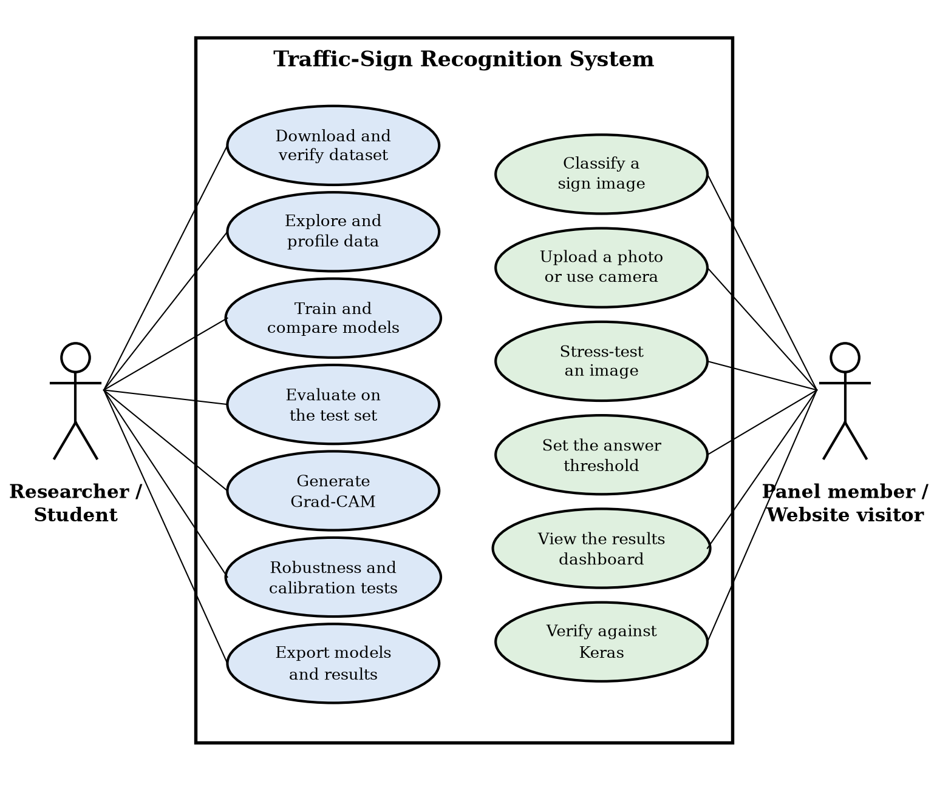
Figure 4.1: Use case diagram of the traffic-sign recognition system
Table 4.5: Principal use cases
Use case | Actor | Main flow | Outcome
Train and compare models | Researcher | Select a mode; run the notebook; models are trained, early stopping selects the best epoch, results are scored on validation | Trained models and training histories
Evaluate on the test set | Researcher | Score each model once on the official test split; compute metrics and analyses | Metrics, confusion matrix, figures
Export results | Researcher | Save models, predictions, tables and figures; reload each model and compare predictions | Verified results bundle
Classify a sign image | Visitor | Pick a sample, upload a photo or use the camera; the model returns the top five classes | Prediction, confidence, answer-or-defer decision
Stress-test an image | Visitor | Move the corruption sliders or press Sweep; the prediction updates | Confidence versus severity
Verify against Keras | Visitor | Press the verify button; the page compares its predictions with recorded Keras values | Agreement report

The context-level data flow diagram (Figure 4.2) shows the system as one process with four external entities: the GTSRB archive, the researcher, the website visitor and the hosting platform. Figure 4.3 decomposes it into five processes (prepare data, train models, evaluate and analyse, export artefacts, browser inference) and five data stores.
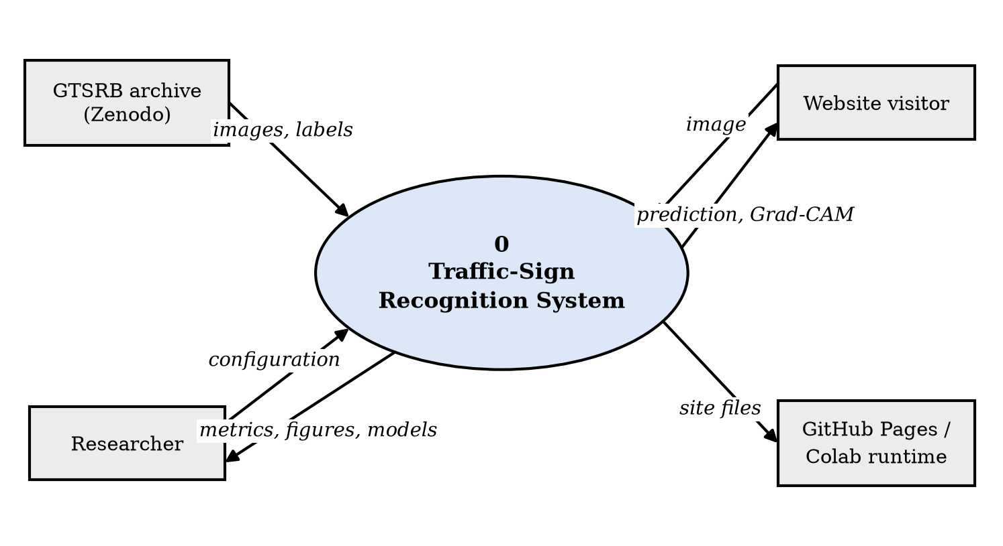
Figure 4.2: Data flow diagram, level 0 (context diagram)
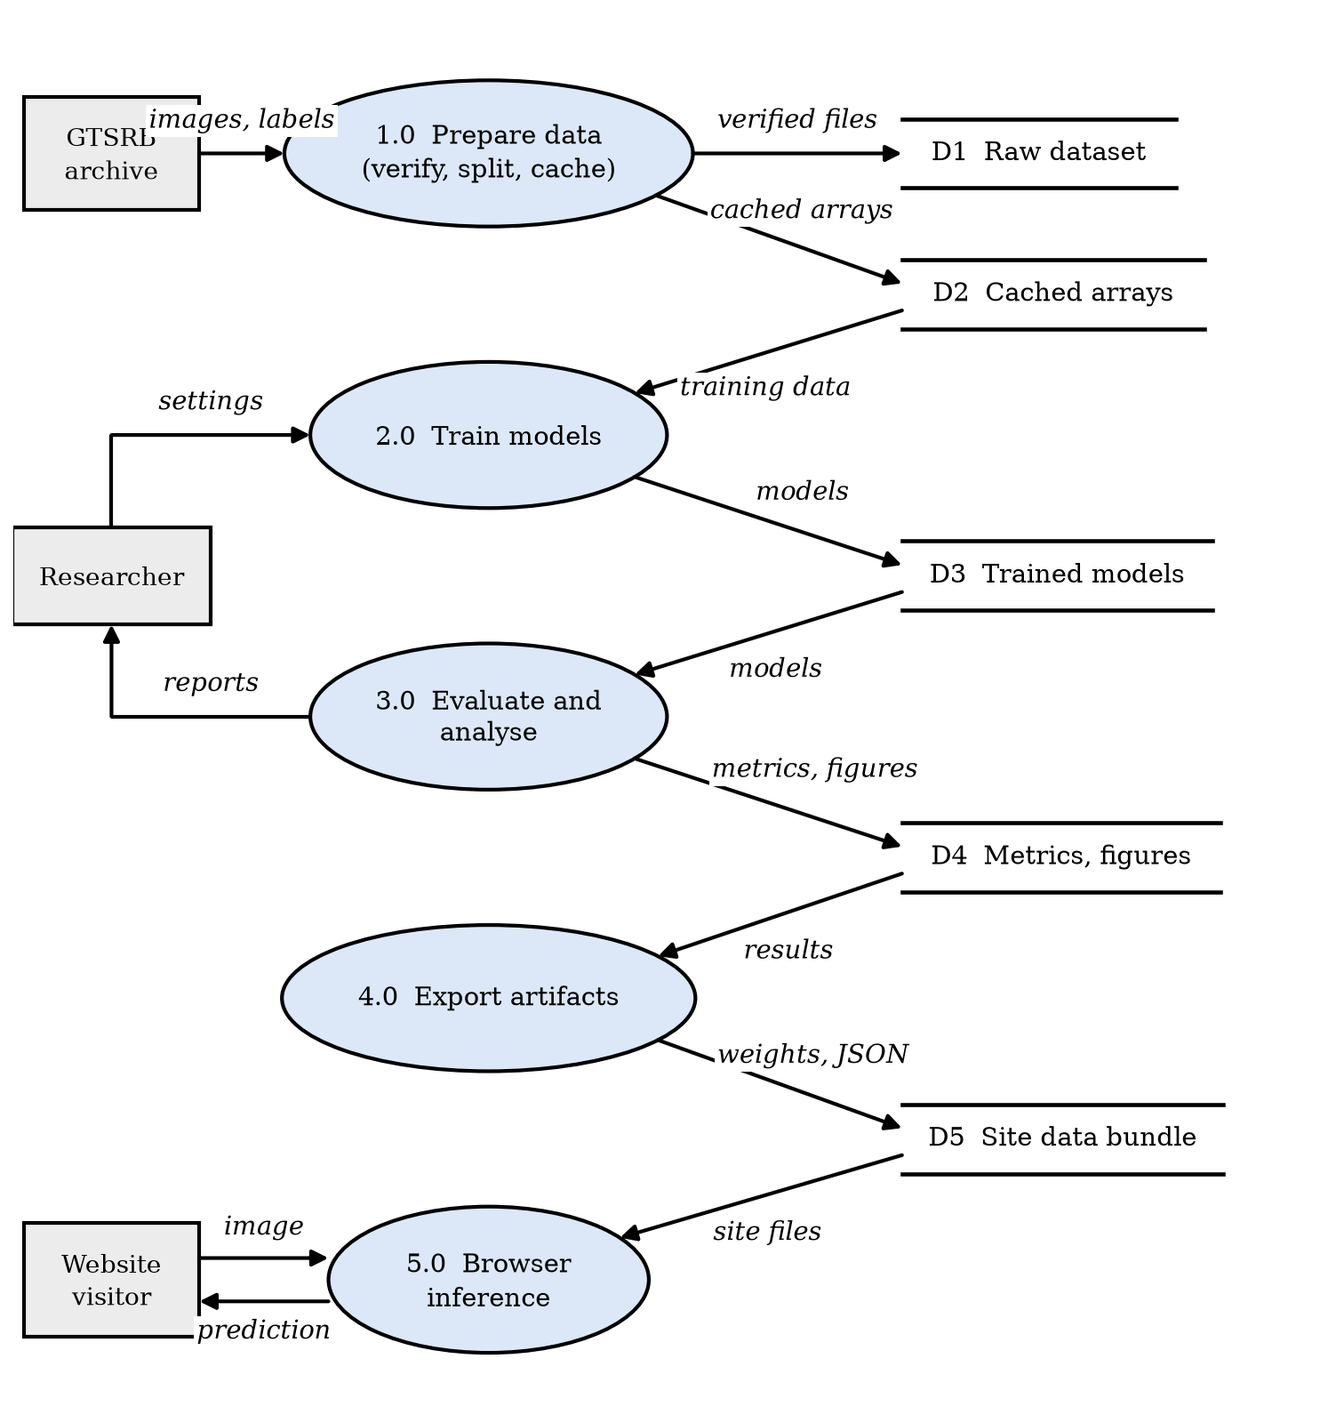
Figure 4.3: Data flow diagram, level 1

CHAPTER 5: RESEARCH METHODOLOGY

5.1 Methodology Used
The study is an experimental one. Figure 5.1 gives the end-to-end workflow, which is executed in a single notebook so that every number in this report can be regenerated.
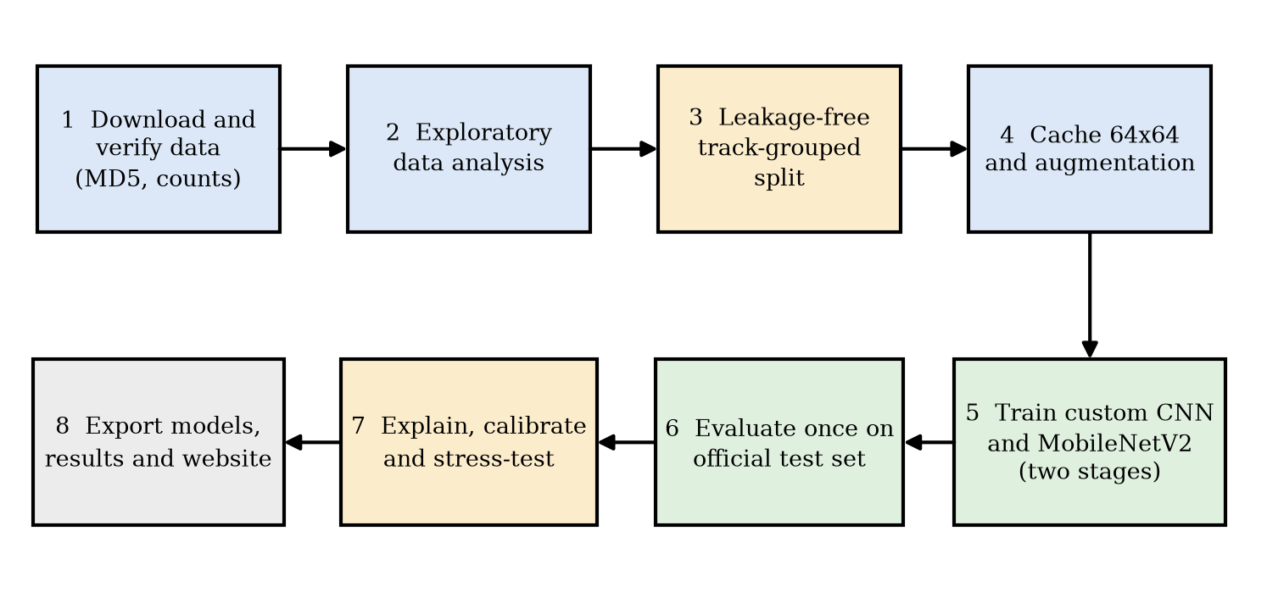
Figure 5.1: End-to-end workflow of the study

5.1.1 Principles
- Protocol before results. The split, metrics and selection rule were fixed before models were compared (Section 2.4).
- One change at a time. The progress ladder changes a single factor per step, so the effect of each decision is attributable.
- Validation for decisions, test once. Early stopping and model selection use validation data. The test set is scored once per model.
- Assertions over trust. Data counts, file existence, split properties and reload parity are checked by code that stops the run if violated.
- Seeds and checksums. A fixed seed (42) and a checksum-verified archive make runs repeatable on the same hardware.

5.1.2 Evaluation Metrics
Let TP_{c}, FP_{c} and FN_{c} be the true positives, false positives and false negatives of class c among N evaluated images and C = 43 classes. The metrics used are:
Accuracy = (1 / N) Σ_i [ ŷ_i = y_i ] (2)
P_c = TP_c / (TP_c + FP_c), R_c = TP_c / (TP_c + FN_c), F1_c = 2 P_c R_c / (P_c + R_c) (3)
Macro-F1 = (1 / C) Σ_c F1_c (4)
Macro-F1 gives every class the same weight, so rare classes are not hidden behind common ones. Top-3 accuracy counts a prediction as correct if the true class is among the three highest-probability classes. The loss minimised in training is the cross-entropy between the one-hot label and the predicted distribution:
L = − log p(y = y_true | x) (5)
Calibration is summarised by the expected calibration error [6]. Predictions are grouped into M = 15 equal-width confidence bins B_{m}; with acc(B_{m}) the accuracy and conf(B_{m}) the mean confidence in a bin:
ECE = Σ_m (|B_m| / N) · | acc(B_m) − conf(B_m) | (6)
Selective prediction. For a threshold t the system answers when the confidence is at least t and defers otherwise. Coverage is the fraction of images answered, and selective accuracy is the accuracy on the answered images. Sweeping t traces the trade-off between them [7].
Grad-CAM. For an image and a class c with score y_{c}, and the activations A^{k} of the last convolutional layer, the channel weights and the heat-map are [5]:
α_k = (1 / Z) Σ_{i,j} ∂y_c / ∂A^k_{ij}, L_Grad-CAM = ReLU( Σ_k α_k A^k ) (7)

5.1.3 Experimental Design
Three families of experiments are run. (i) A progress ladder of nine steps measured on validation data: a majority-class baseline, a linear classifier, a multi-layer perceptron, a basic CNN, a CNN with batch normalisation and global pooling, the final CNN with augmentation and dropout, MobileNetV2 with a frozen backbone, MobileNetV2 fine-tuned, and an ensemble of the two best models. (ii) A final evaluation of four models on the official test set. (iii) Reliability studies of the selected model: per-class analysis, Grad-CAM, calibration, selective prediction and corruption robustness. The training budgets of the three run modes of the notebook are shown in Table 5.1; all reported results use the full mode.
Table 5.1: Training budgets of the notebook run modes (epochs are upper limits)
Mode | Training images | Custom CNN | Ladder (linear, MLP) | MobileNetV2 head | MobileNetV2 fine-tune | Purpose
smoke | 2,400 | 2 | 1 | 1 | 1 | CPU sanity run
demo | all | 12 | 10 | 6 | 8 | Quick demonstration
full | all | 30 | 15 | 12 | 15 | Reported results

5.2 Data Collection and Analysis

5.2.1 Dataset and Acquisition
The study uses the German Traffic Sign Recognition Benchmark [13], obtained as a single 320 MB archive from a public mirror [40]. The notebook downloads the archive, computes its MD5 checksum in streaming fashion, compares it with the published value (7faafd0d78d831c7eb4d555641a83a62) and extracts it only if they match. The archive contains a Train folder with one sub-folder per class, a Test folder, and CSV files (Train.csv, Test.csv) that give the original width, height, region of interest and class of every image. File names in the training folders have the form class_track_frame.png, which identifies the physical sign (the track) that each image belongs to.
Table 5.2: Dataset facts measured by the notebook
Property | Value
Training images | 39,209
Official test images | 12,630
Classes | 43
Physical signs (training tracks) | 1,307, with 29 to 30 frames each
Largest class | Speed limit 50 km/h: 2,250 images
Smallest class | Speed limit 20 km/h: 210 images
Class imbalance | 10.7 times between largest and smallest
Image width | 25 to 243 px; median 43 px; 40 % under 40 px
Aspect ratio (width / height) | Median 1.00; 5th to 95th percentile 0.91 to 1.13
Brightness (grey level, 3,000-image sample) | Mean 82, standard deviation 48; range 7 to 248

5.2.2 Exploratory Data Analysis
Each finding below changed a modelling decision.
Class imbalance. Figure 5.2 shows the number of training images per class. Speed-limit and some warning classes have many images, while several classes have a few hundred. This is why macro-F1 is reported next to accuracy, and why the relationship between class size and per-class F1 is examined in Chapter 9.
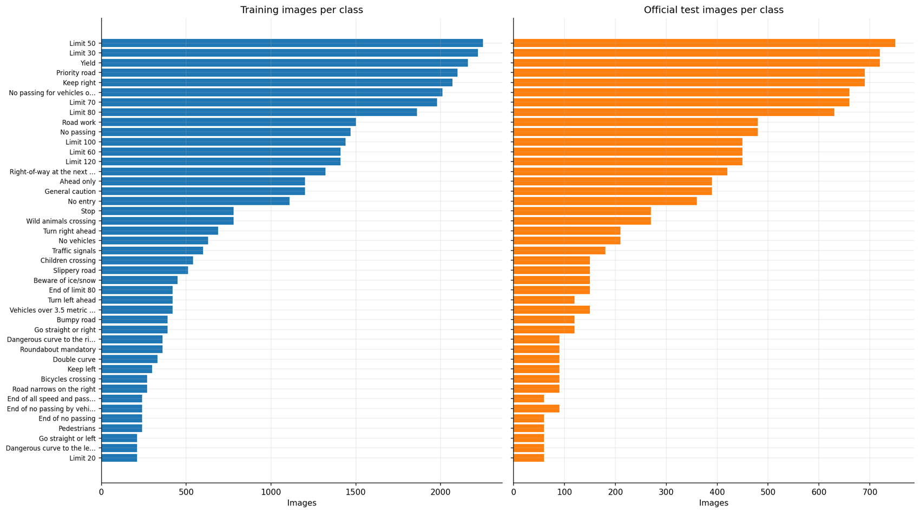
Figure 5.2: Number of images per class in the training and official test sets
Appearance of the classes. Figure 5.3 shows one random training example for each of the 43 classes. Several groups of classes look alike, notably the speed limits, which differ only in the digits.
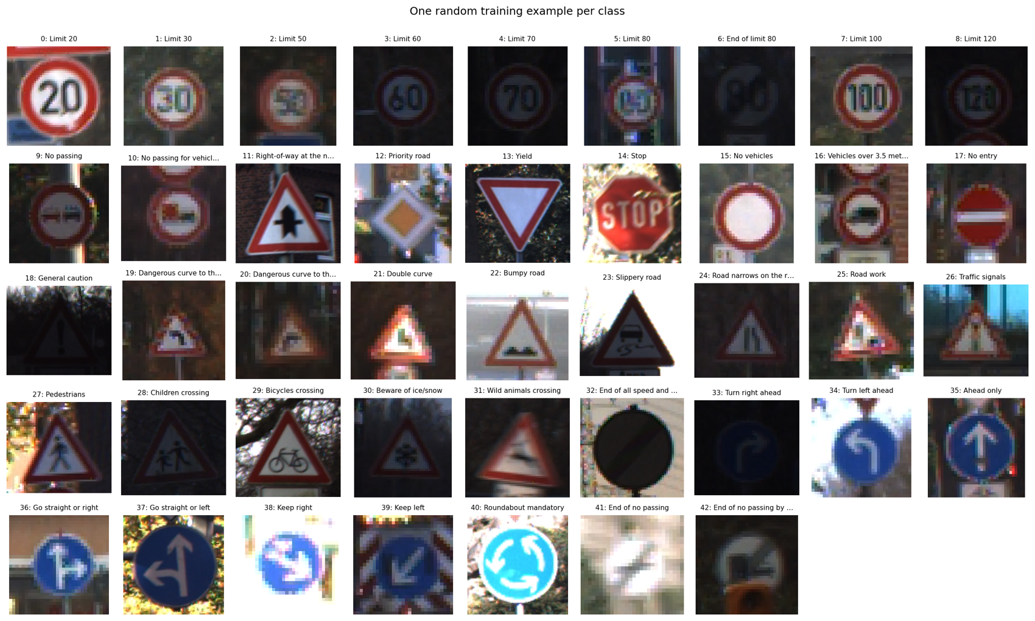
Figure 5.3: One random training example per class
Image size. The images are small (Figure 5.4). The median width is 43 pixels and 40 % are narrower than 40 pixels, so there is little detail to preserve. This supports caching images at 64 x 64 pixels: a higher resolution would only interpolate pixels that do not exist, at higher memory and training cost.
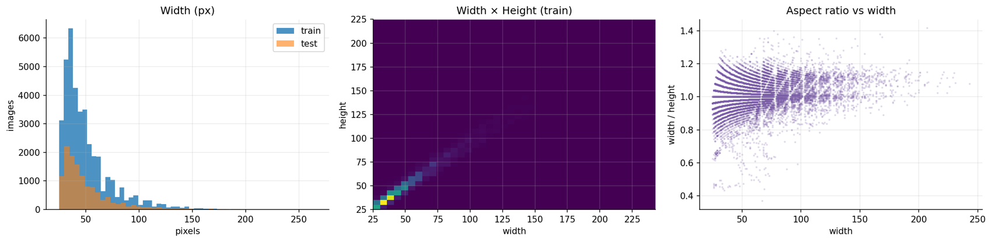
Figure 5.4: Distribution of image width, size and aspect ratio in the training images
Lighting. Brightness varies from almost black to washed out (Figure 5.5). The model must tolerate these changes, which motivates contrast augmentation during training and an explicit darkening and glare test later.
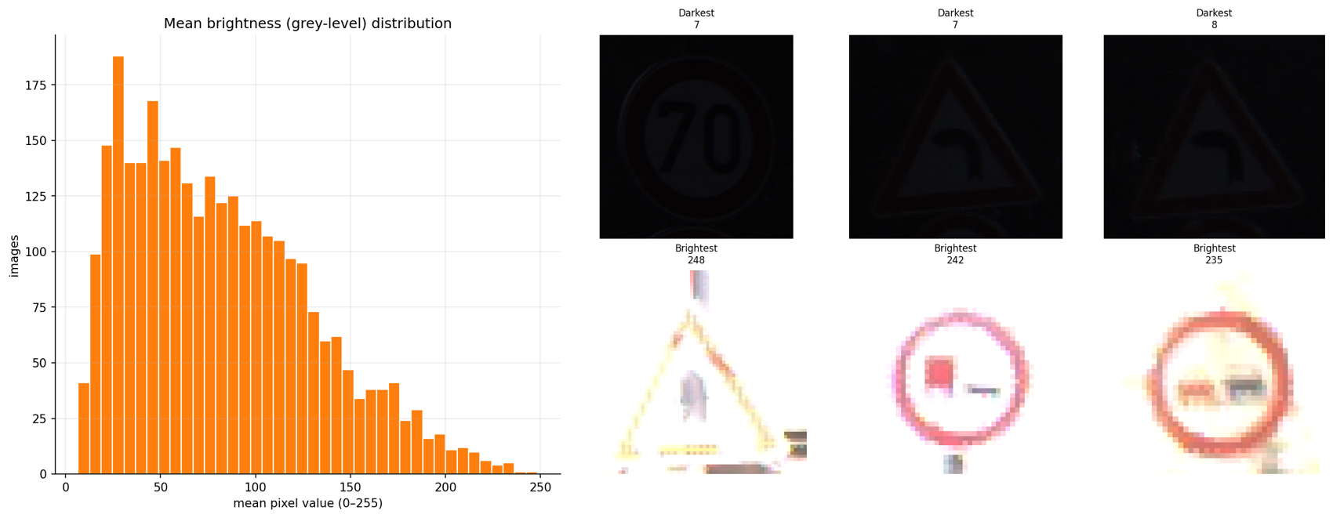
Figure 5.5: Brightness distribution of the training images with the darkest and brightest examples
Track structure. The most important finding is that the images are not independent. The 39,209 training images come from only 1,307 physical signs. Figure 5.6 shows ten frames of a single Stop sign photographed as a vehicle approaches it. Consecutive frames are almost identical in appearance, differing mainly in size. A validation split that separates the frames of one sign would therefore compare the model with images it has effectively already seen.
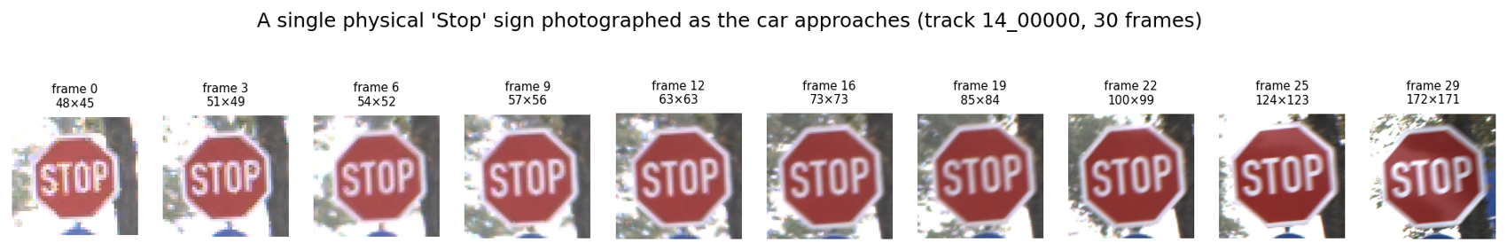
Figure 5.6: Frames of a single physical Stop sign (one training track)

5.2.3 Leakage Analysis
To measure the effect, the notebook compares a random, class-stratified image split with a track-grouped split, each holding out about one seventh of the data. In the random split, 1,291 of the 1,307 tracks have frames on both sides, and every validation track has already been seen in training (100 %). In the grouped split, no track is shared (Figure 5.7). Chapter 7 describes how the grouped split is constructed so that every class also appears in validation.
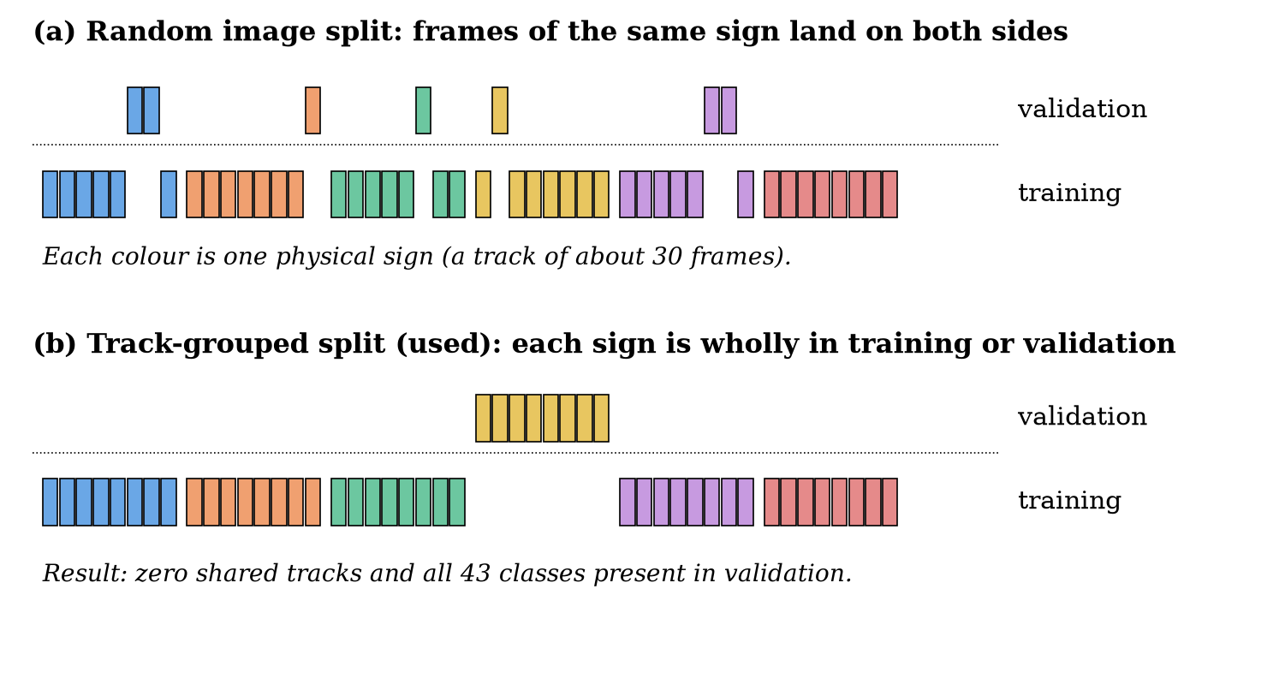
Figure 5.7: Random image split versus the track-grouped split used in this study

5.3 Tools and Technology Used
The tools are listed in Section 4.3. Training and evaluation ran on a Google Colab GPU runtime with TensorFlow 2.21.0 and Keras 3.13.2. The dataset, once cached as 8-bit arrays at 64 x 64 resolution, occupies 0.64 GB, so training streams batches from memory and is limited by the GPU rather than by disk access. Preprocessing and augmentation are layers inside each model, so the exported model accepts raw pixel values and no separate preprocessing code can drift from training.

CHAPTER 6: DESIGN AND ARCHITECTURE

6.1 Structure Chart and Work Breakdown Structure
Figure 6.1 decomposes the project into four work packages: data, modelling, evaluation and delivery. Each package contains the tasks listed under it, and Table 6.1 states the deliverable of each package.
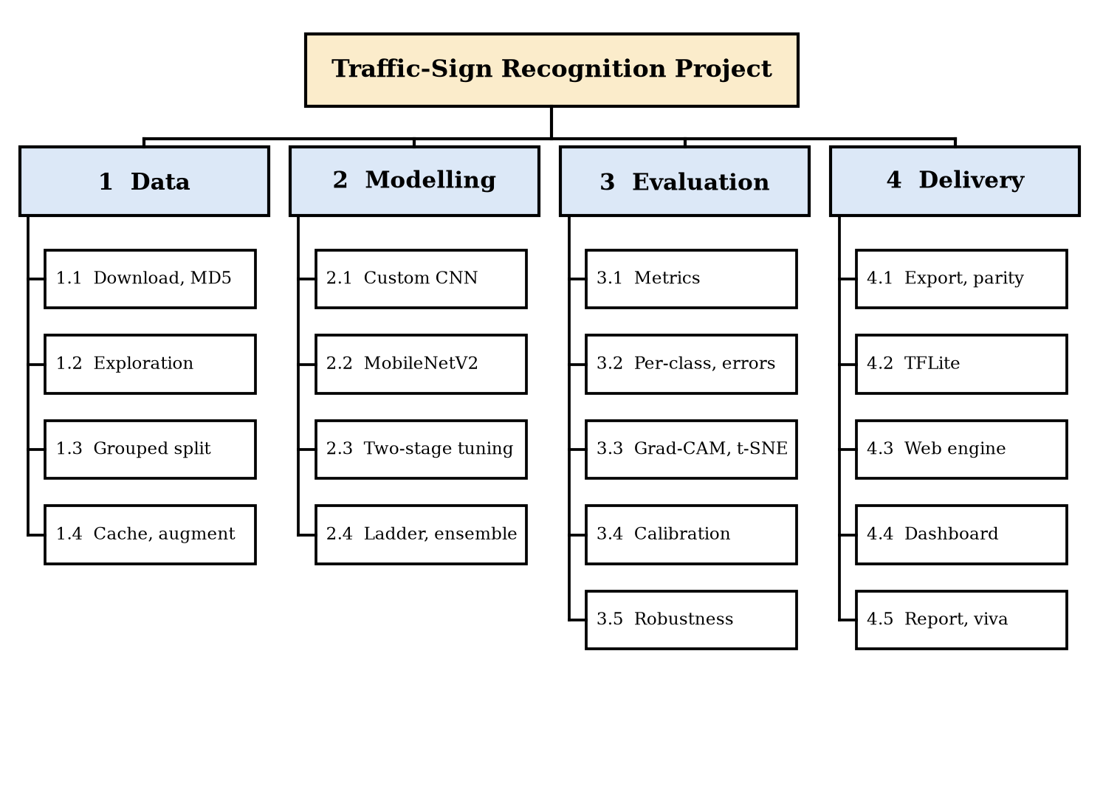
Figure 6.1: Work breakdown structure of the project
Table 6.1: Work packages and deliverables
Work package | Main tasks | Deliverable
1 Data | Download and checksum; exploratory analysis; grouped split; cache and augmentation | Verified, leakage-free training, validation and test arrays
2 Modelling | Custom CNN; MobileNetV2; two-stage tuning; ladder and ensemble | Four trained models and training histories
3 Evaluation | Metrics; per-class analysis and errors; Grad-CAM and t-SNE; calibration; robustness | Result tables and figures
4 Delivery | Export and parity; TFLite; browser engine; dashboard; report and viva material | Results bundle, website, report

6.2 Explanation of Modules
The implementation is divided into the following modules. The Python modules are in the package traffic_sign_recognition and are mirrored by self-contained cells of the notebook; the JavaScript modules form the website.
Table 6.2: Modules and their responsibilities
Module | Responsibility
Data acquisition and loading | Download, checksum verification, extraction; build label tables from folder names and CSV files; assert counts and file existence (data.py; notebook cells 6 and 7).
Splitting and caching | Hold out whole tracks per class; check zero overlap and full class coverage; resize and cache arrays (split_train_validation; notebook cells 19 and 22).
Augmentation | Rotation, translation, zoom and contrast layers active only in training (models.py).
Model definitions | Custom CNN and MobileNetV2 builders (build_custom_cnn, build_mobilenet_v2).
Training | Compile with Adam; early stopping, learning-rate reduction; two-stage fine-tuning (train.py; notebook cells 27 to 29).
Evaluation and reporting | Accuracy, macro-F1, top-3, ECE, latency; classification report and confusion matrix (reporting.py; cells 31 to 36).
Explainability | Grad-CAM for flat and nested models; embedding extraction and t-SNE (gradcam.py; cells 41 and 42).
Reliability | Reliability diagram, coverage curve, corruption functions (cells 44 and 45).
Export | Save models, predictions, tables and figures; reload parity; TFLite conversion (cells 50 to 52).
Browser engine (nn.js) | Loads weights; forward pass; Grad-CAM backward pass.
Imaging and charts (imaging.js, charts.js) | Canvas helpers, corruptions, overlay; SVG and canvas charts with tooltips and table views.
Application (demo.js, dashboard.js) | Live demo, stress lab, verification; results dashboard.

6.3 Flow Chart and Activity Diagram
Figure 6.2 shows the control flow of the experiment pipeline. The two decision points are the data check at the start, which stops the run if the checksum or counts are wrong, and the early-stopping decision in training, which keeps training while validation accuracy improves and restores the best weights otherwise.
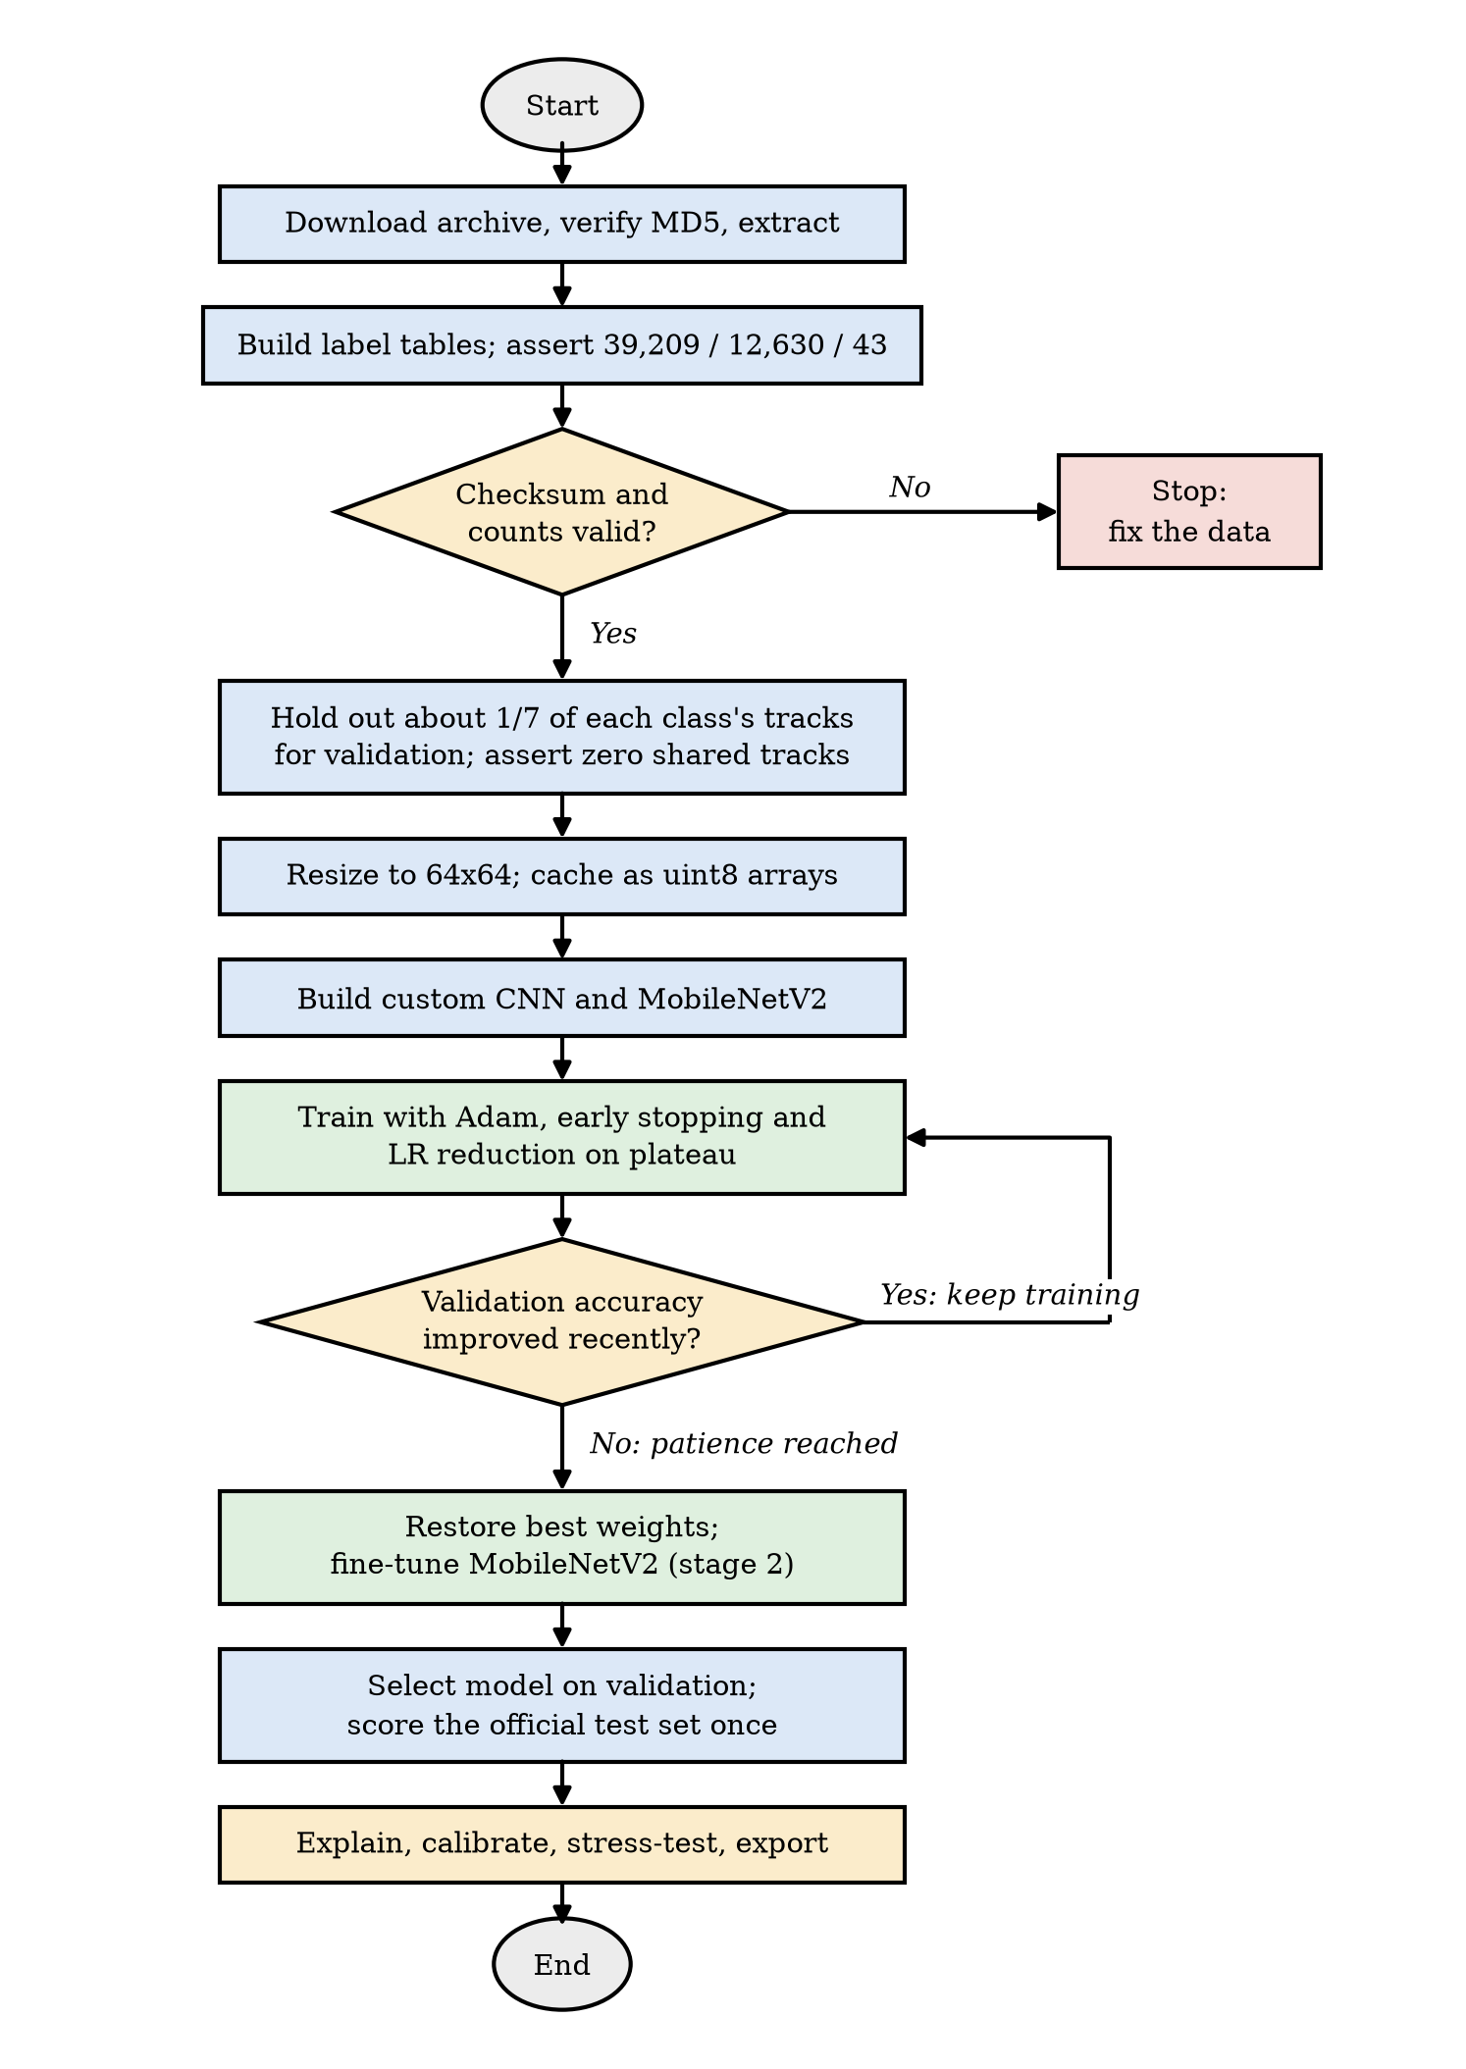
Figure 6.2: Flow chart of the experiment pipeline
The browser application has a second flow, shown in Figure 6.3: files produced by the notebook are converted by a build script into static data files, which the page loads; each image then passes through cropping and optional corruption, the forward pass and Grad-CAM, and the user interface. All of it runs locally.
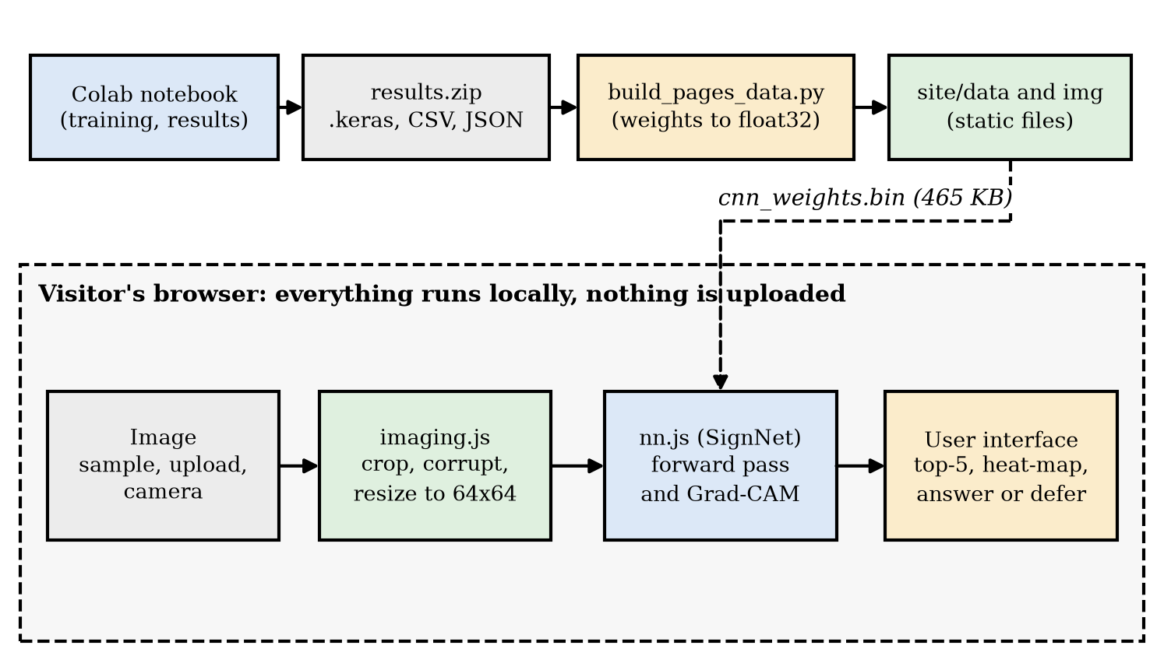
Figure 6.3: Data and control flow of the website

6.4 ER Diagram and Class Diagram
The data handled by the system can be described by the entity-relationship diagram in Figure 6.4. A class contains many tracks, a track contains many images, a model is trained in many runs, each run produces many predictions, and each image appears in many predictions.
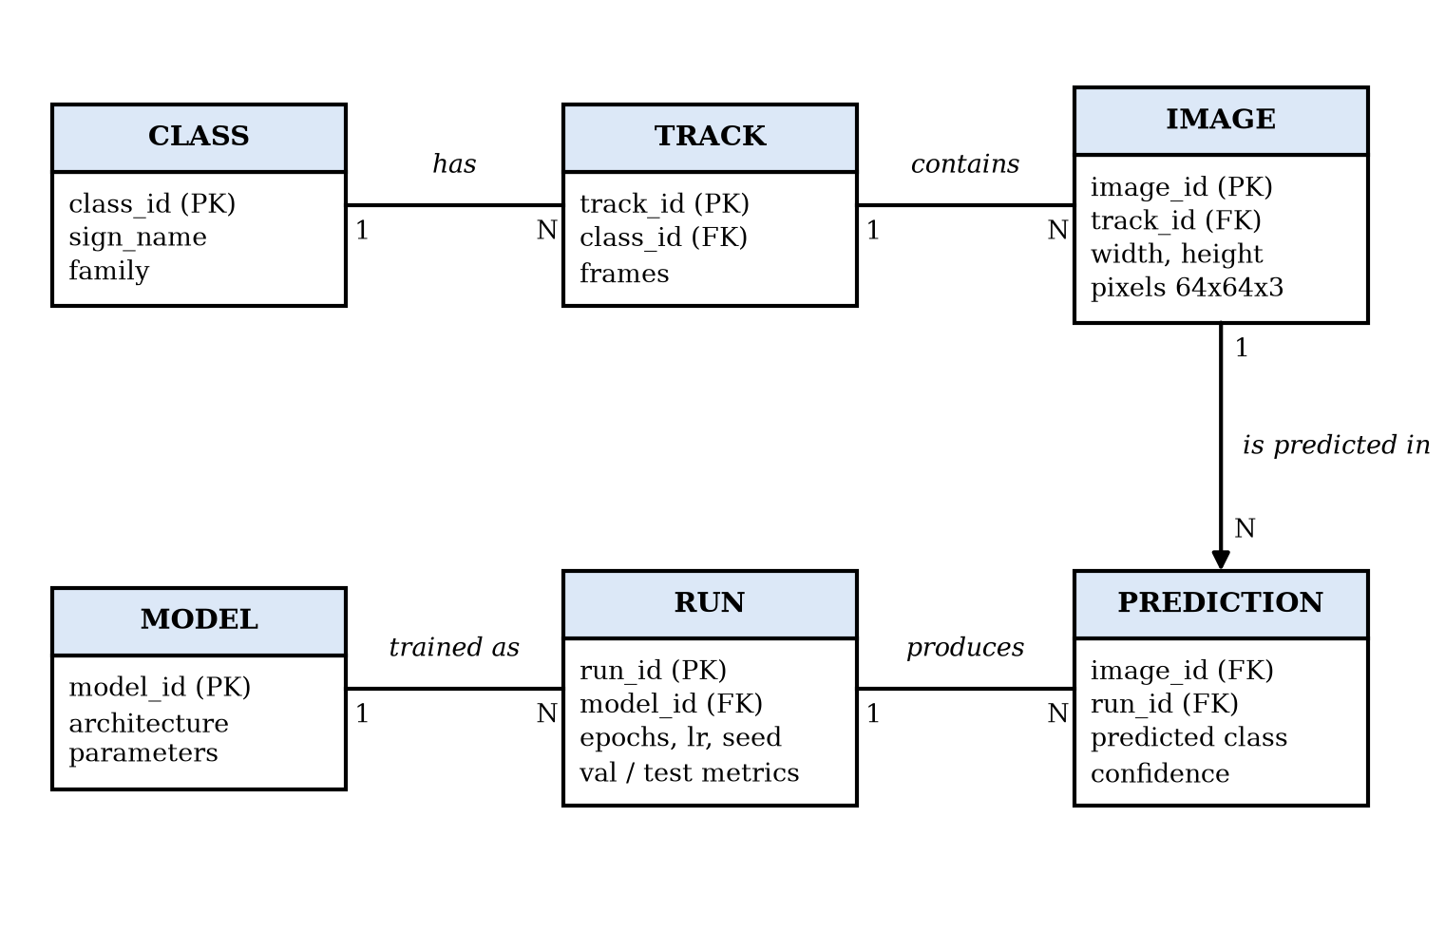
Figure 6.4: Entity-relationship diagram of the data and results
Figure 6.5 shows the structure of the code: the Python package (a) and the browser application (b). The Python package is organised as modules of functions rather than classes, so its modules are drawn as classes with their principal functions; SignNet is the only true class in the browser code.
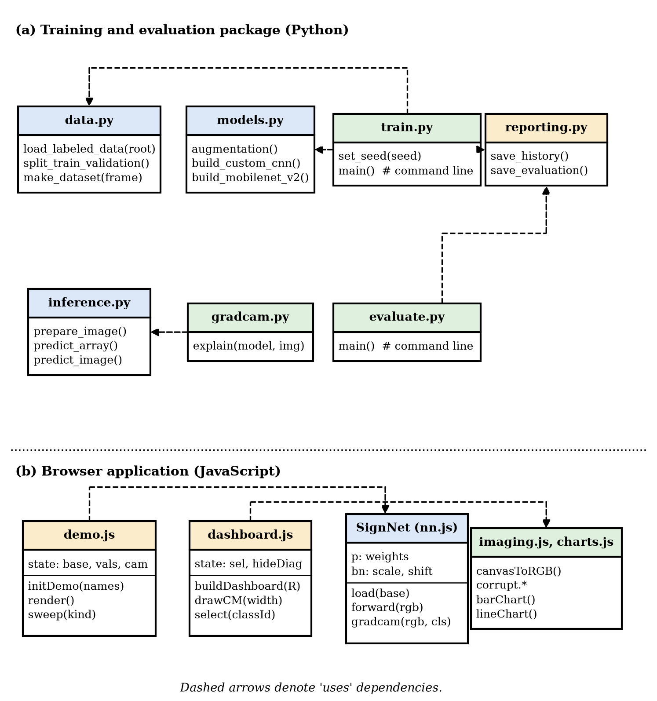
Figure 6.5: Class and module diagram of the code

6.5 Model Architectures and Algorithms

6.5.1 Custom CNN
The custom CNN (Figure 6.6) is intentionally small. It contains three blocks, each a 3 x 3 convolution with ReLU, batch normalisation, 2 x 2 max pooling and dropout (0.2), with 32, 64 and 128 filters. Global average pooling reduces the final 8 x 8 x 128 map to a 128-vector, which passes through a 128-unit dense layer with dropout (0.3) to a 43-way softmax. Augmentation is applied to raw pixels before they are scaled to the range 0 to 1. Table 6.3 lists the layers and parameters; the total is 116,203 parameters, of which 115,755 are trainable, and about 41 million multiply-accumulate operations per image.
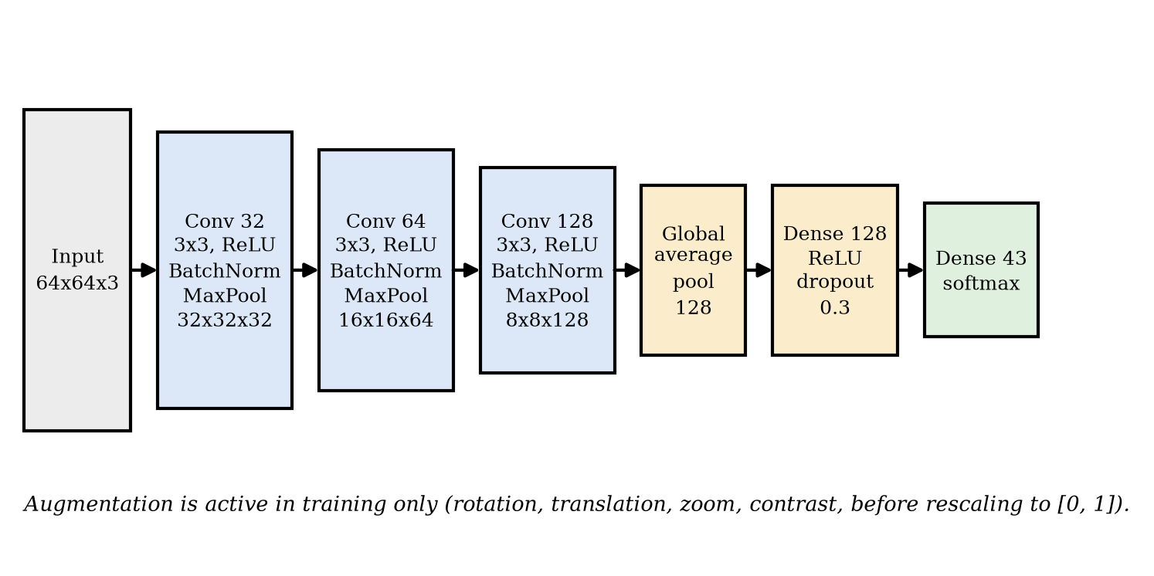
Figure 6.6: Architecture of the custom CNN
Table 6.3: Layers and parameters of the custom CNN
Layer | Output shape | Parameters
Input (raw pixels, augmentation, rescale) | 64 x 64 x 3 | 0
Conv 3x3, 32 filters, ReLU | 64 x 64 x 32 | 896
BatchNorm, MaxPool 2x2, Dropout 0.2 | 32 x 32 x 32 | 128
Conv 3x3, 64 filters, ReLU | 32 x 32 x 64 | 18,496
BatchNorm, MaxPool 2x2, Dropout 0.2 | 16 x 16 x 64 | 256
Conv 3x3, 128 filters, ReLU | 16 x 16 x 128 | 73,856
BatchNorm, MaxPool 2x2, Dropout 0.2 | 8 x 8 x 128 | 512
Global average pooling | 128 | 0
Dense 128, ReLU; Dropout 0.3 | 128 | 16,512
Dense 43, softmax | 43 | 5,547
Total |  | 116,203

6.5.2 MobileNetV2 Transfer Learning
The transfer-learning model (Figure 6.7) upsamples the 64 x 64 input to 128 x 128 inside the model, scales it to the range -1 to 1 as MobileNetV2 expects, passes it through the ImageNet-pretrained backbone with average pooling (a 1,280-dimensional vector), applies dropout (0.25) and a 43-way dense layer. It is trained in two stages. In stage 1 the backbone is frozen and only the new dense layer is trained (55,083 parameters). In stage 2 the last 50 backbone layers are unfrozen while all batch-normalisation layers stay frozen, and training continues at a ten times lower learning rate (1,834,219 of 2,313,067 parameters trainable).
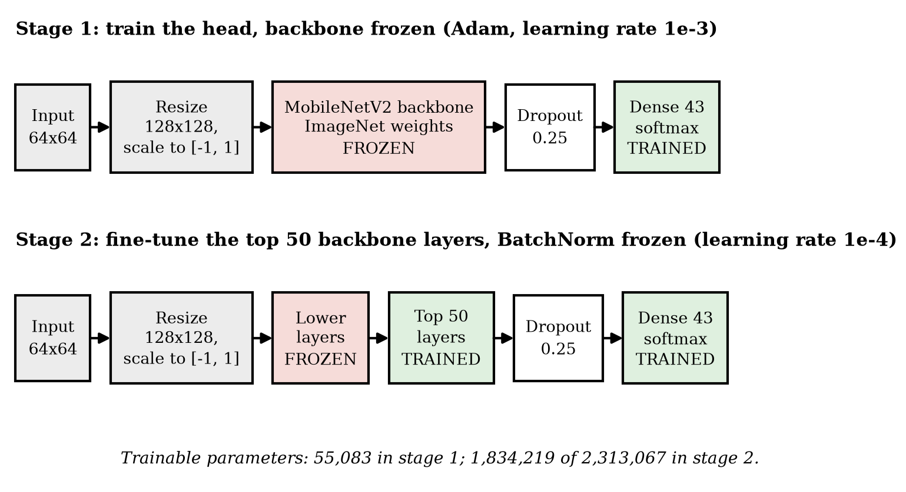
Figure 6.7: Two-stage training of the MobileNetV2 model

6.5.3 Algorithms
Algorithm 6.1 describes the construction of the leakage-free validation split. Algorithm 6.2 describes training with early stopping, and Algorithm 6.3 the Grad-CAM computation used in the browser. Algorithm 6.4 describes selective prediction.
Algorithm 6.1: Per-class, track-grouped validation split
Input: table of training images with (label, track); seed s; fraction f = 1/7
Output: fitting set F and validation set V
rng <- random generator seeded with s
V_tracks <- empty list
for each class c in 0..42:
T <- distinct tracks of class c
k <- max(1, round(f * |T|))
V_tracks <- V_tracks + k tracks drawn from T without replacement using rng
V <- images whose track is in V_tracks; F <- all other images
assert no track occurs in both F and V
assert every class occurs in V

Algorithm 6.2: Training with early stopping and learning-rate reduction
Input: model, fitting set F, validation set V, learning rate a, patience p, epoch limit E
best <- -infinity; wait <- 0
for epoch = 1..E:
update the weights on augmented mini-batches of F with Adam(a)
v <- accuracy of the model on V (augmentation off)
if validation loss did not improve for p/2 epochs: a <- 0.4 * a
if v > best: best <- v; save the weights; wait <- 0
else: wait <- wait + 1
if wait >= p: break
restore the saved weights

Algorithm 6.3: Grad-CAM for the last convolutional layer (class score before softmax)
Input: image x, network with last convolution output A (16 x 16 x 128), target class c
forward pass: obtain A, the logits z and the probabilities p
y_c <- z[c] # class score before the softmax
back-propagate dy_c / dA through dense layers, global average pooling,
max pooling (to the arg-max positions) and batch normalisation
alpha_k <- mean over positions of dy_c / dA[:, :, k]
cam <- ReLU( sum_k alpha_k * A[:, :, k] )
cam <- cam / (max(cam) + 1e-8)
return cam, upsampled bilinearly to the image size

Algorithm 6.4: Selective prediction with an answer threshold
Input: probability vector p for an image, threshold t
conf <- max(p); class <- argmax(p)
if conf >= t: answer class with confidence conf
else: defer to a human or another sensor
Offline: for t in a grid, coverage(t) = mean(conf >= t); accuracy(t) = accuracy on {conf
>= t}

CHAPTER 7: IMPLEMENTATION
This chapter describes how the design of Chapter 6 was implemented: the data pipeline, the models and their training, the evaluation and explanation code, the export step, and the browser implementation. It follows the structure of the research format (data presentation, implementation, analysis) and then gives the screenshots and the source code of selected modules required of development projects.

7.1 Data Presentation and Preparation

7.1.1 Loading and Verification
The notebook builds two label tables. For training, it walks the class folders in sorted order and records, for each image, the path, the class, the track (class and track number taken from the file name) and the frame number; width and height are joined from Train.csv. For testing, it reads Test.csv. The code then asserts that there are 39,209 training images, 12,630 test images and 43 classes, that every file exists, and, for the archive, that the checksum matches. A failed assertion stops the run before any training, so that a wrong or truncated dataset cannot silently produce results.

7.1.2 The Validation Split
The split is the most consequential implementation detail of the project, and it required two corrections. The first version used the scikit-learn GroupShuffleSplit [29], which keeps all frames of a track together but does not balance classes. In the first full run the printed check all 43 classes in validation was False: five classes (0, 19, 21, 23 and 29) had no validation images, which biased validation accuracy, the ladder and the model selection (the test results were unaffected, because those classes were still trained on and the test set is separate). A first repair with StratifiedGroupKFold passed in a local check but failed the same assertion on Colab, because that splitter only attempts to balance classes and its behaviour depends on the library version. The final implementation therefore selects tracks explicitly (Algorithm 6.1): for every class, about one seventh of its tracks (at least one) are chosen with a seeded NumPy generator. It is deterministic, independent of library versions, and guarantees coverage; Listing 7.1 shows the code.
Table 7.1: Random split versus the track-grouped split used
Property | Random image split | Track-grouped split (used)
Validation images | 5,602 | 5,639
Fitting images / tracks | - | 33,570 / 1,119
Validation tracks | - | 188
Tracks present on both sides | 1,291 of 1,307 | 0
Validation tracks already seen in training | 100 % | 0 %
Classes present in validation | - | 43 of 43 (asserted)

7.1.3 Caching and Augmentation
All images are resized to 64 x 64 pixels with bilinear resampling and stored as 8-bit arrays: 33,570 fitting, 5,639 validation and 12,630 test images, 0.64 GB in total, built in 25 seconds with 16 reader threads. The region of interest given in the CSV is deliberately not used to crop: a real detector returns boxes with some margin, so training on the full frame matches deployment better.
Augmentation is implemented as Keras layers placed at the start of each model, so it is active only while training. Table 7.2 lists the settings, and Figure 7.1 shows one image and fifteen augmented versions. Horizontal flipping is deliberately absent: flipping a “turn left ahead” sign yields an image that looks like “turn right ahead” but would keep the original label.
Table 7.2: Augmentation settings (training only)
Transform | Setting | Reason
Rotation | factor 0.04 of a full turn (about 14 degrees either way) | Camera tilt, slanted poles
Translation | 5 % of width and height | Imperfect crops
Zoom | 8 % | Different distances
Contrast | 10 % | Lighting variation
Horizontal flip | Not used | Would change the meaning of directional signs

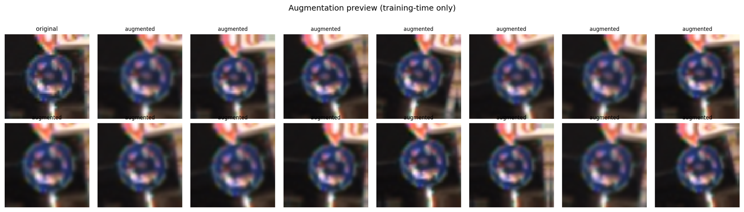
Figure 7.1: Original image and random augmentations (training only)

7.1.4 Hyper-parameters
Table 7.3: Hyper-parameters and training settings of the reported run
Setting | Custom CNN | MobileNetV2 stage 1 | MobileNetV2 stage 2
Optimiser | Adam | Adam | Adam
Learning rate | 1e-3 | 1e-3 | 1e-4
Batch size | 128 | 128 | 128
Epoch limit | 30 | 12 | 15
Early stopping (patience, on validation accuracy) | 5 | 4 | 4
Learning-rate reduction | x0.4 after 2 stalled epochs | x0.4 after 2 | x0.4 after 2
Trainable parameters | 115,755 | 55,083 | 1,834,219
Input to the network | 64 x 64 | 64 x 64, upsampled to 128 x 128 | same
Random seed | 42 | 42 | 42

7.2 Implementation of the Work

7.2.1 Models and Training
Both models are built with the Keras functional API (Listing 7.2). A helper function compiles a model with Adam and sparse categorical cross-entropy, attaches early stopping (monitoring validation accuracy and restoring the best weights) and learning-rate reduction on plateau, trains on the in-memory arrays and returns the history and the elapsed time. For MobileNetV2 the second stage sets the backbone trainable, re-freezes all but its last 50 layers and every batch-normalisation layer, and recompiles with the lower learning rate. If the pretrained weights cannot be downloaded the code falls back to random initialisation with a visible warning, so that the notebook still runs offline.

7.2.2 The Progress Ladder
The ladder trains four additional models of increasing capability on the same fitting and validation sets and with the same optimiser, and reuses the final custom CNN and the two MobileNetV2 models. Table 7.4 defines each step.
Table 7.4: Definition of the progress-ladder steps
Step | Model | What changes
0 | Majority-class baseline | Always predict the most frequent training class
1 | Linear classifier | One dense softmax layer on 16 x 16 pixels
2 | Multi-layer perceptron | Two hidden layers (256, 128 units) on 32 x 32 pixels
3 | Basic CNN | Two convolution layers, flatten, dense layer; no normalisation, augmentation or dropout
4 | Deeper CNN | Three blocks, batch normalisation, global average pooling
5 | Final custom CNN | Adds augmentation and dropout
6 | MobileNetV2, frozen | Pretrained backbone, new head only
7 | MobileNetV2, fine-tuned | Top 50 backbone layers adapted at a lower rate
8 | Ensemble | Average of the probabilities of steps 5 and 7

7.2.3 Evaluation, Explanation and Reliability Code
A scoring function converts a probability matrix into accuracy, macro-F1 (scikit-learn), top-3 accuracy and ECE with 15 bins, so the same code scores the validation and the test set and the ensemble. Latency is the mean time of 200 single-image calls. The per-class report, confusion matrix, most frequent confusions and confident errors are computed from the test predictions. For Grad-CAM the code builds a helper model that returns the last convolutional feature map and the network output; because the MobileNetV2 model contains its backbone as a nested model, the forward pass is carried out layer by layer around it. Embeddings for t-SNE are taken from the input of the last dense layer. The corruption functions apply brightness scaling, Gaussian noise, Gaussian blur, rotation with border replication and a black occluding square to 6,000 test images at three severities each.

7.2.4 Export and Parity Checks
The export step saves each model in the native Keras format together with its metrics, classification report, confusion matrix, training history and per-image predictions; the comparison, ladder, per-class, confusion and robustness tables; a 1,000-image sample of the test set; and a README that shows how to load a model. The two main models are then reloaded and their predictions on 256 images are compared with those of the in-memory models; a difference above 10⁻⁴ stops the run. The selected model is also converted to TensorFlow Lite with 16-bit float weights and evaluated on 500 test images.

7.2.5 The Browser Implementation
To let anyone run the selected model without installation or a server, the trained network was re-implemented in plain JavaScript (nn.js, 150 lines, no libraries). A build script (build_pages_data.py) reads the weights directly from the saved Keras file and writes them as a single 465 KB float32 file with a JSON manifest that records each array's name and shape and the batch-normalisation epsilon. In the browser the weights are folded into per-channel scale and shift constants for the normalisation layers. The forward pass is a direct implementation of the architecture: a 3 x 3 convolution with ReLU, batch normalisation, 2 x 2 max pooling (recording the winning positions), three times, then global average pooling and two dense layers (Listing 7.3).
Grad-CAM is implemented by hand-written back-propagation from the chosen class score to the output of the last convolutional layer, through the dense layers, the ReLU gate, global average pooling, the recorded max-pooling positions and the batch-normalisation scale (Listing 7.4). The channel weights are the spatial means of these gradients; the heat-map is the ReLU of the weighted sum of the activations, scaled to the range 0 to 1 and upsampled bilinearly. The same code supports two scores: the class logit (default) and the class probability (as in the notebook), which allowed the numerical comparison in Section 9.2.4.
The page itself is written as ES modules: imaging.js (crop, corruptions, overlay), charts.js (an SVG and canvas chart kit with tooltips on hover and keyboard focus and a table view for every chart), demo.js (the demonstration and stress lab) and dashboard.js (the result charts). A second build step turns the notebook's results bundle into results.json and a sprite of 116 sample test images (86 correctly classified and 30 misclassified by the Keras model, with the Keras confidence recorded for each). A GitHub Actions workflow publishes the site folder to GitHub Pages on every change.

7.3 Analysis and Interpretation of Training
Table 7.5 records the training cost of each stage and Figure 7.2 and Figure 7.3 show the learning curves.
Table 7.5: Training cost of the reported run
Stage | Epochs run (limit) | Time | Best validation accuracy
Custom CNN | 29 (30) | 341 s | 97.61 %
MobileNetV2 stage 1 (head) | 12 (12) | 244 s | 72.58 %
MobileNetV2 stage 2 (fine-tune) | 14 (15) | 422 s | 90.55 %
Ladder: linear classifier | 15 (15) | 17 s | 70.19 %
Ladder: MLP | 15 (15) | 20 s | 83.24 %
Ladder: basic CNN | 25 (30) | 107 s | 93.37 %
Ladder: deeper CNN | 24 (30) | 150 s | 95.14 %

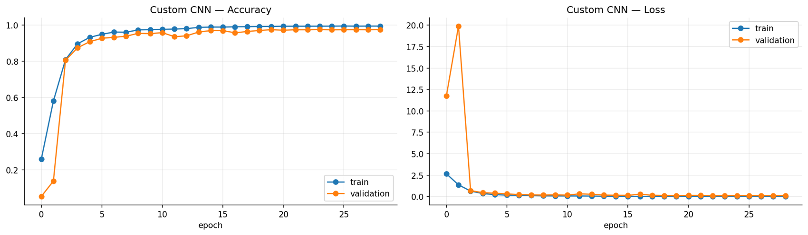
Figure 7.2: Training and validation curves of the custom CNN
The custom CNN's validation accuracy tracks its training accuracy closely: at the last epoch the training accuracy is 99.45 % and the validation accuracy 97.59 %, a gap of under two points. Training accuracy is lower than validation accuracy in the first epochs because augmentation and dropout are active only during training. Early stopping ended training after 29 of at most 30 epochs.
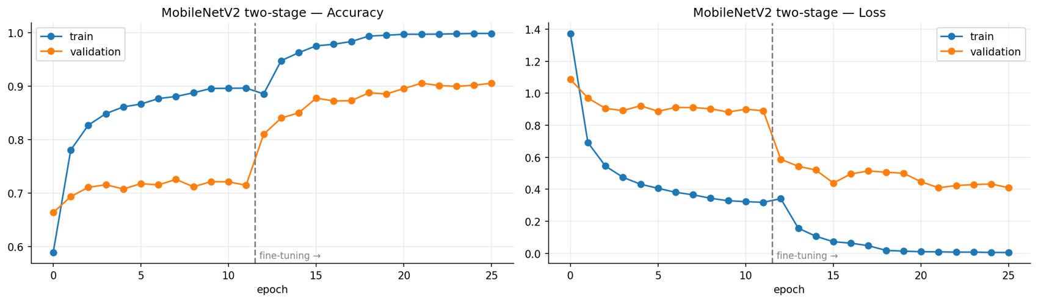
Figure 7.3: Training and validation curves of MobileNetV2 across the two stages (the dashed line marks the start of fine-tuning)
For MobileNetV2 the head-only stage plateaus: its validation accuracy stays near 72 % although the training accuracy reaches 89.6 %. Fine-tuning raises validation accuracy sharply to 90.5 %, but the training accuracy reaches 99.8 %: the fine-tuned model over-fits, memorising the training images far more than the small CNN does. This agrees with the expectation that the pretrained features are not matched to tiny sign crops and that a network with 2.3 million parameters has more capacity than 33,570 highly correlated images can constrain.

7.4 Screenshots
The website is published at https://briskam.github.io/mait-mini/. Figure 7.4 to Figure 7.8 show the main views. In Figure 7.4 the hero panel cycles real test images through the model; each frame shows the image, the Grad-CAM heat-map, the prediction, the confidence and whether it is correct. Figure 7.5 shows a misclassified test image: the true class is Speed limit 120 km/h, the model answers Speed limit 100 km/h with 91.6 % confidence and the page states that the Keras model from the notebook makes the same mistake.
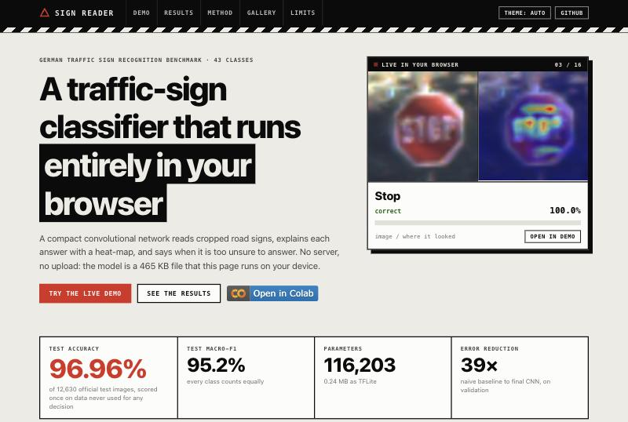
Figure 7.4: Website home view with the live prediction panel and headline results
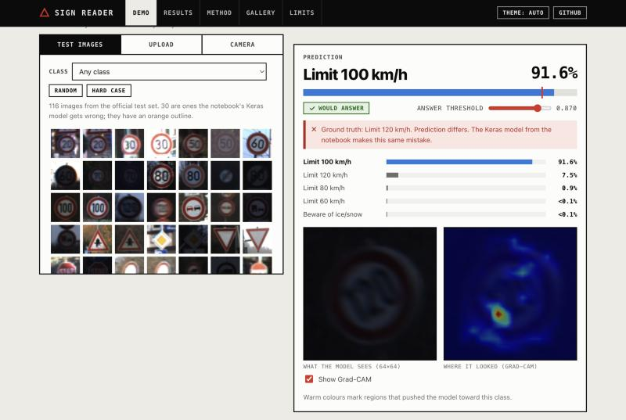
Figure 7.5: Live demonstration of a misclassified test image with Grad-CAM
Figure 7.6 shows the effect of added noise on another test image: the prediction changes to the wrong class with 80 % confidence, which is below the answer threshold of 0.87, so the page reports that the system would defer to a human. Figure 7.7 shows the stress lab with a sweep of the noise level, which plots the model's probability for its clean prediction (and for the true class when they differ) across the range.
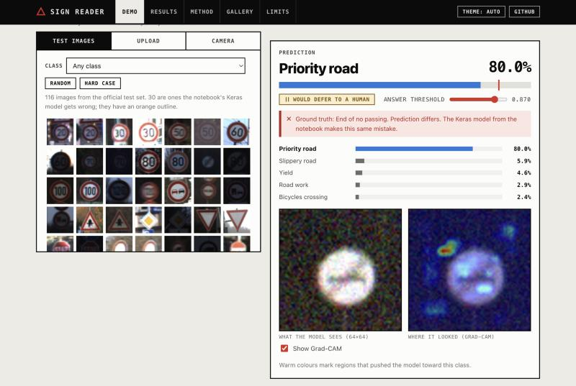
Figure 7.6: Noise applied to a test image; the model would defer
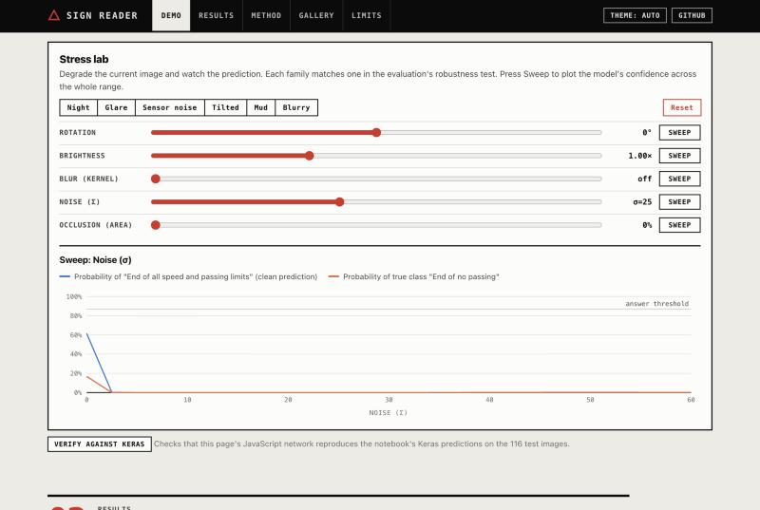
Figure 7.7: Stress lab with presets, sliders and a noise sweep
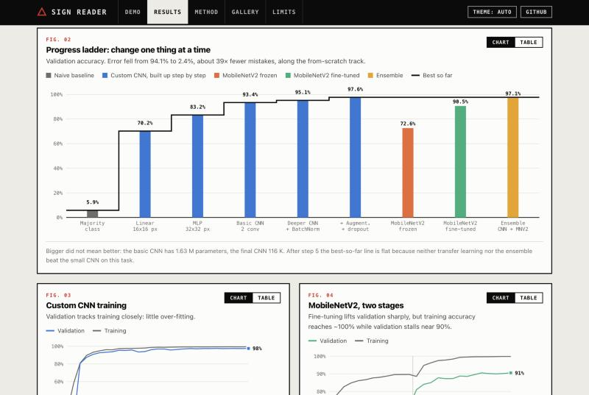
Figure 7.8: Results dashboard: the progress ladder and training curves

7.5 Source Code of Some Modules
The listings below are the most important parts of the implementation. Further code is in the repository and in Appendix A.
Listing 7.1: Per-class, track-grouped validation split (notebook)
rng = np.random.default_rng(SEED); val_groups = []
for _, tracks in train_df.groupby("label").group.unique().items():
# hold out ~1/7 of each class's tracks (at least one)
val_groups += list(rng.choice(tracks, max(1, round(len(tracks) / 7)), replace=False))
is_val = train_df.group.isin(val_groups).values
fit_df, val_df = train_df[~is_val].reset_index(drop=True),
train_df[is_val].reset_index(drop=True)
assert not set(fit_df.group) & set(val_df.group), "Leakage: a track appears in both
splits"
assert val_df.label.nunique() == NUM_CLASSES, "Validation is missing some classes"

Listing 7.2: Custom CNN definition (Keras functional API)
def build_custom_cnn():
inp = layers.Input((IMG, IMG, 3), name="image") # raw pixels 0-255
x = augmentation()(inp) # active in training only
x = layers.Rescaling(1 / 255.0)(x)
for i, f in enumerate((32, 64, 128), 1):
x = layers.Conv2D(f, 3, padding="same", activation="relu", name=f"conv{i}")(x)
x = layers.BatchNormalization()(x); x = layers.MaxPooling2D()(x); x =
layers.Dropout(0.2)(x)
x = layers.GlobalAveragePooling2D()(x)
x = layers.Dense(128, activation="relu", name="embedding")(x); x =
layers.Dropout(0.3)(x)
return keras.Model(inp, layers.Dense(NUM_CLASSES, activation="softmax",
name="probs")(x), name="custom_cnn")

Listing 7.3: Forward pass of the network in JavaScript (nn.js, abridged)
forward(rgb, keep = false) {
let x = Float32Array.from(rgb, (v) => v / 255), H = 64, Cin = 3; const stages = [];
for (const [i, Cout] of [[1, 32], [2, 64], [3, 128]]) {
const a = conv3x3(x, H, H, Cin, p[`conv${i}.w`], p[`conv${i}.b`], Cout); // conv +
ReLU
const bn = batchNorm(a, Cout, this.bn[i].scale, this.bn[i].shift);
const pooled = maxPool(bn, H, H, Cout); // keeps arg-max positions
stages.push({ a, bn, pooled, H, C: Cout }); x = pooled.out; H >>= 1; Cin = Cout;
}
const g = globalAveragePool(x, H * H, Cin); // 128 numbers
const h1 = relu(dense(g, p['dense1.w'], p['dense1.b'])); // 128 units
const probs = softmax(dense(h1, p['dense2.w'], p['dense2.b'])); // 43 classes
return keep ? { probs, stages, h1pre, n } : { probs };
}

Listing 7.4: Grad-CAM back-propagation in JavaScript (nn.js, abridged)
const dz = new Float32Array(43); // gradient of the score w.r.t. the
logits
for (let j = 0; j < 43; j++) dz[j] = score === "prob" ? probs[c] * ((j === c) - probs[j])
: (j === c ? 1 : 0);
dh1pre[i] = h1pre[i] > 0 ? sum_j W2[i][j] * dz[j] : 0; // dense 2 and ReLU gate
dg[i] = sum_o W1[i][o] * dh1pre[o]; // dense 1
for (o of pooledPositions) dB[arg[o]] += dg[o % C] / n; // pooling and global average
alpha[c] = (sum over positions of dB[.., c]) * bnScale[c] / (H * H);
cam = relu( sum_c alpha[c] * A[.., c] ); cam /= max(cam) + 1e-8;

CHAPTER 8: TESTING
The project has no separate unit-test suite for the Python package. Testing was instead built into the pipeline as assertions, into the export step as parity checks, and into dedicated verification scripts and manual test cases for the website. This chapter describes each level and lists test cases with their outcomes.

8.1 Test Strategy
Table 8.1: Levels of testing used
Level | What is tested | How
Data integrity | Archive, counts, files, split properties | Assertions that stop the notebook
Component | Models, scoring, export | Reload parity, TFLite parity, shape and parameter checks
Numerical | Browser network versus Keras | Verification script on 116 images; in-page check
System (functional) | Website behaviour end to end | Manual test cases in a browser (Section 8.4)
Non-functional | Robustness, calibration, layout, accessibility | Corruption study; narrow-viewport and theme checks
Regression | Behaviour after each change | Re-running the notebook; re-running the verification script

8.2 Checks Embedded in the Pipeline
Table 8.2: Automated checks in the notebook and their outcome in the reported run
Check | Expected | Outcome
Archive MD5 equals 7faafd0d78d831c7eb4d555641a83a62 | Equal | Passed
Training images, test images, classes | 39,209; 12,630; 43 | Passed
All image files exist | True | Passed
No track in both fitting and validation sets | Empty intersection | Passed
All 43 classes present in validation | True | Passed (failed in the first run, which led to the corrected split)
Reloaded custom CNN reproduces predictions on 256 images | Difference below 1e-4 | Passed (difference 0)
Reloaded fine-tuned MobileNetV2 | Difference below 1e-4 | Passed (difference 0)
Reloaded ensemble model | Difference below 1e-4 | Passed (difference 0)
TFLite model versus Keras on 500 test images | Same predictions | 100 % agreement; 97.6 % accuracy on those images

8.3 Numerical Verification of the Browser Network
The correctness of the JavaScript network is critical, because the website presents it as the trained model. It was verified in three ways. First, a Keras model with the identical architecture was built outside the notebook, the weights were loaded from the saved file, and its predictions on the 116 sample images were compared with the confidences that the notebook had recorded for the original model: the largest difference was 1.3 x 10⁻⁵, with identical predictions. This validates both the weight mapping and the batch-normalisation constants. Second, the JavaScript network was run in Node.js on the same images and compared with this Keras reference (Table 8.3). Third, the web page contains a Verify against Keras button that repeats the comparison with the values recorded in the notebook, so the check can be repeated by any visitor.
Table 8.3: Agreement between the JavaScript network and Keras on 116 test images
Quantity | Result
Predictions identical | 116 of 116
Largest difference in any class probability | 3.2 x 10^-6
Largest difference in the Grad-CAM map (class-logit score) | 3.1 x 10^-6
Largest difference in the Grad-CAM map (probability score), on the 66 images with confidence below 0.9999 | 5.9 x 10^-4
Images with confidence of at least 0.9999 (probability-score map not meaningful) | 50 of 116
In-page check against notebook confidences | 116 of 116 identical; largest difference 1.3 x 10^-5

The check also revealed a property of the notebook's Grad-CAM implementation that is reported in Section 9.2.4: for the 50 near-certain images the probability-based maps differ between two correct implementations because their gradients are of the order of floating-point rounding.

8.4 Functional Test Cases for the Website
Table 8.4 lists the test cases executed on the deployed site (and on the local copy during development), using the browser's console to confirm that no errors were logged.
Table 8.4: Functional test cases for the website
ID | Feature | Steps | Expected result | Result
TC01 | Page load | Open the site | Model loads; status reads ready; no console errors | Pass
TC02 | Hero panel | Wait on the home view | Test images cycle with prediction and heat-map; counter advances | Pass
TC03 | Select a sample | Click a thumbnail | Prediction, confidence, ground truth and heat-map appear | Pass
TC04 | Hard case | Press Hard case | A misclassified image is shown; page notes Keras makes the same mistake | Pass
TC05 | Answer threshold | Move the threshold slider | Badge switches between Would answer and Would defer; coverage chart updates | Pass
TC06 | Preset | Press Night or Sensor noise | Sliders move; image darkens or noisy; prediction updates | Pass
TC07 | Sweep | Press Sweep for noise or brightness | A confidence-versus-severity line chart appears | Pass
TC08 | Verify against Keras | Press the verify button | Reports 116 of 116 identical; difference about 1e-5 | Pass
TC09 | Upload | Provide an image file | Crop box appears; prediction updates; ground truth hidden | Pass (synthetic image)
TC10 | Camera | Choose Camera and allow access | Live frame with crop box; periodic prediction | Not tested (no camera in the test environment)
TC11 | Class inspection | Click a bar in the F1 chart | Class detail appears with confusions; matrix row highlighted | Pass
TC12 | Metric switch | Select a different metric chip | Bar chart redraws for the metric | Pass
TC13 | Table view | Press Table on a chart card | Data table replaces the chart | Pass
TC14 | Theme | Cycle Theme auto, light, dark | Colours switch; charts remain legible | Pass
TC15 | Narrow layout | Set a 375 px viewport | Single column; no horizontal overflow | Pass
TC16 | Keyboard | Tab to a chart mark | Tooltip appears on focus | Pass (spot check)
TC17 | Deployment | Request the published URL and data files | All files return HTTP 200; page works over HTTPS | Pass
TC18 | Hidden state | Switch from a sample to an upload | Ground-truth box disappears | Pass (after fix, Section 8.5)

8.5 Defects Found and Fixed
Table 8.5: Defects found during development and testing
No. | Defect | Detection | Resolution
1 | Five classes had no validation images with GroupShuffleSplit; validation metrics and model selection were biased | Printed check all 43 classes in validation: False; reproduced from file names | Replaced by the explicit per-class track selection and added an assertion
2 | A first repair with StratifiedGroupKFold passed locally but failed on Colab | Assertion error in the notebook | Deterministic NumPy-based selection independent of library version
3 | Grad-CAM from the class probability was numerically unreliable for near-certain predictions | Keras-versus-JavaScript map comparison | Class-logit score used in the browser; difference documented
4 | Ladder chart labels overlapped; Grad-CAM titles truncated speed limits | Visual inspection of results | Shorter labels and speed-limit abbreviations
5 | A display rule overrode the HTML hidden attribute, leaving a ground-truth box visible after switching to an upload | TC18 observation | Global rule that makes the hidden attribute win
6 | Figure counter also numbered the Chart/Table toggle; headline highlight clipped a letter | Visual inspection | Selector restricted; line height adjusted

8.6 Limitations of the Testing
The Python package has no automated unit-test suite, so its modules rely on the assertions and the end-to-end run. The camera path of the website was not exercised. The website was not tested on Safari, on a range of physical phones or with assistive technology beyond keyboard focus. Timing figures were measured on the development laptop and on a Colab GPU and are not benchmarks of target hardware. Adding a pytest suite for the data and export code and automated browser tests for the website are listed as future work.

CHAPTER 9: RESULTS AND DISCUSSION
All results in this chapter come from one complete run of the notebook in full mode on a Google Colab GPU runtime (TensorFlow 2.21.0, Keras 3.13.2, seed 42), unless stated otherwise. The test-set figures were computed once per model; validation figures are labelled as such.

9.1 Results

9.1.1 Model Comparison
Table 9.1 compares the four models on the official test set. The custom CNN, which was chosen on validation accuracy (97.61 % against 90.55 % for fine-tuned MobileNetV2 and 97.07 % for the ensemble), achieves the highest test accuracy among the single models and the best calibration, with 116,203 parameters.
Table 9.1: Performance of the four models on the official test set (12,630 images)
Model | Val. acc. | Test acc. | Macro-F1 | Top-3 | ECE | Parameters | ms / image
Custom CNN (selected) | 97.61 % | 96.96 % | 95.21 % | 99.03 % | 0.0105 | 116,203 | 18.0
MobileNetV2, frozen | 72.58 % | 75.16 % | 67.46 % | 91.18 % | 0.0413 | 2,313,067 | 153.0
MobileNetV2, fine-tuned | 90.55 % | 91.26 % | 86.59 % | 98.11 % | 0.0537 | 2,313,067 | 153.0
Ensemble (CNN + MobileNetV2) | 97.07 % | 96.88 % | 95.07 % | 99.48 % | 0.0267 | 2,429,270 | 171.0

Fine-tuning improves MobileNetV2 by 16.1 points of test accuracy (75.16 % to 91.26 %) but it still ends 5.7 points below the custom CNN. The ensemble does not beat the best single model: it is slightly lower on both validation (97.07 % against 97.61 %) and test (96.88 % against 96.96 %), and its calibration is worse (ECE 0.0267 against 0.0105); its only advantage is a higher top-3 accuracy (99.48 % against 99.03 %). Latency was timed through single un-compiled calls on a GPU runtime and therefore includes Python overhead; it should be used to compare the models with each other, not as a device benchmark. On this basis MobileNetV2 is about eight to nine times slower than the CNN.
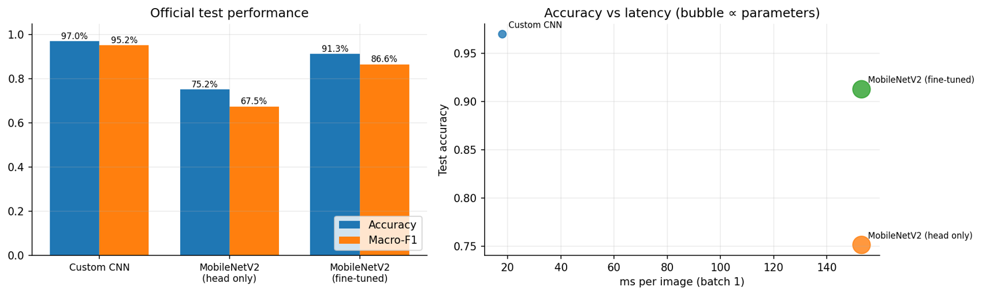
Figure 9.1: Test accuracy and macro-F1 of the models, and accuracy versus latency

9.1.2 Progress Ladder
Table 9.2 and Figure 9.2 show the ladder, measured on validation data. Along the from-scratch track every step improves the result: from 5.85 % for the majority-class baseline to 97.61 % for the final CNN, a reduction of the error rate from 94.1 % to 2.4 %, a factor of about 39.
Table 9.2: Progress ladder: validation accuracy and macro-F1 at each step
Step | Model | Val. accuracy | Val. macro-F1 | Parameters
0 | Majority-class baseline | 5.85 % | 0.3 % | 0
1 | Linear classifier on 16x16 pixels | 70.19 % | 61.1 % | 33,067
2 | MLP on 32x32 pixels | 83.24 % | 78.0 % | 825,131
3 | Basic CNN (2 conv layers) | 93.37 % | 91.8 % | 1,630,699
4 | Deeper CNN + BatchNorm + global pooling | 95.14 % | 93.8 % | 116,203
5 | Final CNN (+ augmentation, dropout) | 97.61 % | 96.9 % | 116,203
6 | MobileNetV2, frozen backbone | 72.58 % | 65.3 % | 2,313,067
7 | MobileNetV2, fine-tuned | 90.55 % | 88.9 % | 2,313,067
8 | Ensemble (CNN + MobileNetV2) | 97.07 % | 96.7 % | 2,429,270

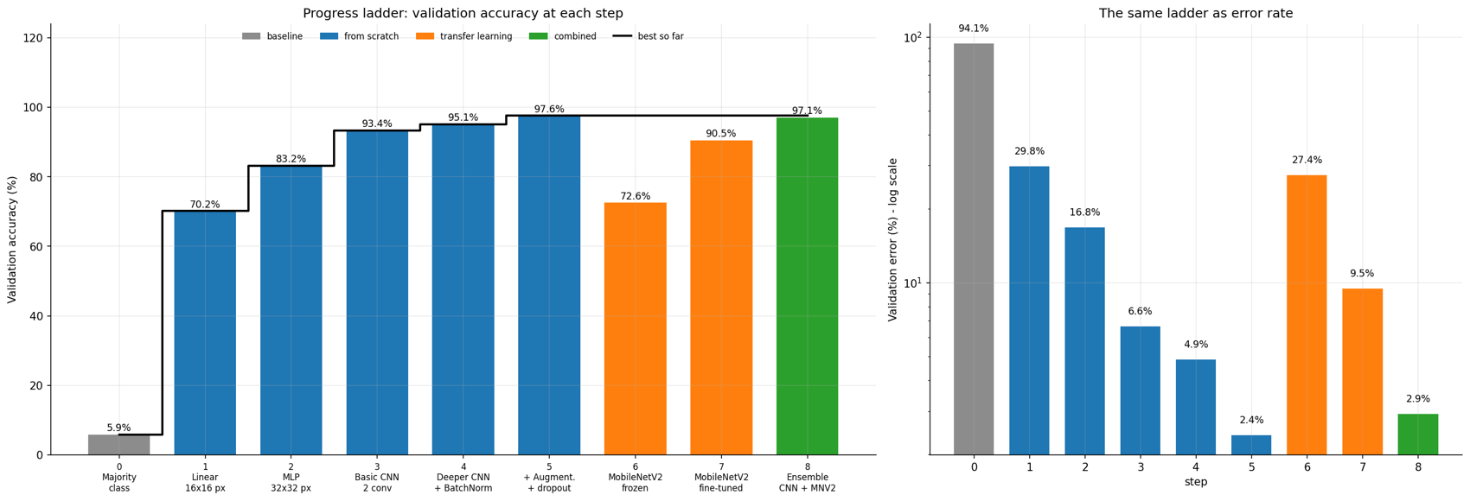
Figure 9.2: Progress ladder: validation accuracy at each step (left) and the same data as error rate on a logarithmic scale (right)
The largest single gains after the linear model come from adding a hidden layer (+13.0 points), convolutions (+10.1 points), and batch normalisation with global pooling and regularisation (+1.8 and +2.5 points). The gains shrink as accuracy rises, which is why the error-rate view is informative. Bigger is not better here: the basic CNN has 1.63 million parameters, the final CNN 116 thousand, yet the final CNN is 4.2 points more accurate. The frozen MobileNetV2 (72.58 %) is below even the MLP; fine-tuning adds about 18 points but remains below the custom CNN. The ensemble (97.07 %) does not improve on its best member, so the “best so far” line is flat after step 5.

9.1.3 Per-Class Performance
Of the 43 classes, 6 have an F1 score below 0.90 and 10 are at or above 0.99. Table 9.3 lists the eight weakest. The weakest class is Pedestrians, whose precision is high (0.94) but whose recall is only 0.50: half of the pedestrian signs are classified as something else, for example as Slippery road. Dangerous curve to the right shows the opposite pattern: recall is 1.00 but precision 0.69, because other classes (for example Wild animals crossing) are wrongly assigned to it. The Spearman rank correlation between class size and F1 is +0.28, a weak positive relationship, so class scarcity explains only part of the weakness; visual similarity among warning triangles matters more.
Table 9.3: The eight classes with the lowest F1 on the test set
ID | Class | Precision | Recall | F1 | Test images | Training images
27 | Pedestrians | 0.938 | 0.500 | 0.652 | 60 | 240
20 | Dangerous curve to the right | 0.692 | 1.000 | 0.818 | 90 | 360
21 | Double curve | 0.867 | 0.800 | 0.832 | 90 | 330
22 | Bumpy road | 0.863 | 0.842 | 0.852 | 120 | 390
30 | Beware of ice/snow | 0.992 | 0.800 | 0.886 | 150 | 450
40 | Roundabout mandatory | 0.842 | 0.944 | 0.890 | 90 | 360
41 | End of no passing | 0.932 | 0.917 | 0.924 | 60 | 240
29 | Bicycles crossing | 0.865 | 1.000 | 0.928 | 90 | 270

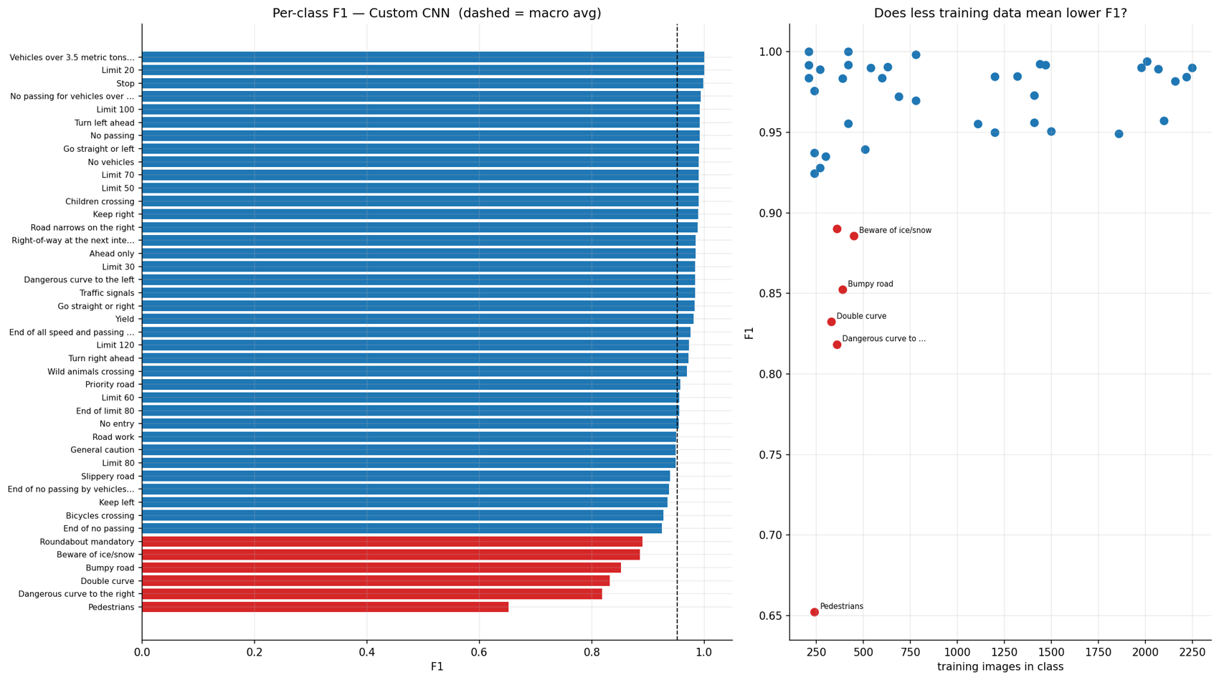
Figure 9.3: F1 score of every class (left) and F1 against class size (right)

9.1.4 Confusion Analysis
The custom CNN makes 384 errors on 12,630 test images. 75 % of them are confusions between signs of the same family (speed limits, prohibitory, warning, mandatory, other), against about 23 % expected by chance. Table 9.4 lists the ten most frequent confusions; the largest is Speed limit 60 km/h predicted as 80 km/h (36 images), a pair that differs in one digit.
Table 9.4: The ten most frequent confusions on the test set
No. | True class | Predicted class | Images
1 | Speed limit (60km/h) | Speed limit (80km/h) | 36
2 | No entry | Priority road | 20
3 | Bumpy road | Road work | 18
4 | Speed limit (120km/h) | Speed limit (80km/h) | 16
5 | Wild animals crossing | Dangerous curve to the right | 15
6 | Priority road | Yield | 14
7 | Road work | Bumpy road | 12
8 | Pedestrians | Slippery road | 12
9 | Double curve | General caution | 11
10 | Speed limit (70km/h) | Speed limit (30km/h) | 10

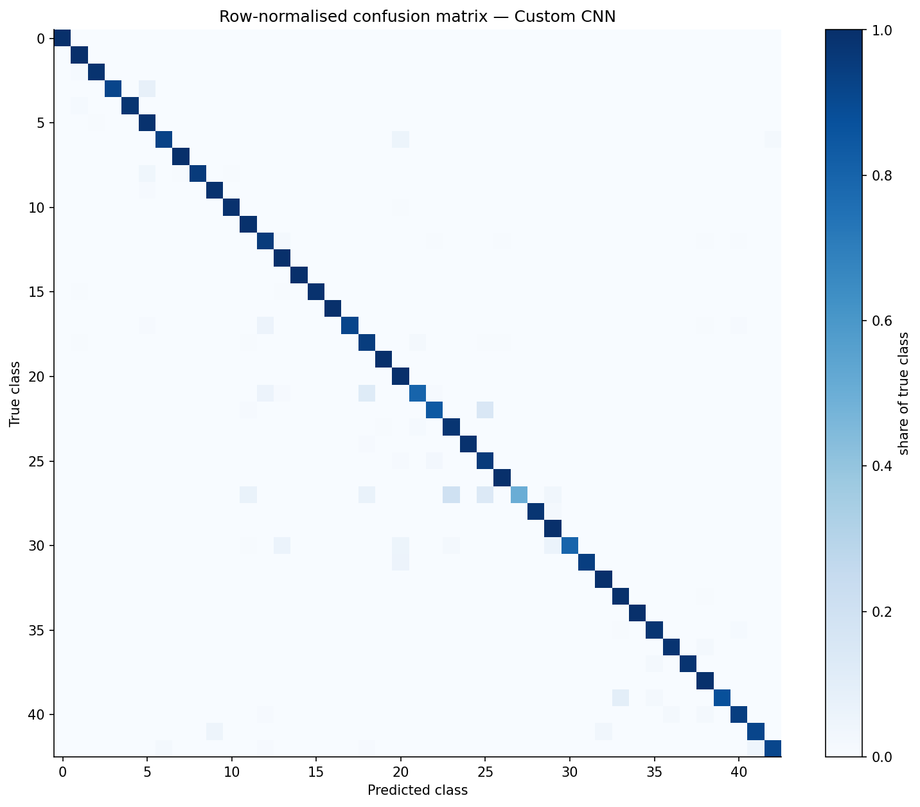
Figure 9.4: Row-normalised confusion matrix of the custom CNN on the test set
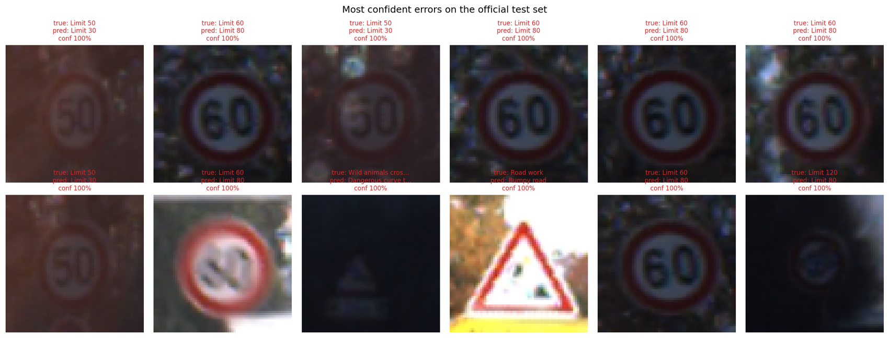
Figure 9.5: The twelve most confident errors on the test set
The most confident errors are dominated by very dark or very small images in which the digits of a speed limit are barely visible, so a wrong neighbouring speed limit is chosen with near-certainty.

9.1.5 Explainability
Figure 9.6 shows Grad-CAM maps of the custom CNN and of MobileNetV2 for five correct predictions and five confident errors (notebook version). For correct predictions the CNN's heat lies on the sign's symbol or rim: the arrow, the digits or the corners of a triangle. For the confident errors, which are dark speed-limit signs, the CNN's heat is scattered or sits on a fragment of one digit. MobileNetV2's final feature map is only 4 x 4, so its maps are coarse blocks that often cover the edge of the image or the background even for correct predictions, which is a reason to treat them with caution.
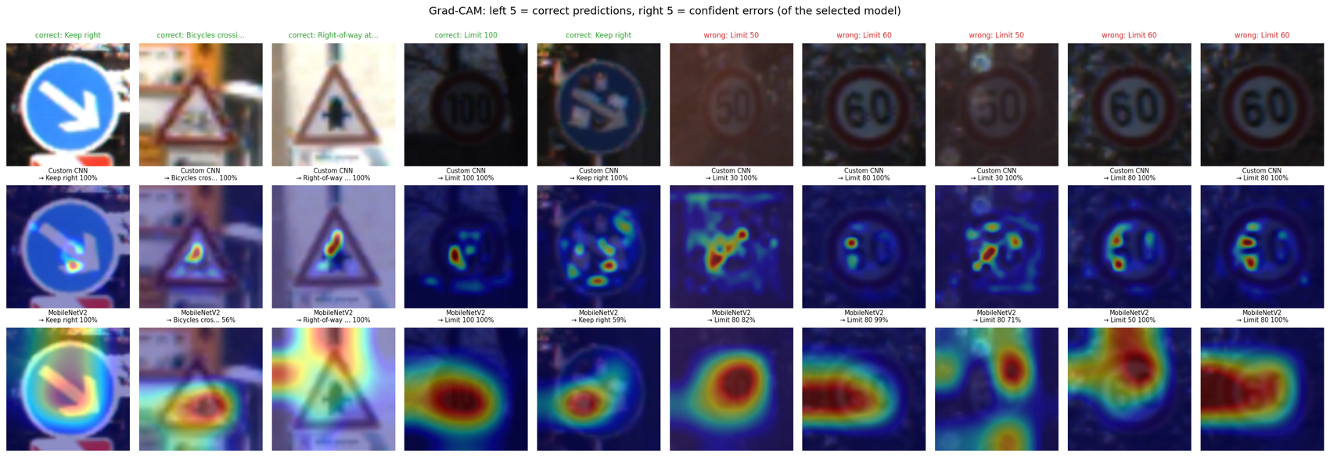
Figure 9.6: Grad-CAM for the custom CNN (middle row) and MobileNetV2 (bottom row): five correct predictions (left) and five confident errors (right)
Figure 9.7 projects the 128-dimensional embedding of 4,000 test images with t-SNE. Images of the same class form tight clusters, and the clusters that touch are those of look-alike signs, in agreement with the confusion analysis.
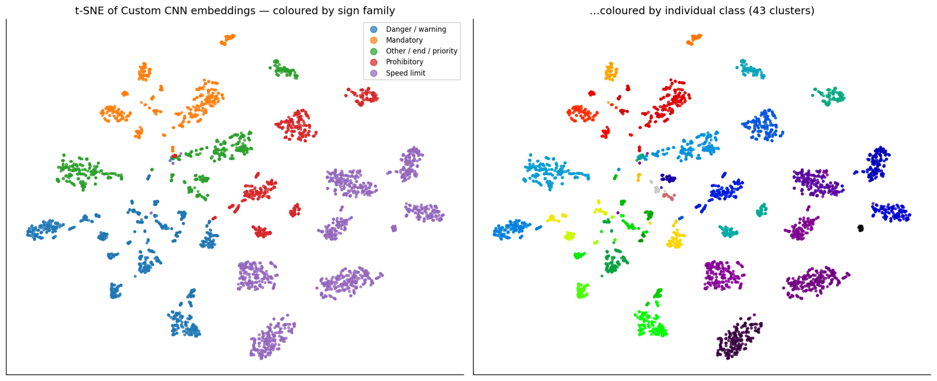
Figure 9.7: t-SNE projection of the penultimate-layer embedding, coloured by sign family and by class

9.1.6 Calibration and Selective Prediction
The expected calibration error of the custom CNN is 0.0105, which is low; the fine-tuned MobileNetV2 is more over-confident (0.0537) and the ensemble is intermediate (0.0267). Wrong predictions are usually made with lower confidence than correct ones, so a threshold can trade coverage for accuracy (Table 9.5, Figure 9.8). With a threshold of 0.866 the model answers 95.5 % of the test images and is right on at least 99.0 % of those; to reach 99.9 % it must defer on 17.4 % of the images. These thresholds are read off the test set and show the trade-off; a deployed system should choose its threshold on separate validation data.
Table 9.5: Selective prediction of the custom CNN on the test set
Target accuracy on answered images | Confidence threshold | Images answered | Images deferred
99.0 % | 0.866 | 95.5 % | 4.5 %
99.5 % | 0.972 | 92.0 % | 8.0 %
99.9 % | 0.999 | 82.6 % | 17.4 %

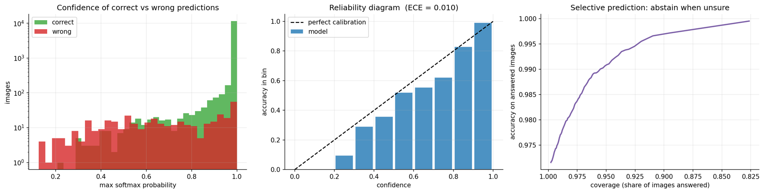
Figure 9.8: Confidence of correct and wrong predictions, reliability diagram and coverage-accuracy curve

9.1.7 Robustness to Corruptions
Table 9.6 and Figure 9.9 show the accuracy of the custom CNN on 6,000 test images (clean accuracy 96.97 %) under six corruptions at three severities. Blur, darkening and glare are tolerated: accuracy stays above 94 % for blur even at the largest kernel and above 82 % for the strongest darkening or glare. The model is fragile to Gaussian noise (62.6 % at σ = 10 and 34.3 % at σ = 25, on a 0 to 255 scale), to occlusion (52.7 % when a fifth of the image is covered, 9.5 % when a third is) and to large rotation (51.6 % at 35 degrees, beyond the roughly 14 degrees used in training). Noise and occlusion were never seen in training, and the rotation result shows a cliff beyond the trained range.
Table 9.6: Accuracy of the custom CNN under corruptions (6,000 test images; clean accuracy 96.97 %)
Corruption | Mild | Medium | Severe | Levels (mild, medium, severe)
Darkening ((brightness)) | 96.3 % | 93.9 % | 82.2 % | x0.7, x0.5, x0.3
Glare ((brightness)) | 94.8 % | 91.8 % | 84.6 % | x1.4, x1.8, x2.4
Gaussian noise (sigma) | 62.6 % | 34.3 % | 14.1 % | sigma 10, 25, 50
Blur (kernel) | 97.1 % | 96.6 % | 95.0 % | kernel 3, 5, 7
Rotation | 96.5 % | 93.9 % | 51.6 % | 10, 20, 35 degrees
Occlusion | 82.6 % | 52.7 % | 9.5 % | 10 %, 20 %, 35 % of area

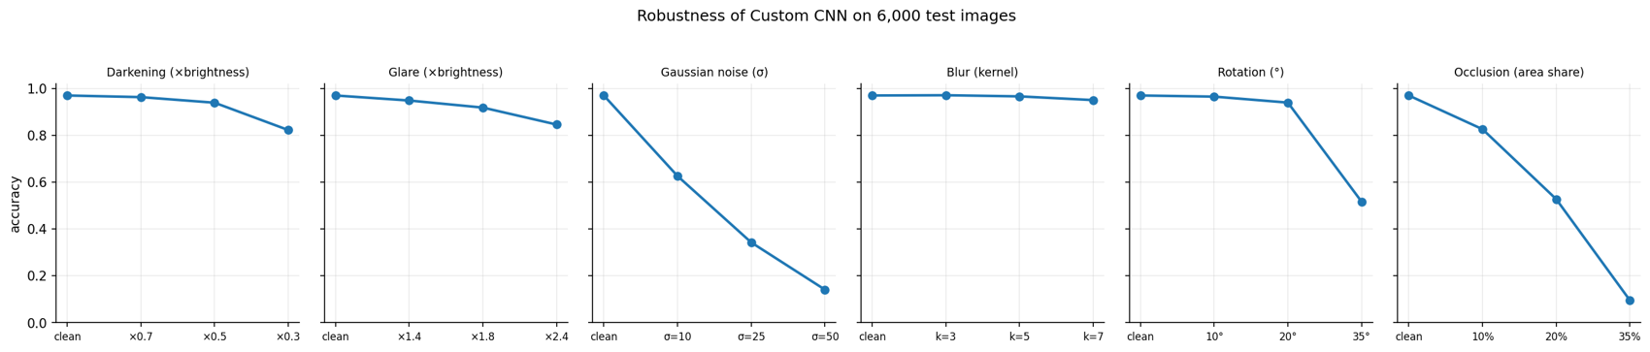
Figure 9.9: Accuracy of the custom CNN under increasing corruption severity
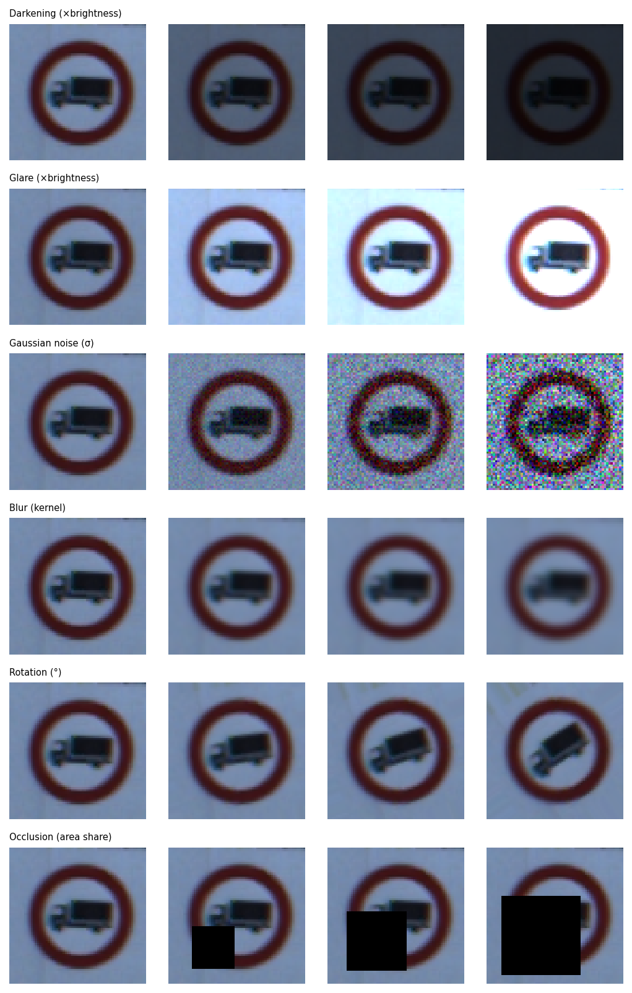
Figure 9.10: Examples of the corruptions at the three severities

9.1.8 Export and Deployment
The selected CNN converts to a TensorFlow Lite file of 0.24 MB (the Keras file is 1.5 MB), which agrees with the Keras model on 100 % of 500 test images, scores 97.6 % on them and runs at 1.24 ms per image on a single CPU thread. The browser implementation loads a 465 KB weight file, and a prediction with Grad-CAM takes about a tenth of a second in Node.js on the development laptop. The whole results bundle (four models, per-model predictions, tables, figures and a sample of test images) is 86.5 MB, of which the MobileNetV2 and ensemble models make up most.

9.2 Discussion

9.2.1 Merits and Demerits of the Approach
Table 9.7: Merits and demerits of the proposed approach and pipeline
Merits | Demerits
Leakage-free, class-complete validation; test set used once | Handles cropped signs only; needs a detector for real scenes
Compact model: 116,203 parameters, 0.24 MB as TFLite, 18 ms per image in a GPU runtime | Fragile to noise, occlusion and large rotation
Well calibrated (ECE 0.0105); supports abstention with measured trade-off | Over-confident on inputs unlike its training data (for example drawings)
Explained with Grad-CAM and t-SNE; explanation method checked numerically | Grad-CAM maps are coarse and qualitative
Each design step measured; transfer learning compared fairly | Pretrained MobileNetV2 over-fits and does not beat the small CNN at this resolution
Reproducible, with seeds, checksums and assertions | Single seed; run-to-run spread about half a point
Runs in the browser with no server; private; verified against Keras | Only the custom CNN is deployed in the browser; weak classes (Pedestrians recall 0.50)

9.2.2 Comparison with Published Results
The best published GTSRB results are close to or above human accuracy: about 98.8 % for human participants [2] and about 99.5 % for a committee of CNNs [3]. The custom CNN of this study reaches 96.96 %, below both. This is expected from its design: a single small network on 64 x 64 inputs trained for a few minutes, without the input normalisation variants, multi-network committees or long training schedules used in the competition. The aim of the project was not to beat these numbers but to measure honestly, explain and stress a compact model. The result is nevertheless in the range expected for compact CNNs, and its error rate of about 3 % is dominated by identifiable factors (dark speed-limit signs, look-alike warning triangles, a few weak classes) that suggest concrete improvements (Chapter 11).

9.2.3 Why Did the Small CNN Beat MobileNetV2?
Three observations are consistent with the domain-gap explanation proposed in Chapter 3. First, the frozen backbone performs barely better than a linear classifier on raw pixels (72.6 % against 70.2 %, and far below the 83.2 % of the MLP), meaning that ImageNet features at this scale add little. Second, fine-tuning helps substantially (+18 points), meaning that adapting the features matters. Third, the fine-tuned network over-fits (99.8 % training accuracy against 90.6 % validation), so its extra capacity is not constrained by the 33,570 highly correlated training images. None of these observations proves the explanation, and the result should not be generalised: it concerns tiny, low-resolution crops and a frozen or lightly tuned MobileNetV2, not pretrained networks in general. A different resolution, stronger augmentation or a larger unfrozen portion might change the outcome.

9.2.4 Grad-CAM at Saturation
The comparison of two correct implementations of Grad-CAM exposed a weakness of using the class probability as the score. When the network is almost certain, the probability is close to 1 and its derivative with respect to the logits, which is proportional to p(1 - p), is close to zero. The gradients that reach the last convolutional layer are then of the order of floating-point rounding, and after normalisation by the maximum the heat-map is dominated by numerical noise. This happened for 50 of the 116 sample images, and the maps of Keras and of the JavaScript code disagreed on exactly those images, while agreeing to 5.9 x 10⁻⁴ on the other 66. Using the class logit instead, as in the original Grad-CAM paper [5], removes the problem: the two implementations then agree to 3.1 x 10⁻⁶ on all 116 images. The website therefore uses the logit; the notebook figures in this report use the probability and are most reliable for the less confident cases.

9.2.5 Run-to-Run Variation
The first full run of the pipeline used a validation split with the defect described in Section 7.1.2; the second, reported here, used the corrected split. The two runs share the code, seed and budgets and differ only in the training data of the fitting set and the validation set, so they give a direct, if small, indication of run-to-run variation (Table 9.8).
Table 9.8: Test accuracy in the two full runs
Model | First run | Reported run | Difference
Custom CNN | 96.52 % | 96.96 % | +0.44
MobileNetV2, fine-tuned | 92.35 % | 91.26 % | -1.09
Ensemble | 97.01 % | 96.88 % | -0.13

Differences of about half a point to one point are therefore within the run-to-run spread, and the ordering of the ensemble and the CNN flipped on the test set between the runs. The large effects (baseline to CNN, frozen to fine-tuned, CNN against fine-tuned MobileNetV2) are many times larger than this spread and held in both runs. Only one seed was used in each run, so a proper confidence interval would require repetition with several seeds.

9.3 Findings
- Random validation leaks. On GTSRB a random split puts 1,291 of 1,307 physical signs on both sides; every validation sign has been seen in training. Grouping by sign removes this, and the grouping must also guarantee class coverage.
- A small, well-regularised CNN is enough. A 116,203-parameter CNN reaches 96.96 % test accuracy and 95.21 % macro-F1 and is better calibrated and about eight times faster than the fine-tuned MobileNetV2.
- Each design step matters, and size does not. The ladder rises monotonically from 5.85 % to 97.61 %; a plain CNN with 14 times more parameters is 4 points worse than the final design.
- Transfer learning needs fine-tuning, and here it still falls short. A frozen backbone reaches 75.16 %, fine-tuning 91.26 %, and the fine-tuned model over-fits.
- Errors are between look-alike signs. 75 % of errors stay inside a sign family; the most frequent is Speed limit 60 predicted as 80. Class size explains only part of the weak classes (Spearman +0.28).
- The model can say when it is unsure. ECE is 0.0105; answering only above a confidence of 0.866 gives 99 % accuracy at 95.5 % coverage.
- The weaknesses are noise, occlusion and large rotation. Accuracy falls to 34 % at noise sigma 25, 53 % with a fifth of the image covered and 52 % at 35 degrees, while blur, darkening and glare are tolerated.
- The most confident errors are very dark speed-limit signs.
- Probability-based Grad-CAM is unreliable at saturation. The class logit should be used as the score.
- Compact deployment is practical. The selected network runs in the browser from a 465 KB file, matches Keras to about 3 x 10⁻⁶, and converts to a 0.24 MB TFLite file with 100 % agreement.

CHAPTER 10: SUMMARY AND CONCLUSION

10.1 Summary of the Work
This project set out to build a traffic-sign classifier for the 43 classes of the German Traffic Sign Recognition Benchmark and, more importantly, to evaluate it in a way that can be trusted. The work began with a verified acquisition of the dataset and an exploratory analysis whose central finding was structural: the 39,209 training images come from only 1,307 physical signs, each photographed about thirty times. A random validation split puts almost all of these signs on both sides of the split. The validation set was therefore built from whole signs, selected per class so that every class is represented, and the code asserts both properties.
Two model families were compared: a compact convolutional network of 116,203 parameters trained from scratch, and MobileNetV2 with ImageNet weights trained in two stages. A ladder of nine steps, from a majority-class baseline to the final network, measured the contribution of each design decision on validation data. The models were then evaluated once on the official test set. The selected custom CNN reached 96.96 % accuracy and 95.21 % macro-F1, ahead of fine-tuned MobileNetV2 (91.26 % and 86.59 %) and an ensemble of both (96.88 % and 95.07 %).
Beyond accuracy, the study examined why and when the model fails. Per-class and confusion analyses showed that errors are mostly between look-alike signs of the same family, and that the weakest classes are Pedestrians, Dangerous curve to the right and Double curve. Grad-CAM and t-SNE showed what the network attends to and how it organises the classes. The network is well calibrated (expected calibration error 0.0105) and can trade coverage for accuracy: answering only above a confidence of 0.866 gives 99 % accuracy on 95.5 % of the images. Corruption tests showed tolerance to blur, darkening and glare and fragility to noise, occlusion and large rotation. A numerical comparison of two implementations showed that Grad-CAM based on the class probability is unreliable for nearly certain predictions.
Finally, the trained network was re-implemented in dependency-free JavaScript, verified against Keras, and published as a static website that classifies images locally, explains them and lets the user stress them. The same pipeline exports every trained model with its results for reuse.

10.2 Conclusions
Table 10.1: Answers to the research questions
Question | Answer
RQ1. How much does a random split overstate performance, and how is the leakage removed? | A random split shares 1,291 of 1,307 signs between training and validation, so every validation sign has been seen. Holding out whole signs, selected per class, removes the leakage and keeps all 43 classes in validation.
RQ2. Small CNN or MobileNetV2, and which decisions matter? | The small CNN is better (96.96 % against 91.26 % test accuracy) and faster. Convolutions, batch normalisation with global pooling, augmentation and dropout each helped; size did not. Fine-tuning gained 16 points over a frozen backbone but over-fitted.
RQ3. Which classes are hardest and why? | Pedestrians (F1 0.65), Dangerous curve to the right (0.82) and Double curve (0.83). Errors are between look-alike signs (75 % within a family); class size explains only part of it (Spearman +0.28).
RQ4. Does the network attend to the sign, and is Grad-CAM reliable? | For correct predictions the heat lies on the symbol or rim. Probability-based Grad-CAM is numerically unreliable for near-certain predictions; the class logit is reliable.
RQ5. Is confidence calibrated, and what does abstention buy? | ECE is 0.0105. A threshold of 0.866 gives 99 % accuracy while answering 95.5 % of images.
RQ6. Which corruptions hurt most? | Noise, occlusion and large rotation. Blur, darkening and glare are tolerated.

The overall conclusion is that, for a task like this, a carefully evaluated small network is a better engineering choice than a larger pretrained one, and that the quality of the evaluation, not only of the model, determines whether a reported accuracy can be believed. The project contributes a reproducible pipeline that makes this evaluation explicit and a verified, serverless demonstration of the resulting model.

10.3 Learning Outcomes
Through this project the team applied machine-learning, software-engineering and communication skills in a single piece of work: designing and running controlled experiments, discovering and correcting a flaw in its own evaluation, implementing a neural network and its explanation method from first principles, verifying numerical equivalence across two implementations, building and deploying an accessible web application, and documenting limitations honestly. These correspond to the program outcomes on engineering knowledge, problem analysis, modern tool usage, ethics, teamwork and communication.

CHAPTER 11: LIMITATIONS OF THE PROJECT AND FUTURE WORK

11.1 Limitations
- Cropped signs only. The classifier assumes a tight crop of one sign. Locating signs in a scene needs a detector, which GTSRB cannot train; the repository contains optional detection scripts that require a separately supplied checkpoint and were not evaluated.
- One country, one dataset. GTSRB contains German signs. Signs from other countries, newer designs or other weather and camera conditions are untested, and performance measured on one dataset may not transfer to another [28].
- Single seed. Each configuration was trained once per run. Two runs of the pipeline differed by up to about one point for some models, so small differences between models are not statistically supported.
- Resolution. Images are reduced to 64 x 64 pixels. Details such as the digits of speed limits may be lost, and the most frequent confusion (60 versus 80 km/h) is of this kind.
- Training did not include noise or occlusion. The corruption study measures the cost of this omission but the model was not retrained to remove it.
- Descriptive use of the test set. The abstention thresholds and the robustness study use test-set behaviour to illustrate trade-offs; they were not used to choose a model, but a deployed threshold should be set on separate validation data.
- Explanation is qualitative. Grad-CAM shows influence, not causation, and MobileNetV2's maps are coarse.
- Timing and hardware. Latency was measured on a GPU runtime and a laptop with Python or browser overhead, not on automotive hardware.
- Testing. There is no automated unit-test suite for the Python package, and the camera input of the website was not exercised.
- Not safety-certified. The system is an educational research project. It is not designed, validated or certified for use in vehicles [11], [12].

11.2 Future Work
Table 11.1 lists improvements ordered by how directly the results of this project motivate them.
Table 11.1: Proposed future work and the evidence that motivates it
Priority | Improvement | Motivation from the results
1 | Add Gaussian-noise and random-erasing augmentation and widen the rotation range | Accuracy 34 % at noise sigma 25, 53 % with a fifth of the image covered, 52 % at 35 degrees
2 | Brightness augmentation and contrast normalisation (for example CLAHE) | Most confident errors are very dark speed-limit signs; strong darkening lowers accuracy to 82 %
3 | Higher input resolution (for example 96 pixels) for the CNN | Speed limit 60 versus 80 (36 images), 120 versus 80 (16), 70 versus 30 (10)
4 | Class weights or targeted augmentation for the weakest classes | Pedestrians has recall 0.50; Dangerous curve to the right has precision 0.69
5 | Stronger regularisation for fine-tuned MobileNetV2 (more augmentation, fewer unfrozen layers, label smoothing) | Training accuracy 99.8 % against 90.6 % validation
6 | Repeat every experiment with several seeds and report intervals | Run-to-run spread of up to about one point; ensemble ordering flipped
7 | Temperature scaling and a validation-chosen abstention threshold | The threshold was read off test data; ensemble and MobileNetV2 are less calibrated
8 | Knowledge distillation from the ensemble into the small CNN [41] | Ensemble has the best top-3 accuracy but costs two models
9 | A detection front end for full scenes and video [34] | Classifier handles cropped signs only
10 | Out-of-distribution detection and evaluation on signs from other countries | Over-confidence on non-sign inputs; GTSRB covers one country
11 | Automated tests: a pytest suite for the package and browser tests for the website | Testing limitations (Section 8.6)

11.3 Ethical and Safety Considerations
Traffic-sign recognition is a safety-relevant technology, and over-stating the reliability of a classifier can cause harm. For this reason the website states that it handles cropped signs only, is not a driving system and can be over-confident on inputs unlike its training data; the report separates decisions made on validation data from descriptive analyses that use the test set; and the limitations above are stated explicitly. Images supplied to the website are processed locally and are never uploaded. The sample images shown come from a public research benchmark and are used for illustration with attribution; their redistribution should follow the dataset's terms.

REFERENCES
[1] World Health Organization, Global Status Report on Road Safety 2023. Geneva, Switzerland: WHO, 2023.
[2] J. Stallkamp, M. Schlipsing, J. Salmen, and C. Igel, "Man vs. computer: Benchmarking machine learning algorithms for traffic sign recognition," Neural Netw., vol. 32, pp. 323–332, Aug. 2012.
[3] D. Cireşan, U. Meier, J. Masci, and J. Schmidhuber, "Multi-column deep neural network for traffic sign classification," Neural Netw., vol. 32, pp. 333–338, Aug. 2012.
[4] S. Kaufman, S. Rosset, C. Perlich, and O. Stitelman, "Leakage in data mining: Formulation, detection, and avoidance," ACM Trans. Knowl. Discov. Data, vol. 6, no. 4, pp. 1–21, Dec. 2012.
[5] R. R. Selvaraju et al., "Grad-CAM: Visual explanations from deep networks via gradient-based localization," in Proc. IEEE Int. Conf. Comput. Vis. (ICCV), Venice, Italy, 2017, pp. 618–626.
[6] C. Guo, G. Pleiss, Y. Sun, and K. Q. Weinberger, "On calibration of modern neural networks," in Proc. ICML, Sydney, Australia, 2017, pp. 1321–1330.
[7] Y. Geifman and R. El-Yaniv, "Selective classification for deep neural networks," in Advances in NIPS, vol. 30, 2017, pp. 4878–4887.
[8] D. Hendrycks and T. Dietterich, "Benchmarking neural network robustness to common corruptions and perturbations," in Proc. ICLR, New Orleans, LA, USA, 2019.
[9] S. Houben, J. Stallkamp, J. Salmen, M. Schlipsing, and C. Igel, "Detection of traffic signs in real-world images: The German Traffic Sign Detection Benchmark," in Proc. IJCNN, Dallas, TX, USA, 2013.
[10] Z. Zhu, D. Liang, S. Zhang, X. Huang, B. Li, and S. Hu, "Traffic-sign detection and classification in the wild," in Proc. CVPR, Las Vegas, NV, USA, 2016, pp. 2110–2118.
[11] Road Vehicles — Functional Safety, ISO Standard 26262, International Organization for Standardization, Geneva, Switzerland, 2018.
[12] Road Vehicles — Safety of the Intended Functionality, ISO Standard 21448, International Organization for Standardization, Geneva, Switzerland, 2022.
[13] J. Stallkamp, M. Schlipsing, J. Salmen, and C. Igel, "The German Traffic Sign Recognition Benchmark: A multi-class classification competition," in Proc. Int. Joint Conf. Neural Networks (IJCNN), San Jose, CA, USA, 2011, pp. 1453–1460.
[14] P. Sermanet and Y. LeCun, "Traffic sign recognition with multi-scale convolutional networks," in Proc. IJCNN, San Jose, CA, USA, 2011, pp. 2809–2813.
[15] Y. LeCun, L. Bottou, Y. Bengio, and P. Haffner, "Gradient-based learning applied to document recognition," Proc. IEEE, vol. 86, no. 11, pp. 2278–2324, Nov. 1998.
[16] A. Krizhevsky, I. Sutskever, and G. E. Hinton, "ImageNet classification with deep convolutional neural networks," in Advances in Neural Information Processing Systems (NIPS), vol. 25, 2012, pp. 1097–1105.
[17] I. Goodfellow, Y. Bengio, and A. Courville, Deep Learning. Cambridge, MA, USA: MIT Press, 2016.
[18] V. Nair and G. E. Hinton, "Rectified linear units improve restricted Boltzmann machines," in Proc. ICML, 2010, pp. 807–814.
[19] S. Ioffe and C. Szegedy, "Batch normalization: Accelerating deep network training by reducing internal covariate shift," in Proc. Int. Conf. Mach. Learn. (ICML), 2015, pp. 448–456.
[20] N. Srivastava, G. Hinton, A. Krizhevsky, I. Sutskever, and R. Salakhutdinov, "Dropout: A simple way to prevent neural networks from overfitting," J. Mach. Learn. Res., vol. 15, no. 56, pp. 1929–1958, 2014.
[21] D. P. Kingma and J. Ba, "Adam: A method for stochastic optimization," in Proc. Int. Conf. Learn. Represent. (ICLR), San Diego, CA, USA, 2015.
[22] K. He, X. Zhang, S. Ren, and J. Sun, "Deep residual learning for image recognition," in Proc. IEEE Conf. Comput. Vis. Pattern Recognit. (CVPR), Las Vegas, NV, USA, 2016, pp. 770–778.
[23] S. J. Pan and Q. Yang, "A survey on transfer learning," IEEE Trans. Knowl. Data Eng., vol. 22, no. 10, pp. 1345–1359, Oct. 2010.
[24] J. Yosinski, J. Clune, Y. Bengio, and H. Lipson, "How transferable are features in deep neural networks?" in Advances in NIPS, vol. 27, 2014, pp. 3320–3328.
[25] J. Deng, W. Dong, R. Socher, L.-J. Li, K. Li, and L. Fei-Fei, "ImageNet: A large-scale hierarchical image database," in Proc. CVPR, Miami, FL, USA, 2009, pp. 248–255.
[26] A. G. Howard et al., "MobileNets: Efficient convolutional neural networks for mobile vision applications," arXiv:1704.04861, 2017.
[27] M. Sandler, A. Howard, M. Zhu, A. Zhmoginov, and L.-C. Chen, "MobileNetV2: Inverted residuals and linear bottlenecks," in Proc. CVPR, Salt Lake City, UT, USA, 2018, pp. 4510–4520.
[28] A. Torralba and A. A. Efros, "Unbiased look at dataset bias," in Proc. CVPR, Colorado Springs, CO, USA, 2011, pp. 1521–1528.
[29] scikit-learn developers, "sklearn.model_selection.GroupShuffleSplit," scikit-learn documentation. [Online]. Available: https://scikit-learn.org. Accessed: Oct. 2026.
[30] F. Pedregosa et al., "Scikit-learn: Machine learning in Python," J. Mach. Learn. Res., vol. 12, pp. 2825–2830, 2011.
[31] L. van der Maaten and G. Hinton, "Visualizing data using t-SNE," J. Mach. Learn. Res., vol. 9, pp. 2579–2605, Nov. 2008.
[32] C. Szegedy et al., "Intriguing properties of neural networks," in Proc. ICLR, Banff, Canada, 2014.
[33] K. Eykholt et al., "Robust physical-world attacks on deep learning visual classification," in Proc. CVPR, Salt Lake City, UT, USA, 2018, pp. 1625–1634.
[34] J. Redmon, S. Divvala, R. Girshick, and A. Farhadi, "You only look once: Unified, real-time object detection," in Proc. CVPR, Las Vegas, NV, USA, 2016, pp. 779–788.
[35] M. Abadi et al., "TensorFlow: A system for large-scale machine learning," in Proc. 12th USENIX Symp. Operating Syst. Design Implement. (OSDI), Savannah, GA, USA, 2016, pp. 265–283.
[36] F. Chollet et al., "Keras," 2015. [Online]. Available: https://keras.io. Accessed: Oct. 2026.
[37] C. R. Harris et al., "Array programming with NumPy," Nature, vol. 585, pp. 357–362, Sep. 2020.
[38] J. D. Hunter, "Matplotlib: A 2D graphics environment," Comput. Sci. Eng., vol. 9, no. 3, pp. 90–95, 2007.
[39] Google, "Google Colaboratory." [Online]. Available: https://colab.research.google.com. Accessed: Oct. 2026.
[40] "GTSRB: German Traffic Sign Recognition Benchmark (dataset archive)," Zenodo, record 13741936. [Online]. Available: https://zenodo.org/records/13741936. Accessed: Oct. 2026.
[41] G. Hinton, O. Vinyals, and J. Dean, "Distilling the knowledge in a neural network," arXiv:1503.02531, 2015.

Appendix A: Source Code of Selected Modules (Annexure 1)
The complete source code is available in the project repository (https://github.com/BriskAM/mait-mini). This appendix reproduces selected modules that complement the listings of Chapter 7.
Listing A.1: Dataset download with streaming MD5 verification (notebook)
def md5_of(path, chunk=1 << 20):
h = hashlib.md5()
with open(path, "rb") as f:
for block in iter(lambda: f.read(chunk), b""): h.update(block)
return h.hexdigest()

if not archive.exists() or md5_of(archive) != EXPECTED_MD5:
urllib.request.urlretrieve(URL, archive, hook) # progress hook prints every
~25 MB
got = md5_of(archive)
assert got == EXPECTED_MD5, "Checksum mismatch: delete data.zip and rerun."
with zipfile.ZipFile(archive) as z: z.extractall(WORK / "gtsrb")

Listing A.2: Training helper with early stopping and learning-rate reduction (notebook)
def fit(model, epochs, lr, patience, tag):
model.compile(optimizer=keras.optimizers.Adam(lr),
loss="sparse_categorical_crossentropy", metrics=["accuracy"])
cbs = [keras.callbacks.EarlyStopping(monitor="val_accuracy", mode="max",
patience=patience, restore_best_weights=True),
keras.callbacks.ReduceLROnPlateau(monitor="val_loss", factor=0.4,
patience=max(1, patience // 2), min_lr=1e-6)]
t0 = time.time()
h = model.fit(X_fit, y_fit, validation_data=(X_val, y_val), batch_size=BATCH,
epochs=epochs, callbacks=cbs, verbose=2)
print(f"[{tag}] {len(h.history['loss'])} epochs in {time.time() - t0:.0f}s | best val
acc {max(h.history['val_accuracy']):.4f}")
return h.history, time.time() - t0

Listing A.3: Scoring: accuracy, macro-F1, top-3 accuracy and expected calibration error (notebook)
def ece_score(conf, correct, bins=15):
edges = np.linspace(0, 1, bins + 1); e = 0.0
for lo, hi in zip(edges[:-1], edges[1:]):
m = (conf > lo) & (conf <= hi)
if m.any(): e += m.mean() * abs(correct[m].mean() - conf[m].mean())
return e

def score_from_probs(p, y):
pred = p.argmax(1); conf = p.max(1)
return dict(probs=p, pred=pred, conf=conf, accuracy=(pred == y).mean(),
macro_f1=f1_score(y, pred, average="macro", labels=range(NUM_CLASSES),
zero_division=0),
top3=np.mean([yy in np.argsort(pp)[-3:] for yy, pp in zip(y, p)]),
ece=ece_score(conf, pred == y))

Listing A.4: Grad-CAM for a flat model (Python, notebook version)
def gradcam(model, x_uint8, target=None):
kind, cam_model, idx = _cam_parts(model); x =
tf.convert_to_tensor(x_uint8[None].astype("float32"))
with tf.GradientTape() as tape:
conv_out, probs = cam_model(x, training=False) # last conv output and
network output
cls = int(tf.argmax(probs[0])) if target is None else target
score = probs[:, cls] # post-softmax score (see
Section 9.2.4)
grads = tape.gradient(score, conv_out)
cam = tf.nn.relu(tf.reduce_sum(conv_out * tf.reduce_mean(grads, axis=(1, 2))[:, None,
None, :], axis=-1))[0].numpy()
cam = cam / (cam.max() + 1e-8)
return cv2.resize(cam, (64, 64), interpolation=cv2.INTER_CUBIC).clip(0, 1), cls

Listing A.5: Convolution and max pooling in JavaScript (nn.js)
function conv3x3(inp, H, W, Cin, w, b, Cout) {
const out = new Float32Array(H * W * Cout);
for (let y = 0; y < H; y++) for (let x = 0; x < W; x++) {
const o = (y * W + x) * Cout;
for (let co = 0; co < Cout; co++) out[o + co] = b[co];
for (let ky = 0; ky < 3; ky++) { const yy = y + ky - 1; if (yy < 0 || yy >= H)
continue;
for (let kx = 0; kx < 3; kx++) { const xx = x + kx - 1; if (xx < 0 || xx >= W)
continue;
const ib = (yy * W + xx) * Cin, wb = (ky * 3 + kx) * Cin * Cout;
for (let ci = 0; ci < Cin; ci++) { const v = inp[ib + ci], wo = wb + ci * Cout;
for (let co = 0; co < Cout; co++) out[o + co] += v * w[wo + co]; } } }
for (let co = 0; co < Cout; co++) if (out[o + co] < 0) out[o + co] = 0; // ReLU
}
return out;
}

Listing A.6: Exporting the Keras weights for the browser (build_pages_data.py, abridged)
order = [("conv1", "conv2d", 2), ("bn1", "batch_normalization", 4), ("conv2", "conv2d_1",
2), ("bn2", "batch_normalization_1", 4),
("conv3", "conv2d_2", 2), ("bn3", "batch_normalization_2", 4), ("dense1",
"dense", 2), ("dense2", "dense_1", 2)]
for tag, group, n in order:
for i in range(n):
arr = np.asarray(h5[f"layers/{group}/vars/{i}"], dtype="<f4")
entries.append({"name": f"{tag}.{names[key][i]}", "shape": list(arr.shape),
"offset": offset})
chunks.append(arr.ravel()); offset += arr.size
blob = np.concatenate(chunks).astype("<f4") # 116,203 float32 values = 465 KB
(out / "data" / "cnn_weights.bin").write_bytes(blob.tobytes())

Appendix B: Per-Class Results of the Custom CNN
Table B.1 gives the precision, recall and F1 score of every class for the selected custom CNN on the official test set, together with the number of test and training images.
Table B.1: Per-class test results of the custom CNN
ID | Class | Precision | Recall | F1 | Test | Train
0 | Speed limit (20km/h) | 1.000 | 1.000 | 1.000 | 60 | 210
1 | Speed limit (30km/h) | 0.970 | 0.999 | 0.984 | 720 | 2220
2 | Speed limit (50km/h) | 0.993 | 0.987 | 0.990 | 750 | 2250
3 | Speed limit (60km/h) | 1.000 | 0.916 | 0.956 | 450 | 1410
4 | Speed limit (70km/h) | 1.000 | 0.980 | 0.990 | 660 | 1980
5 | Speed limit (80km/h) | 0.911 | 0.990 | 0.949 | 630 | 1860
6 | End of speed limit (80km/h) | 0.986 | 0.927 | 0.955 | 150 | 420
7 | Speed limit (100km/h) | 0.987 | 0.998 | 0.992 | 450 | 1440
8 | Speed limit (120km/h) | 0.993 | 0.953 | 0.973 | 450 | 1410
9 | No passing | 0.992 | 0.992 | 0.992 | 480 | 1470
10 | No passing for vehicles over 3.5 metric tons | 0.997 | 0.991 | 0.994 | 660 | 2010
11 | Right-of-way at the next intersection | 0.977 | 0.993 | 0.985 | 420 | 1320
12 | Priority road | 0.961 | 0.954 | 0.957 | 690 | 2100
13 | Yield | 0.964 | 1.000 | 0.982 | 720 | 2160
14 | Stop | 1.000 | 0.996 | 0.998 | 270 | 780
15 | No vehicles | 0.990 | 0.990 | 0.990 | 210 | 630
16 | Vehicles over 3.5 metric tons prohibited | 1.000 | 1.000 | 1.000 | 150 | 420
17 | No entry | 0.997 | 0.917 | 0.955 | 360 | 1110
18 | General caution | 0.953 | 0.946 | 0.950 | 390 | 1200
19 | Dangerous curve to the left | 0.968 | 1.000 | 0.984 | 60 | 210
20 | Dangerous curve to the right | 0.692 | 1.000 | 0.818 | 90 | 360
21 | Double curve | 0.867 | 0.800 | 0.832 | 90 | 330
22 | Bumpy road | 0.863 | 0.842 | 0.852 | 120 | 390
23 | Slippery road | 0.902 | 0.980 | 0.939 | 150 | 510
24 | Road narrows on the right | 0.989 | 0.989 | 0.989 | 90 | 270
25 | Road work | 0.941 | 0.960 | 0.951 | 480 | 1500
26 | Traffic signals | 0.968 | 1.000 | 0.984 | 180 | 600
27 | Pedestrians | 0.938 | 0.500 | 0.652 | 60 | 240
28 | Children crossing | 1.000 | 0.980 | 0.990 | 150 | 540
29 | Bicycles crossing | 0.865 | 1.000 | 0.928 | 90 | 270
30 | Beware of ice/snow | 0.992 | 0.800 | 0.886 | 150 | 450
31 | Wild animals crossing | 0.996 | 0.944 | 0.970 | 270 | 780
32 | End of all speed and passing limits | 0.952 | 1.000 | 0.976 | 60 | 240
33 | Turn right ahead | 0.950 | 0.995 | 0.972 | 210 | 689
34 | Turn left ahead | 0.984 | 1.000 | 0.992 | 120 | 420
35 | Ahead only | 0.992 | 0.977 | 0.984 | 390 | 1200
36 | Go straight or right | 0.983 | 0.983 | 0.983 | 120 | 390
37 | Go straight or left | 1.000 | 0.983 | 0.992 | 60 | 210
38 | Keep right | 0.984 | 0.994 | 0.989 | 690 | 2070
39 | Keep left | 1.000 | 0.878 | 0.935 | 90 | 300
40 | Roundabout mandatory | 0.842 | 0.944 | 0.890 | 90 | 360
41 | End of no passing | 0.932 | 0.917 | 0.924 | 60 | 240
42 | End of no passing by vehicles over 3.5 metric tons | 0.965 | 0.911 | 0.937 | 90 | 240

Appendix C: Reproducing the Work

C.1 Running the Experiments
- Open the notebook notebooks/traffic_sign_recognition_demo.ipynb in Google Colab (the badge in the repository README opens it directly).
- Choose Runtime, Change runtime type, GPU.
- In the first code cell set MODE to smoke (2-minute sanity run), demo or full (reported results).
- Run all cells. The notebook downloads and verifies the dataset, trains and evaluates the models, and finally downloads gtsrb_demo_results.zip with the models, results and figures.

C.2 Rebuilding the Website Data
- Unzip the results bundle to a folder.
- Run python scripts/build_pages_data.py --results <folder> --data data/raw/gtsrb --out site (needs numpy, pandas, Pillow and h5py).
- Serve the site locally with python3 -m http.server 8000 --directory site and open http://localhost:8000.
- Verify the browser network against Keras with node scripts/verify_pages_model.mjs (using reference outputs generated from the same weights).
- Push to the main branch; the workflow .github/workflows/pages.yml publishes the site to GitHub Pages.

C.3 Repository Layout
Table C.1: Layout of the project repository
Folder or file | Contents
notebooks/ | The demonstration notebook (generated by scripts/build_demo_notebook.py) and an earlier lighter notebook
src/traffic_sign_recognition/ | Reusable Python package: data, models, training, evaluation, Grad-CAM, inference
scripts/ | Dataset download, analysis and document builders; website data build; browser-network verification
site/ | The static website: page, styles, JavaScript modules, generated data and figures
docs/ | Earlier synopsis and report, literature survey, presenter documentation
report/ | Sources that generate this report (diagrams, content, build script)

Appendix D: Research and Publication Status (Annexure 2)
As required by the departmental notice, the status of research output related to this project is as follows.
Table D.1: Research and publication status
Item | Status
Book chapter | None submitted, accepted or published
Conference paper | None submitted, accepted or published
Research article | None submitted, accepted or published
Hard copy of research paper | Not applicable

The experimental results of this project (the leakage analysis, the progress ladder and the reliability study) could form the basis of a short paper; this is listed as a possible follow-up.

