Project Synopsis
GTSRB Traffic-Sign Recognition
Akshit Mehta

Abstract
This synopsis presents a reproducible 43-class traffic-sign image-classification pipeline. The work covers verified dataset acquisition, exploratory analysis, grouped validation, augmented training, model comparison, evaluation, inference, and project communication through a Colab notebook and dashboard website.
Index Terms—GTSRB, traffic-sign recognition, convolutional neural network, MobileNetV2, image classification.

1. Project Overview
This project develops an end-to-end image-classification system for recognizing German traffic signs. It covers data acquisition, integrity validation, exploratory data analysis, preprocessing, augmentation, model training, evaluation, command-line inference, a Colab workflow, and a presentation website.

2. Problem Statement
Traffic signs are visually diverse and may appear at different scales, viewpoints, lighting conditions, and backgrounds. The goal is to map a cropped traffic-sign image to one of 43 GTSRB class labels while preserving a reproducible evaluation boundary. This version addresses classification only; object detection and real-time camera streaming are outside scope.

3. Objectives
- Download and verify the complete public GTSRB classification archive.
- Profile class balance, image geometry, brightness, color, and representative examples.
- Train a compact CNN baseline and compare it with MobileNetV2 transfer learning.
- Use a grouped validation split, deterministic seeds, augmentation, checkpointing, and learning-rate control.
- Publish interpretable accuracy, macro F1, per-class metrics, confusion matrices, and learning curves.
- Provide local CLI commands, a Google Colab notebook, a static project website, and formal documentation.

4. Dataset and EDA Snapshot
Measure | Observed value
Training images | 39,209
Official test images | 12,630
Classes | 43 (IDs 0–42)
Training class range | 210–2,250 images
Archive MD5 | 7faafd0d78d831c7eb4d555641a83a62
Source | Zenodo record 13741936

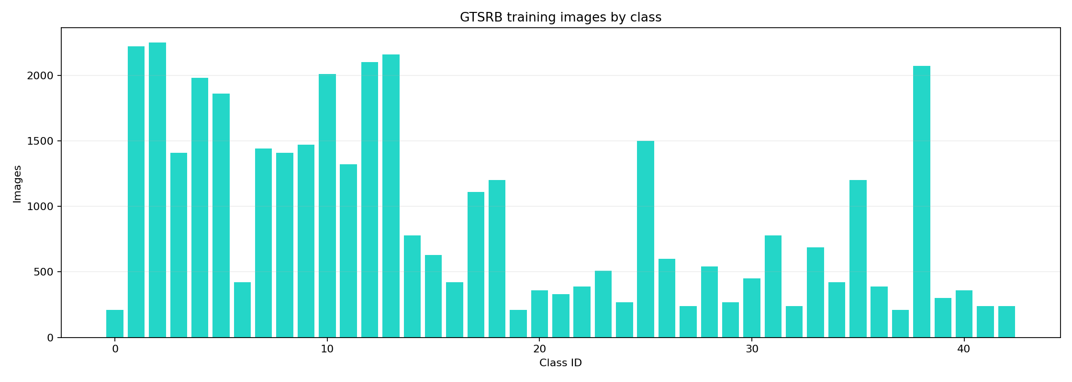
Figure 1. Training class distribution.

5. Methodology
Images are loaded from the official training directories and test CSV, resized to a consistent model-specific input size, normalized, and converted into TensorFlow datasets. Related image sequences are grouped before validation splitting to reduce near-duplicate leakage. Moderate random rotation, translation, zoom, brightness, and contrast transformations are applied during training.
Model | Role | Input
Custom CNN | Transparent baseline | 64 × 64 × 3
MobileNetV2 | Transfer-learning comparison | 96 × 96 × 3

6. Demonstration Results
Model | Test accuracy | Macro F1
Custom Cnn | 56.90% | 56.19%
Mobilenet V2 | 62.86% | 55.74%

The recorded runs use the full training and official test sets. Both models were trained for five matched epochs with class balancing on the Apple M1 Metal GPU. These are reproducible project runs, not a claim of the best possible GTSRB score.

7. Deliverables
Source modules live in src/traffic_sign_recognition. Reproducible commands are documented in README.md. The Colab notebook is notebooks/traffic_sign_recognition_colab.ipynb, the static website is site/dist, and the detailed report is docs/traffic_sign_recognition_project_report.docx.

8. Expected Impact
The project demonstrates how a machine-learning experiment can be made inspectable from raw data through inference. Its artifacts help students and reviewers connect data quality, model design, evaluation choices, and limitations in one coherent pipeline.

