Project Synopsis
GTSRB Traffic-Sign Recognition
Akshit Mehta

Abstract
This synopsis presents a reproducible 43-class traffic-sign image-classification pipeline. The work covers verified dataset acquisition, exploratory analysis, grouped validation, augmented training, model comparison, evaluation, inference, and project communication through a Colab notebook and dashboard website.
Index Terms—GTSRB, traffic-sign recognition, convolutional neural network, MobileNetV2, image classification.

1. Project Overview
This project develops an end-to-end image-classification system for recognizing German traffic signs. It covers data acquisition, integrity validation, exploratory data analysis, preprocessing, augmentation, model training, evaluation, command-line inference, a Colab workflow, and a presentation website.

2. Problem Statement
Traffic signs are visually diverse and may appear at different scales, viewpoints, lighting conditions, and backgrounds. The goal is to map a cropped traffic-sign image to one of 43 GTSRB class labels while preserving a reproducible evaluation boundary. This version addresses classification only; object detection and real-time camera streaming are outside scope.

3. Objectives
- Download and verify the complete public GTSRB classification archive.
- Profile class balance, image geometry, brightness, color, and representative examples.
- Train a compact CNN baseline and compare it with MobileNetV2 transfer learning.
- Use a grouped validation split, deterministic seeds, augmentation, checkpointing, and learning-rate control.
- Publish interpretable accuracy, macro F1, per-class metrics, confusion matrices, and learning curves.
- Provide local CLI commands, a Google Colab notebook, a static project website, and formal documentation.

4. Dataset and EDA Snapshot
Measure | Observed value
Training images | 39,209
Official test images | 12,630
Classes | 43 (IDs 0–42)
Training class range | 210–2,250 images
Archive MD5 | 7faafd0d78d831c7eb4d555641a83a62
Source | Zenodo record 13741936

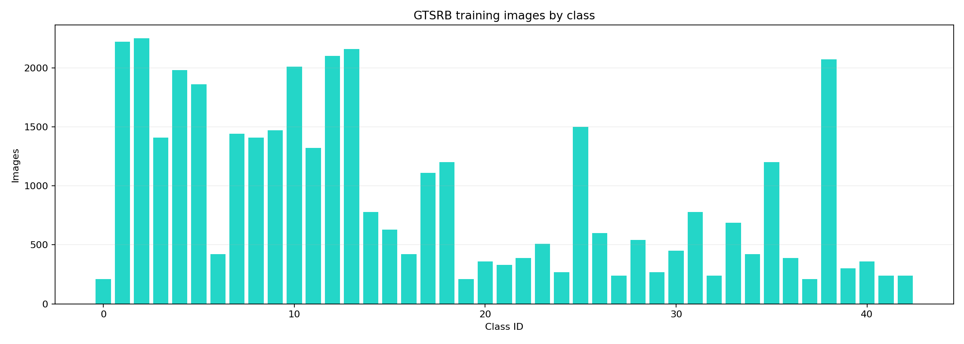
Figure 1. Training class distribution.

5. Methodology
Images are loaded from the official training directories and test CSV, resized to a consistent model-specific input size, normalized, and converted into TensorFlow datasets. Related image sequences are grouped before validation splitting to reduce near-duplicate leakage. Moderate random rotation, translation, zoom, brightness, and contrast transformations are applied during training.
Model | Role | Input
Custom CNN | Transparent baseline | 64 × 64 × 3
MobileNetV2 | Transfer-learning comparison | 96 × 96 × 3

6. Demonstration Results
Model | Test accuracy | Macro F1
Custom Cnn | 97.12% | 95.14%
Mobilenet V2 | 76.18% | 68.23%

The recorded runs use the full training and official test sets. The custom CNN was trained for 30 epochs and MobileNetV2 for 25 epochs on a Colab GPU. These are reproducible project runs, not a claim of the best possible GTSRB score.

7. Deliverables
Source modules live in src/traffic_sign_recognition. Reproducible commands are documented in README.md. The Colab notebook is notebooks/traffic_sign_recognition_colab.ipynb, the static website is site/dist, and the detailed report is docs/traffic_sign_recognition_project_report.docx.

8. Expected Impact
The project demonstrates how a machine-learning experiment can be made inspectable from raw data through inference. Its artifacts help students and reviewers connect data quality, model design, evaluation choices, and limitations in one coherent pipeline.

