Workshop Feedback Analysis Report
Date: 12 September 2025

Executive summary
- Sample size: 50 responses.
- Average likelihood to attend future events: 2.92 (1–5 scale).
- Most valued aspects: Variety/quality of speakers & talks (25), Operations/logistics (17), Networking (opportunities & sessions) (6).
- Top improvement areas: Content breadth & perspectives (13), Q&A and time management (12), Networking (opportunities & sessions) (8).

Key graphics
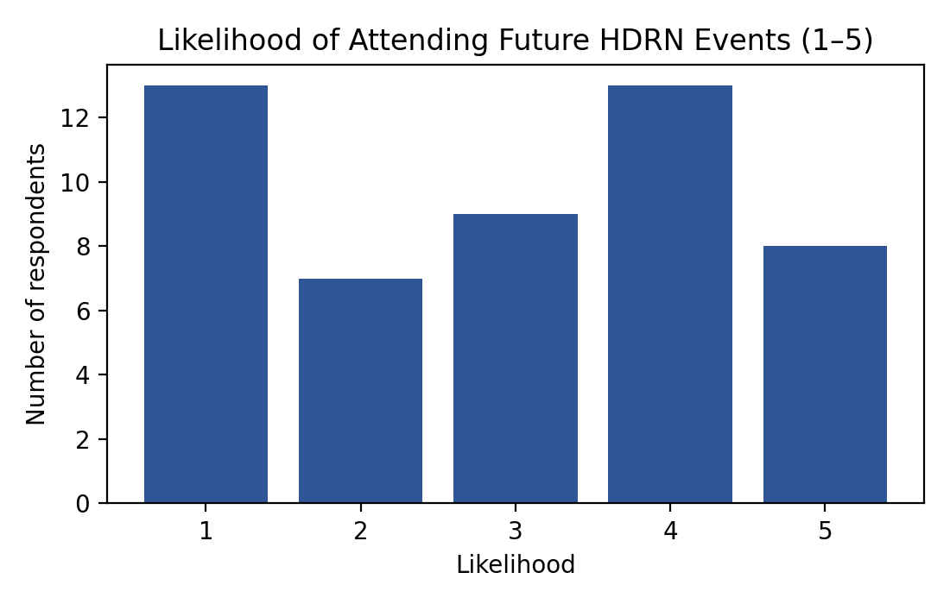
Chart Likelihood
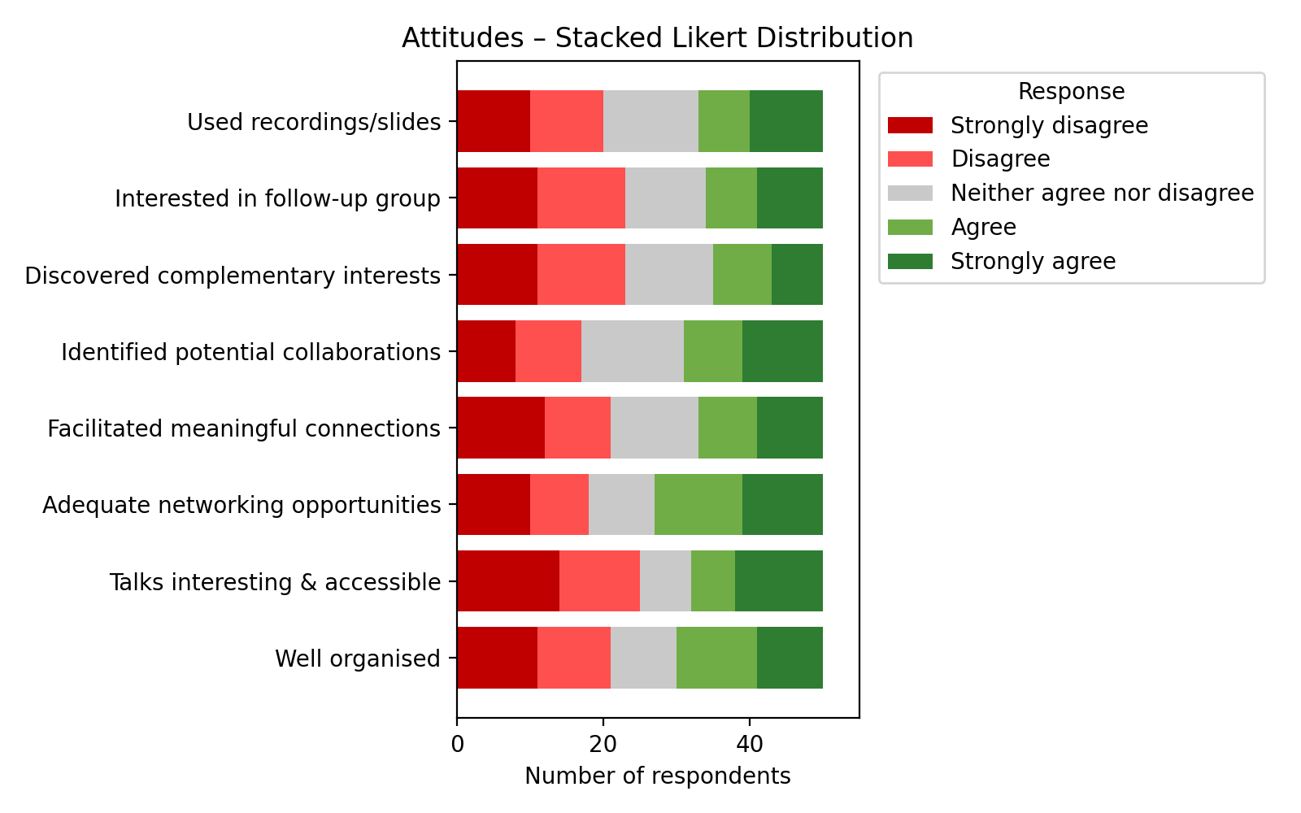
Chart Stacked Likert
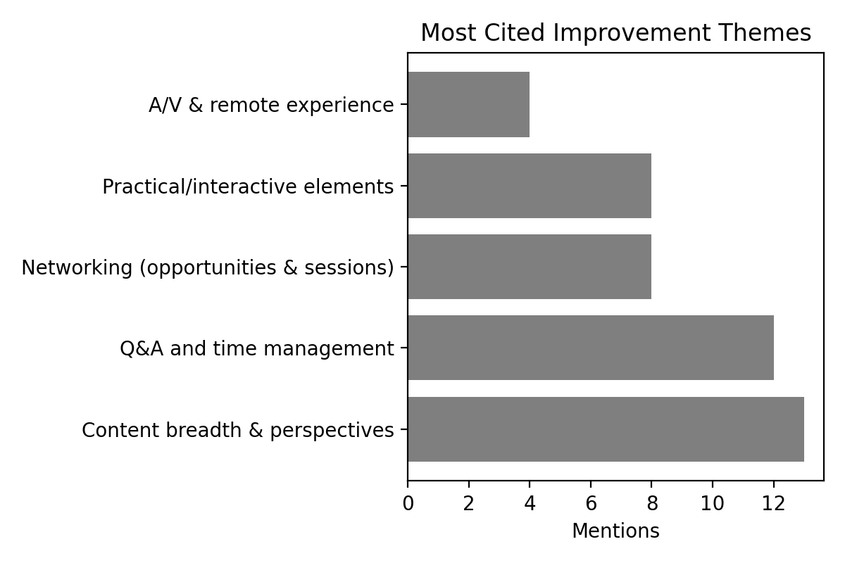
Chart Improvements
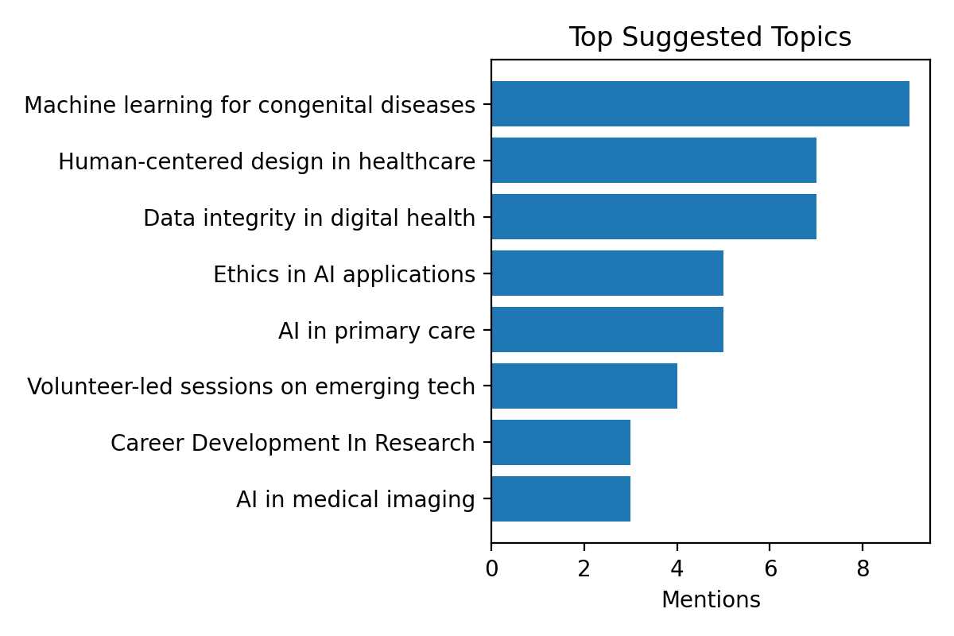
Chart Topics

Quantitative breakdown of responses
Likelihood of attending future events (1–5):
Score | 1 |  | 2 |  | 3 |  | 4 |  | 5
Count | 13 |  | 7 |  | 9 |  | 13 |  | 8
Question |  | N |  | % agree (A+SA) |  | 95% CI |  | SD/D/N/A/SA
Well organised |  | 50 |  | 40.0% |  | 28–54% |  | 11/10/9/11/9
Talks interesting & accessible |  | 50 |  | 36.0% |  | 24–50% |  | 14/11/7/6/12
Adequate networking opportunities |  | 50 |  | 46.0% |  | 33–60% |  | 10/8/9/12/11
Facilitated meaningful connections |  | 50 |  | 34.0% |  | 22–48% |  | 12/9/12/8/9
Identified potential collaborations |  | 50 |  | 38.0% |  | 26–52% |  | 8/9/14/8/11
Discovered complementary interests |  | 50 |  | 30.0% |  | 19–44% |  | 11/12/12/8/7
Interested in follow-up group |  | 50 |  | 32.0% |  | 21–46% |  | 11/12/11/7/9
Used recordings/slides |  | 50 |  | 34.0% |  | 22–48% |  | 10/10/13/7/10

Major themes with supporting evidence

What worked well
- Variety/quality of speakers & talks: 25 mentions
“Good variety of speakers.”
“Good mix of people and topics.”
- Operations/logistics: 17 mentions
“Gluten-free food was appreciated.”
“Gluten-free food was appreciated.”
- Networking (opportunities & sessions): 6 mentions
“Networking opportunities were excellent.”
“In-person events worked well.”
- Recordings & materials: 6 mentions
“Recordings were helpful.”
“Recordings were helpful.”

What could be improved
- Content breadth & perspectives: 13 mentions
“Include ethics/humanities perspectives.”
“Consistency in themes across sessions.”
- Q&A and time management: 12 mentions
“More time for brainstorming in small groups.”
“More time for questions would be helpful.”
- Networking (opportunities & sessions): 8 mentions
“More time for brainstorming in small groups.”
“Breakout sessions for networking could be added.”
- Practical/interactive elements: 8 mentions
“Add practical demonstrations.”
“Add practical demonstrations.”
- A/V & remote experience: 4 mentions
“Improve audio/visual quality for remote speakers.”
“Improve audio/visual quality for remote speakers.”

Notable observations (unusual or conflicting feedback)
- Networking opportunities rated Agree while meaningful connections rated Strongly disagree.
- Networking opportunities rated Strongly disagree while meaningful connections rated Strongly agree.
- Networking opportunities rated Strongly agree while meaningful connections rated Disagree.
- Networking opportunities rated Disagree while meaningful connections rated Strongly agree.
- Networking opportunities rated Disagree while meaningful connections rated Agree.
- Networking opportunities rated Strongly agree while meaningful connections rated Strongly disagree.
- Networking opportunities rated Strongly disagree while meaningful connections rated Strongly agree.
- Networking opportunities rated Strongly agree while meaningful connections rated Strongly disagree.
- Networking opportunities rated Disagree while meaningful connections rated Strongly agree.
- Networking opportunities rated Agree while meaningful connections rated Strongly disagree.
- Networking opportunities rated Agree while meaningful connections rated Disagree.
- Networking opportunities rated Disagree while meaningful connections rated Agree.
- Networking opportunities rated Strongly agree while meaningful connections rated Strongly disagree.
- Networking opportunities rated Agree while meaningful connections rated Disagree.
- Networking opportunities rated Strongly agree while meaningful connections rated Strongly disagree.
- Networking opportunities rated Strongly disagree while meaningful connections rated Strongly agree.
- Networking opportunities rated Strongly disagree while meaningful connections rated Strongly agree.
- Networking opportunities rated Agree while meaningful connections rated Strongly disagree.
- Networking opportunities rated Strongly disagree while meaningful connections rated Strongly agree.
- Organisation rated Strongly disagree, but future attendance likelihood 4.
- Organisation rated Strongly disagree, but future attendance likelihood 4.
- Organisation rated Disagree, but future attendance likelihood 4.
- Organisation rated Strongly disagree, but future attendance likelihood 4.
- Organisation rated Disagree, but future attendance likelihood 4.
- Organisation rated Disagree, but future attendance likelihood 5.
- Talks rated Disagree, yet positive comment about presentations: Very insightful and impactful presentations.
- Talks rated Strongly disagree, yet positive comment about presentations: Very insightful and impactful presentations.
- Talks rated Strongly disagree, yet positive comment about presentations: Very insightful and impactful presentations.
Minority perspectives:
- Gluten-free food appreciated
- Gluten-free food appreciated
- Gluten-free food appreciated
- Gluten-free food appreciated
- Gluten-free food appreciated
- Gluten-free food appreciated

Specific recommendations for improvement
- Balance networking format: combine structured introductions and small-group breakouts to strengthen meaningful connections while preserving open networking time.
- Protect Q&A time by trimming talk slots or using moderated question voting to surface key queries.
- Add 1–2 practical demonstrations per programme (short live demos or interactive case walk-throughs).
- Publish a simple thematic thread across sessions in advance to address “consistency of themes” feedback.
- Enhance hybrid delivery: standardise microphones for audience Q&A, brief remote speakers on A/V checks, and have a live tech host.
- Introduce an ethics/humanities perspective slot and a careers spotlight (5-minute lightning talks from partners).
- Pilot a follow-up networking group with opt-in interest forms and rotating hosts aligned to top topics (e.g., AI in primary care, data integrity).

