**Workshop Feedback Analysis Report**

Date: 12 September 2025

# Executive summary

* Sample size: 50 responses.
* Average likelihood to attend future events: 2.92 (1–5 scale).
* Most valued aspects: Variety/quality of speakers & talks (25), Operations/logistics (17), Networking (opportunities & sessions) (6).
* Top improvement areas: Content breadth & perspectives (13), Q&A and time management (12), Networking (opportunities & sessions) (8).

## Key graphics

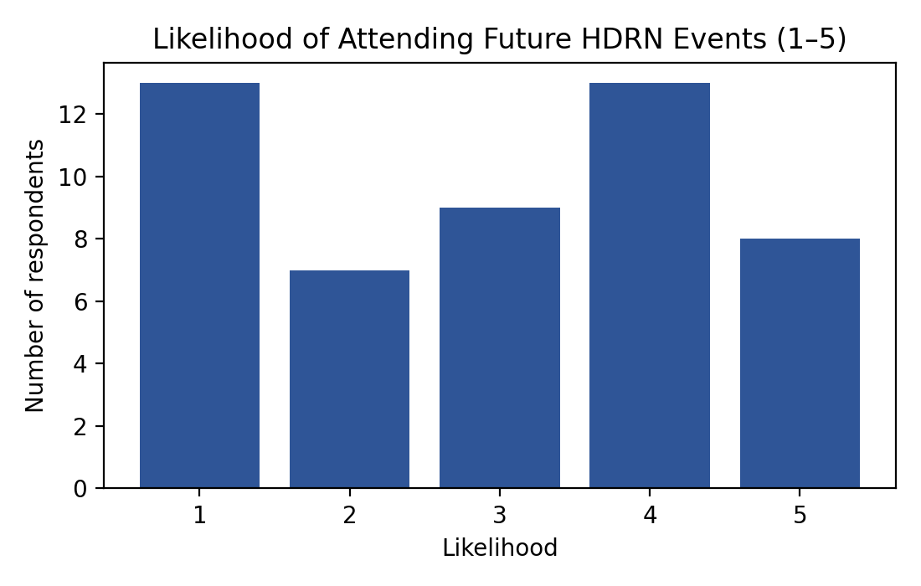

Chart Likelihood

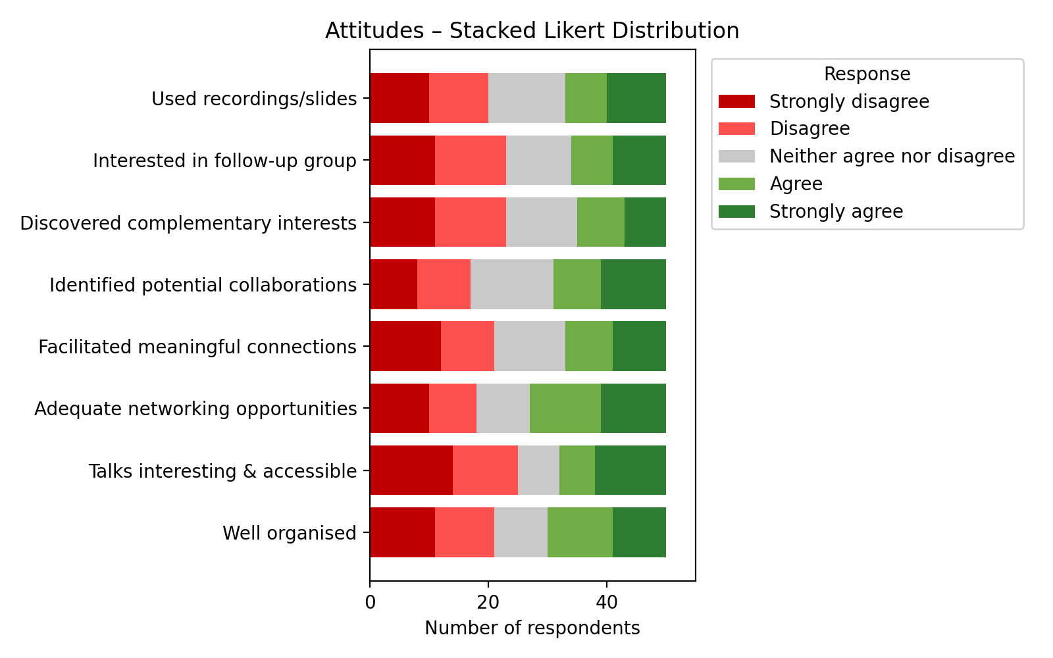

Chart Stacked Likert

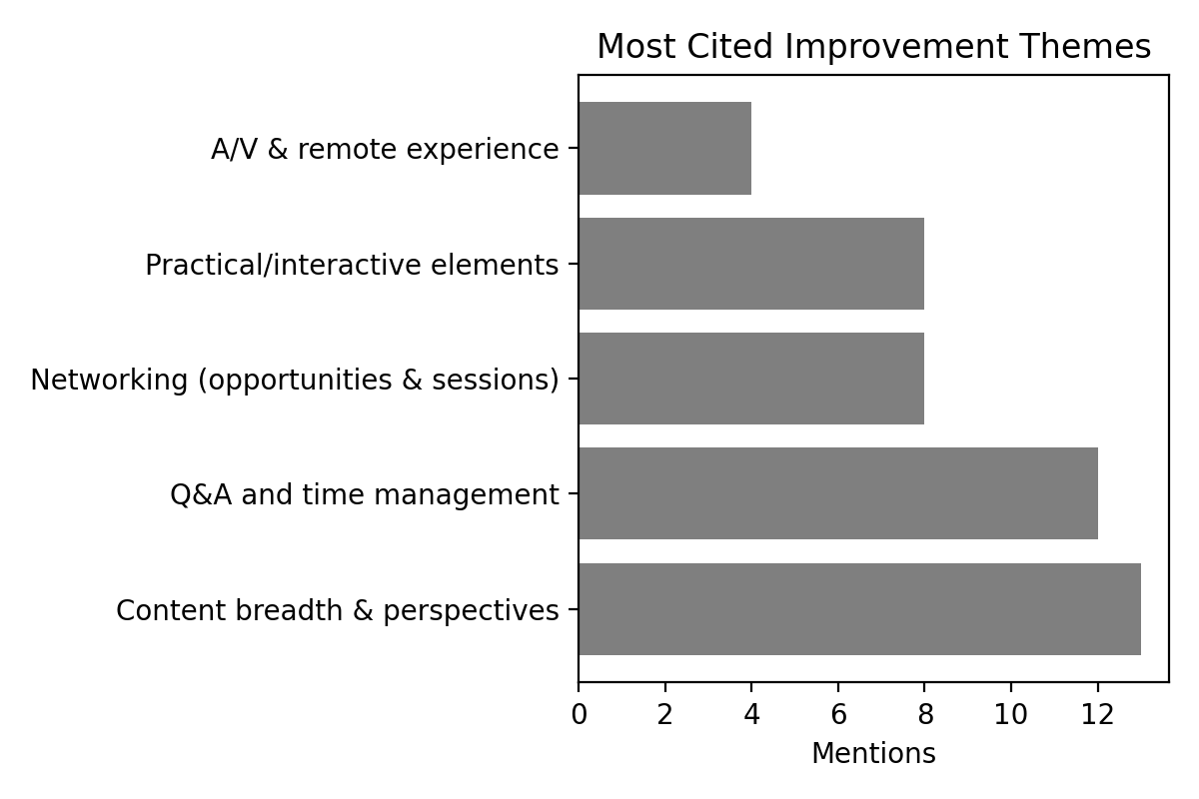

Chart Improvements

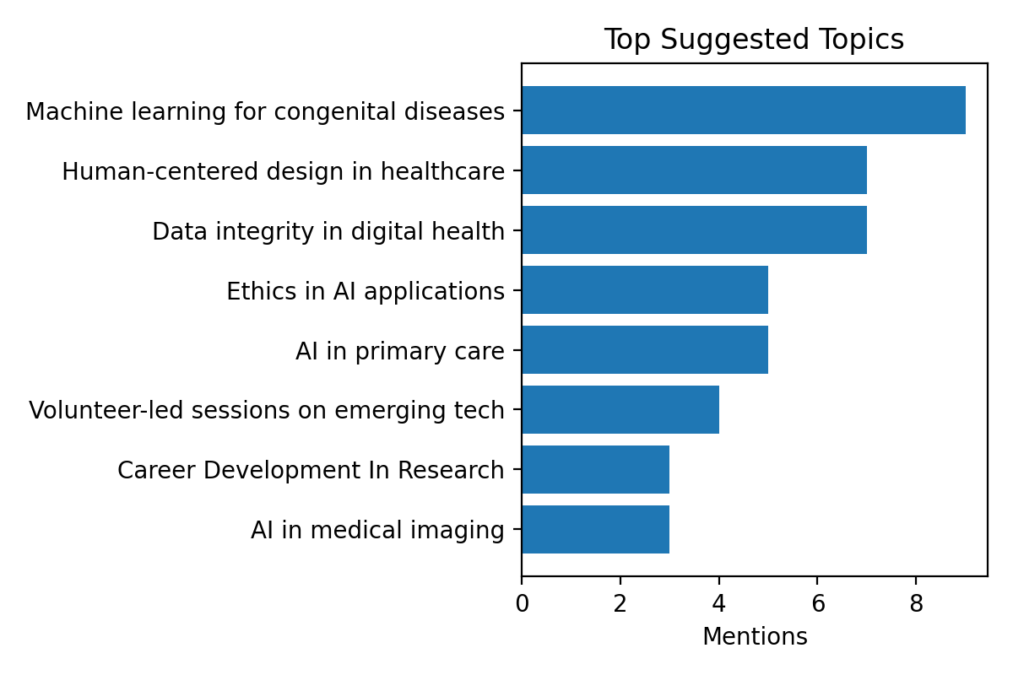

Chart Topics

# Quantitative breakdown of responses

Likelihood of attending future events (1–5):

|  |  |  |  |  |  |  |  |  |  |
| --- | --- | --- | --- | --- | --- | --- | --- | --- | --- |
| Score | 1 | | 2 | | 3 | | 4 | | 5 |
| Count | 13 | | 7 | | 9 | | 13 | | 8 |
| Question | | N | | % agree (A+SA) | | 95% CI | | SD/D/N/A/SA | |
| Well organised | | 50 | | 40.0% | | 28–54% | | 11/10/9/11/9 | |
| Talks interesting & accessible | | 50 | | 36.0% | | 24–50% | | 14/11/7/6/12 | |
| Adequate networking opportunities | | 50 | | 46.0% | | 33–60% | | 10/8/9/12/11 | |
| Facilitated meaningful connections | | 50 | | 34.0% | | 22–48% | | 12/9/12/8/9 | |
| Identified potential collaborations | | 50 | | 38.0% | | 26–52% | | 8/9/14/8/11 | |
| Discovered complementary interests | | 50 | | 30.0% | | 19–44% | | 11/12/12/8/7 | |
| Interested in follow-up group | | 50 | | 32.0% | | 21–46% | | 11/12/11/7/9 | |
| Used recordings/slides | | 50 | | 34.0% | | 22–48% | | 10/10/13/7/10 | |

# Major themes with supporting evidence

## What worked well

* Variety/quality of speakers & talks: 25 mentions

“Good variety of speakers.”

“Good mix of people and topics.”

* Operations/logistics: 17 mentions

“Gluten-free food was appreciated.”

“Gluten-free food was appreciated.”

* Networking (opportunities & sessions): 6 mentions

“Networking opportunities were excellent.”

“In-person events worked well.”

* Recordings & materials: 6 mentions

“Recordings were helpful.”

“Recordings were helpful.”

## What could be improved

* Content breadth & perspectives: 13 mentions

“Include ethics/humanities perspectives.”

“Consistency in themes across sessions.”

* Q&A and time management: 12 mentions

“More time for brainstorming in small groups.”

“More time for questions would be helpful.”

* Networking (opportunities & sessions): 8 mentions

“More time for brainstorming in small groups.”

“Breakout sessions for networking could be added.”

* Practical/interactive elements: 8 mentions

“Add practical demonstrations.”

“Add practical demonstrations.”

* A/V & remote experience: 4 mentions

“Improve audio/visual quality for remote speakers.”

“Improve audio/visual quality for remote speakers.”

# Notable observations (unusual or conflicting feedback)

* Networking opportunities rated Agree while meaningful connections rated Strongly disagree.
* Networking opportunities rated Strongly disagree while meaningful connections rated Strongly agree.
* Networking opportunities rated Strongly agree while meaningful connections rated Disagree.
* Networking opportunities rated Disagree while meaningful connections rated Strongly agree.
* Networking opportunities rated Disagree while meaningful connections rated Agree.
* Networking opportunities rated Strongly agree while meaningful connections rated Strongly disagree.
* Networking opportunities rated Strongly disagree while meaningful connections rated Strongly agree.
* Networking opportunities rated Strongly agree while meaningful connections rated Strongly disagree.
* Networking opportunities rated Disagree while meaningful connections rated Strongly agree.
* Networking opportunities rated Agree while meaningful connections rated Strongly disagree.
* Networking opportunities rated Agree while meaningful connections rated Disagree.
* Networking opportunities rated Disagree while meaningful connections rated Agree.
* Networking opportunities rated Strongly agree while meaningful connections rated Strongly disagree.
* Networking opportunities rated Agree while meaningful connections rated Disagree.
* Networking opportunities rated Strongly agree while meaningful connections rated Strongly disagree.
* Networking opportunities rated Strongly disagree while meaningful connections rated Strongly agree.
* Networking opportunities rated Strongly disagree while meaningful connections rated Strongly agree.
* Networking opportunities rated Agree while meaningful connections rated Strongly disagree.
* Networking opportunities rated Strongly disagree while meaningful connections rated Strongly agree.
* Organisation rated Strongly disagree, but future attendance likelihood 4.
* Organisation rated Strongly disagree, but future attendance likelihood 4.
* Organisation rated Disagree, but future attendance likelihood 4.
* Organisation rated Strongly disagree, but future attendance likelihood 4.
* Organisation rated Disagree, but future attendance likelihood 4.
* Organisation rated Disagree, but future attendance likelihood 5.
* Talks rated Disagree, yet positive comment about presentations: Very insightful and impactful presentations.
* Talks rated Strongly disagree, yet positive comment about presentations: Very insightful and impactful presentations.
* Talks rated Strongly disagree, yet positive comment about presentations: Very insightful and impactful presentations.

Minority perspectives:

* Gluten-free food appreciated
* Gluten-free food appreciated
* Gluten-free food appreciated
* Gluten-free food appreciated
* Gluten-free food appreciated
* Gluten-free food appreciated

# Specific recommendations for improvement

1. Balance networking format: combine structured introductions and small-group breakouts to strengthen meaningful connections while preserving open networking time.
2. Protect Q&A time by trimming talk slots or using moderated question voting to surface key queries.
3. Add 1–2 practical demonstrations per programme (short live demos or interactive case walk-throughs).
4. Publish a simple thematic thread across sessions in advance to address “consistency of themes” feedback.
5. Enhance hybrid delivery: standardise microphones for audience Q&A, brief remote speakers on A/V checks, and have a live tech host.
6. Introduce an ethics/humanities perspective slot and a careers spotlight (5-minute lightning talks from partners).
7. Pilot a follow-up networking group with opt-in interest forms and rotating hosts aligned to top topics (e.g., AI in primary care, data integrity).