Penguin body mass
Your name here

Summary
This report compares the body mass of three kinds of penguin. The Gentoo penguins were the heaviest, at 5,092 g on average.

Data
The measurements are for 333 penguins on three islands. Rows with missing values were removed before the analysis.

Results
Species | Penguins | Mean body mass (g) | Mean flipper length (mm)
Adelie | 146 | 3,706 | 190
Chinstrap | 68 | 3,733 | 196
Gentoo | 119 | 5,092 | 217
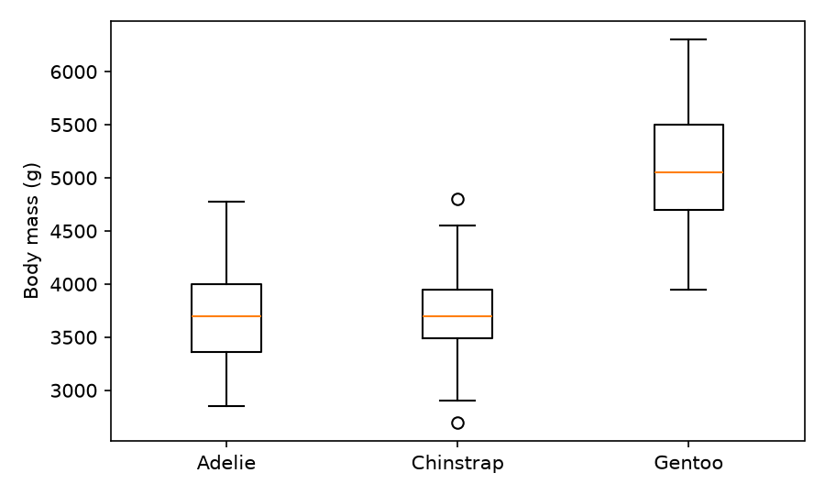
Body mass of each kind of penguin

Conclusion
Gentoo penguins are clearly heavier than the other two kinds.

