Body mass of Gentoo penguins
Your name here
2026-11-10
Abstract
Male Gentoo penguins are heavier than females. This report measures the difference.

1 Introduction
Penguins near Palmer Station, Antarctica, were measured between 2007 and 2009 (Gorman et al. 2014). We use the version of the data in the palmerpenguins package (Horst et al. 2020), and look at one species, Gentoo.

2 Data
After removing incomplete rows, there are 119 Gentoo penguins in the data.

3 Results
On average, males were 805 g heavier than females (Table 1 and Figure 1).
Table 1: Mean body mass of Gentoo penguins, by sex
Sex | Mean body mass (g)
female | 4680
male | 5485

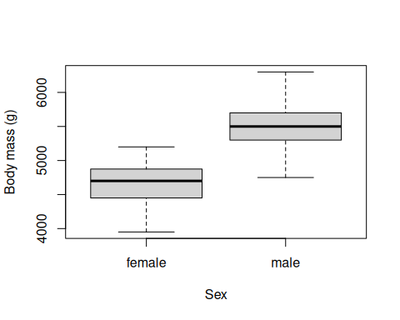
Figure 1: Body mass of Gentoo penguins, by sex

4 References
Gorman, Kristen B., Tony D. Williams, and William R. Fraser. 2014. “Ecological Sexual Dimorphism and Environmental Variability Within a Community of Antarctic Penguins (Genus Pygoscelis).” PLoS ONE 9 (3): e90081. https://doi.org/10.1371/journal.pone.0090081.
Horst, Allison Marie, Alison Presmanes Hill, and Kristen B. Gorman. 2020. Palmerpenguins: Palmer Archipelago (Antarctica) Penguin Data. https://doi.org/10.5281/zenodo.3960218.

