Using EOSAI:

Type of AI: EOSAI is setup for turn-based games where all units move simultaneously.

More specifically:
- "Turn based game" means a game where time is broken up into discrete steps and the AI has some time to think about his turn. (This is in contrast to real-time games.) Real-time AI involves a few extra challenges: the AI must think very quickly about his moves, otherwise, it will slow down the game and also cause the AI to think too slowly to react to important events, and second, the AI would need to be able to figure out when and how often to update its strategy/moves in the game and which things don't need to be recalculated (because they haven't changed). With some more development, the EOSAI could eventually meet both of these challenges.
- "All units move simultaneously" means that it's not a game like chess (where one "unit" is moved per turn), and the turns aren't broken up into sub-steps:
- For example, in the game of Civilization, a player attacking a city can determine exactly what orders units attack - e.g. attack the city with a catapult, then another catapult, then horsemen, then with pikemen. With some work, EOSAI could handle this kind of logic, as well, but it's not part of the AI system.
- For example, in the game of Shogun or Risk, a player attacks a region, then moves through the region to attack a second region and a third region. In the game of Risk, a significant amount of planning can be involved in finding a good starting region so you can progressively capture a bunch of enemy regions without getting caught in a dead-end. EOSAI is not setup to handle this kind of strategy.

Setting up a game to use EOSAI:

Each turn, the game needs to send information to the AI so that it can make decisions. An example of how to do this can be found in the EOSAIInterface.cpp file.

Input data:

- Map Data: The AI needs to know the layout of the map. EOSAI sees the world as a bunch of connected territories. Based on the cities and units in those territories, it classifies them into categories: border territories, internal territories, territories he owns, territories controlled by other players, etc. It uses the connection data to figure out movement pathways for units, what territories are at risk from enemies, what types of units to build, etc.
[ Show an example map with connection data ]

- Unit Templates: The units in the game need to be classified into types. For example, all units of the "Sherman Tank" type have the same movement and combat attributes. (If the game is setup so that every unit on the map have completely different attributes, then the developer can simply create a unique unit template for each unit in the game.) The Unit Templates are described by the CAIUnitTemplate2 class.

- Units: Each unit in the game needs to be described - it needs a unit template, a location, health information, an owner (what player controls the unit), etc. Units are described by the CAIUnit class.

- Points of Interest (POI): Cities, Resources, Airfields, Fortresses, and other points of interest - everything of value on the map should be described because the AI has to make decisions about capturing or destroying them.

- Foreign Relations, Agreements and Constraints: The AI needs to know about what kinds of agreements and constraints it has with other players. This allows the developer to restrain the AI in various ways (e.g. in a World War 2 game, under no conditions is the US player allowed to declare war on England because that would be historically inaccurate), and allows the AI to make decisions about who to attack and when to make peace (e.g. if the AI is currently at war with Player 2 and is losing, then the AI should not declare war on another player, but should seek to maintain peace with other players to avoid getting overwhelmed).

- Technology: The AI needs to make decisions about what technologies to research and how much effort to put into these research efforts. In order to make these decisions, the AI needs to know information about the research options, including the cost, time, and benefits of the technology.

- Personality: Each AI can have a different personality. The personalities are described by variables that affect his decisions. For example, the personality might favor certain types of units (e.g. ground units over air units) or might influence his tendency towards aggressive vs cautious play.

- History: The AI keeps track of past interactions with other players - for example, if the player recently did a sneak-attack against them (or someone else), or if they were a loyal ally. This is important in deciding who to attack and who to maintain peace with. While much of this information is stored inside the AI's data structures, the developer must inform the AI about events in the game (e.g. Player X just sneak attacked them), and the Player can include pre-game historical information (for example, if the game is a WW2 historical scenario that begins in January, 1940, then the developer might want to include historical information that the Germans sneak attacked Poland in September 1939).

- Influencers: these are used to influence the AI's decisions in particular ways. (Not yet developed.) Influencers can be used to makeup for deficiencies in the AI's decision-making process, make the AI behave in a certain way (in line with the game-developer's scenario), or make the AI behave according to some historical timeline (for example, making a WW2 German player pursue aircraft and tank technologies while neglecting nuclear-bomb research).

Output:

Based on the input data, the AI will create some output data:

- Agreements, Trade, Messages, Declarations: The AI will output some foreign relations actions. This might include declarations of war, requests for peace, responses to player messages, trade agreements, etc.

- Orders: The AI will write-out orders describing what each city should build, and orders for each of his units, and technology research orders. (This data is contingent on responses to/from other players. For example, the AI might give his units order to attack an enemy while, at the same time, sending a message to that same player requesting peace. If the player agrees to the peace agreement, then the AI's orders will have to be recalculated, changing his units' attack orders and changing his city-build orders to be less war-oriented.)

Customization:

If the game allowed for unique types of agreements (like "research agreements"), then those will have to coded into the system.

AI Debug System:

The EOSAI system can output a variety of debug data to help players customize and debug the AI's decision-making process. This includes a variety of warnings, errors (e.g. if the map data contains errors), and outputs intermediate results during the AI's processing. This gives insight into how the AI is making its decisions. (Effectively, this is like having students "show their work" which will help the developer identify where the AI's decision-making is going wrong when it's making bad decisions.)

xxxxxxxxxxxxxxxxxxxx
xxxxxxxxxxxxxxxxxxxx

Introduction
EOSAI is an artificial intelligence system for strategy games. It was originally part of the game "Empires of Steel" (EOS), but the code is being genericized for use in other strategy games. The code is C++, compiles to a DLL, and is setup to run in its own thread.
The expected use of this project include:
- Developing/Improving AI for the game Empires of Steel
- Using this AI in other strategy games (see legal restrictions)
- Providing an example AI for the purpose of teaching developers about writing AI
EOSAI is setup for turn-based games where all units move simultaneously.
- "Turn based game" means a game where time is broken up into discrete steps and the AI has some time to think about his turn. This is in contrast to real-time games. Real-time AI involves a few extra challenges: the AI must think very quickly about his moves (otherwise, it will slow down the game and also cause the AI to think too slowly to react to important events), and second, the AI would need to be able to figure out when and how often to update its strategy/moves in the game. The AI might also need to figure out which things need to be recalculated and which things don't need to be recalculated (because they haven't changed). With some additional development, EOSAI could eventually meet both of these challenges.

- "All units move simultaneously" means that it's not a game like chess (where one "unit" is moved per turn) and the turns aren't broken up into sub-steps. For example, the following games do not use an "all units move simultaneously" system:

- In the game of Civilization, a player attacking a city can determine exactly in what sequence units attack - e.g. attack the city with a catapult, then another catapult, then horsemen, then with pikemen. With some work, EOSAI could handle this kind of logic, but it's not currently part of the AI system.

- In the game of Shogun or Risk, a player attacks a region, then moves through the region to attack a second region and a third region. In the game of Risk, a significant amount of planning can be involved in finding a good starting region so you can progressively capture a bunch of enemy regions without getting caught in a dead-end. EOSAI is not setup to handle this kind of strategy.

Setting Up A Game To Use EOSAI:

Libraries:
EOSAI gets compiled into a DLL (named EOSAI.dll). The DLL is dynamically linked to the game. The game needs an interface layer which has knowledge about both the game and the EOSAI structures. This must be custom-built for each game.
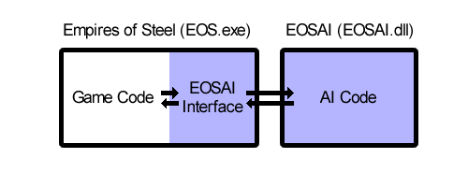
How to include EOSAI in EOS:
Note: The current version of EOS (version 1.01.17283) does not use the EOSAI.dll library. In other words there is no way to use EOSAI with EOS. The EOSAI code is currently compiled into EOS. (The EOSAI project is going to spin-off the artificial intelligence into a separate library.)
When EOS is switched over to using EOSAI.dll, the EOSAI developer will need to compile the dll and copy it to the directory where EOS.exe exists. (The EOSAI interface will already exist and won't need to be created by the EOSAI developer.)
How to include EOSAI in another game:
Including EOSAI into a third-party game will require two things: the EOSAI dll and an interface layer between the game and the EOSAI system (the EOSAI Interface).
The developer need to compile EOSAI.dll and create an EOSAI Interface (which gets compiled into the original game). In order to construct the EOSAI Interface, a developer should take a look at the "EOSAI\ExampleCode" directory. The EOSAI Interface needs to access files in the "EOSAI\Export" directory.
The contents of the EOSAI\Exports directory:
\EOSAI\Export\EOSAI.dll (release build of EOSAI)
\EOSAI\Export\EOSAI-debug.dll (debug build of EOSAI)
\EOSAI\Export\Include\... (files needed to construct the EOSAI Interface)

EOSAI Data Input/Outout:
Each turn, the game needs to send information to the AI so that it can make decisions. The AI will process the data and return results. An example of how to do this can be found in the EOSAIInterface.cpp file. Details on how to do this are listed below.
Input data:
- Map Data: The AI needs to know the layout of the map. EOSAI sees the world as a bunch of connected territories. This map information is used for a few different purposes: to find pathways and to figure out the vulnerability of different regions. Below is a image of the regions. Each different color represents a separate region. (EOS doesn't use regions, everything moves continuously over the map, but the map is cut up into regions for the purpose of doing AI calculations.) Click here to view more details on the map system.
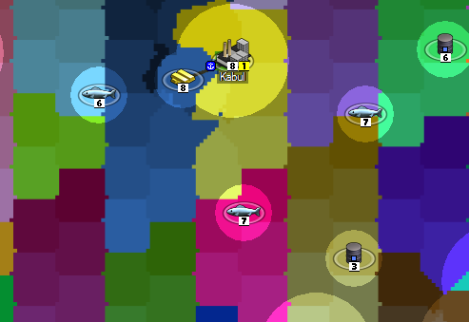
- Unit Templates: The units in the game need to be classified into types. For example, all units of the "Sherman Tank" type have the same movement and combat attributes. (If the game is setup so that every unit on the map have completely different attributes, then the developer can simply create a unique unit template for each unit in the game.) The Unit Templates are described by the CAIUnitTemplate2 class.
- Units: Each unit in the game needs to be described - it needs a unit template, a location, health information, an owner (what player controls the unit), etc. Units are described by the CAIUnit class.
- Points of Interest (POI): Cities, Resources, Airfields, Fortresses, and other points of interest - everything of value on the map should be described because the AI has to make decisions about capturing or destroying them.
- Foreign Relations, Agreements and Constraints: The AI needs to know about what kinds of agreements and constraints it has with other players. This allows the developer to restrain the AI in various ways (e.g. in a World War 2 game, under no conditions is the US player allowed to declare war on England because that would be historically inaccurate), and allows the AI to make decisions about who to attack and when to make peace (e.g. if the AI is currently at war with Player 2 and is losing, then the AI should not declare war on another player, but should seek to maintain peace with other players to avoid getting overwhelmed).
- Technology: The AI needs to make decisions about what technologies to research and how much effort to put into these research efforts. In order to make these decisions, the AI needs to know information about the research options, including the cost, time, and benefits of the technology.
- Personality: Each AI can have a different personality. The personalities are described by variables that affect his decisions. For example, the personality might favor certain types of units (e.g. ground units over air units) or might influence his tendency towards aggressive vs cautious play.
- History: The AI keeps track of past interactions with other players - for example, if the player recently did a sneak-attack against them (or someone else), or if they were a loyal ally. This is important in deciding who to attack and who to maintain peace with. While much of this information is stored inside the AI's data structures, the developer must inform the AI about events in the game (e.g. Player X just sneak attacked them), and the Player can include pre-game historical information (for example, if the game is a WW2 historical scenario that begins in January, 1940, then the developer might want to include historical information that the Germans sneak attacked Poland in September 1939).
- Influencers: these are used to influence the AI's decisions in particular ways. (Not yet developed.) Influencers can be used to makeup for deficiencies in the AI's decision-making process, make the AI behave in a certain way (in line with the game-developer's scenario), or make the AI behave according to some historical timeline (for example, making a WW2 German player pursue aircraft and tank technologies while neglecting nuclear-bomb research).
Output:
Based on the input data, the AI will create some output data:
- Agreements, Trade, Messages, Declarations: The AI will output some foreign relations actions. This might include declarations of war, requests for peace, responses to player messages, trade agreements, etc.
- Orders: The AI will write-out orders describing what each city should build, and orders for each of his units, and technology research orders. (This data is contingent on responses to/from other players. For example, the AI might give his units order to attack an enemy while, at the same time, sending a message to that same player requesting peace. If the player agrees to the peace agreement, then the AI's orders will have to be recalculated, changing his units' attack orders and changing his city-build orders to be less war-oriented.)
Customization:
If the game allowed for unique types of agreements (like "research agreements"), then those will have to coded into the system.
AI Debug System:
The EOSAI system can output a variety of debug data to help players customize and debug the AI's decision-making process. This includes a variety of warnings, errors (e.g. if the map data contains errors), and outputs intermediate results during the AI's processing. This gives insight into how the AI is making its decisions. (Effectively, this is like having students "show their work" which will help the developer identify where the AI's decision-making is going wrong when it's making bad decisions.)
-----

Introduction
The Maps system is used for pathfinding and also for figuring out which areas are vulnerable.
Below is an example of a map. The left image is the 'normal view' of the map. The right image shows AIRegions (each colored area is an AIRegion).
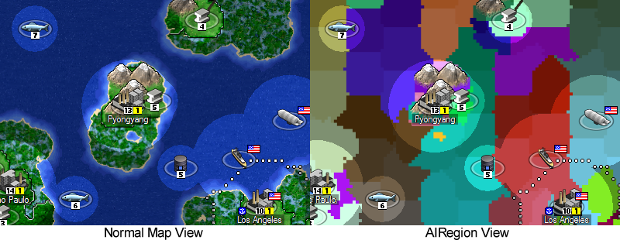

Creating the EOSAI Interface
The EOSAI Interface must convert the game map into an AIRegion map.
The mapping system requires several things:
- Each part of the map must belong to an AIRegion. (In other words: there should never be a situation where a unit or city or any other point of interest exists on the map, but can't be resolved to an AIRegion. The AI will never be able to find a parthway to any object that doesn't exist inside an AIRegion.)
- The AIRegions must be linked together so the AI knows what regions connect to which regions (i.e. Region A is adjacent to Region B).
- Each AIRegion should have the same terrain. In other words: a region might a "water" or "forest" or "plains". An AIRegion can't contain both forest+water or even forest+plains. This is important for figuring out pathways because the pathway calculated for a ground unit is different than a pathway calculated for ships. If a tank can't move through forests, then it won't be allowed to move through any AIRegions designated as "forest".

Creating the EOSAI.dll
The EOSAI code does several things with the map: pathfinding and evaluating the vulnerable regions.
Pathfinding
The pathfinding system has to take several factors into account when running pathfinding calculations. The system wants to minimize the amount of time it takes to move from point A to point B. However, the pathfinding system may also want include other factors as well, including: avoiding enemy units and avoiding being sighted by enemies.
Region Evaluation
The pathfinding system is used to figure out what regions are vulnerable (this includes vulnerable regions controlled by the AI and vulnerable regions controlled by enemy nations). This system takes into account the movement rates of enemy units and movement ranges of aircraft. (For example, if an enemy has aircraft with a movement range of 500 pixels, then all regions within 500 pixels of airports are vulnerable to enemy aircraft.)
------

Ideas for the Future
While I won't attempt to create a timeline for these features, here's some features which might be nice in the future:
- Cross Platform. The library currently relies on MFC data structures. It would be better to move to stl so that cross-platform capability could be achieved.
- Lua Scripting. While the current AI system doesn't really need Lua to accomplish anything, having a scripting language might be useful for AI customization (so the AI plays differently in general) and customization scenario (so that the AI either performs better on a specific map, or so that the AI follows a historically accurate path).
- Multithreaded. The AI runs in a single thread. If the AI was multithreaded, then it could take advantage of multiple processors which would allow it to make decisions faster. (One of the main roadblocks to being multithreaded is the fact that the map-pathway finder is not re-entrant. The easiest way to solve this would be to duplicate the data structures, which will increase the memory requirements.)

-----

Why Doesn't EOS use EOSAI?
The code in EOSAI was originally inside EOS.exe. It's being split off into a separate dll, and during the process of separating the two, some things stopped working. They stopped working because the EOSAI no longer had access to some of the classes specific to EOS. Since EOSAI is being turned into a general AI system, I needed to introduce more separation between EOS and EOSAI.

