**Pizza_Sales MySql Queries**

1. Total Revenue:

select sum(total_price) as Total_Revenue from pizza_sales.pizza_sales

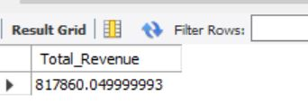

1. Average Order Value:

select sum(total_price)/count(distinct order_id) as Avg_order_value from pizza_sales.pizza_sales

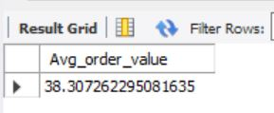

1. Total Pizza Sold:

select sum(quantity) as Total_pizza_sold from pizza_sales.pizza_sales

1. Total Orders:

select count(distinct order_id) as Total_orders from pizza_sales.pizza_sales

1. Average Pizza per order:

select sum(quantity)/count(distinct order_id) as Avg_pizza_per_order from pizza_sales.pizza_sales

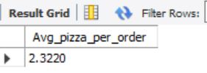

1. Percentage of sales by pizza category:

select pizza_category, sum(total_price) * 100 /(select sum(total_price) from pizza_sales.pizza_sales) as POS_by_pizza_category

from pizza_sales.pizza_sales

group by pizza_category

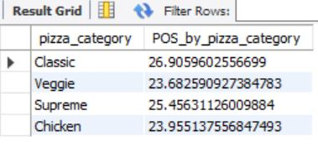

1. Percentage of sales by Pizza size:

select pizza_size, sum(total_price) * 100 /(select sum(total_price) from pizza_sales.pizza_sales) as POS_by_pizza_size

from pizza_sales.pizza_sales

group by pizza_size

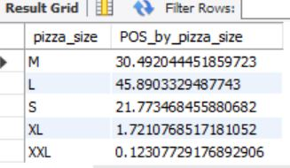

1. Total pizza sold by pizza category:

select pizza_category, sum(total_price) as Total_pizza_sold

from pizza_sales.pizza_sales group by pizza_category

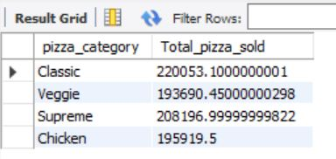

1. Top 5 Pizza by Revenue:

select pizza_name, sum(total_price) as Total_Revenue from pizza_sales.pizza_sales

group by pizza_name order by Total_Revenue desc limit 5

1. Bottom 5 Pizza by Revenue:

select pizza_name, sum(total_price) as Total_Revenue from pizza_sales.pizza_sales

group by pizza_name order by Total_Revenue limit 5

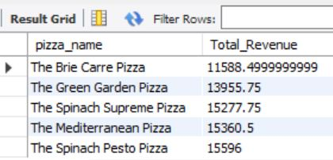

1. Top 5 Pizza by Quantity:

select pizza_name, sum(quantity) as Total_Quantity from pizza_sales.pizza_sales

group by pizza_name order by Total_Quantity desc limit 5

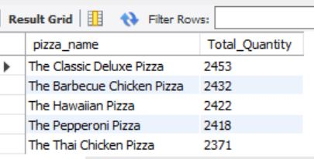

1. Bottom 5 Pizza by Quantity:

select pizza_name, sum(quantity) as Total_Quantity from pizza_sales.pizza_sales

group by pizza_name order by Total_Quantity limit 5

1. Top 5 Pizza by Order:

select pizza_name, count(distinct order_id) as Total_order from pizza_sales.pizza_sales

group by pizza_name order by Total_order desc limit 5

1. Bottom 5 Pizza by Order:

select pizza_name, count(distinct order_id) as Total_order from pizza_sales.pizza_sales

group by pizza_name order by Total_order limit 5

