horizontal line

## Glossary

|  |  |
| --- | --- |
| Term | Definition |
| Innocalendar personal message screen. | It is a message feed in Telegram chat.  (InnoSchedule for an example) |
| University Education Department schedule system or UED schedule system | It is a google doc with the schedule currently used by the University Education Department. |

## Use Cases

|  |  |
| --- | --- |
| **Use Case name** | **Subscribe for an initial core program** |
| **Actors** | Students (primary), Bot(secondary) |
| **Pre-conditions** | The student has a telegram account |
| **Flow of event** | 1. The student searches for InnoCalendar bot on telegram.(**B1**) 2. The bot shows the greeting message which contains descriptions and helps instructions. 3. The student starts the bot.(**B2**) 4. The student selects configure schedule command.(**B3**) 5. The bot shows the available programs (Bachelor and Master). 6. The student clicks on the button with the name of his/her core program name.(**B4**) |
| **Alternative flow of event** | 1. The student cannot find InnoCalendar bot on telegram.  1.1 Student writes to the owners of the bot  3. Bot doesn’t starts  3.1 Student checks internet connection  4(6). Student writes instead of clicking button  4(6).1 Bot says student what student should do |
| **Post conditions** | The Student is assigned to the core program. |

|  |  |
| --- | --- |
| **Use Case name** | **Subscribe to a course** |
| **Actors** | Students (primary), Bot(secondary) |
| **Pre-conditions** | The student has already subscribed the initial core program on Innocalendar system |
| **Flow of event** | 1. Student searches Innocalendar from telegram app(**B1**) 2. Student opens Innocalendar personal message screen on telegram app 3. Student clicks “Add new course” button(**B2**) 4. The bot shows the list of all available elective courses. 5. The student selects one of the listed courses.(**B3**) |
| **Alternative flow of event** | 1. The student cannot find InnoCalendar bot on telegram.  1.1 Student writes to the owners of the bot  3(5). Student writes instead of clicking button  3(5).1 Bot says student what student should do |
| **Post conditions** | 1. System updates the changes 2. The Student is assigned to the selected course. |
| **Non-behavioural Requirements** | 1. Updates are consistent on personal message screen |

|  |  |
| --- | --- |
| **Use Case name** | **Receive notification** |
| **Actors** | Students (primary), Bot(secondary) |
| **Pre-conditions** | The Student is subscribed in some courses.  The schedule of the subscribed courses was updated/changed. |
| **Flow of event** | 1. The user receives the notification. |
| **Post conditions** | The student got a notification. |
| **Assumptions** | The student has an internet connection |

|  |  |
| --- | --- |
| **Use Case name** | **Update schedule** |
| **Actors** | Bot (Primary), UED schedule system (secondary) |
| **Pre-conditions** | Access agreement with Innopolis University Education Department on the current semester program schedule |
| **Flow of event** | 1. System checks for changes in University Education Department current semester program schedule. 2. The bot receives and records changes to the database. |
| **Post conditions** | The system sends notifications about changes to the Students |
| **Non-behavioural Requirements** | 1. There will be no database outage, data loss, and leakage.  2. All course changes kept up to date   1. The system will update once in two hours from UED schedule system. |

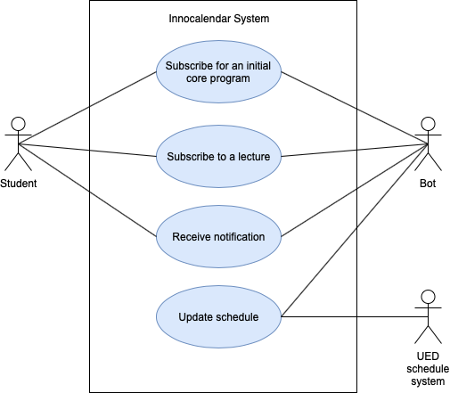

## Test Case Matrix:

|  |  |  |  |  |  |
| --- | --- | --- | --- | --- | --- |
| **Subscribe for an initial core program** | | | | | |
| **Step** | **Variable or selection** | TC1 | TC2 | TC3 | TC4 |
| **B1** | Name of bot | @InnoScheldue_bot | @InnoScheldue_bot | @InnoScheldue_bot | @InnoScheldue_bot |
| **B2** | Click start button | /start | /start | /start | /start |
| **B3** | Configure command | /configure | /cake | /configure | someStuff |
| **B4** | Select core program | /configure | /cake | /configure | someStuff |

|  |  |  |  |  |  |
| --- | --- | --- | --- | --- | --- |
| **Subscribe for an initial core program** | | | | | |
| **Step** | **Variable or selection** | TC1 | TC2 | TC3 | TC4 |
| **B1** | Name of bot | @InnoScheldue_bot | @InnoScheldue_bot | @InnoScheldue_bot | @InnoScheldue_bot |
| **B2** | Сlick “Add new course” button | Click on button | Write Add new course in the Telegram | Click on button | someStuff |
| **B3** | Select cource | Advanced Python | Programming on Haskell | someStuff | someStuff |