Citation given on the occasion of the award of the BCA-IG prize to
Professor Paul F. Fewster

Professor Paul Fewster is widely acknowledged as one of the leading experts on X-ray diffraction world-wide. He has made major contributions to the development of both the apparatus and the analysis of the results and has used this expertise to contribute to the development of a wide variety of electronic and photonic devices.

Paul started his work on this topic at Philips Research Laboratories where he began by modify the existing X-ray equipment and enhancing the software, both of which were rudimentary by modern standards. This led ultimately to the emergence of the PANalytical X’Pert Materials Research Diffractometer, which is the “state of the art” equipment in this field. The system is used by all the major manufacturers of semiconductor products world-wide for structural evaluation of their products. His laboratory now based at the Sussex Innovation Centre on the University of Sussex campus where they continue to develop both the equipment and the simulation software for increasingly sophisticated applications.
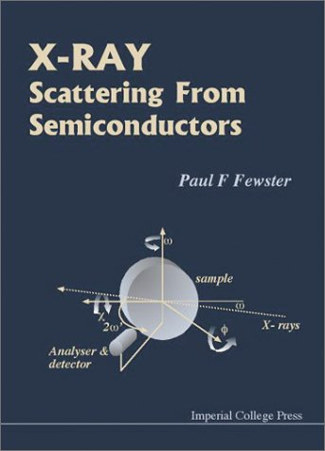
Over the years, first at Philips and later as an independent scientist, Paul has influenced the development of many semiconductor devices. This began with his early studies of III-V compound semiconductors such as AlGaAs, where he did much pioneering work on the structural quality of multi-quantum well structures, which now form the basis for all solid state lasers. He extended this work to include the much wider family of III-V, II-VI and silicon based structures, most recently including spintronic materials and quantum dots. Much of this work is now summarised in the second edition of his classic book “X-ray Scattering from Semiconductors”.

Paul has also made major contributions to the work of both the Institute of Physics and the British Crystallographic Association being active in both bodies for many years. His expertise has been acknowledged by his appointment as a visiting Professor of Physics at Imperial College. He was awarded the Paterson Prize and Medal from the Institute of Physics in 1991 and obtained a D.Sc. for his work in crystallography from London University.

Paul has made an enormous contribution to the BCA in several areas: he was a hard working member of the PCG committee for many years (1983-1996) serving in many rôles during this period, then after a short break he agreed to serve on the Industrial Group committee. In addition, during this latter period he was elected Vice-President of the British Crystallographic Association for 2001-2004, which at that time involved organising the programme for the BCA Spring Meetings. In summary, Paul has made an invaluable contribution to the application of X-ray diffraction to a variety of scientific problems and major commercial applications.

