

EARLY EGYPT
Gallery Activities
Rooms 64 and 65

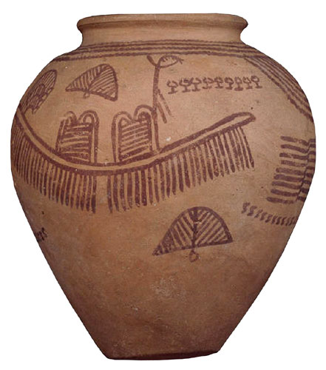

Department of Education and Information Great Russell Street
Telephone +44 (0)20 7323 8851/8850 London WC1B 3DG
Facsimile +44 (0)20 7323 8855 Switchboard +44 (0)20 7323 8000
education@thebritishmuseum.ac.uk www.thebritishmuseum.ac.uk

Egyptian Gallery Activities
Rooms 64 and 65

This pack contains gallery activities of differing levels of difficulty targeted at KS2 pupils along with accompanying guidance for teachers.

- If at all possible, visit the galleries yourself first to be thoroughly familiar with how to reach them, their layout and the objects they contain.

- Consider what you would like the visit to focus on and which activity sheets would be most appropriate for your pupils. In most cases it would not be reasonable to plan to use all of the activities.

- Please modify the activity sheets to suit your own purposes and the needs of your pupils.

- Familiarise your pupils and all accompanying adults with the chosen activity sheets at school before the visit. Make sure pupils know what they are to do, and are familiar with vocabulary used.

- If galleries are very crowded, activities which suggest discussion may have to be postponed until you are back at school.

Activities: Sand burial and coffin burial
Room 64
Sand burial and coffin burial: 2 sheets
Sand burial: 2 sheets; three different versions of first sheet

Main learning objectives
- Observation.
- Discussion.
- Understanding the beginnings of the development of mummification.
- Use of evidence to support views.

Before the visit
- Explain that pupils will be examining two different kinds of burials used before mummification and considering the similarities and differences.

During the visit
- Some pupils may find the human remains disturbing and not want to look at them.

- The pupils should be in small groups with a leader.

- To avoid crowding, have each group do the exercise at a different time – the sand burial is a very popular display and pupils may not be able to spend a long time around it.

- The pupils may need some help in realising that the basketwork with the coffin burial is the remains of a coffin. The wooden coffin nearby is a separate burial.

- First, each pupil completes the observation chart by filling in the boxes. The, groups should find a space in the gallery to sit down (if possible) and discuss what they have observed, using the agree/disagree statements on the second sheet. It is important for one pupil to complete this sheet with the group's findings as this requires them to talk about the issues.

Back at school
- The views of each group should be presented and discussed by the whole class. A display could be made to show the movement from sand burials to coffin burials, to full mummification.

Guidance
- Statements 1 and 2 on the second sheet are important because they introduce key ideas about the deterioration of human remains.

- Statements 3-6 are open:

- Statement 3. It may seem that a sand burial is more likely to survive on the basis of the evidence here, but, coffins would protect bodies from animals to which sand burials were vulnerable. Try to bring this point out, perhaps to disrupt easy agreement.

- Statement 4. ‘Always’ is the key word here and children need to consider the limitations of evidence: maybe the coffin burial grave was robbed; maybe the Museum has put the objects on display somewhere else; there are traces of cloth in the coffin- a pupil could be asked to go and check if they can see anything close up.

- Statements 5 and 6. Encourage the pupils to list the similarities and differences for each body separately and compare with mummies. The sand burial is likely to score more highly here as the body is well preserved and has lots of grave goods. However, it is worth stressing the container in the case of the coffin burial and the cloth the body was wrapped in. One obvious difference is the crouched position of both bodies as opposed to the stretched mummy.

- Encourage the pupils to refer to evidence.

Information

- The sand burial dates from the late Pre-Dynastic period (before the reigns of the pharaohs) about 3400 BC. It is a direct burial in the sand, which completely enveloped the body and desiccated and preserved it. The grave goods are appropriate for the burial, although they do not strictly belong to it. You can see bowls and distinctive black-topped jars. Other pots including one with a picture of a boat. Near to the body are a bracelet of red carnelian stones, a mudstone palette for grinding make-up (the grey object half-buried in sand) and a flint knife (half-buried very close to the body.) Over the years this burial has become known as ‘Ginger’.

- The coffin burial dates from the middle of the First Dynasty about 2950BC. The body was buried in a basketwork coffin of reeds and was put inside a cave. It is thought to be a poor burial - there is no evidence of grave goods, although there are traces of a garment. Although the coffin was intended to protect the body from wild animals, it actually kept the sand away from the body, thus allowing the flesh to rot away.

- The Egyptians could have become aware of the problems associated with coffin burials through opening graves for subsequent burials as well as through accidental or other uncoverings of sand burials. Increasing understanding of the processes of natural preservation coupled with the religious emphasis on the importance of the body in the afterlife generated the development of full mummification.

Sand burial

- This activity begins with observation. We have provided sheets for three differentiated levels.

- The second sheet is to encourage pupils to scan the whole gallery to find similar objects. This helps them understand that the objects found in a burial are not necessarily unique.

Sand burial and coffin burial comparison
Look at the two burials and fill in the answers.

 | Sand burial | Coffin burial
Have the skin and flesh survived ?
If not, what has
happened to them.
Have the bones survived ?
Has the hair survived ?
What position is the body in ?
Was the body buried in any sort of container ?
If yes, what was this made of ?
Could wild animals dig the body up easily ?
Was the body in contact with the dry sand when it was buried ?
Were any objects buried with the body ?
Would the body be good for the dead person’s spirit to use ?

What to do

- Read these sentences.

- Discuss them in your group.

- Use the evidence in the table to help you decide which you AGREE with and which you DISAGREE with.

1. The sand of the desert helped to preserve dead bodies.
Agree/Disagree

2. The air in a coffin helped to rot the bodies.
Agree/Disagree

3. A body's chance of survival was better without a coffin.
Agree/Disagree

4. The Egyptians always buried objects with the dead.
Agree/Disagree

5. The sand burial is more like a mummy burial.
Agree/Disagree

6. The coffin burial is more like a mummy burial.
Agree/Disagree
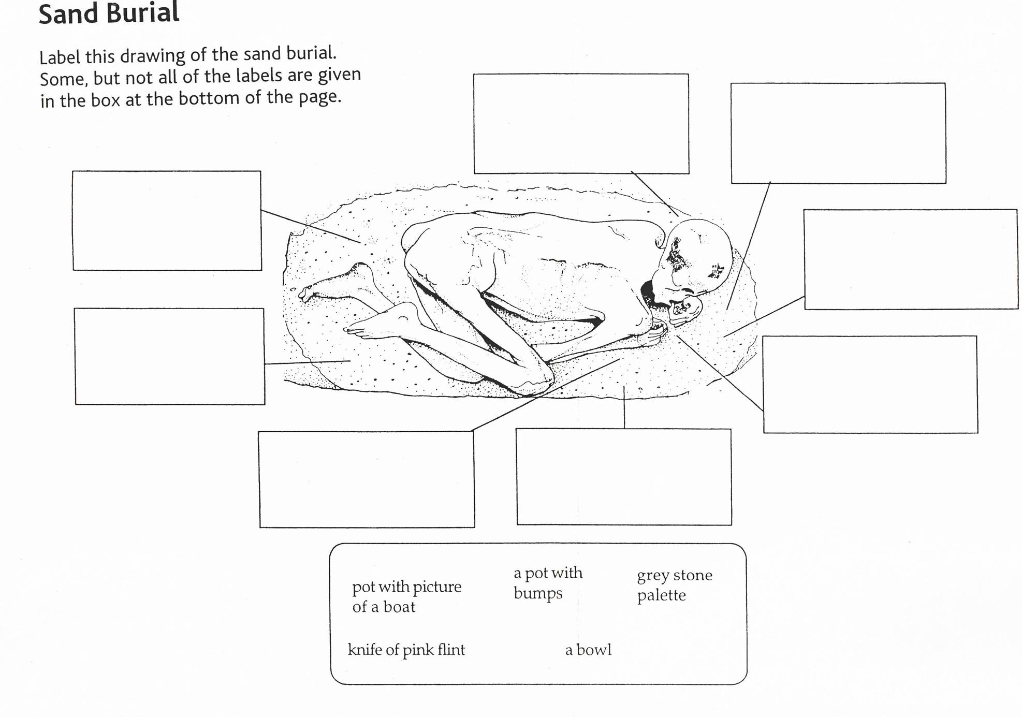
Sand Burial
Put the objects in the right places.
Use the letters shown in the picture boxes.
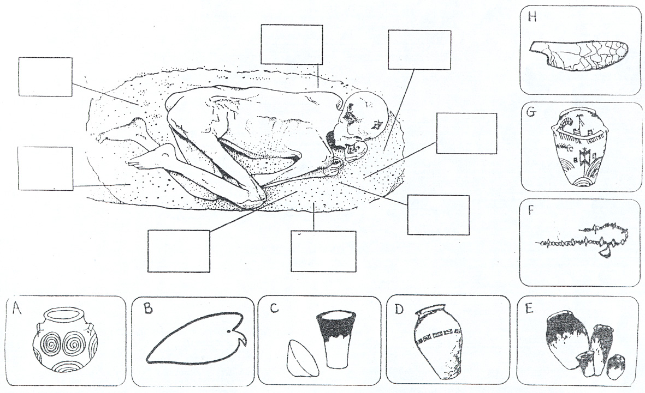

Sand Burial
Can you see these objects? Draw a line from the object to where it is in the sand burial
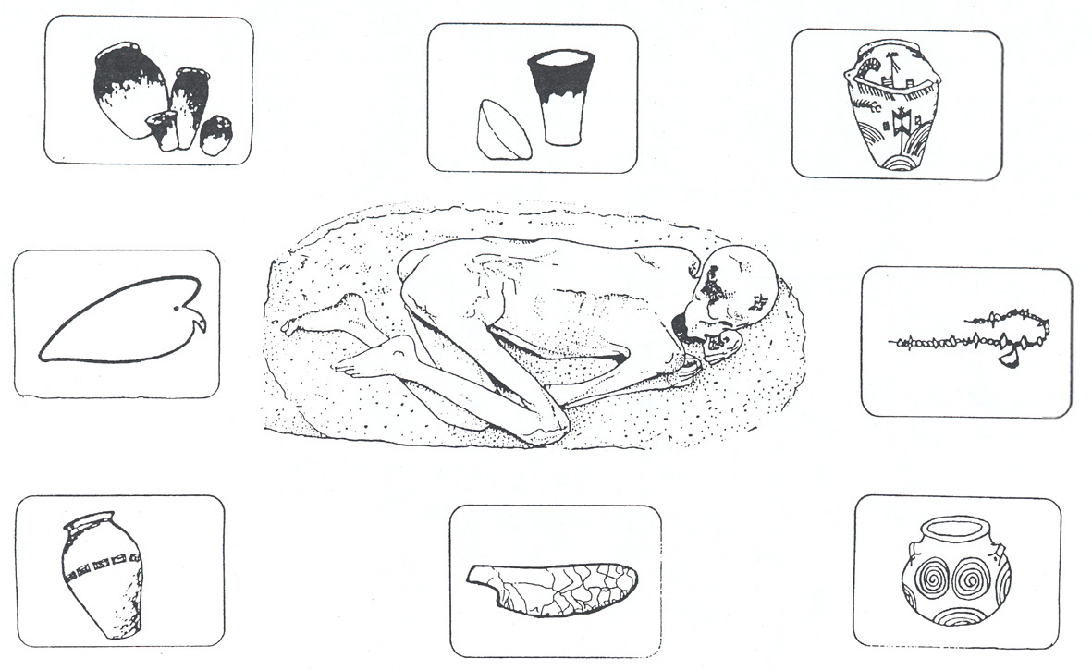

Sand burial
Objects like the ones in the sand burial can be seen elsewhere in the gallery.
How many can you find ?

Objects | Which case are they in ?
red pots with black lips |  | What do you think they contained ?
a pot with a picture of a boat |  | What do you think it contained ?
a necklace made of red beads |  | Do you think it was valuable ? Why ?
a knife made of flint |  | Do you think it was valuable ? Why ?
a palette made of grey stone |  | Do you think it was valuable ? Why ?
a pot with whirly designs |  | What do you think it contained ?
a pot with bumps |  | What do you think it contained ?
a bowl |  | What do you think it contained ?

Activity: Materials
Rooms 64 and 65

One activity sheet for ‘Materials’, two for ‘Animal, Plant or Mineral?’ and two for ‘Fill in the Gaps’. The three activities are essentially the same with differing levels of difficulty.

Learning objectives
- Scanning exhibits for specific data.
- Knowledge of range and types of materials used by Egyptians.
- Understanding how passage of time affects different materials.

Before the visit
- Encourage children to try to find unusual materials and to be very precise in identifying the material.

- For ‘Materials’, a more interactive exercise involves the pupils exchanging sheets as a challenge to another group. They should only fill in the column on the left, describing the object as clearly and accurately as possible.

Back at school
A survey of materials could be followed up in several ways:
- Pupils could represent their findings as pie charts, bar charts, etc to show what sorts of material survive most commonly. They could then consider that the reasons for this have to do with the nature of the material, as well as the role of graves in preservation. In Egypt the combination of a dry, hot climate and the practice of burying objects made from all sorts of materials produces a rich variety of material finds. Pupils could do a similar exercise in another gallery (say Iron Age or Roman Britain of Greek and Roman Life) and compare the results.

- Pupils could consider the technologies required to produce the range of objects/materials found. This could lead to further research into woodworking, metalworking, stone carving, pottery-making, basket and textile weaving.

Guidance and information
- Suitable for individuals, pairs or groups. It is a possible warm-up exercise to familiarise the pupils with the gallery.

- For ‘Fill in the Gaps’, pupils could choose to draw the object.

- Early Egypt displays quite a wide range of materials. Ancient people made full use of their physical environment, and they also developed levels of technology suitable for doing so.

- Perhaps restrict this activity to room 64 (Early Egypt) as room 65 moves well up into the Christian era. The following materials are in the rooms:

Room 64  crystal  limestone  granite  flint  mudstone  malachite  garnet  turquoise  carnelian  gold  copper  bronze  lead | clay  shell  elephant ivory  hippo ivory  horn  bone  wood  ebony  reeds  cloth | Extras in Room 65  sandstone  green feldspar  jasper  diorite  ox bone  sheep bone  ostrich egg  leather  papyrus

Materials

Choose 10 objects in the gallery. They should be made of different materials. Write a short description in the first column for example: ‘a necklace of red beads’ or ‘a pot’.

Now swap with a friend and try to find each other's objects. When you find an object, write down what it is made of. Remember: some things may be made of more than one material.

object | material | animal, plant or mineral ?

In the third column write down A if the material comes from an animal; P if it comes from a plant; M if it is a mineral and does not come from a plant or an animal. If the object is made from more than one material, you may need to write in more than one letter.

Animal, plant or mineral ? page 1

Find these 10 objects in the gallery.

In the second column write down what they are made of. Some things may be made of more than one material. Write down all the materials the object is made of.

object | material | animal, plant or mineral ?
throwing stick

necklace

one kind of jar

another kind of jar

In the third column write:
A if the material comes from an animal
P if the material comes from a plant
M if the material is a mineral

If the object is made from more than one material, you may need to write in more than one letter.

Animal, plant or mineral ? page 2

In the second column write down what the things are made of. Some things may be made of more than one material. Write down all the materials the object is made of.

object | material | animal, plant, mineral
palette for grinding make-up

chisel for cutting stone

sandals

one type of coffin

another type of coffin

In the third column write:
A if the material comes from an animal
P if the material comes from a plant
M if the material is a mineral

If the object is made from more than one material, you may need to write in more than one letter.

Fill in the gaps page 1
The table is meant to show ten objects in the gallery and what they are made of.
Find the objects and fill in the gaps.
Add one of your own.

object | material | animal, plant or mineral ?
throwing stick | wood and flint | P and M
 | wood
 | clay
another kind of jar |  | M
sandals

Fill in the gaps page 2

Continue from page one.
Add one of your own at the bottom.

object | material | animal, plant or mineral ?
 | metal
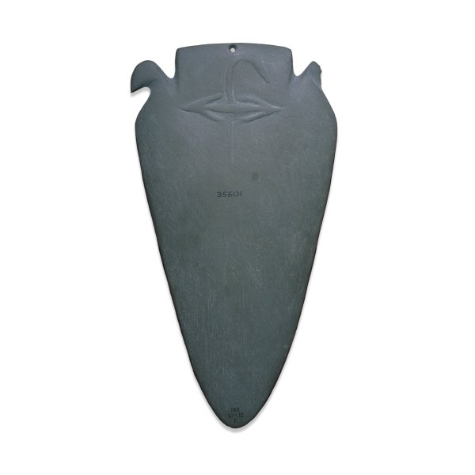

 | wooden planks | P
another type of coffin

Activity: The Hunters Palette Room 64 One sheet

Learning objectives
- Close observation.
- Comparison of two objects.

Before the visit
- Familiarise the pupils with the activity sheet. Remind the pupils that the picture is of a palette which is not in the British Museum and that their job is to make a comparison.
- Point out that the animal names in the box lower left are for labelling the picture.

During the visit
- The activity is best suited to one small group working on it at a time.
- The drawing is of a palette in Oxford. First, the pupils need to label the animals and then find the Hunters Palette and see whether these animals are also shown there. The Hunters Palette is in case 6 near the door leading to room 63.
- Enrich this short activity by discussing points given in the information section and by finding other palettes or items to do with hunting.

Information and guidance
- Palettes were used for grinding the pigments for eye-make-up. The Early Egypt room has several examples of different types of palette. Some of the earlier ones (4000 BC) are very simple, perhaps made in the simplified shape of an animal. Some later palettes are also very simple while other later palettes like the Hunters Palette and the Oxford palette (3100 BC) are highly decorated.
- The strange figure lower left on the Oxford palette is probably a man in an animal suit or mask playing a flute. This may refer to some ritual practice associated either with the use of the palette or the scene depicted.
- The only animals common to both palettes are the lion, the oryx, and perhaps the gazelle. There is a strange two bull-headed creature on the Hunters Palette which the pupils could link with the bull in the picture. The Hunters Palette also has familiar animals: a dog, an ostrich, a deer (with antlers rather than horns) and a hare.
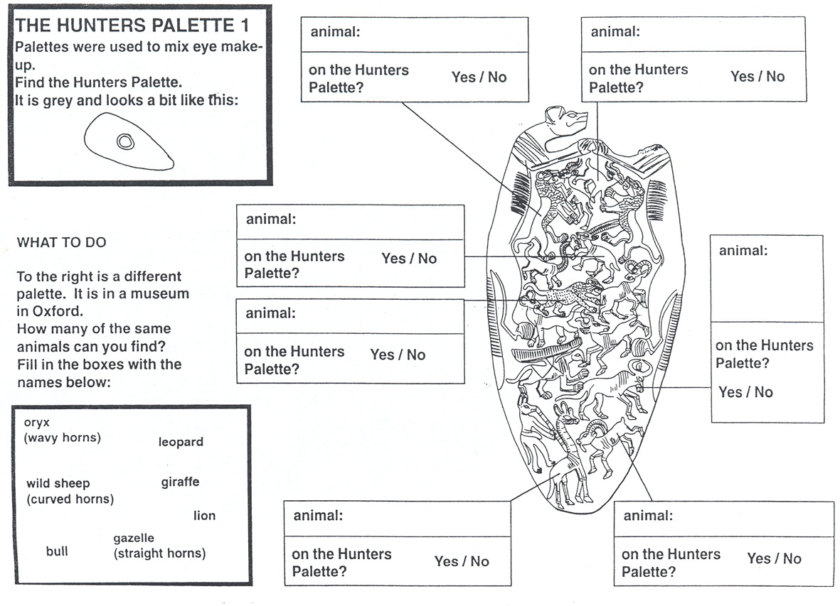

Activity: Imports from Nubia Rooms 65 Two sheets

Learning objectives
- Close observation.
- Build an understanding of the relationship between Egypt and Nubia.
- Understand and begin to appreciate the wealth of the continent of Africa.

Before the visit
- Familiarise pupils with the location of Nubia in relation to Egypt. You might discuss climate or geographic features in order to draw distinctions between the two.
- What distinguishes the materials the pupils will be looking for is that they are luxury items. You may need to discuss this concept along with that of imports.
- Finding evidence of an item requires the pupils to consider what might be associated with the animal or object, or what might be made from an animal's parts.

During the visit
- Pupils look for and tick off items on sheet one.
- Sheet two requires looking in case 1 for evidence of items ticked off on sheet one.

After the visit
- Make a class list of the different pieces of evidence the pupils found. Then divide these into types: the object/material itself; an image of the object; something from which they infer that the object/material was available.
- Explore with the pupils how the materials may have reached Egypt. What might the Egyptians have traded for them? In what other ways could the Egyptians guarantee their supply of these materials - one pertinent example is by conquest.

Imports from Nubia 1

Look at the large painting on the wall.
The right hand part shows animals, valuable goods and captives being brought from Nubia to the pharaoh Ramesses II.
Where is pharaoh Ramesses II ?

Tick if you can find:

an ostrich 

gold rings 

ostrich eggs 

elephant’s tusks 

a monkey 

a leopard skin 

ostrich feathers 

Imports from Nubia 2

Now look on both sides of case 1.
What other evidence can you find for the things you saw in the painting?

ostriches

gold rings

elephant tusks or ivory

anything else

