

ANCIENT EGYPTIAN HIEROGLYPHS
KEY STAGE 2 Starting Points
A Guide for Teachers to Room 4

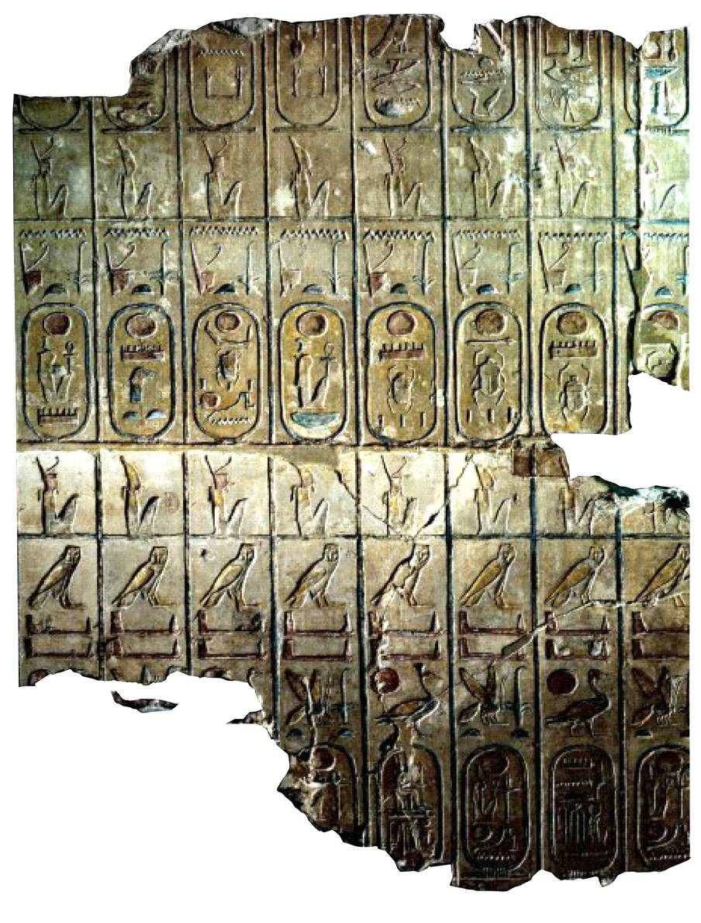

Department of Education and Information Great Russell Street
Telephone +44 (0)20 7323 8851/8850 London WC1B 3DG
Facsimile +44 (0)20 7323 8855 Switchboard +44 (0)20 7323 8000
education@thebritishmuseum.ac.uk www.thebritishmuseum.ac.uk

Please note:

- The Museum is very popular and attracts large crowds. It is important to explain this to the pupils before their visit, so that they can decide to use this public space thoughtfully.

- Please encourage your pupils to behave calmly and to respect the needs and interests of other visitors.

- Many of our galleries serve as main routes to other parts of the British Museum. Pupils should be aware of this so that they can ensure that they do not block pathways themselves or with their possessions. Please remind them not to sit or lie in the main routes through the galleries and that they should never run.

- Before the visit it is advisable to discuss with your class the issue of the display of human remains. In addition to the wrapped mummies, the pupils may see skeletal and other human remains in the Museum. The ethical arguments concerning such displays are an important subject for discussion, but you may also want to take into account the personal circumstances of the pupils.

Feedback:
We would be very grateful for feedback on our materials.

Further Reading:
Adult
Collier, M. & Manley, B. (1998) How to Read Egyptian Hieroglyphs: a step-by step guide to teach yourself British Museum Press.

Davis, W. V. (1987) Reading the Past: Egyptian Hieroglyphs British Museum Press.

Children
Donoughue, C. (1999) The Mystery of the Hieroglyphs: Egyptian hieroglyphs and how they were deciphered British Museum Press

The British Museum
Department of Education and Information

How to Use this Guide
The purpose of this guide is to introduce you to the hieroglyphs carved on the sculptures and give a brief insight into how this complicated system of communications worked. The guide will also help you to locate some of the hieroglyphs in the Egyptian galleries and enable you to identify certain examples in other contexts. We provide here some basic information about hieroglyphs, which may by useful to you in designing activities for the gallery. We also hope that you will be able to use this information to generate questions which could actually be asked of the pupils as they observe the hieroglyphs themselves.

We have supplied some information and tasks for eight sculptures in the gallery.
- The intention is that you can use these discussion notes for adult group leaders.
- You may choose to give each of your groups one or two of the sculptures to focus on.
- Do not give them all eight sculptures to study. Allow the pupils time to tour the gallery with their adult leader, to experience awe and wonder at the sculptures/space and look at or record things which are of interest to them.

The British Museum
Department of Education and Information

Introduction
The ancient Egyptians called their picture writing ‘divine word’ because they believed that Thoth, god of wisdom, had given them the knowledge of how to write. Consequently the signs were full of a magical force which, for example, could bring to life the items shown as the funerary offerings. Today we call Egyptian picture writing hieroglyphs. This word derives from a phrase meaning ‘sacred carvings’ used by the ancient Greek visitors to Egypt to describe the symbols that they saw on tomb and temple walls.

In the repertoire of the Egyptian scribes there were more than 700 hieroglyphic signs. The hieroglyphs were chosen from a wide variety of observed images, for example, people, birds, trees, or buildings. Some signs represent the sounds of the ancient Egyptian language, but indicate consonants only. No vowels were written out. Also, it was not an alphabetic system, since one sign could represent a combination of two or more consonants like the gaming-board hieroglyph which stands for the consonants mn. Egyptologists make the sounds pronounceable by putting an e between the consonants, so mn is read as men. A vast number of other hieroglyphic signs were not pronounced at all but acted as sense indicators, such as a boat following the sound sign dpt which was the word for boat.

Invented in about 3250 BC, hieroglyphs were still used in the early centuries AD but gradually became less and less understood except by temple priests. By the time Egypt officially became a Christian country in the fourth century AD, hieroglyphs were history.
Of course, the Egyptian language continued to be spoken, but it was now written in an alphabetic script called Coptic, the knowledge of which helped Champollion to decipher the hieroglyphs forgotten for almost 2000 years. When the Arabs conquered Egypt in the seventh century AD, they introduced the Arabic language and writing, which you will find used by Egyptians today.

The British Museum
Department of Education and Information

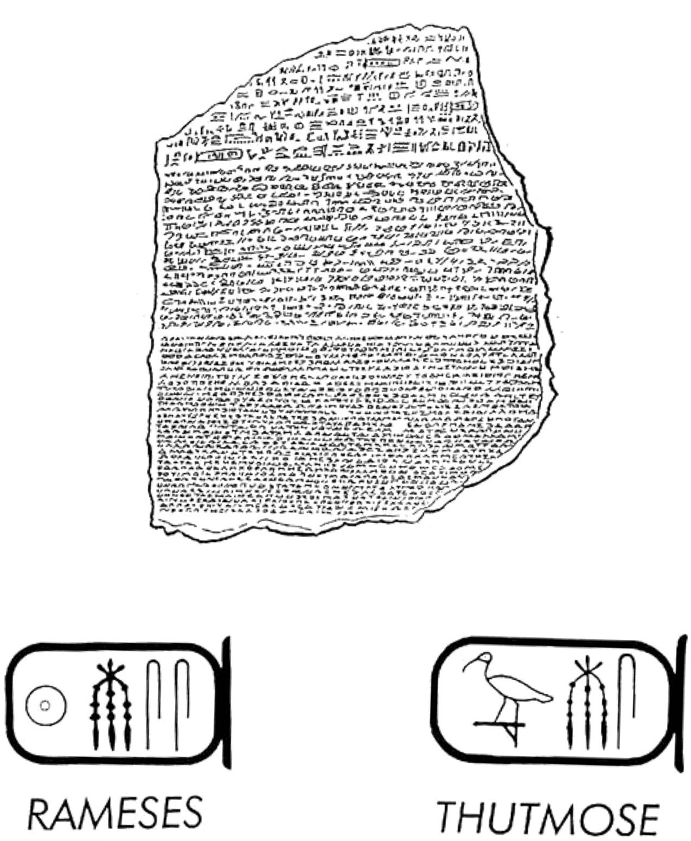

The Rosetta Stone (EA 24)
Date: Ptolemaic Periods -196 BC

One of the British Museum's most famous objects, this slab of granite was the key to the decipherment of hieroglyphs. Discovered in 1799 by Napoleon's troops, the stone is inscribed with the same text in three different kinds of script; hieroglyphs at the top, demotic (a later form of Egyptian writing) in the centre and ancient Greek at the bottom. Since Greek was understood scholars were able to use this language to help decipher the hieroglyphs. Thomas Young was the first person to show that some of the hieroglyphs on the Rosetta Stone wrote the sounds of the royal name Ptolemy, while the Frenchman Jean-Francois Champollion finally deciphered all the hieroglyphs in 1822.

- Draw the outline of the Rosetta Stone, show the position of the three different types of writing.

- Hieroglyphs were written on a wide range of materials. How many different materials are there in Room 4 ?

- As you go through the other galleries, tick the materials on which you find hieroglyphs:

 stone  papyrus

 pottery  plaster

 wood  metal

 cloth  clay

The British Museum
Department of Education and Information

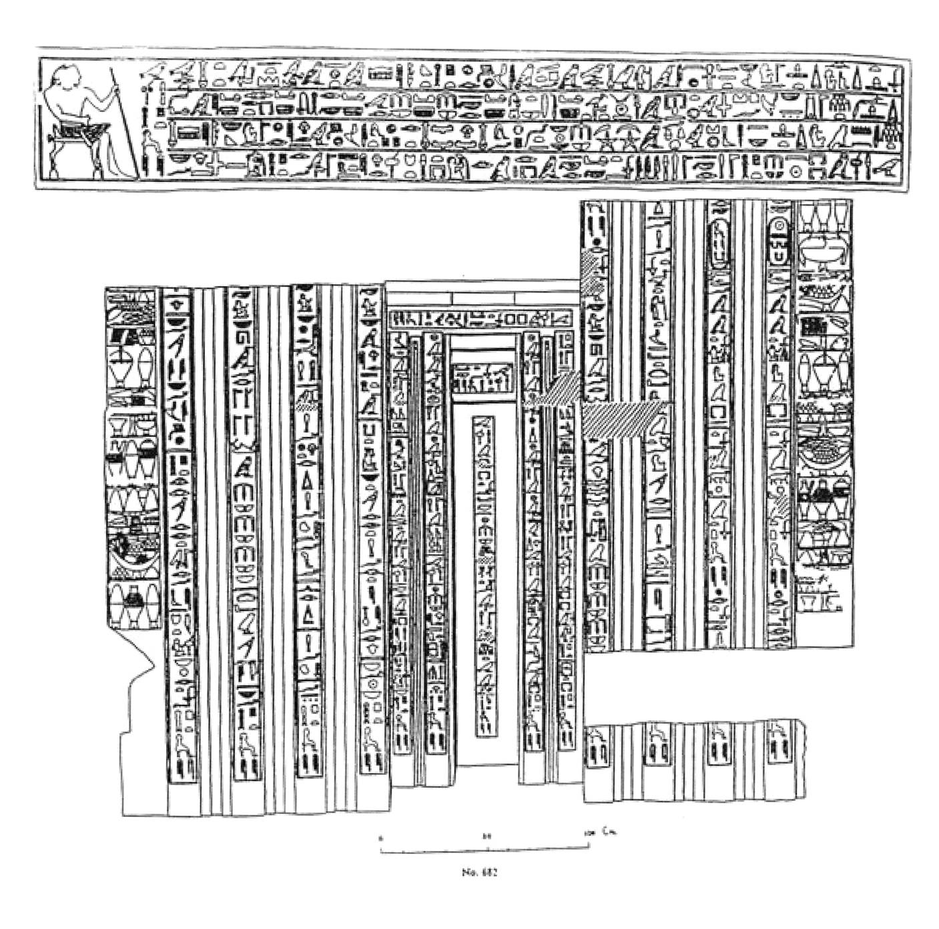

False Door (EA682)
Date: Fifth Dynasty – 2400BC

This huge red door is from the top level of a tomb belonging to a man called Ptahshepses. Through this door, it was believed that his spirit could come up to where offerings were left for him and then return to the burial chamber below.

All around the door are carved hieroglyphs. This is Ptahshepses’ autobiography. To find the beginning of the text, look for a picture you recognise, an animal or a person. Which way do they face? They all point to the start of that section of text. Text could be read in any direction, sometimes changing part way through. On the sides of the door you can see representations of baskets of food; grapes, fresh dates on their stalks, figs, pomegranates and bread. These were used by the deceased for food in case something happened to the offerings left by their relatives.

- Show which direction the humans or animals are facing.

- Use arrows to show the direction in which the text was read.

- Record another example which is different or changes direction.

The British Museum
Department of Education and Information
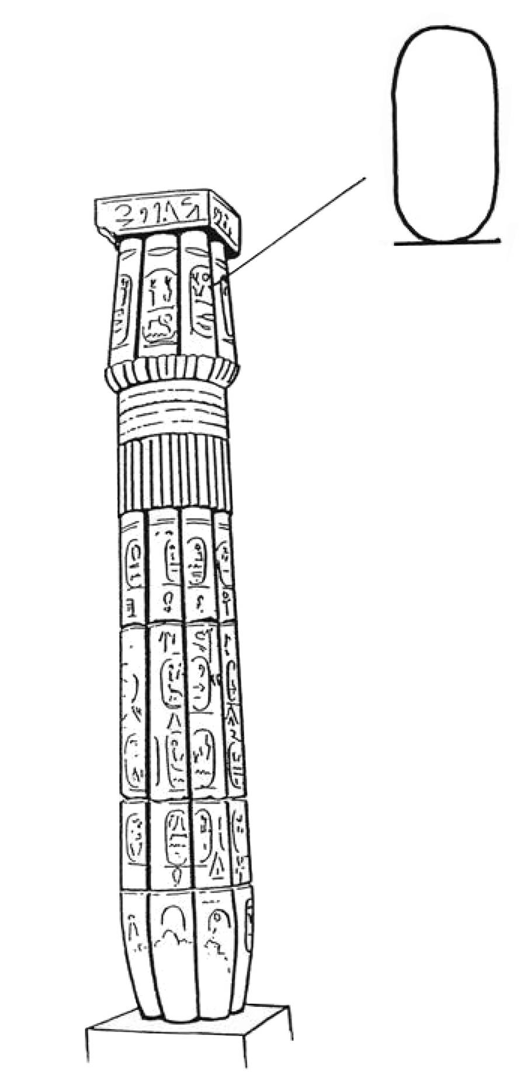

Papyrus Column (EA 64)
Date: Eighteenth Dynasty – about 1390 BC

This column, shaped like a giant bundle of papyrus, was made in the Eighteenth Dynasty. It was later inscribed with the names of the pharaohs. All over the column you can see some hieroglyphs contained within an oval with a line across the base.

This shape is called a ‘cartouche’. The ancient Egyptians placed royal names inside the cartouche probably for a number of reasons. It is thought that the bar is used to represent the flat earth, and the oval is used to show the passage of the sun across the sky each day in the form of the god Ra. It symbolized the power of the pharaohs over everything on which the sun shone. It was also an easy way to highlight royal names in a text.

Draw the column in three stages:
- The whole column, to get the general outline,
- A part or cross-section of the column, to study the papyrus shape,
- A close-up of a detail of the column or its decoration or a cartouche.

- Read the label for the column carefully.
- Write out a new label for the column using no more than 30 words. Use your own ideas and those above to describe it.

The British Museum
Department of Education and Information

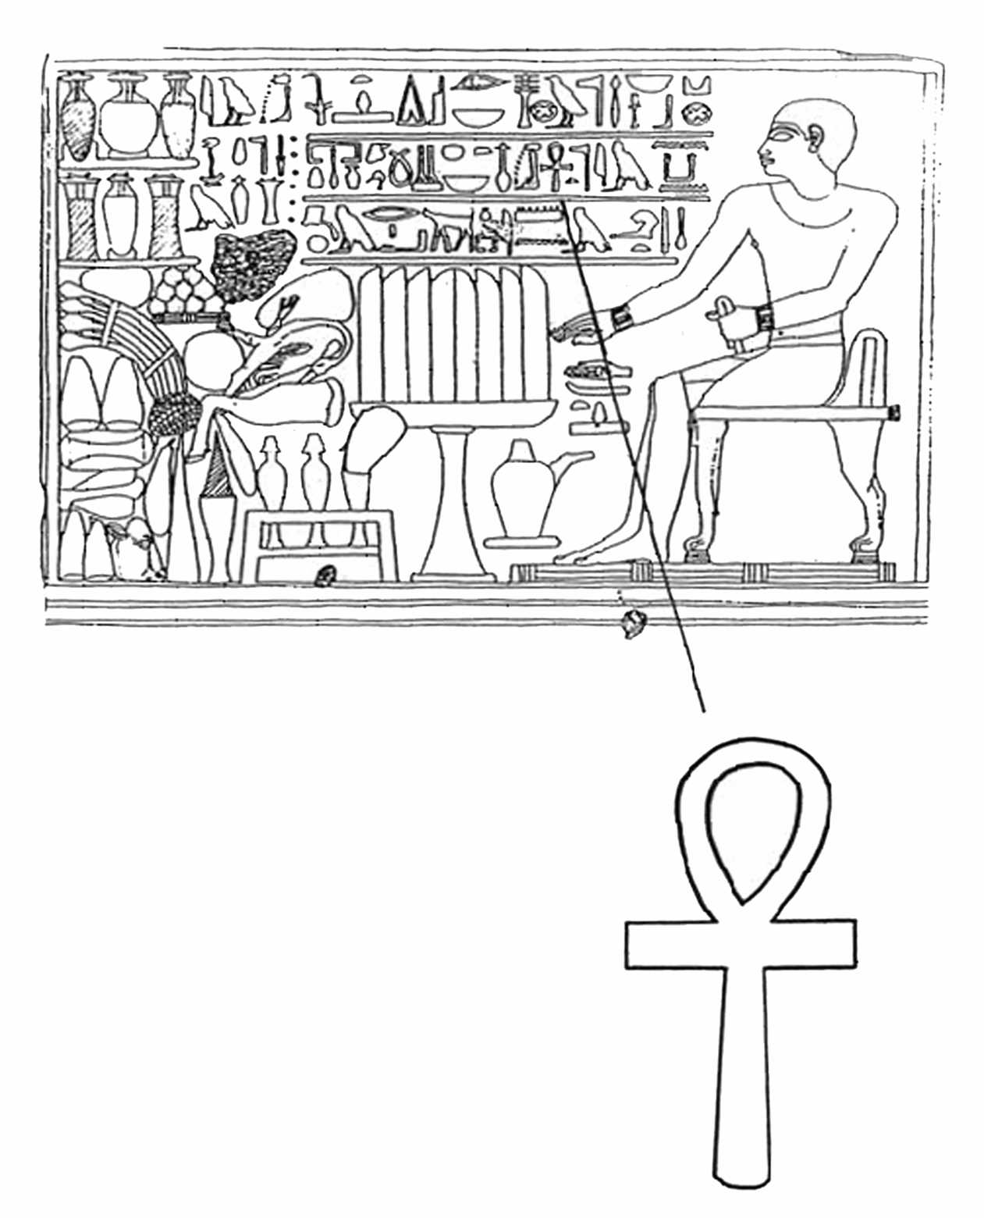

Stela of Amenemhat (EA 587)
Date: Twelfth Dynasty – about 1900 BC

This stela or plaque, carved in low relief, is an example of a common type of burial relief. The dead person was an official called Amenemhat. He is shown sitting down at a table piled high with a feast. The foods are similar to those shown on the other tomb decoration. Look at Amenemhat’s skin, it still has some of the original paint on it. There are three lines of hieroglyphs to the side of Amenemhat. On the second line you will see the symbol enlarged on the illustration. This is called an ankh, and was the hieroglyph for ‘life’.

- Make a list of the food you can identify.

- Can you make a judgement about how healthy the Ancient Egyptian diet was?

- Do you think everyone ate like this all of the time?

- Can you see paint on the stela, where?

- Write a dictionary definition for the word stela.

- Make a tally chart for the number of times you see the ankh sign on the sculptures in Room 4.

The British Museum
Department of Education and Information

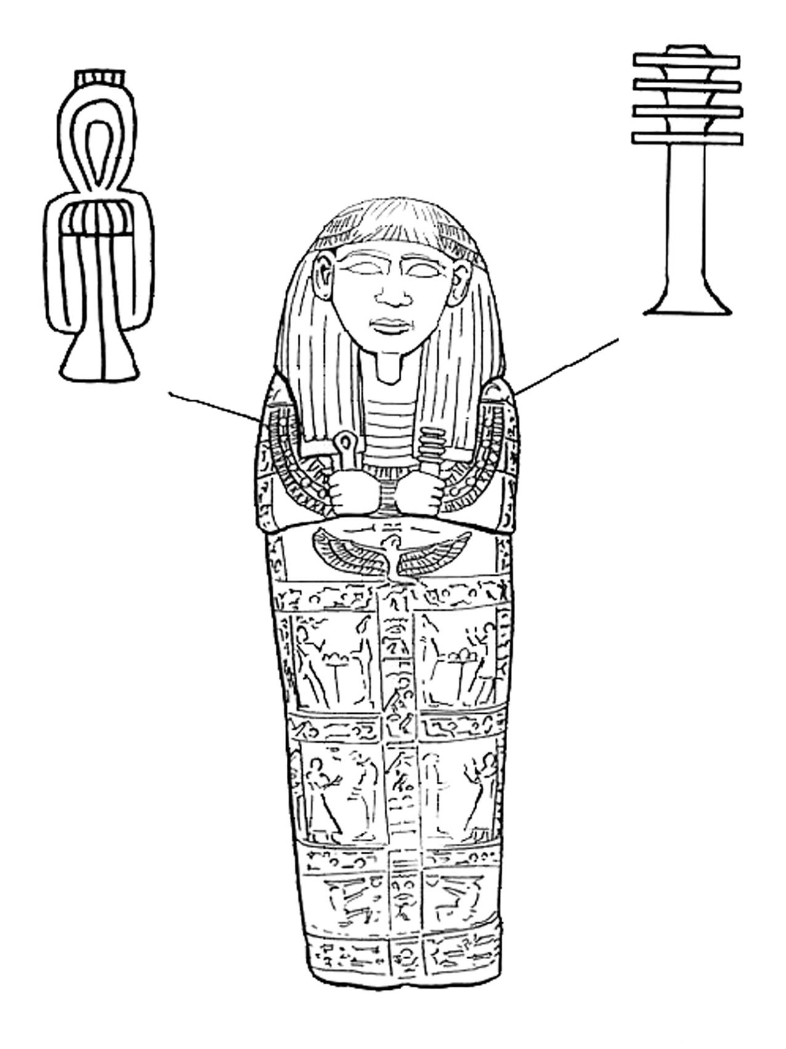

Sarcophagus lid of Setau (EA 78)
Date: Nineteenth Dynasty - around 1230BC

Setau governed Kush, south of ancient Egypt, for the Egyptian pharaohs. This is the lid of his sarcophagus, the large stone box that would have held his coffin. Setau probably didn’t wear a beard when he was alive, but he is shown with one here. This is may have been because Osiris, Lord of the Dead wore a beard.

Setau holds two hieroglyphs that were also used as amulets (symbols with protective powers). In his right hand, he holds the djed pillar, which is one of Osiris' symbols. In his left hand he holds the tyet, a knot shaped hieroglyph, one of the symbols of Isis, the wife of Osiris - be careful, his hands are crossed over!

- Draw the outline of the sarcophagus, draw in the hands.

- Decide which amulet is the djed and which is the tyet. Draw them in and label them.

- Think of other special or religious symbols or amulets you know of, draw and label them.

- Draw in the other figures carved on the lid. How could you find out who they are and why they have been carved here?

The British Museum
Department of Education and Information
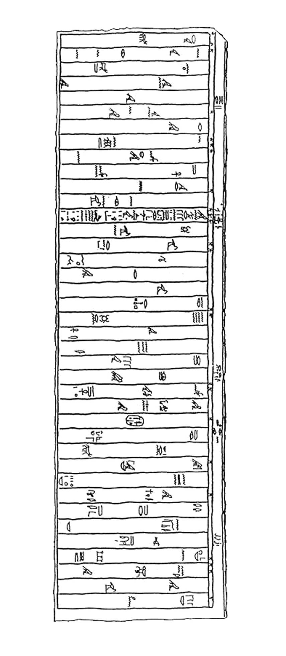

Sarcophagus of Ankhnesneferibre (EA 32)
Date: Twenty-sixth Dynasty - about 525 BC

This is a sarcophagus, which would have contained a coffin. It was originally made for a princess who was a high priestess of Amun, but it was re-used hundreds of years later in the Roman period for another person.

On the lid there is a carving of Ankhnesneferibre, shown dressed as a goddess. During her life each high priestess was the living wife to the god Amun Ra. It was important that a princess and daughter of the royal family held this position, as the priestess was in charge of the Egyptian treasury.

- Look for the cartouche with the name of Ankhnesneferibre.

- Draw the hieroglyphs around it and show the direction of the text where it is written.

- Does the text change direction? How can you tell?

- Why does the text change direction?

- Why does the museum display the sarcophagi in a downstairs gallery, while the coffins and mummies are upstairs? Discuss all of the following: size, shape, weight, material, control of temperature and dampness in the galleries. State and explain your ideas.

The British Museum
Department of Education and Information

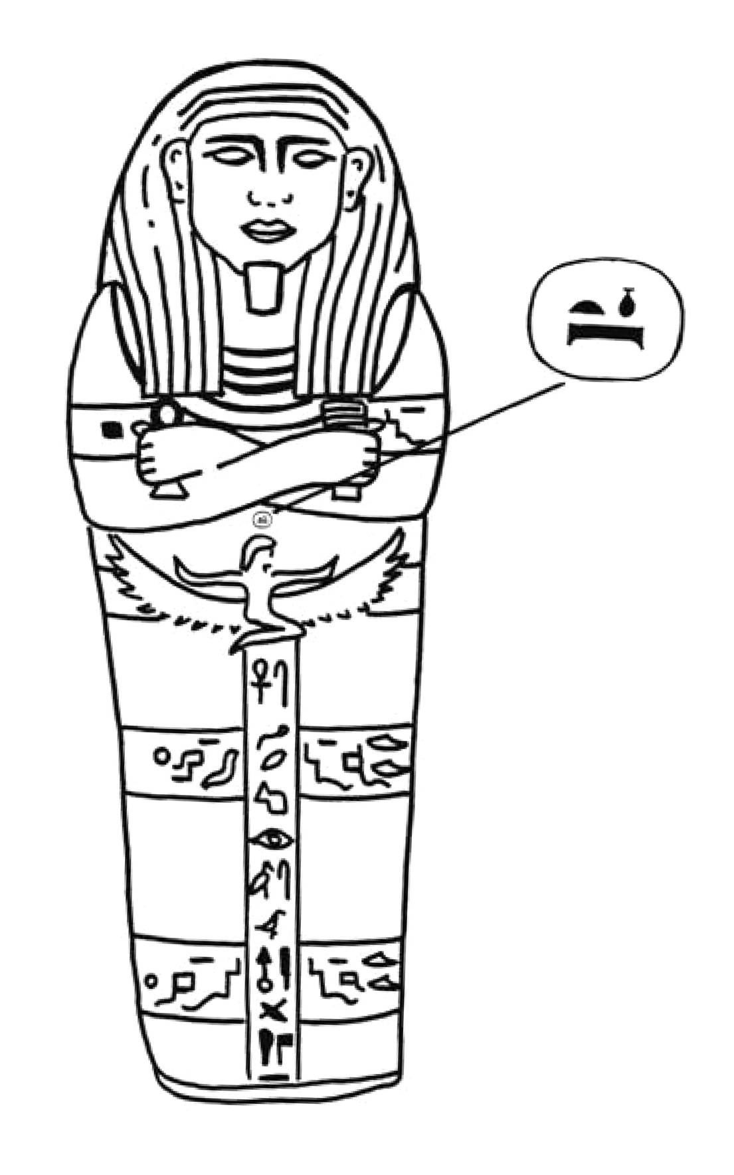

Sarcophagus lid of Sisebik (EA 17)
Date: Twenty-sixth Dynasty - about 525 BC

This sarcophagus was made of a black stone called schist. It was made for a minister called Sisebik. He holds two amulets in his hands. The winged woman carved below his hand is the goddess Nut. Her name is carved above her head. Nut was the sky goddess. She is connected with re-birth, and therefore the afterlife. It was believed that she swallowed the sun every night (sunset) and gave birth to it in the morning (dawn).

She is often shown on coffins, sarcophagi and other burial equipment.

- Look closely at the sarcophagus.

- Can you see the circle on top of Nut's head? What do you think it
might mean?

- Copy the circle and the signs, and write a label, explaining what it says.

- Think about the Sisebik's choice of stone. Consider all of the following: price, local or foreign stone, distance transported and transport cost, common or unusual, favourite colour, easy or hard to carve.

The British Museum
Department of Education and Information
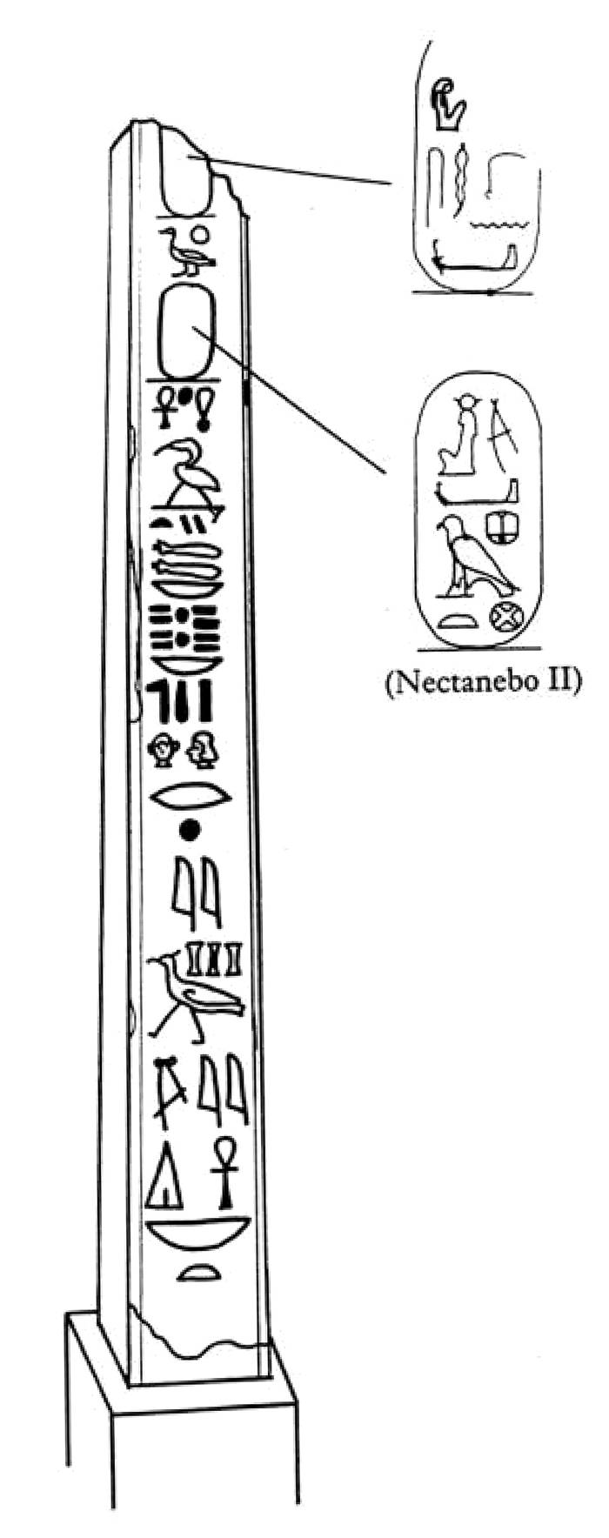

Obelisks (EA 523-524) (at the southern end of the Great Court)
Date: Thirteenth Dynasty - about 350 BC

This is one of two obelisks, or decorative columns, which once stood in front of a temple to Thoth, the god of wisdom and writing. They were ordered by the pharaoh Nectanebo II. They are made of black schist stone, which shows detailed carvings clearly.

- Can you see the cartouches with the name of the pharaoh in them?

- Draw and label the cartouche with the name of the pharaoh.

- What other symbols can you recognise?

- The god Thoth is often represented by the sacred ibis. Can you find a picture of this bird on the obelisk?

- Draw and label Thoth's sacred ibis.

The British Museum
Department of Education and Information
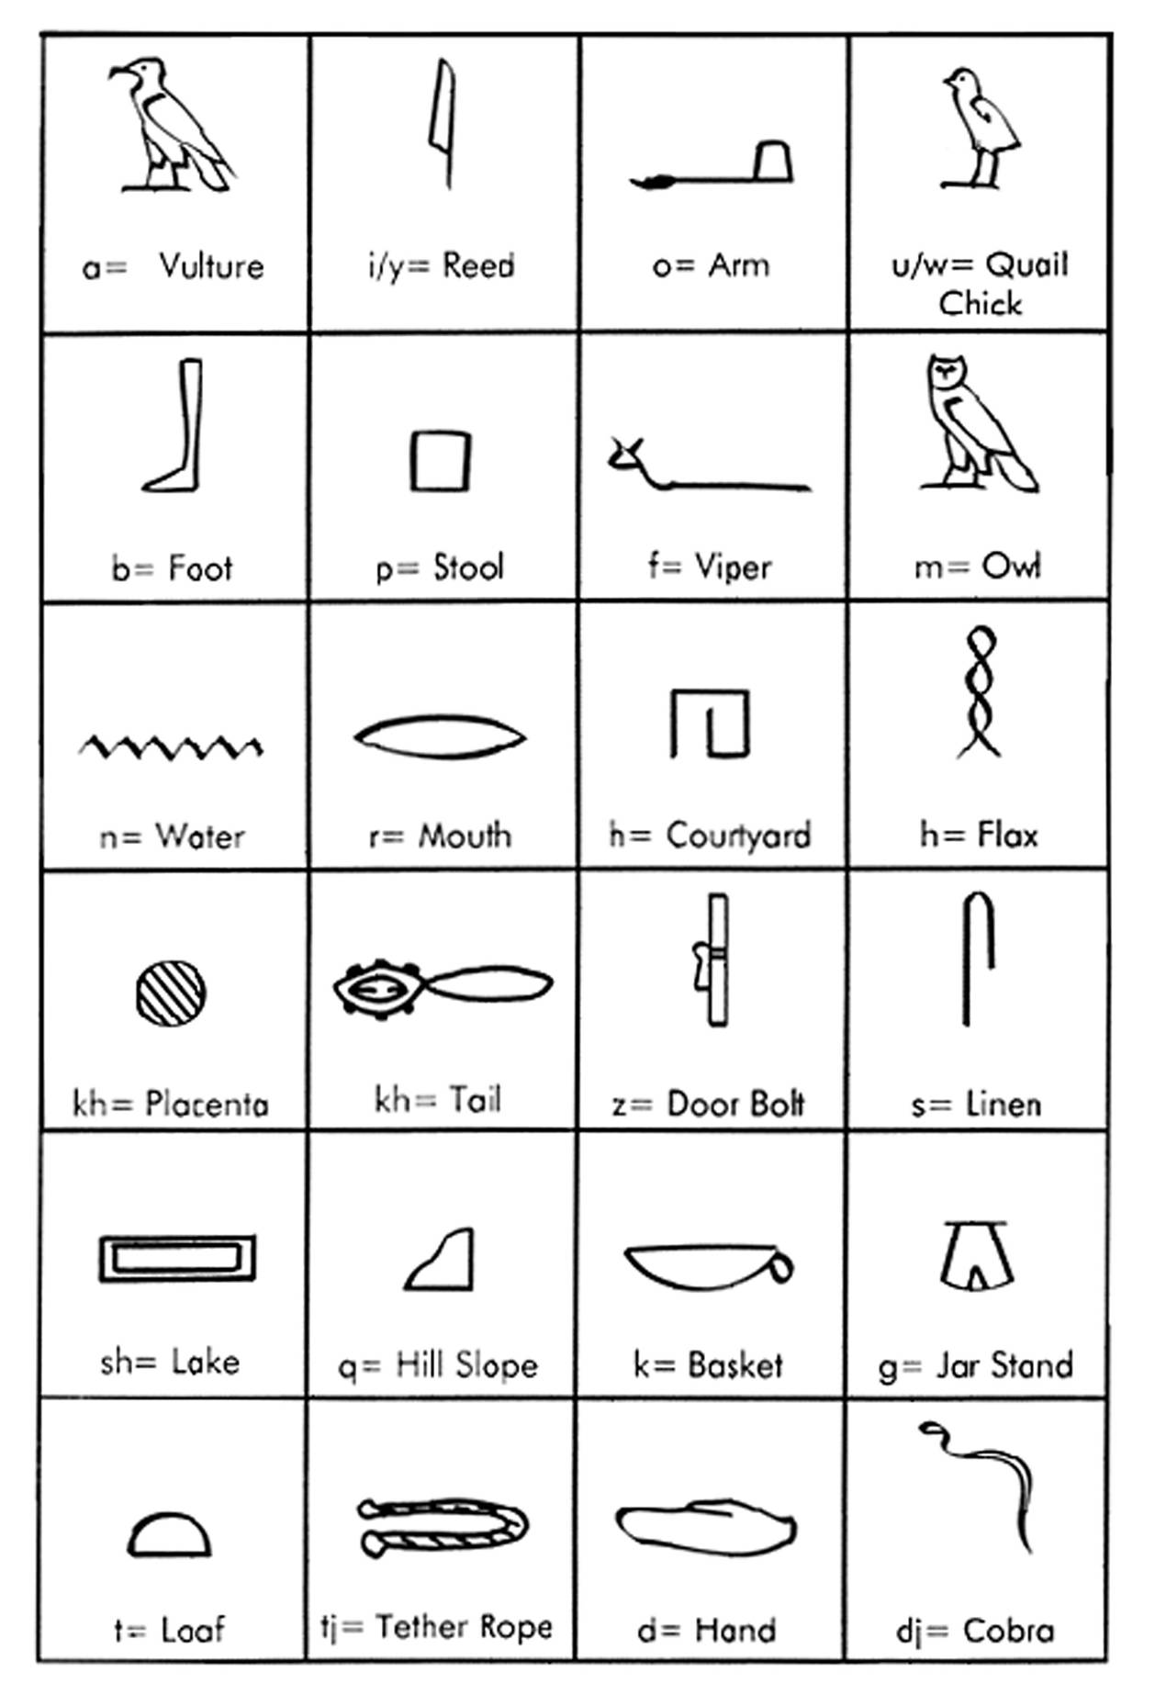
Table of Alphabetic Hieroglyphs

