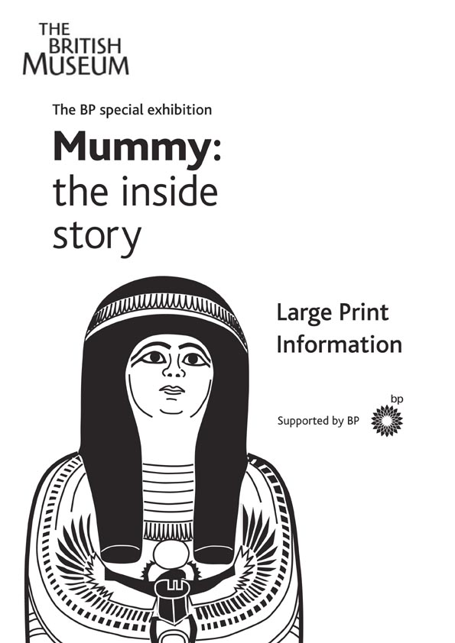
Discover the secrets of
a 3000 year old mummy.

‘O you who are alive on earth,
I speak to you of what happened to me.’
From the tomb of Petosiris at Hermopolis, Egypt.

Nesperennub, a priest of Karnak, died 3000 years ago and his body was preserved for his journey to the after-life. His sealed mummy case will never be opened, but data obtained by using a CT scanner has been transformed into a three dimensional virtual mummy.

Sir Ian McKellen narrates a film describing an amazing journey from the outer casing of the mummy to its body inside.
The extraordinary visual effects of the three dimensional film give the impression that a real mummy case is looming out of the screen, then hovering and turning in mid-air. Pictorial signs or hieroglyphs identifying the occupant are painted onto the smooth outer coffin. As the priest’s name is spelt out, the hieroglyphs which represent the letters appear to detach themselves from the screen and fly out into the auditorium.
Nes-s-per-en-nub (the hieroglyphic signs are not all alphabetic, so only five signs are used to write the name).
Echoing the swaddled shape of the preserved body within,
the mummy case and outer coffin are painted to resemble a figure. Inside the mummy case we delve beneath the layers of linen bandages and discover the significance of objects
concealed between the wrappings. We explore the body cavity, zooming at speed through the skeleton and even inside the bones themselves.

Measurements taken from the skull have enabled scientists
to recreate the face of Nesperennub. An actor bearing a strong resemblance to him brings the priest dramatically to life as he performs his daily tasks around the temple. After death his embalmers preserve his body, enclosing it inside the mummy case. We plunge down a vertical shaft to the secret chamber where the mummy is eventually laid to rest.

In room one there is a narrated introduction followed by the film in the main auditorium. In a third room, the outer coffin and the decorated mummy case are on display. The attendants present can describe these to visually impaired visitors. They have examples of Egyptian hieroglyphs and artefacts for handling. Please make it clear at the entrance that you are interested in this aspect of the exhibition.

‘Life on earth passes; it is not long;
being remembered is the only success.’
From the teaching of King Merikare, around 1800 BC
The exhibition is situated above the Reading Room in the middle of the Great Court, which is directly ahead as you enter the Museum from Great Russell Street.

Access is up four flights of steps or by lift located on the left hand side of the Reading Room. Guide dogs are welcome.

Tickets should be bought in advance from the box office,
to the right as you enter the Great Court, or booked by
telephone (see below). Concessions £3.

There will be a special handling session with the curator of the exhibition, John Taylor, on 19 February 2005 from 10.30 to 12.00.

For further information please contact the Box Office on
020 7323 8181.

