

Anglo-Saxons
Gallery Activities

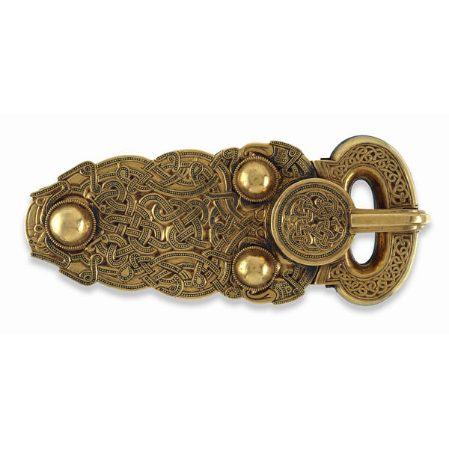

Department of Education and Information Great Russell Street
Telephone +44 (0)20 7323 8851/8850 London WC1B 3DG
Facsimile +44 (0)20 7323 8855 Switchboard +44 (0)20 7323 8000
education@thebritishmuseum.ac.uk www.thebritishmuseum.ac.uk

Contents

Gallery activities: notes for teachers

When you visit the Museum

Gallery activities
- Ship burials
- Beliefs about Life and Death
- The Sutton Hoo ship burial
- Old and New

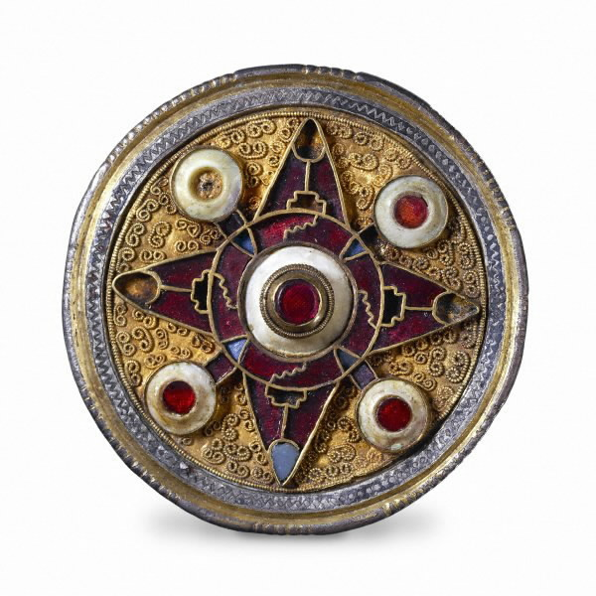

Anglo-Saxon brooch, late 6th century AD

Gallery activities: notes for teachers

- The activities help pupils to develop gallery skills and literacy skills in tandem. They encourage the pupils to scan the displays, select objects and then look at them and their labelling in detail. The activities help to focus the note taking and annotated drawings which many schools already undertake.

- The activities encourage pupils not to follow a fixed route around the exhibits. This means that the pupils are distributed across the gallery space, helping to avoid congestion in the crowded galleries.

- Select enough activities to fit the objectives of your visit, but do give the pupils enough time for thought and wonder.

- Use this pack in conjunction with the general Museum Activities booklet.

- We strongly recommend that you come on a preliminary visit to check the activities on site.

- This approach to visiting will help you use the galleries to their best effect, but it does require preparation before the visit and perhaps some changes to the way in which you might use helpers who come with you.

- Some of the activities fit with the schemes of work on The Anglo-Saxons issued by QCA.

The gold buckle from the Sutton Hoo ship burial, Anglo-Saxon, 7th century AD.
When you visit the museum

- Before you leave the Ford Centre for Young Visitors, remind the pupils what tasks you plan to undertake on return to school, and the importance of the quality of their research in the museum for completing the school based tasks.

- Remind the pupils that what they are looking at what has survived in the ground for over 1400 years.

- Tell the pupils that some objects which were made of more than one material have been reconstructed, but others, namely the wholly organic objects, e.g. the textiles, are a mystery.

- Supply your helpers with a couple of prompting questions to help keep pupils on task together with some extension questions for those who need it.

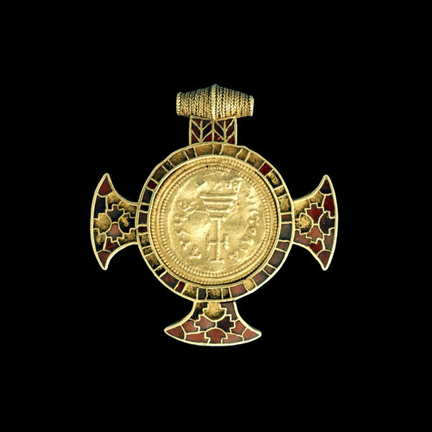

The Wilton Cross, Anglo-Saxon, 7th century AD

Ship Burials

- Study the objects from the Sutton Hoo burial and the Taplow burial.
- Record up to 4 objects on display from both burials.
- Play close attention to: the shape, colour, possible use, materials the objects are made from and the decoration.
- Compare similarities and the differences between objects.

Record your 4 objects from the Use these boxes to compare Record your 4 objects from the
Taplow Burial similarities and differences. Sutton Hoo Burial

1 |  | 1 |  | 1
2 |  | 2 |  | 2
3 |  | 3 |  | 3
4 |  | 4 |  | 4

Name: Date:
Beliefs about death

- The Anglo-Saxons held beliefs about life after death.

Record an object from a burial which provides evidence for the statements on
the right.

You will need to impress people with
your wealth.

The strength and skills of a warrior are
still important.

Life after death mirrors life before death:
you keep your place in society.

Your time in the afterlife is spent with
other people: there are feasts to go to.

Name: Date:

The Sutton Hoo ship burial

- Here is an artist’s impression of how the Sutton Hoo burial looked.

- Choose 5 objects from the drawing and circle them.

- Find the 5 objects in the gallery cases.

Record how they appear now.

Link you sketches and notes to the matching object in the picture.

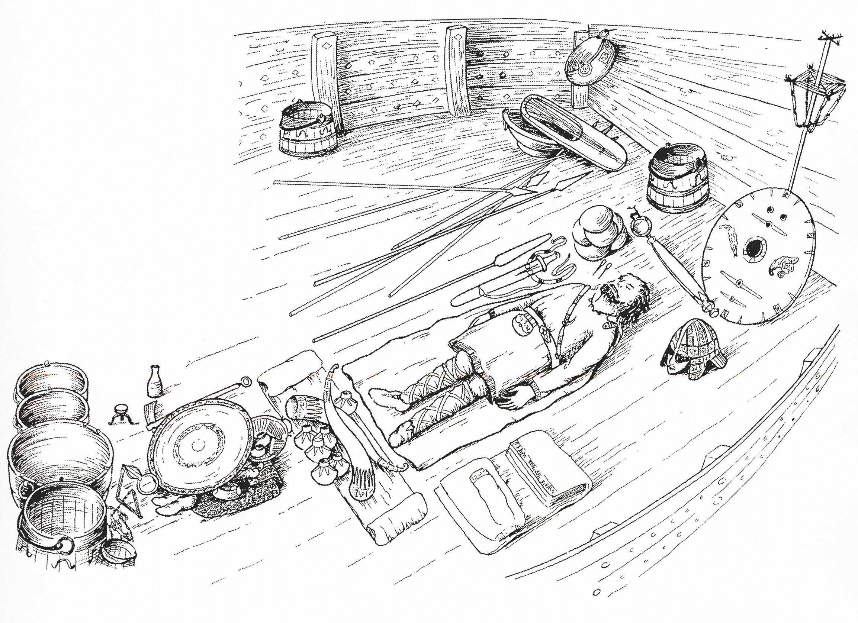

- Which of the objects have not survived?

- Which materials have survived the best?

Name: Date:
Old and New
Compare an original object and a reconstruction.
- The famous Sutton Hoo helmet was in poor condition when it was excavated in 1939.
- Archaeologists studied it closely to work out the original shape and decoration.
- Drawings and models were made to show how the helmet may have looked.

- Pieces of the original helmet. Use these boxes to make notes Archaeological reconstruction.
about similarities and differences.
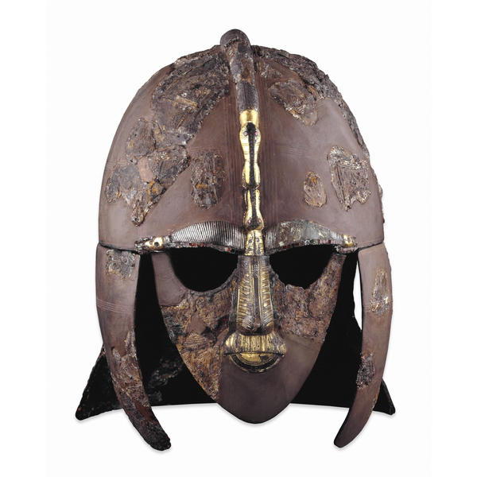 |  | Similarities  Differences |  | 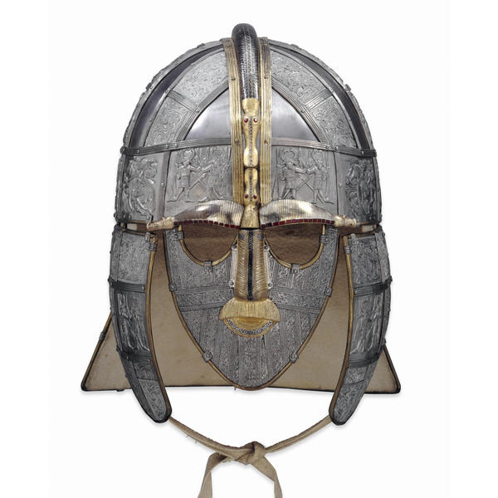

Name: Date:

Anglo-Saxon Bibliography
Adult Interest
Black, J. 2000 A New History of England Sutton Publishing
Bruce-Mitford, R.L.S. The Sutton Hoo Ship Burial: A Handbook British Museum Press
1968

Care Evans, A 1994 The Sutton Hoo Ship Burial * British Museum Press

Carver, M. 1998 Sutton Hoo: Burial of Kings British Museum Press

Carver, M. (ed) 1999 The Age of Sutton Hoo * The Boydell Press

Clarke, H. 1984 The Archaeology of Medieval England British Museum Press

Heaney, S. 1999 Beowulf Faber and Faber

Hinton, D.A. 1990 Archaeology, Economy and Society: Routledge
England from the fifth to the fifteenth
century (Chapter 7 onwards)

Lang, J. 1988 Anglo-Saxon Sculpture Shire Archaeology

Page, R.I. 1987 Reading the Past: Runes British Museum Press

Strong, R. 1998 The Story of Britain: A People’s History Pimlico

Wilson, E. 1998 Early Medieval Designs from Britain British Museum Press

Teaching Resources

East, K. 1982 A King’s Treasure Kestrel

Loverance, R. 1992 The Anglo-Saxons (Zig-Zag) BBC Fact Finders

Mason, J. 1991 Sense of History: The Anglo Saxons Longman

Reeve, J. & Chattington, J. The Anglo-Saxons Activity Book British Museum Press
1999

Sharman, M. 1995 Britain through the Ages: Anglo-Saxons Evans

*recommended

Useful Web Addresses

Education Department homepage with full details for planning visits, resources and programmes and events.
www.thebritishmuseum.ac.uk/education

Children’s COMPASS: Take a virtual tour of Anglo-Saxon England based on the objects from the British Museum. Using the search facility to find out about different aspects of everyday life in Anglo-Saxon times.
www.thebritishmuseum.ac.uk/children’scompass

COMPASS: The British Museum’s collections on the web.
www.thebritishmuseum.ac.uk/compass/

Archaeology
Council for British Archaeology website.
www.britarch.ac.uk

Map of Anglo-Saxon England
www.georgetown.edu/cball/oe/oe-map.html

Information about English Heritage sites, resources and services, including those related to the Anglo-Saxons.
www.english-heritage.org.uk

Anglo-Saxon Britain, the Viking raids and the Norman invasion. History and maps.
www.great-britain.co.uk/history/ang-sax.htm

Introduction to the West Stow Country Park and Anglo-Saxon Village. Living History Park.
www.stedmunds.co.uk/west_stow

Recreations of the Sutton Hoo Ship.
www.natmus.min.dk/nmf/nb/8/english/art6.htm

On line live tour of the Sutton Hoo cemetery by the Sutton Hoo Society.
Visitor information and teacher’s notes.
www.suttonhoo.org

BBC History website on the Anglo-Saxons.
www.bbc.co.uk/history/ancient/anglo_saxons/

Anglo – Saxon England Time Line
1st
century
AD
2nd
century
AD
3rd
century
4th
century
5th
century
6th
century
7th
century
8th
century
9th
century
10th
century
11th
century

43 The Roman Emperor, Claudius, invades Britain and incorporates it into the Empire. Colchester is set up as a centre of Roman administration.

122 The Roman Emperor, Hadrian, orders a wall to be built to separate the Romans from the barbarians in the Northern Britannia (notably the Caledonians)

270s-280s Saxon Shore Forts built to prevent Saxon invaders landing on the British Coastline.

407-11 The Roman Emperor, Constantine III, takes the field army of Britain to the Continent to fight continental barbarians and to support his claim on the Empire. This leaves Britain with fewer troops, mostly on the frontiers.
c. 410 After the barbarian raids on the Continent, Britain is cut off from Roman rule and the Roman administration and military organisation of the province collapses.
c. 450 First Anglo-Saxon settlements in Kent; records of leadership from Hengist and Horsa.

c. 500 At the Battle of Badon (probably in the West Country), the Romano-Britons defeat the incoming Anglo-Saxons and temporarily halt Anglo-Saxon expansion into western Britain.
567 St Augustine converts King Ethelbert of Kent to Christianity.

600 Anglo- Saxons control most of central and western England.
625 the Ship Burial at Sutton Hoo, probably of King Redwald.
635 Aidan founds the monastery on Lindisfarne.

760 Offa causes a dyke to be built between England and Wales.
793 The Vikings raid the monastery on Lindisfarne.

850 Vikings make permanent settlements in Britain.
867 Vikings establish the Kingdom of York.
878 Guthrum and the Danes agree to leave Wessex after Alfred defeats then at the Battle of Eddington.

991 Battle of Maldon, Essex, Vikings defeat the Anglo-Saxons.
994 Danish raids led by King Sweyn.

1016 Canute the Dane becomes King of England.
1066 William of Normandy becomes King of England.

Sutton Hoo Excavation Time Line
6th
century
AD
c. 600
c. 625
c. 640
Mid-7th
century
onwards
late16th
century
17th – 19th
century
1938
1939
1965/7
1967/71
1973
1983/92
2000

800m north of the royal cemetery an early burial containing the graves of men and women from a local settlement; some men buried with swords and shields, possibly denoting warrior status.

Foundation of royal cemetery; first graves.

Mound 1 ship burial; Mound 2 chamber burial.

Abandonment of cemetery by Christian rulers.

Judicial executions with burial of criminals in and adjacent to royal cemetery.

Robber pit dug into Mound 1, just missing burial deposit.

Mounds 2, 3, 4, 5, 6, 7, 14 and 18 ransacked.

June/July: Basil Brown opens 3 mounds: Mound 3, a cremation on a wooden platform, Mound 2, an inhumation in a burial chamber with a boat placed over the top, Mound 4, a cremation placed in a bronze bowl.

May/June: Basil Brown begins to excavate Mound 1 and finds remains of large ship and an undisturbed burial chamber.
July: small team excavates the contents of the burial chamber.
August: the Science Museum records the ship.
September: war breaks out in Europe.

A British Museum team surveys the cemetery, opens ship trench and records remains of ship and ship trench.

The remains of Mound 1 and the spoil heaps from 1939 are excavated.
Mound 5 is examined and the first sand-bodies are excavated.
Traces of the underlying Prehistoric landscape are recorded.

Mound 1 rebuilt to its original profile and diameter.

The Sutton Hoo Excavation Research Project excavates Mound 2, 5, 6, 7, 14, 17 and 18. All, with the exception of Mound 17, are robbed. Mound 2 established as a chamber grave with a boat placed over it. Prehistoric landscape revealed with mounds placed in association with it. Two groups of sand-bodies, one around the skirt of mound 5 and one on the eastern edge of the cemetery are excavated and interpreted as judicial killings associated perhaps with a gallows on the site.

Excavations by the National Trust beneath the area of a new visitor centre 800m north of the royal cemetery reveal a burial ground (6th century) which appears to have been for the graves of men and women from a local settlement.

