News of Dr Rabi’a al-Qaisi’s death
4 November 2003
Dr Rabi’a Mahmud Sami al-Qaisi died in a car crash in Jordan on 3 November 2003 on his way to Paris to attend the opening on 5 November of the new Hammurabi Gallery at the Louvre. Dr Rabi’a was born in 1941 and had served with the Antiquities Service in Iraq for over thirty years. Among the sites he excavated was Tell es-Sawwan near Samarra. He was Director of Excavations, had been Acting Director General of Antiquities and had recently been appointed President of the State Board of Antiquities and Heritage. He was a good and experienced colleague, and a very generous, dependable and genuine person. Dr Rabi’a had attended a conference on Nimrud at The British Museum in March 2002 and was present at the Rencontre Assyriologique Internationale at The British Museum in July 2004 (qv).
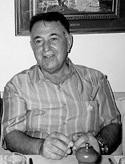
Photograph taken at a dinner party
in London on 10 July 2003 during the Rencontre.
(reproduced courtesy of
Dr Barabara A. Porter).

