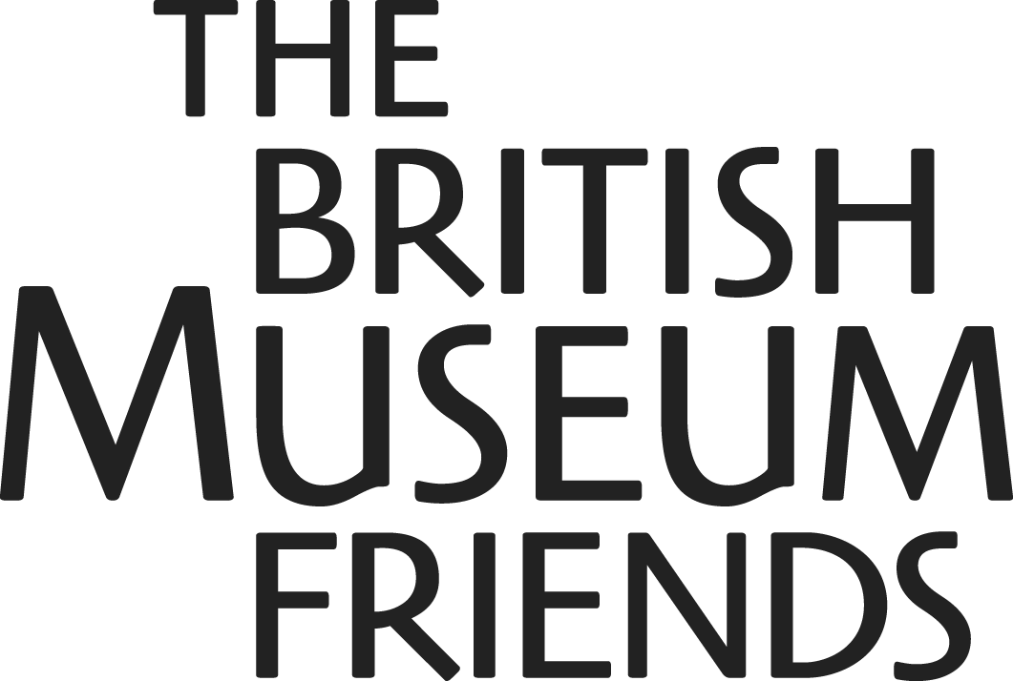

The British Museum Friends

Annual Report

Financial statements for the year ended 31 March 2002

Registered Charity No. 1086080

The British Museum Friends Objectives

The Friends’ objective is to support The British Museum in maintaining and expanding its collections and its services to scholars and the general public. It achieves this by encouraging as many people as possible from all walks of life to become members. Success in these activities requires the Friends’ Council and staff to be highly professional in all they do.

The Friends support The British Museum by:
- Making financial grants
- Recruiting and deploying volunteers
- Publishing the British Museum Magazine and ReMUS magazine
- Encouraging members of the Friends to make supplementary donations and legacies

The Friends support members by:
- Providing opportunities for members to get closer to the collections and curators in order to better understand the work and function of the Museum
- Arranging programmes of educational events and activities for adults and members of the Young Friends
- Publishing the Magazine for adult Friends and ReMUS for Young Friends
- Providing a member’s room service in the East Residence

The Friends work for the benefit of the British Museum. Close working relationships are maintained with appropriate Museum staff in all the work of the Friends - whether this is for the organisation of events and activities or the publishing of the Magazine and ReMUS.

Address The British Museum Friends
Great Russell Street
London WC1B 3DG

Registered Charity No. 1086080

Bankers National Westminster
PO Box 158
214 High Holborn
London WC1V 7BX

Auditors Kingston Smith
Devonshire House
60 Goswell Street
London EC1M 7AD

Investment Managers
Merril Lynch Fund Managers Limited
33 King William Street
London EC4R 9AS

Deutsche Asset Management Limited
20 Finsbury Circus
London EC2M 1NB

The British Museum Friends

Notice of 2nd Annual General Meeting

To be held on Tuesday, 19th November 2002, in the BP Lecture Theatre,
The British Museum.

Agenda

1 Approval of minutes of 1st Annual General Meeting (32nd Annual Meeting of the Friends)

2 Chairman’s Report

3 Approval of Accounts for the year ended 31st March 2002

4 Elections

4.1 Election of New Members of the Council

- Brendan Finucane
- Dr J D Hill
- Andrew Thatcher

4.2 Re-election of Members of the Council

- Griselda Bear
- Lesley King-Lewis
- Patti White
- Hilary Williams

5 Any Other Business

After the formal meeting, Neil MacGregor, the new Director of The British Museum, will give a presentation on his vision for the BM and the plans for marking the 250th Anniversary in 2003. We hope that you will have time to join the Council for a glass of wine after this presentation.

The British Museum Friends Council

Nicholas Barber Chairman and Trustee of the BM (appointed 1992)
Dudley Buchanan Deputy Chairman (re-elected Nov. 2001)
Richard Allan Hon. Treasurer (re-elected Nov. 2000)
Kusuma Barnett Volunteers Organiser, BMF and BM (re-elected Nov. 2000)
Griselda Bear Fundraising Consultant (due for re-election Nov. 2002)
Chris Beetles Art Dealer (appointed Nov. 2001, resigned March 2002
Andrew Burnett Keeper, Dept of Coins & Medals, BM (re-elected Nov. 2001)
Jean Carr Management Consultant (resigned June 2002)
Elizabeth Dalkeith Trustee of the BM (appointed 1999)
Jessica Harrison-Hall Special Assistant in the Directorate, BM (resigned Nov. 2002)
Geoffrey House Head of Exhibitions, BM (re-elected Nov 2001)
Lesley King-Lewis Chief Executive, Action on Addiction (due for re-election Nov. 2002)
Henrietta McCall Curator, Dept. of the Ancient Near East, BM (re-elected Nov. 2001)
Ian Plenderleith Banker (re-elected Nov. 2000)
Hugh Purcell Film Maker (appointed Nov. 2001)
John Robins Chairman, Austin Reed (appointed Nov. 2001)
Sarah Stowell Solicitor, Bircham Dyson Bell (re-elected Nov. 2000)
Jeremy Taylor Chairman, Townley Group (re-elected Nov. 2001)
Kate Trevelyan Managing Director, Burlington Magazine (appointed Nov. 2001)
Patti White Chairman, Young Friends (due for re-election Nov. 2002)
Hilary Williams Art History Officer, Education Department, BM (due for re-election Nov. 2002)
Patrick Wright Managing Director, British Museum Company
(resigned Nov. 2001)

The British Museum Friends is a charity in the form of a limited company and the members of the Council are Directors of the Company. All but two members of the Council are elected at the Annual General Meetings, the remaining two being British Museum Trustees who are appointed by the Trustees of The British Museum.

Staff Head of BMF Margaret Fenn
Finance Manager Roger Halford
Membership Manager Vasilis Gialias
Membership Coordinator Frances Bowcock
Membership Coordinator Gavin Davies
Events Manager Joanne Webb
Events Coordinator, Adult Members David Dinnage
Events Coordinator, Young Friends Victoria Thompson

Volunteers Coordinator Kusuma Barnett
Magazine Editor Anna Lethbridge

Membership of Committees (* denotes Council Member)

Finance Richard Allan (Chairman)*, Nicholas Barber*, Dudley Buchanan*

Fundraising Griselda Bear (Chairman)*, Nicholas Barber*, Kusuma Barnett*,
Dr Andrew Burnett*, Lady Heap, Kirsten Jarvis, Lesley King-Lewis*, Henrietta McCall*, Mollie Norwich, Jeremy H Taylor*, Patti White*, John Yatchisin.

Magazine Kate Trevelyan (Chairman)*, Nicholas Barber*, Elizabeth Dalkeith*, Anna Lethbridge, Tony Logie, Thomas Manns, Andrew Thatcher*, Jonathan Williams

Townley Group Jeremy Taylor (Chairman)*, Nicholas Barber*, Griselda Bear*, Lord Egremont, Lady Heap, Rodney Little, Geoff Low, Henrietta McCall*, Judith Nugée, Ian Plenderleith*, Prof. Michael Rogers, Christopher Taylor, Sir Simon Towneley, Lady Trend, Jeremy Willoughby, Frank Woods

Young Friends Patti White (Chairman)*, Cleo Whittaker, Janna Spark, Bekky Moran, Delia Pemberton, Alison Bodley, Katie Opposs (13/14 years), Aram Karakashian (12/13 years), Ben Ryan (under 12 years)

This report complies fully with the Statement of Recommended Practice for Charities,
has been prepared in accordance with the provision of the Companies Act 1985, and is
in accordance with the Friends’ Memorandum and Articles of Association.

As reflected in last year’s report the Friends organisation became a company limited by guarantee in December 2000. This company acquired the assets and liabilities of the previous unincorporated organisation on 1 April 2001 and consequently the accounts on pages xx are the first of the newly formed company. For the purposes of comparison the previous year’s figures of the unincorporated body have been included in these accounts.

The British Museum Friends
Report of the Council April 2001 to March 2002

Support for The British Museum

The saying that a friend in need is a friend indeed has been particularly true of the British Museum Friends’ support for The British Museum this past year. The pressures on the Museum have been widely publicised and it has been especially good news that its supporters club, the Friends, is flourishing and in a position to provide the Museum's Director and curators with increasing help. This help takes several forms, financial grants, fundraising appeals, the Volunteers, and the Magazine.

Grants
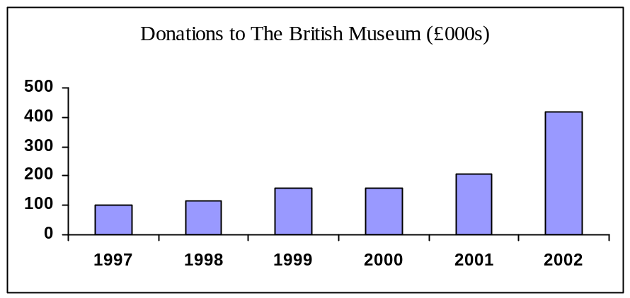This year grants to support the Museum came to £418,000. This compares with £223,000 in the previous year, which was itself the first time our grants had exceeded £200,000. Of the total grant, £45,000 was for Townley projects. Most of the remaining grant was for the acquisition of objects. This included grants of £240,000 for four purposes which received a good deal of publicity at the time, £40,000 for the Milton Keynes Treasure, £50,000 each for the Winchester Treasure and the Jennings Dog, and £100,000 for the Flannery Brooch. These grants were exceptionally large by our past standards and it was most encouraging that your support enabled us to be bold.

The first three of these grants were made from our normal operating surplus but the £100,000 for the Brooch was in effect funded from our accumulated surplus: please see the sections on Finance and Grant Making Policy below. This is only the second time that the Council has made a grant from accumulated funds. The Brooch which is third century BC and marries a Celtic theme with Greek craftsmanship was simply outstanding and in the light of the pressures on the BM's own acquisitions budget we decided that this was the sort of need for which the Friends' reserves had been built up. Our grant in turn acted as seed money and allowed the BM to trigger further grants from external sources.

Fundraising
Following the success of our first fundraising campaign, for the Great Court, we established a Fundraising Committee to recommend future policy. It had become clear that many members appreciated the opportunity to make donations to projects of particular personal interest, so we decided on two further appeals. The first was in July 2001 for the Winchester Treasure already referred to. Many were excited at the idea of helping to save these marvellous Iron Age objects for the nation and your generosity in contributing £25,000, which was subsequently matched by the Friends, was critically important to the Museum's efforts to raise the required sum.

In February we launched a more ambitious appeal for £100,000 for the King’s Library project. Your response was highly encouraging. We soon beat the target and are well on our way to achieving our revised target of £200,000. Again, many thanks to those many members who contributed, not least to those who rose to the challenge of sponsoring a sculpture.

Volunteers

Over 50,000 visitors to the Museum benefited from the handling sessions run by the Friends’ volunteer programme in the HSBC Money Gallery. This service has been extended under the ‘Please Touch’ initiative to the Weston Gallery and the Cypriot Gallery during the year. ‘Please Touch’ has been featured in the Times newspaper and on BBC Radio during the year.

The Council thanks all volunteers, especially the BMF Volunteers Organiser Kusuma Barnett, who is herself a volunteer, for all their hard work and commitment to the Museum. Thanks also go to those volunteers who continue to devote their time to the Membership Desk.

The Magazine
The Council has worked to continue to improve the Magazine. It now runs to 48 pages, giving scope for a wider range of articles.

Membership
Membership reached 14,802 by the end of the financial year. 926 of these were Young Friends, 357 were Associate members and 137 were Townleys. Compared to the last financial year-end overall membership was up 7%.

Young Friends of the British Museum
Attendance at events remains high and sleepovers continue to sell out.

Townley Group
Over £45,000 was donated to specific projects thanks to the generosity of Townley contributors. The Townley party is now an annual fixture when curators offer specific projects for Townley members to adopt; this provides a very enjoyable event whereby curators take up ‘pitches’ to promote their projects to assembled guests. This is followed during the coming year by visits to each of the adopted projects so that individual donors get both a report on progress and a closer understanding of the work of the curators.

Events
Over 190 events were run for members during the year. The First Tuesday evenings remain our flagship events. Evening lectures, days out and special weekend events regularly sell out. Associates have priority booking for all events. During the year the Events team were also responsible for organising the Museum’s Public Events for the general public for which all Friends have priority booking.

Subscriptions
Thanks to the increases in membership numbers and a full year of the new subscription rates introduced the previous year, income from subscriptions was up some 25% on an underlying basis.

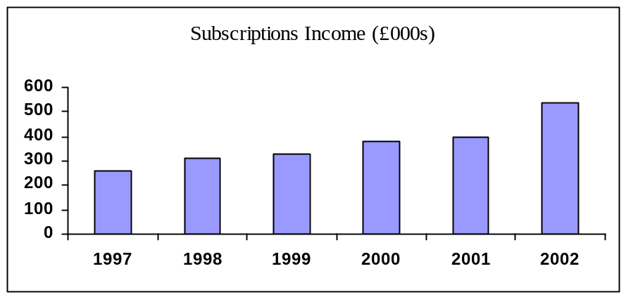The subscriptions figure is boosted by an additional £100,000 from Gift Aid, which is the tax the BMF can claim back on the subscriptions of members who pay UK tax (whether income tax or capital gains tax). We are grateful to all Friends who returned the form to enable us to claim this valuable income and we urge all others to do likewise.

Finance
The Statement of Financial Activities appears on page X. Despite a substantial increase in subscriptions income, a deficit of £99,000 was incurred before taking account of losses on investments. This resulted from the significant increase in grants to The British Museum. Subscriptions included, for the first time, tax recoverable under the Gift Aid scheme, including a portion attributable to the previous year. Restricted income in the year related to amounts donated to the Friends by members in connection with fundraising for the Winchester Treasure and the King’s Library appeals. The cash position remains strong and an additional £250,000 has been invested in the common investment funds since the year-end.

The Friends’ reserves are held in the form of property and units listed in the common investment funds. The investment policy is to manage these assets on a total return basis, such that the income and a proportion of any appreciation in capital value is taken to income and made available for distribution annually by way of grants to The British Museum.

Although no restrictions were placed on the legacy from Eva Lorant, the Trustees have decided that the funds should be invested until such time as The British Museum requests assistance for exceptional objects or projects. Apart from the funds designated from this legacy (£875,000) and fixed assets (£57,000) the remaining reserves (£347,000) are held to provide for contingencies, to enable selective “top-up” grants to be made to the Museum in the appropriate circumstances and to help finance the proposed fitting out of the new Friends’ Room.

Grant Making Policy
In accordance with its stated objective, the BMF supports the Museum by making grants to extend its permanent collection and to help fund other Museum projects. The Council applies the BMF’s annual surplus to these ends and occasionally makes more substantial grants towards special purchases or projects from its accumulated funds. All applications for grants are first vetted and agreed by the Director of the Museum. The Council periodically authorises fundraising appeals in order to provide additional support for a major Museum project, such as the King’s Library, or particularly important objects, such as the Winchester Treasure.

Governance
The Council aspires to the highest standards of governance to ensure that the BMF is run economically and effectively and that it achieves its charitable purpose to the full. As part of this process the governing documents are reviewed from time to time to ensure they keep pace with developments. The major risks to which the Charity is exposed, as identified by the trustees, have been reviewed and systems have been established to mitigate those risks.

In June 2002, following a careful review of the alternatives, we introduced a more transparent process for finding the non-professional members of the Council. For the first time the whole membership was invited to propose candidates for consideration by a new Nominations Committee, which would then put its recommendation to the full Council for submission to the AGM. We look to this new nominations process to make the Council more aware of people who are willing to serve the Friends in more active ways, whether on the Council itself or on a committee. We will keep the new process under review.

In August 2002 the BMF received an inspection visit from the Charities Commission. This was the first such occasion and we were pleased to get a clean bill of health. The Commission's report highlighted numerous examples of good practice. It also included some helpful suggestions; these were more technical than substantive.

Staff
Last year we thanked the previous Head of Friends, Sarah Carthew. Her successor, Margaret Fenn, has had an impressive first year. Elizabeth Barbarska our Finance Manager resigned after 14 years service in December 2001. We thank her for all her hard work and loyalty and wish her well. Her successor is Roger Halford.

Joanne Webb joined the BMF in June 2001 as the BMF Event Team leader to replace Fiona Burtt who left in January 2001. Judy Lindsay, the Events Assistant, was promoted within the BM in March 2002. Judy left with our thanks and good wishes. So did Jane Campling in September 2001, to pursue a career as an artist.

We continue to emphasise staff development and all members of staff have undertaken further training to develop their skills. The growing success of the BM Friends is underpinned by the enthusiasm and commitment of our staff, often beyond the call of duty, and the Council thanks them warmly for their efforts.

Council
Chris Beetles resigned from the Council because of time pressures from his other commitments. So did Jean Carr. And Jessica Harrison-Hall, a BM curator in the Department of Oriental Antiquities, has completed her three years. They have all been valuable contributors and their efforts were much appreciated.

This year Griselda Bear, Lesley King-Lewis, Patti White and Hilary Williams stand for re-election after serving terms of three years.

Three new members are proposed for election. Dr J D Hill, a curator in Prehistory and Early Europe, is well known to many members, not least to those who heard his lecture on the Winchester Treasure at last year's AGM. A second "in house" candidate is Andrew Thatcher, the new Managing Director of the British Museum Company. The third name has emerged from the new process for electing the non-professional members referred to above. On this first occasion there were nine candidates for one vacancy and I am delighted that Brendan Finucane is now proposed for election. He is a longstanding member and a frequent attender at BMF events. A barrister by profession, he will bring valuable experience of other charitable organisations, including the Friends of the Tate, and of magazine publishing.

The Future
The value of the Friends to the BM has been steadily growing. So has its visibility to the public and this is increasing further in three ways: the imminent move of our membership desk to the Great Court, our new website, due for completion by the end of 2002, and in the galleries the highlighting of objects acquired with BMF support by means of new labels displaying the BMF's mark. The project to develop a new Members Room has made less progress than intended; it is expensive and we are conducting formal research to ensure we have a sound understanding of Members’ requirements.

The BM is set to move into a new chapter. The new Director Neil McGregor arrived in August and next year is the 250th Anniversary of the Museum's founding in 1753. Among the many highlights will be two openings, the Wellcome Gallery marking the final return of Ethnography from the Museum of Mankind, and the refurbished King's Library with its powerful displays examining the intellectual world of George III and the Enlightenment approach to collecting. It will be an exciting time to be a Friend and we look forward to seeing the BMF continue to increase its support to the BM and its curators.

On behalf of the Council.

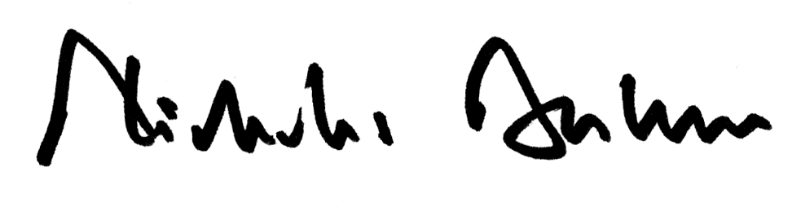

NCF Barber
Chairman
31st August 2002.

(Followed by 3 Pages on Accounts)
The British Museum Friends
Summarised Statement of Financial Activities
For the year ended 31 March 2002

The British Museum Friends
Summarised Balance Sheet
For the year ended 31 March 2002

The British Museum Friends
Note to Accounts
For the year ended 31 March 2002

