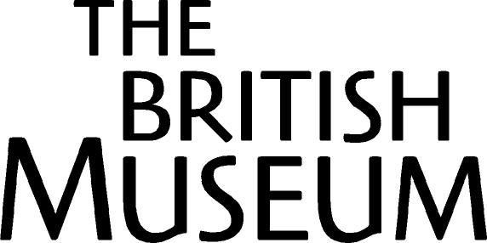
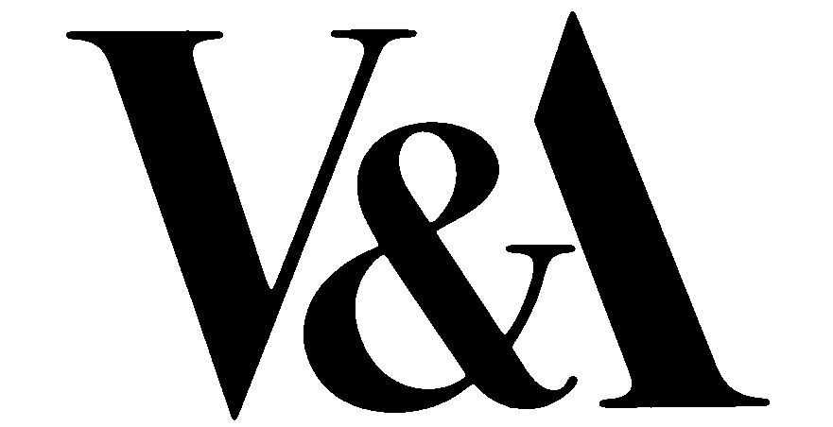

A Buddha for the Nation

V&A AND BRITISH MUSEUM
ACQUIRE RARE 7TH CENTURY BUDDHA

The British Museum and the V&A have joined together to acquire a rare Indian 7th century metal statue of a standing figure of the Buddha Sakyamuni, the first to enter a public European collection.

This is the first time that the V&A and the British Museum have made a joint acquisition to secure for the entire British public an opportunity to see a work of outstanding historical importance. The Buddha will be on display in the Indian sculpture gallery at the V&A from 25 March for three months. It will then be displayed at the British Museum, after which it will tour to Birmingham, Bradford, Leicester and Exeter as the centrepiece of a loan exhibition of Indian Buddhist sculpture. The V&A and the British Museum are working in close partnership with Birmingham Museum and Art Gallery, Cartwright Hall Art Gallery, Bradford, New Walk Museum, Leicester and Royal Albert Memorial Museum, Exeter on the exhibition, a series of associated educational events and activities and a web programme. Subsequently, it will be shown alternatively at the V&A and the British Museum.

The Buddha has been bought for £850,000 with the assistance of the Heritage Lottery Fund, the National Art Collections Fund, the British Museum’s Brooke Sewell Permanent Fund, the Friends of the V&A, and private donors.

The exquisite gold-toned figure, 14 inches high, depicts the Buddha in the style of the late Gupta period in India in the late 6th or early 7th century. It shares a number of distinctive features with other Buddhas of the period. The historical Buddha is represented standing in a slightly flexed pose, with his right hand raised in the gesture of benevolent reassurance, reaffirming the Buddha’s role as protector of devotees.

Made of copper alloy, it features a finely carved head with stylised hair curls and delicate features. The robes are folded and drawn across both shoulders and ‘wet drapery’ defines the bodily form beneath. The downward cast of the eyes indicates that this image was designed to be installed in an elevated position, on an altar, and, on occasions, to be carried in processions. It displays a number of supernatural marks, the auspicious marks of Buddhahood, including the skull protuberance and webbed fingers.

Mark Jones, Director of the V&A, said: “The V&A has wanted to acquire a Gupta-style Buddha for more than forty years. This is a rare and beautiful object which adds immeasurably to our Indian collections. It is wonderful that the opportunity to buy this statue has arisen and that by joining with the British Museum, and with the help of generous donors, we are together able to put it on public display.”

Neil MacGregor, Director of the British Museum, said: “This magnificent object is a document of Buddhism's spiritual and artistic inheritance and contribution to world civilisation. There are more people interested in Buddhism throughout the UK and many more practising Buddhists than ever before. I am delighted that these two national museums can come together in this new way to make this acquisition for the nation, and show it in a new way that means it will be seen this year by people across the length and breadth of Britain”.

Sue Bowers, Regional Manager for HLF in London, comments; ‘This is a very rare sculpture, the only one of its kind in a public collection in Europe, and we are delighted to help the V&A and British Museum display it for the widest possible audience across the UK. Buddhism is now one of the world's most universally respected religions, and this is a wonderful opportunity to celebrate its rich heritage.’

David Barrie, Director, National Art Collections Fund, said: "We are delighted to have played a role in securing this rare work for both the Indian sculpture and oriental antiquities collections for the V&A and the British Museum. We hope, moving forward, that this acquisition will encourage more museums to work together to acquire works of historical importance."

In the history of Indian art, the Gupta-style Buddha epitomises the culmination of early Buddhist sculptural art. It marks a watershed in Indian stylistic development and in the spread of Indian cultural influence throughout Asia. It is credited with creating the quintessential Buddha-type, was disseminated and emulated throughout the Asian Buddhist world – in Pala eastern India, in Licchavi Nepal, in Tang China, and among the newly formed Hindu-Buddhist states of South-East Asia.

This sculpture belongs to the mature phase of the Gupta style. The Gupta period is confined historically to the 4th to late 6th centuries, but the immediate north Indian legacy of the style, sometimes referred to as the Post-Gupta style, extends into the 7th and 8th centuries.

The V&A’s annual Anthony Gardner lecture on Indian and Southeast Asian Art will de devoted to the history of this sculpture of the Buddha Sakyamuni. It will take place at 7.00pm in the V&A Lecture Theatre on Tuesday 27 April (free, no ticket required, access Exhibition Road entrance).

NOTES TO EDITOR:
- The Buddha was purchased for £850,000. The Heritage Lottery Fund awarded a grant of £621,500 towards the purchase and to support a regional educational tour, and the independent art charity, the National Art Collections Fund awarded a grant of £100,000. The V&A, the British Museum’s Brooke Sewell Permanent Fund, the Friends of the V&A, and private donors jointly contributed the balance.
- The Victoria and Albert Museum has one of the greatest collections of Indian art in the world, spanning the wealth and diversity of artistic creativity across the sub-continent from 2,000 years ago to the present day.
- The British Museum’s great collection of Indian art and antiquities ranges from Palaeolithic stone tools to modern paintings. Within that huge range are collections of religious sculpture, paintings, textiles and a great array of ethnographic material. The Indian collections of the BM and the V&A are together in London a public educational resource unique in the world.

For further press information please contact:
Helen Beeckmans, V&A Press Office Tel: 020 7942 2503 Email: h.beeckmans@vam.ac.uk
Hannah Boulton, BM Press Office Tel: 020 7323 8522 Email: hboulton@british-museum.ac.uk

(NOT FOR PUBLICATION)
