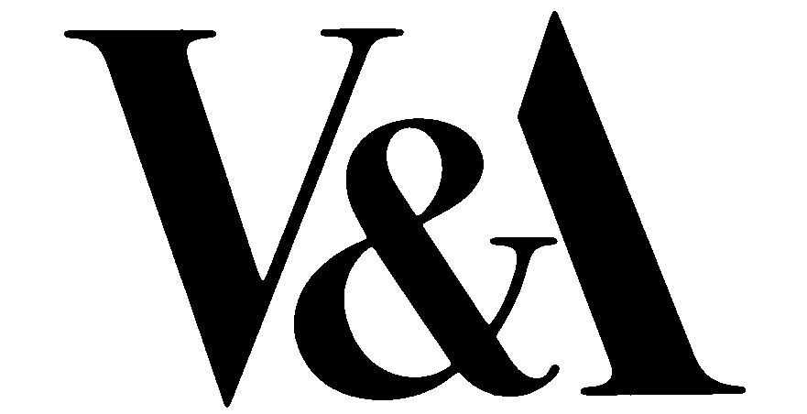
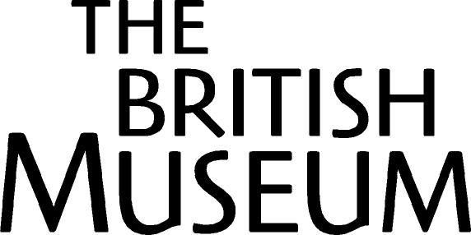
Embargoed until Tuesday 6 September.

New UK cultural engagement in China –
The British Museum and the V&A in historic partnerships with museums across China

The British Museum and the Victoria & Albert Museum (V&A) both announce today an unprecedented programme of collaboration with museums across China. Initiatives unveiled by both museums will enable objects from their unparalleled world collections to be seen in China and for masterpieces of Chinese culture to be loaned to the UK. It will also involve curatorial exchanges, skills sharing and joint projects which will benefit the museums and their audiences in both countries.

The British Museum
The British Museum has today signed an historic agreement with the National Museum of China in Beijing, the first cultural agreement between a British institution and the National Museum of China. Neil MacGregor, the Director of the British Museum who is accompanying the Prime Minister Tony Blair’s delegation to Beijing, signed the agreement with Pan Zhenzhou, vice-minister of Culture and the Director of the National Museum of China in the presence of the Prime Minister and the Chinese Premier Wen. It will guarantee a significant programme of collaboration between the British Museum and its Chinese counterparts. The first fruits of the agreement will be a series of loan exhibitions on world cultures not currently represented in museums in China, which will run from 2008 onwards. More details can be found overleaf.

Neil MacGregor, Director of the British Museum said “I am delighted to announce the signing of this historic memorandum which will cement an important partnership between the British Museum and the National Museum of China. The British Museum is committed to sharing its exceptional world collection with the world and this agreement will also allow many in China to explore other civilisations and ensure that the audience in London can appreciate the cultural achievements of China.

The Victoria & Albert Museum
The V&A is engaged in a series of Anglo-Chinese collaborations to 2010 drawing on its curatorial expertise in ancient Chinese art and encouraging an exchange of new design ideas between China and the UK. Mark Jones, Director of the V&A, who is accompanying the Prime Minister Tony Blair’s delegation to Beijing, announced that in 2008, to coincide with the Beijing Olympics, the V&A will host a major exhibition, China Design Now, showing the best of contemporary Chinese design. He also unveiled a loan exhibition of 17th century Chinese porcelain from the Shanghai Museum to the V&A in 2006. A collaborative exhibition in Shanghai to celebrate the Shanghai Expo in 2010 is planned, while the V&A’s retrospective of fashion designer Vivienne Westwood has just been staged in Shanghai in July 2005. An exhibition of contemporary Chinese photography and video will be at the V&A in London in September 2005. More details can be found overleaf.

Mark Jones, Director of the V&A, commented: “There is enormous interest in both our countries in seeing cultural treasures from the past as well as learning about the latest design ideas from across the world. The V&A is committed to encouraging and inspiring
creativity and the best of international design. These collaborations will help promote these aims.”

New UK cultural engagement in China cont/…

The British Museum in China
The agreement signed today ensures an unmatched level of partnership between the British Museum and China. The Museum will loan objects which shed light on the history of the world’s cultures and in turn the National Museum of China will collaborate on exhibitions to present Chinese culture to the British Museum’s worldwide audience. The agreement also taps into the wealth of expertise available at both institutions and the potential for cross-cultural and academic exchanges, providing an invaluable communication of expert curatorial and artistic knowledge. A series of planned British Museum exhibitions in China from 2008 onwards will showcase different world cultures, allowing material from other great world civilisations to be seen in China alongside the National Museum of China’s own collections. This series will begin with an exhibition on Ancient Egypt, to coincide with the reopening of the National Museum of China in 2008.

China in the British Museum
As part of the agreement, the National Museum of China has committed to loan a major exhibition of Chinese antiquities to the British Museum, which will complement the existing collection and programme of exhibitions at the Museum. The British Museum’s long-term commitment to the display and promotion of Chinese culture is demonstrated by its permanent collection dating back to the museum’s foundation in 1753. In addition to permanent galleries devoted to the display of Chinese material the Museum has always mounted temporary exhibitions with a particular focus on China, most recently, ‘Mountains and Water’ an exhibition of Chinese landscape painting. The museum is currently committed to a five-year series of exhibitions of Chinese painting, highlighting this important Chinese artistic tradition.

Other initiatives in China
In addition to the arrangement with the National Museum, the British Museum is engaged in many other projects in China. These include the touring exhibition ‘Treasures of the World’s Cultures - the British Museum after 250 years’ which will run at the Capital Museum in Beijing and in Hong Kong in 2006. And ‘Assyria: Art and Empire: Treasures from Assyria in the British Museum’, a major exhibition of Ancient Mesopotamian material planned for the Shanghai Museum in 2006. In 2007 ‘Britain meets the World’ will open at the National Palace Museum in Beijing. The British Museum is also working with the Palace Museum via curatorial exchanges and skills sharing. The Museum has sent specialists to the Palace Museum to conduct a survey of the museum’s European clocks collection and Chinese scholars will assist on the project to publish the British Museum’s Chinese paintings collection.

These alliances will complement the cultural and artistic spotlight that will be focused on Beijing and London, both host Olympic cities over the coming years. This provides a significant opportunity to promote the story and achievement of Chinese culture to the British Museum’s worldwide audience, and to bring the British Museum’s collection to new audiences in China.

For further information please contact Joanna Mackle on + 44 207323 8345 or jmackle@thebritishmuseum.ac.uk

New UK cultural engagement in China cont/…

China at the Victoria and Albert Museum
The V&A is hosting important exhibitions of classical Chinese art and contemporary Chinese design through collaborations with China. In 2008, to mark the Beijing Olympics, the V&A is staging a major exhibition China Design Now. It will showcase work by leading Chinese designers and international designers working in China today across the fields of architecture, graphic design, photography, film, fashion, product and furniture. In 2006, the V&A is hosting Dragons and Immortals: 17th Century Chinese Porcelain, a display drawn from the collections of the Shanghai Museum and the Butler family, the first of its kind in the UK. In September 2005, the V&A is showing contemporary Chinese video and photography in Between Past and Future. The V&A ‘s Chinese gallery has a permanent display covering a vast spectrum of Chinese art from 5,000 years ago to the present day, while the Museum has a constant programme of new displays devoted to Chinese subjects.

The Victoria and Albert Museum in China
The V&A’s retrospective of the British fashion designer Vivienne Westwood transferred to Bund 18 Arts Centre in Shanghai in July 2005. The V&A is currently collaborating with the Expo Bureau in Shanghai and the Shanghai Museum on an exhibition to mark the Shanghai Expo in 2010. The Expo exhibition will present a history of world expos commencing with the first ever such event, the Great Exhibition of 1851 in London, which led to the founding of the V&A. The V&A, the Shanghai Museum and the Expo Bureau are also collaborating on the Expo Forum in May 2006

Other initiatives in China
Placements for Chinese museum professionals at the V&A have been organised with the Beijing Museum and the Sichuan Provincial Museum. These collaborations are designed to strengthen cultural relationships between the UK and China as attention focuses on these two Olympic cities and the Shanghai Expo in 2010, and to promote the wider exchange of new ideas in contemporary international design.

For further information please contact Debra Isaac on +44 207 942 2508 or d.isaac@vam.ac.uk

Notes to Editors:
- The British Museum’s collection of Chinese material covers the whole range of Chinese art and the entire span of China’s long history. It includes prints and drawings, jades, bronzes, ceramics and decorative objects. Around 2000 objects are on permanent display in the Hotung Gallery of Oriental Antiquities, freely available to the Museum’s international audience of five million visitors a year, with the rest of the collection always available for study on request. As part of the Museum’s commitment to increase worldwide access to its collection, highlights of the Chinese collection are available to view online at www.thebritishmuseum.ac.uk/compass and on two stand alone education websites www.ancientchina.co.uk and www.earlyimperialchina.co.uk. The Museum is also engaged in a project to digitise the collection of material found in Dunhuang. www.thebritishmuseum.net/thesilkroad already features silk paintings and by the end of 2005 we plan to have images of textiles, as well as other smaller objects and architectural remains found at major sites along the Silk Road online.
- Neil MacGregor has been Director of the British Museum since August 2002. He was previously Director of the National Gallery, London, 1987-2002. From 1981-1987 he was Editor of The Burlington Magazine. He has recently been invited to join the cultural task force set up by Deputy Prime Minister John Prescott.

New UK cultural engagement in China cont/…

- The Victoria & Albert Museum’s collections cover a vast spectrum of Chinese art, from goods buried 5,000 years ago to recent examples of craft and design. The V&A acquired its first Chinese artefacts in 1852 and now has more than 22,000 fine examples, collected over 150 years. The V&A’s collection is particularly strong in Chinese ceramics and also includes jade, metalwork, lacquer, textiles, furniture, sculpture, ivory, bamboo, glass, paintings and prints. The objects are on permanent display in the China gallery and arranged according to the use of objects to show how they have been integral to Chinese life over the ages. The collection is available free to the Museum’s two million annual visitors Highlights are available to view online at www.vam.ac.uk/collections/asia. A Chinese language version is available online.
- Mark Jones has been Director of the Victoria and Albert Museum since May 2001. He was Director of the National Museums of Scotland for eight years (1993 to 2001). He is an expert on the history of medallic art and was previously Keeper of Coins and Medals at the British Museum.

