
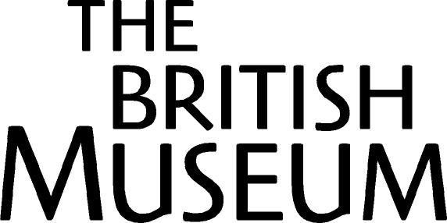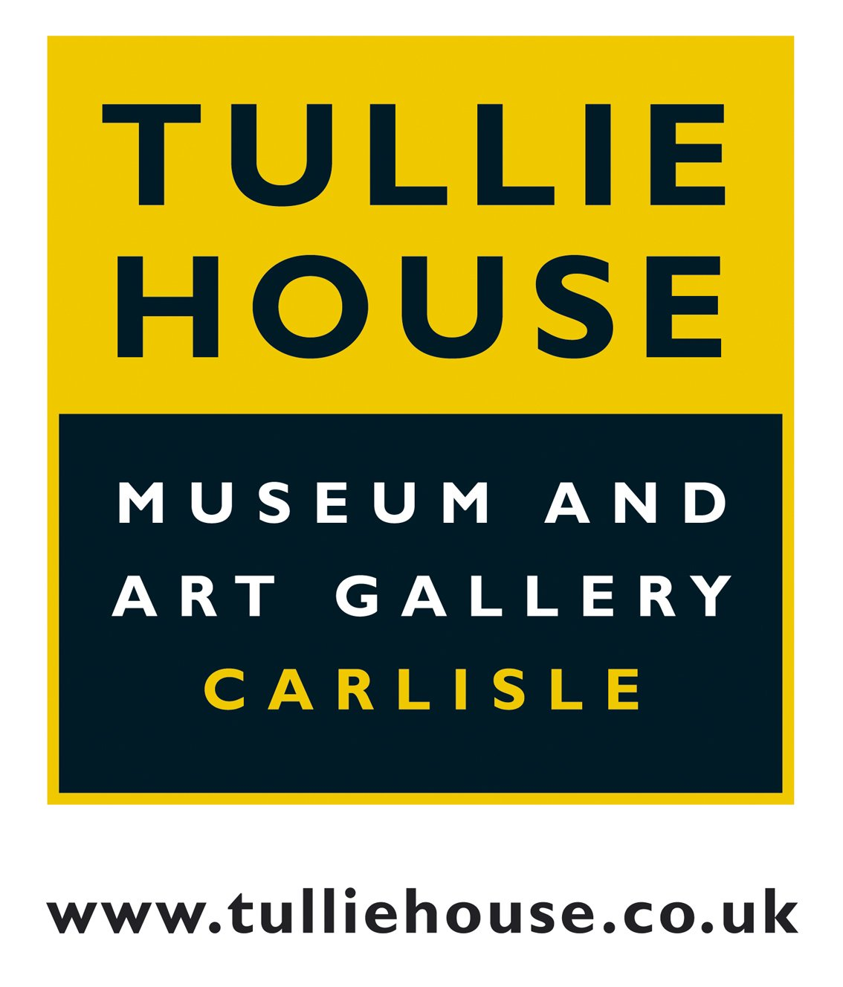

UNDER EMBARGO UNTIL 10.00am, TUESDAY 16 AUGUST

Rare Roman souvenir is acquired in unique agreement by three British museums.

The Staffordshire Moorlands Pan has been acquired in a unique tripartite arrangement between the Potteries Museum and Art Gallery (Stoke-on-Trent), the Tullie House Museum and Gallery (Carlisle), and the British Museum (London). This important and exciting find will be joint-owned and displayed equally between the three partners. The pan has been acquired with the substantial and generous support of a Heritage Lottery Fund (HLF) grant of £112,200.

The pan, although lacking its handle, is an extremely well preserved enamelled and inscribed bronze trulla dating to the Roman period. It was made both as a functional vessel and as a ‘souvenir’ of Hadrian’s Wall, and is a find of great national and international significance. Uncovered by a metal detectorist in Staffordshire in June 2003, it was promptly reported to the Portable Antiquities Scheme who drew the attention of relevant museums to the find.

The shared acquisition of the pan will mean that people across the country will be able to admire and enjoy this remarkable object. It will enable the pan to be seen in the context of the original find site, of Hadrian’s Wall and as part of the foremost collection of Romano-British material in the UK. The pan will be displayed initially in the British Museum, it will then travel to the Potteries Museum for display during 2006 and to Carlisle for 2007. Replicas of the pan are being made as part of the acquisition grant to ensure that when the original is at one venue, a representation of the pan can still be displayed at the other venues.

Kate Clark, Heritage Lottery Fund Deputy Director, Policy and Research, said
“This two thousand-year-old souvenir of Hadrian's Wall is a very special part of our past and one which people across the country should have the chance to see. This unique sharing scheme is exactly the sort of innovative joint working that the Heritage Lottery Fund wants to encourage UK museums to undertake”.

Hilary Wade, Director of the Tullie House Museum and Art Gallery in Carlisle, commented “This is a wonderful 'icon' to focus on the rich Roman heritage of
Carlisle and the western end of Hadrian's Wall. Tullie House looks forward
very much to displaying it in 2007 and to working with our new partners”.

Ian Lawley, Stoke-on-Trent City Council's Head of Museums said 'The joint acquisition of the Staffordshire Moorlands Pan by the three museums is truly trail-blazing. It marks a new era in co-operation between National and regional museums and will enable this enormously significant national treasure to be seen and enjoyed by a large number of people at all three venues. We hope that this will be the first of many such partnerships'.

Ralph Jackson, Curator of Romano-British collections at the British Museum in London added “This little gem of British craftsmanship, a unique find of the greatest importance, shows us that Hadrian’s Wall was as famous in the Roman world as it is today. Visually striking and replete with fascinating information, it is a most notable acquisition for the nation”.

The Staffordshire Moorlands Pan
Dating to the mid 2nd century AD the pan is intricately decorated with a band of Celtic-style roundels. Spectacularly colourful, the roundels are inlaid with red, blue, turquoise and yellow enamel. The pan at its widest diameter is 94mm and it weighs 132.5g. Immediately above the band of roundels is an engraved inscription which lists four forts on Hadrian’s Wall: MAIS (Bowness-on-Solway), COGGABATA (Drumburgh), VXELODVNVM (Stanwix) and CAMMOGLANNA (Castlesteads). The mention of Drumburgh is interesting as this is the first time the name of this fort has been found on a Wall souvenir. The other part of the inscription is the most significant and reads RIGORE VALI AELI DRACONIS. The first ten letters appear to be a direct reference to Hadrian’s Wall. The remaining letters may be interpreted as the personal name Aelius Draco (or Dracon) which may be that of the person it was made for, perhaps an officer whose command related to the Wall. Draco is a Greek name, suggesting an origin in the eastern Roman Empire. ‘Aelius’ is Hadrian’s family name and would have been traditionally adopted by anyone obtaining Roman citizenship under his rule. This is the first time that a personal name has been found within the inscription on such a vessel. Further research on the inscription is being undertaken and may reveal yet more information about the find and about life in and around the Wall itself, the most potent symbol of the Roman province of Britannia.

For further information or images of the pan please contact Hannah Boulton at the British Museum on 020 7323 8522 or hboulton@thebritishmuseum.ac.uk or Tony Adams at tony.adams@civic2.stoke.gov.uk or Cheryl Eastburn at Tullie House Museum and Art Gallery on 01228 534781 or cheryle@carlisle-city.gov.uk

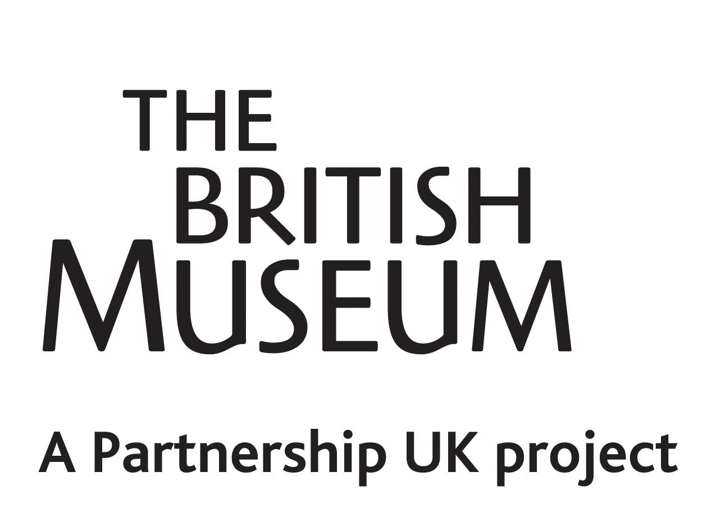
Notes to Editors
- The pan will be on display at the British Museum from 17 August 2005 until the end of December. It will go on display in the Potteries Museum and Art Gallery for the whole of 2006 and the Tullie House Museum and Gallery for 2007.
- The Portable Antiquities Scheme is a voluntary scheme to record archaeological objects found by the public and to broaden awareness of these finds for understanding our past. Since 1997 the Scheme's Finds Liaison Officers have examined over 100,000 objects, many of which might have otherwise gone unrecorded. Data is passed on to Sites and Monuments Records (SMRs) and is also published on the Scheme's website – www.finds.org.uk
- The Heritage Lottery Fund enables communities to celebrate, look after and learn more about our diverse heritage. From our great museums and historic buildings to local parks and beauty spots or recording and celebrating traditions, customs and history, HLF grants open up our nation’s heritage for everyone to enjoy. They have supported more than 16,000 projects, allocating £3.3billion, of which £1billion has been awarded to museums and galleries, across the UK. Website: www.hlf.org.uk. For more information, please contact Katie Owen, HLF press office, on 020 7591 6036.
- The tripartite acquisition is in keeping with the aims of the British Museum's Partnership UK, the largest and most wide-ranging of any such scheme between a national institution and other museums around the country. Its principal purpose is to share collections and expertise with audiences across the UK. Over the past two years it has included tours of objects such as the Queen of the Night and the Throne of Weapons, and exhibitions such as Buried Treasure and Across the Board.

