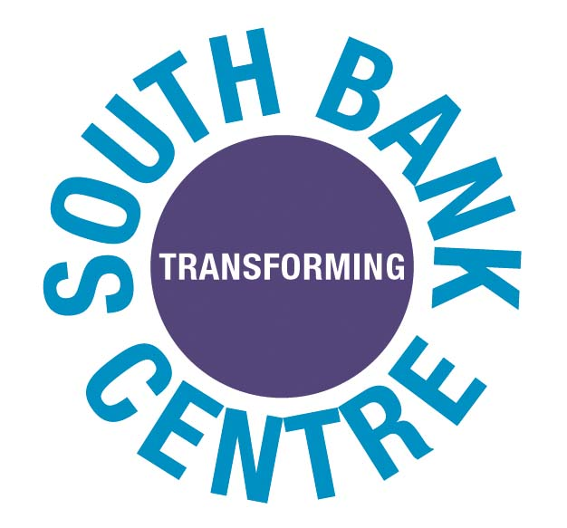
For immediate release
Administered on behalf of the Arts Council England
Arts Council Collection
National Touring Exhibitions
Saison Poetry Library:
Housing The Arts Council Poetry Collection
Royal Festival Hall
London SE18XX
T +44 0870 380 4300
F +44 0870 163 3898
www.southbankcentre.org.uk

Book Online
www.rfh.org.uk
www.hayward.org.uk

Patron
Her Majesty The Queen

Chairman
Lord Hollick

Chief Executive
Michael Lynch AM

Artistic Director
Jude Kelly

The South Bank Centre
Is a Registered Charity
No 298909

Trustee
The South Bank Board Ltd
Registered in England
No 2238415
South Bank Centre London
Royal Festival Hall
Hayward Gallery
Queen Elizabeth Hall
Purcell Room

News Release
Music Dance Literature Visual Arts Education
Music Dance Literature Visual Arts Education

Rembrandt as Printmaker
A new Hayward Gallery Touring/ British Museum Partnership UK exhibition
Opens at the Ferens Art Gallery, Hull, 8 April –18 June 2006

The 400th anniversary of the birth of Rembrandt (1606-1669) is the occasion to celebrate the work of one of the greatest artists of all time. His outstanding achievement as a graphic artist is supremely well represented in the collection of the British Museum, whose expert Martin Royalton-Kisch has made the selection of 60 prints for this new Hayward Gallery Touring exhibition which opens in Hull on 8 April 2006.

Rembrandt was the first modern etcher, producing more than 300 prints over a period of 40 years. His influence has been incalculable, profoundly affecting subsequent graphic art, encompassing some of the most radical and contemporary forms of expression. The exhibition will show the whole range of his work, including self-portraits, biblical scenes, landscapes and character studies. Some of Rembrandt’s etchings were so sought after in his lifetime that they commanded higher prices than his paintings. The exhibition includes his masterpiece as a printmaker, Christ healing the sick, which was known as the Hundred guilder print, because it changed hands several times for what was then an enormous sum.

Rembrandt is famous for his command of light and darkness, exemplified by the nocturnal scene of The three crosses. This monumental print is generally regarded as one of the high points of his career. Two different versions will be shown, giving fascinating insights into his working methods. Etchings are produced by drawing a design with a steel needle onto a wax-coated copper plate. The plate is then immersed in acid, which bites into the exposed parts of the copper, creating the lines. The technique enables the artist to draw almost as freely as with a pen on paper. The exhibition also includes the evocative landscape, The three trees, in which Rembrandt creates, in layer upon layer of tone, graduations of distance and atmosphere with breathtaking subtlety.

At the other extreme from his highly finished prints, is the rapid sketch from nature, Six’s bridge. The story behind this print is that Rembrandt allegedly produced it after Jan Six, a Dutch landowner, wagered him to complete an etching in the time it took a servant to fetch a pot of mustard from a nearby village.

Rembrandt’s profound understanding of human character is revealed in his portraits and self-portraits. The exhibition includes vivid self-portraits: the artist posing at the age of 24, open-mouthed with wild, curly hair, wearing an expression that he then transposed to the face of a beggar in a study of the same year. In other self-portraits he is wide-eyed with a look of astonishment, or frowning fiercely. In his thirties, he portrays himself proudly in Renaissance
…/…
costume leaning on a sill in a pose inspired by Titian. A decade later, he portrays himself humbly working at a window with etching needle in hand. These are among the many masterpieces to be seen in this important Hayward Gallery Touring exhibition of one of the world’s greatest artists.

Notes to editors:

- This exhibition is the latest in an ongoing series of collaborations between the Hayward Gallery and the British Museum that has been in operation for the past 15 years.

- For over 35 years, the Hayward Gallery has a played a key role in creating imaginative, high profile exhibitions in London and across the UK through Hayward Gallery Touring exhibitions. The touring programme and the Arts Council Collection are managed by the Hayward Gallery on behalf of Arts Council England, and add to the Hayward's distinctive national remit.

- The Hayward Gallery is a constituent part of the South Bank Centre, which is also responsible for the Royal Festival Hall, Queen Elizabeth Hall, Purcell Room and the Poetry Library. The South Bank Centre each year presents nearly 1,000 paid performances of music, dance, literature, a dynamic education programme and more than 300 free foyer events. While the Royal Festival Hall is closed for a major refurbishment, a full programme of activities continues in the Queen Elizabeth Hall, Purcell Room and Hayward Gallery. The Royal Festival Hall re-opens in June 2007.

- Partnership UK is the British Museum’s strategic framework for its collaborative activity throughout the British Isles. Recent examples include the successful tour of the Throne of Weapons as part of the Africa 05 season.

Venue information:

Ferens Art Gallery
Queen Victoria Square
Hull
HU1 3RA

Tel: 01482 613902
www.hullcc.gov.uk/museums

Admission: free
Opening hours: Monday – Saturday 10am – 5pm
Sunday 1.30 – 4.30pm

Tour dates:
24 June – 3 September Bath, The Victoria Art Gallery
14 October – 31 December Newcastle, Laing Art Gallery
Tour continues

For further information or press images, please contact Judith Holmes or
Eleanor Bryson in the Hayward Gallery press office on 020 7921 0887/0631
or email press@hayward.org.uk

Information on the British Museum is available from Hannah Boulton in the British Museum’s Department of Communications on 020 7323 8522 or email HBoulton@thebritishmuseum.ac.uk

