Medieval Iraq study day


BP Lecture Theatre, Clore Education Centre
Saturday 15 May 2004

09.30 Registration

10.00 Opening remarks - Neil MacGregor, Director of the British Museum

10.10 Baghdad and Early Abbasid Architecture

Alastair Northedge, Université de Paris 1 (Panthéon-Sorbonne)

10.40 Abbasid Iraq and the Indian Ocean
Jessica Hallett, Lisbon, Portugal

11.10 Coffee

11.35 Sunnis and Shiis in Iraq: Sacred Times and Places

Gerald Hawting, School of Oriental and African Studies, London

12.05 Message and Mission: The Church of the East and the Abbasids

Erica Hunter, Cambridge University

12.35 Questions

12.50 Lunch (please make your own arrangements)

14.00 Astronomy in Abbasid Baghdad

David King, Johann Wolfgang Goethe Universität, Frankfurt

14.30 Basra: The Literary Capital of the Abbasid Caliphate

Robert Irwin, author of The Arabian Nights: A Companion (I B Tauris, 2003)

15.00 Tea

15.25 Music in Abbasid Baghdad

Owen Wright, School of Oriental and African Studies, London

15.55 Manuscript Painters of Iraq
Barbara Brend, author of Islamic Art (British Museum Press, 1991)

16.25 Questions

16.40 Closing remarks - Francis Robinson, President of the Royal Asiatic Society

Cost: £28, BM Friends and Royal Asiatic Society £25, Concessions £18

Bookings can be made at The British Museum Box Office and by calling 020 7323 8181 10.00-17.30 daily. Alternatively please send a cheque, payable to ‘The British Museum Great Court Ltd’, along with your name, address and the title of the event to: Box Office, The British Museum, Great Russell Street, London WC1B 3DG.
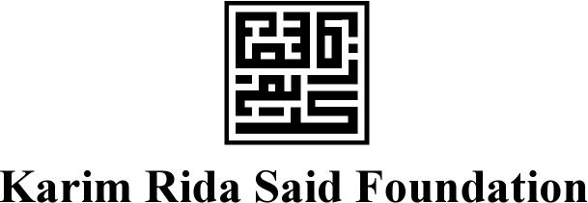
Education and Information Department
Telephone +44 (0)20 7323 8511/8854
Facsimile +44 (0)20 7323 8855
education@thebritishmuseum.ac.uk
Great Russell Street
London WC1B 3DG
Switchboard +44 (0)20 7323 8000
www.thebritishmuseum.ac.uk

