AI ASSISTED RETAIL PERFORMANCE & CUSTOMER INSIGHTS

PROJECT OVERVIEW:

This project combines traditional data analytics with AI-assisted tools to accelerate data exploration, automate repetitive data cleaning tasks, and generate deeper analytical insights. AI tools such as ChatGPT, Julius AI were used to assist with data profiling, cleaning strategies, and query optimization while Python, PostgreSQL, and Power BI were used for implementation and visualization.

DATASET SUMMARY:
- Total Records: 3,900 transactions
- Total Attributes: 18 variables

AI ASSISTED DATA SUMMARY:
Before starting the analysis, AI-assisted profiling was used to quickly understand dataset structure, detect potential data quality issues, and recommend cleaning strategies. Using AI tools, the dataset was evaluated for:
- Missing values
- Data type inconsistencies
- Outliers and anomalies
- Potential feature engineering opportunities
These AI suggestions helped accelerate the exploratory phase and ensured a structured data cleaning approach.

Key Data Dimensions:
- Customer Profile: Age, Gender, Location, Subscription Status
- Purchase Information: Item Purchased, Product Category, Purchase Amount, Seasonality, Size, Colour
- Behavioural Indicators: Discount Usage, Promo Code Application, Prior Purchase Count, Purchase Frequency, Review Rating, Shipping Preference
- Data Quality Note: 37 missing entries identified within the Review Rating field, addressed during the data cleaning phase to maintain analytical accuracy.

EDA USING PYTHON:
The Exploratory Data Analysis began by importing the dataset into Python using Pandas. AI-assisted guidance was used to accelerate data profiling and recommend appropriate strategies for handling missing values and feature engineering.
- Importing the Data into Jupyter notebook using Pandas
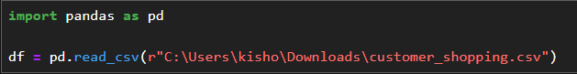
- Used df.info() to check structure and df.describe() for summary statistics 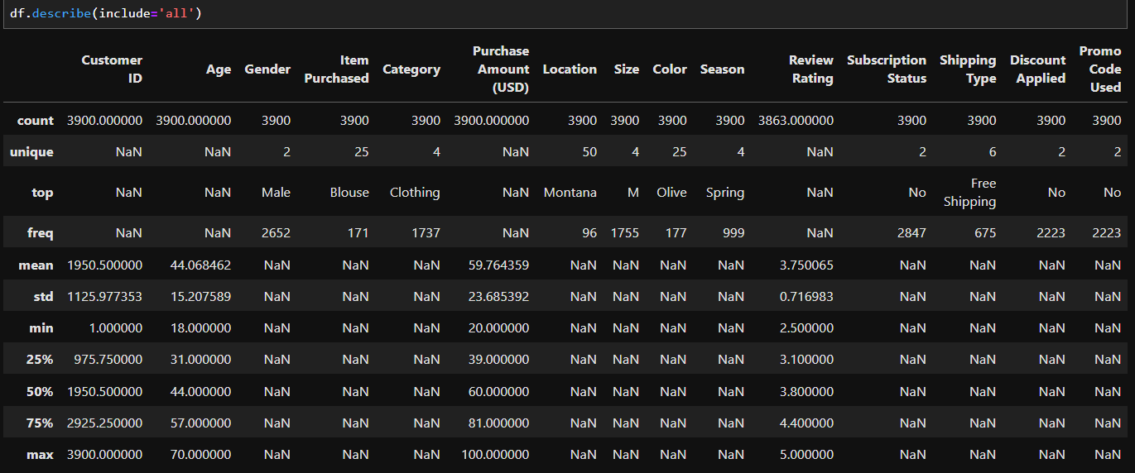
NOTE: df.describe(include='all') This provides the statistical summary of all the columns irrespective of the numerical values

- Finding Nulls in the data set using df.isnull().sum()
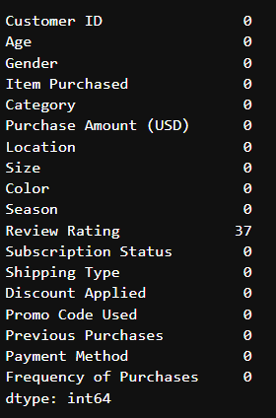

- Since I have 37 missing values in the columns ‘Review Rating’, they are replaced with the median value with respect to its category

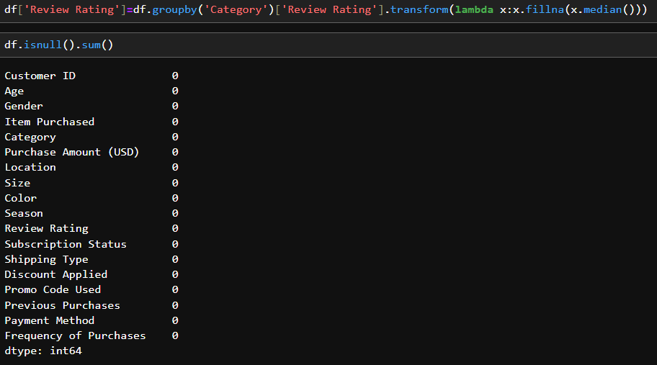

- Renaming the columns for easy implementation in further analysis.
- Changing all the string into Lower case
- Replacing the space with ‘-’ for better understanding in SQL
- Renaming the specified column for better usage.

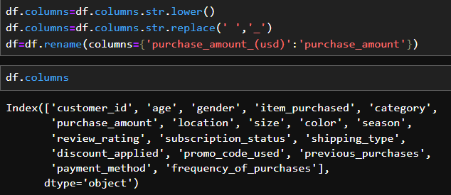

- Creating new columns for named ‘Age Category’ and ‘Purchase frequency days’

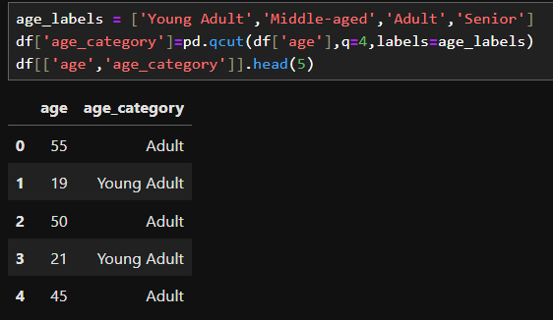
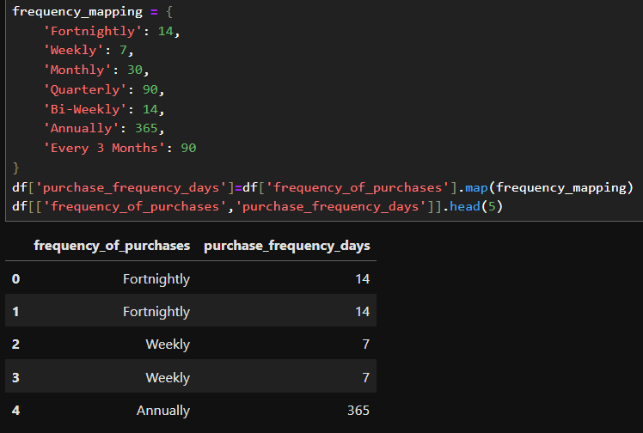
- Checking if two columns have the same value so that we could eliminate the unused column if not required.

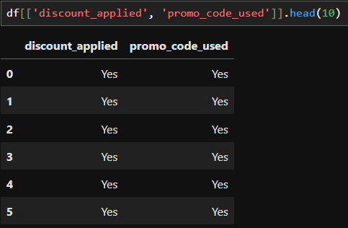

- Since both the columns have same value, one column has been dropped.

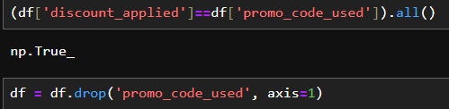

- Thus the final columns are as follows

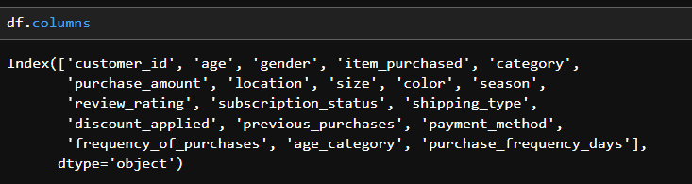

- Database Integration: Connected Python script to PostgreSQL and loaded the cleaned Data Frame into the database for SQL analysis.

DATA ANALYSIS WITH SQL:
Using PostgreSQL, I executed optimized queries involving joins, CASE statements, GROUP BY, and window functions to analyse customer purchasing behaviour. The analysis enabled identification of revenue drivers, discount effectiveness, and high-performing product categories.

- Revenue by gender: Compared total revenue generated by male vs female customers.

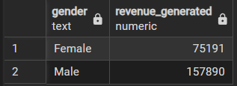

- Discounts and Average amount: Finding the customer who used a discount but still spent more than average purchased amount.

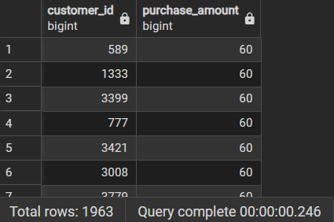

- Highest Review Products: Top 5 products with highest Average review rating:

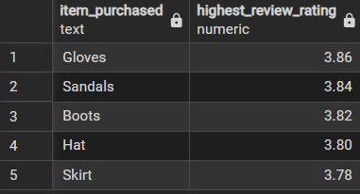

- Subscriber vs Non-subscribers: Do subscribed customers spend more? Compare average spent amount and Total revenue between subscribers and non-subscribers.

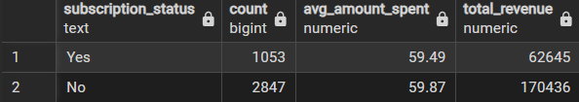
It is evident that the non-subscribers bring more revenue than the subscribers.

- Five products which have highest % of purchases with discounts applied

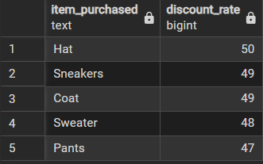

- Types of customers: Segmenting customers into New, Returning, Loyal based on the Total number of previous purchases and show count for each segment

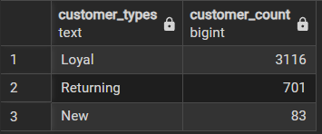

- Repeated products: Top 3 most purchased products within each category

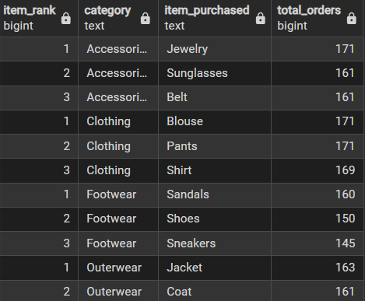

- Repeat Buyers: Are the Customers who are repeat buyers (>5 previous purchases) also likely to subscribe?

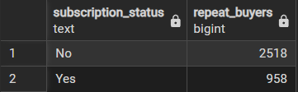

- Revenue: Revenue contribution of each group

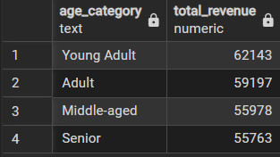

INTERACTIVE DASHBOARD USING POWER BI:
Based on the insights generated from Python and SQL analysis, an interactive Power BI dashboard was developed. AI-assisted visualization recommendations were used to select the most effective chart types and KPI indicators to present customer behaviour insights clearly.

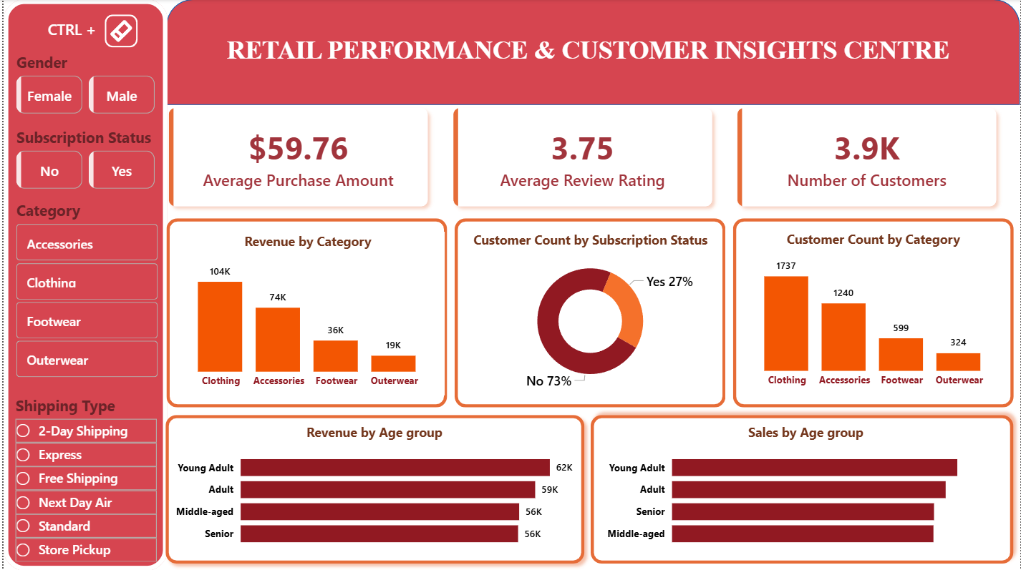

KEY INSIGHTS:

Female customers generated slightly higher average transaction values compared to male customers.

Non-subscribers contributed a larger portion of revenue, indicating untapped subscription potential.

Discount-driven purchases significantly influence product demand across certain categories.

Loyal customers contribute disproportionately to total revenue despite being a smaller segment.

TOOLS USED:
Julius AI | Dataset profiling, identifying missing values, and recommending cleaning strategies
ChatGPT | Assisted with data cleaning logic, SQL query optimization, and insight formulation
Python (Pandas) | Data cleaning, transformation, and exploratory data analysis
PostgreSQL | Advanced data analysis using SQL queries
Microsoft Power BI | Interactive dashboard creation and business insight visualization

BUSINESS RECOMMENDATIONS:
1. Boost Subscriptions
Introduce and promote exclusive subscriber benefits such as early access to new collections, personalized offers, loyalty-only discounts, and faster shipping options. Highlighting long-term value rather than one-time savings can increase subscription adoption and improve recurring revenue stability.
2. Customer Loyalty Programs
Develop structured loyalty tiers that reward repeat purchases with points, cashback, or milestone-based incentives. By identifying frequent buyers and nurturing them with targeted engagement strategies, customers can be gradually moved into a high-value “Loyal” segment, increasing retention and lifetime value.
3. Review Discount Policy
While discounts effectively drive short-term sales, excessive reliance may impact profit margins. Conduct margin-impact analysis to determine optimal discount thresholds and implement conditional promotions (e.g., minimum cart value or product-specific offers) to balance revenue growth with profitability.
4. Product Positioning
Leverage analytics to spotlight top-rated and best-selling products in marketing campaigns, homepage placements, and recommendation engines. Highlighting social proof (ratings and reviews) builds trust and improves conversion rates while maximizing the visibility of high-performing inventory.
5. Targeted Marketing
Segment customers based on revenue contribution, age group, purchase frequency, and shipping preferences. Allocate marketing budgets toward high-revenue demographics and express-shipping users who demonstrate stronger purchase intent, ensuring higher return on marketing investment.

