UnganaConnect Project Management Document
Copyright & Disclaimer
Government of South Africa reserves the right to make changes in the information contained in this publication without prior notice. The reader should in all cases consult Ungana-Afrika to determine whether any such changes have been made.
© 2015 Government of South Africa. All rights reserved.
Other product or brand names are trademarks or registered trademarks of their respective holders.
This document contains proprietary and confidential information about Government of South Africa; disclosure or reproduction is prohibited without the prior express written permission from Government of South Africa.

Revision History
Revision | Date | Status | Author | Reviewed By | Summary of Changes
1.0 | 12/09/2025 | Draft | Zoleka | Terence | Initial project plan documentation
1.1 | 15/09/2025 | Reviewed | Terence | Brintey | Added scope and deliverables
1.2 | 20/09/2025 | Final | Team | Ungana-Afrika | Final approval version

Document Approval List
Version | Approved By | Signature | Date
1.2 | Client (Ungana-Afrika) | ________ | 20/09/2025

Document Distribution List
Name / Group | Date Sent
Ungana-Afrika Team | 20/09/2025
Project Team (5 members) | 20/09/2025

Table of Contents

1. INTRODUCTION
1.1 Background
Ungana-Afrika supports African civil society organisations (CSOs) by providing ICT training, consulting, and research. Currently, most of these services are manual and fragmented. UnganaConnect will digitise the process, providing an online platform for training, knowledge sharing, consultancy, events, and impact reporting.
1.2 Purpose
The purpose of this project is to design and develop UnganaConnect, a web and mobile platform that streamlines training, resources, consultancy requests, events, and community engagement for CSOs.
1.3 Scope
The project will deliver six modules: Training, Resource Repository, Consultancy Management, Event Management, Community Forum, and Impact Dashboard.

2. GENERAL PROJECT INFORMATION
2.1 Core Project Data
- Project Name: UnganaConnect
- Client: Ungana-Afrika
- Department: ICT for Development
2.2 Department Description
Ungana-Afrika works to strengthen ICT adoption in African civil society by providing training, research, and consulting.
2.3 Project Size & Complexity
- Size: Medium-scale digital platform with multiple modules.
- Complexity: Moderate (requires integration of authentication, database, and cloud hosting).

3. EXECUTIVE SUMMARY
UnganaConnect will provide a centralised digital hub for African CSOs to access training, resources, consultancy services, events, and a community forum. The system will enhance efficiency, scalability, and accessibility, enabling Ungana-Afrika to expand its impact across the continent.

4. PROJECT SCOPE
4.1 Scope Statement
- In-Scope: Development of six functional modules, cloud hosting, mobile/web access, reporting, multi-language support.
- Out-of-Scope: Payment systems, AI-driven analytics, integration with third-party CSO platforms.
4.2 Scope Management Strategy
Scope will be managed using Trello/Jira, with weekly check-ins led by the Project Manager (Zoleka).
4.3 List of Deliverables
- Requirements document
- UML & ER diagrams
- Wireframes
- Web & mobile app
- Technical & user manuals
- GitHub repo with CI/CD
- Recorded presentation
4.4 Work Breakdown Structure (WBS)
- Phase 1: Requirement Gathering
- Phase 2: Planning & Design
- Phase 3: Development (4 sprints)
- Phase 4: Testing & Client Feedback
- Phase 5: Submission & Presentation

5. PROJECT GOVERNANCE & ORGANISATIONAL STRUCTURES
5.1 Governance Structure
- Client: Ungana-Afrika
- Project Sponsor: ICT Department
- Oversight: Project Manager (Zoleka)
5.2 Organisational Structure
Team Roles:
- Terence – Group Leader & Backend Developer
- Bhekile – Full Stack Developer (frontend + backend)
- Sage – Frontend Developer
- Brintey – Business Administrator (documentation, reporting)
- Zoleka – Project Manager (planning, coordination, communication)

6. RESOURCE REQUIREMENTS
6.1 Project Team
5 members with complementary roles (listed above).
6.2 Roles & Responsibility Assignments
Team Member | Role | Responsibility
Terence | Backend Developer / Leader | Database, API development, overall code reviews
Bhekile | Full Stack Dev | UI + backend integration, consultancy & event modules
Sage | Frontend Dev | User interfaces, wireframes, responsive design
Brintey | Business Admin | Documentation, reports, client engagement notes
Zoleka | Project Manager | Timeline management, communication, risk management

7. SCHEDULE AND BUDGET
7.1 Schedule
- Weeks 1–2: Requirement gathering
- Weeks 3–4: Planning & design
- Weeks 5–10: Development sprints
- Weeks 11–12: Testing & client feedback
- Week 13: Final submission
7.3 Budget (hypothetical for student project)
- Hosting (cloud): $50/month
- Development tools: Free (student licenses)
- Total estimated cost: $150–$200

8. COMMUNICATIONS & QUALITY MANAGEMENT
- Communication: Weekly meetings via Teams/Zoom, Trello for task tracking, GitHub for version control.
- Quality: Code reviews by Terence; testing in each sprint; client feedback loops.

9. RISK MANAGEMENT
9.1 Key Risks
- Missed deadlines (medium risk)
- Technical issues with hosting (medium risk)
- Scope creep (high risk)
- Limited internet access in target regions (medium risk)
9.2 Risk Response
- Strict sprint planning
- Backup hosting option
- Scope freeze after design approval
- Mobile-first, low-bandwidth optimisation

10. MONITORING & CONTROL
- Weekly progress reporting by each member.
- Change control process managed by Project Manager.
- Issues logged in Trello/Jira and resolved within 1 sprint.

11. CONSTRAINTS & ASSUMPTIONS
- Constraints: Time (13 weeks), budget limits, student resource constraints.
- Assumptions: Client will provide feedback promptly; tools like GitHub and cloud hosting will be accessible.

Document UnganaConnect Project Management

1. Introduction
UnganaConnect is a digital platform designed for Ungana-Afrika to streamline training, resources, consultancy, events, and community forums for African CSOs.

2. Work Breakdown Structure (WBS)
The following table outlines the WBS:
WBS ID | Phase / Task | Subtasks | Assigned To
1.0 | Requirement Gathering | Client engagement, Documentation, Approval | Zoleka, Brintey
2.0 | Planning & Design | Project planning, UML & ER diagrams, Wireframes | Zoleka, Terence, Bhekile, Sage
3.0 | Development | Authentication, Training, Consultancy, Forum | Development team
4.0 | Testing & Presentation | Testing, Feedback, Presentation | Whole team
5.0 | Submission | Final documentation, GitHub, Submission package | Whole team

3. Gantt Charts
The project timeline is represented in two Gantt charts below:
General Project Timeline:
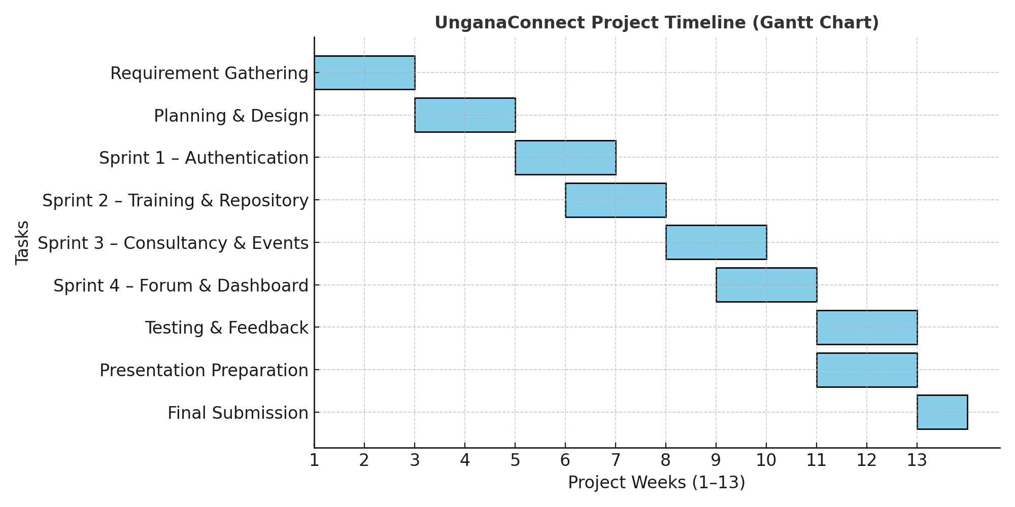
Timeline with Team Member Responsibilities:
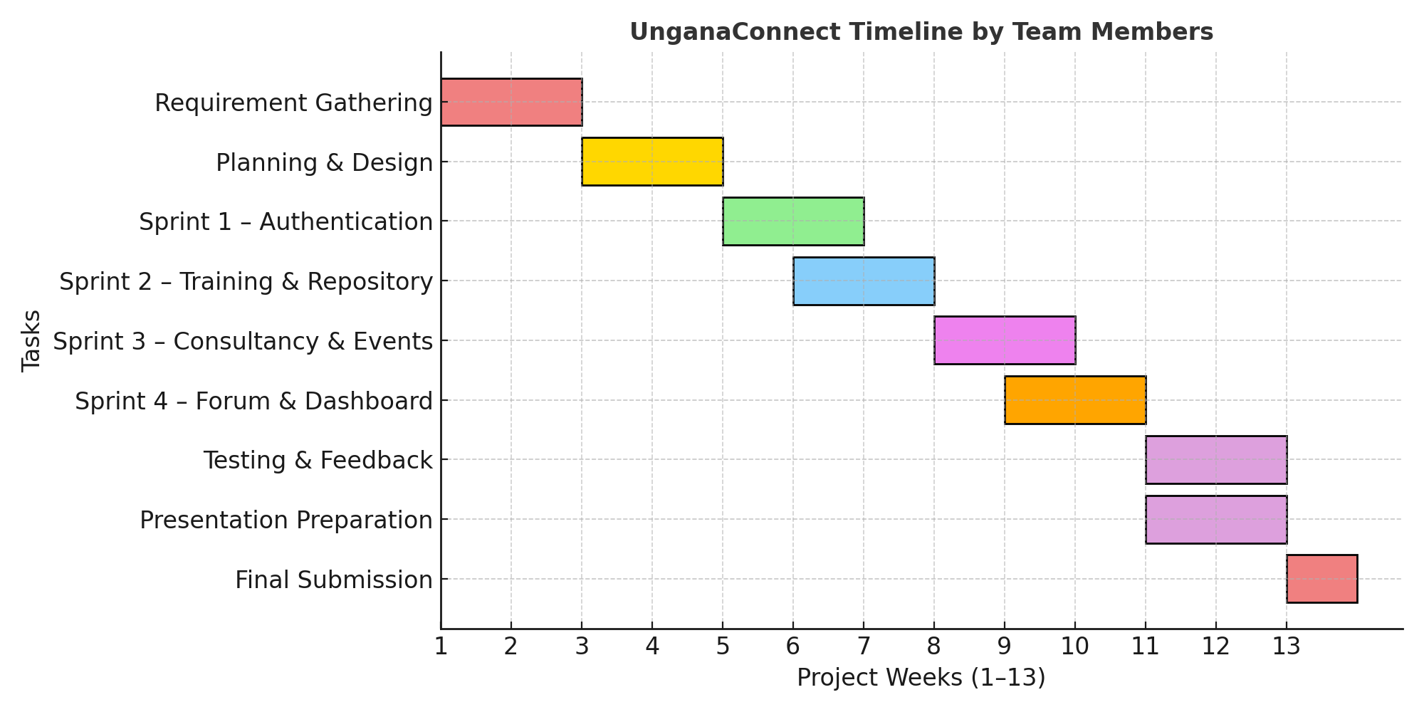

4. Risk Management
The following risk matrix shows potential risks based on likelihood and impact:
