CMPG223 Distance group 9  
CMPG 223  
ODL Bsc(IT)  
Assignment 1  
Title

CMPG 223

|  |  |
| --- | --- |
| Group Members |  |
| Jaco Brits | 38980274 |
| Marcel Volschenk | 33451524 |
| Hendrik Diedericks | 45973466 |
| Karina Visagie | 40878554 |
| Ryno Williamson | 47492058 |

# **Scope**

* The system must include functionality for the following:
* Maintenance of stock (inventory)
* Maintenance of category (lights, switches)
* Maintenance of subcategory (light white, light yellow)
* Maintenance of employees
* Maintenance of equipment
* Maintenance of clients
* Maintenance of jobs
* Selling of stock
* Detailed reporting, including job reports , equipment tracking and Inventory tracking.

# **Physical Data Model**

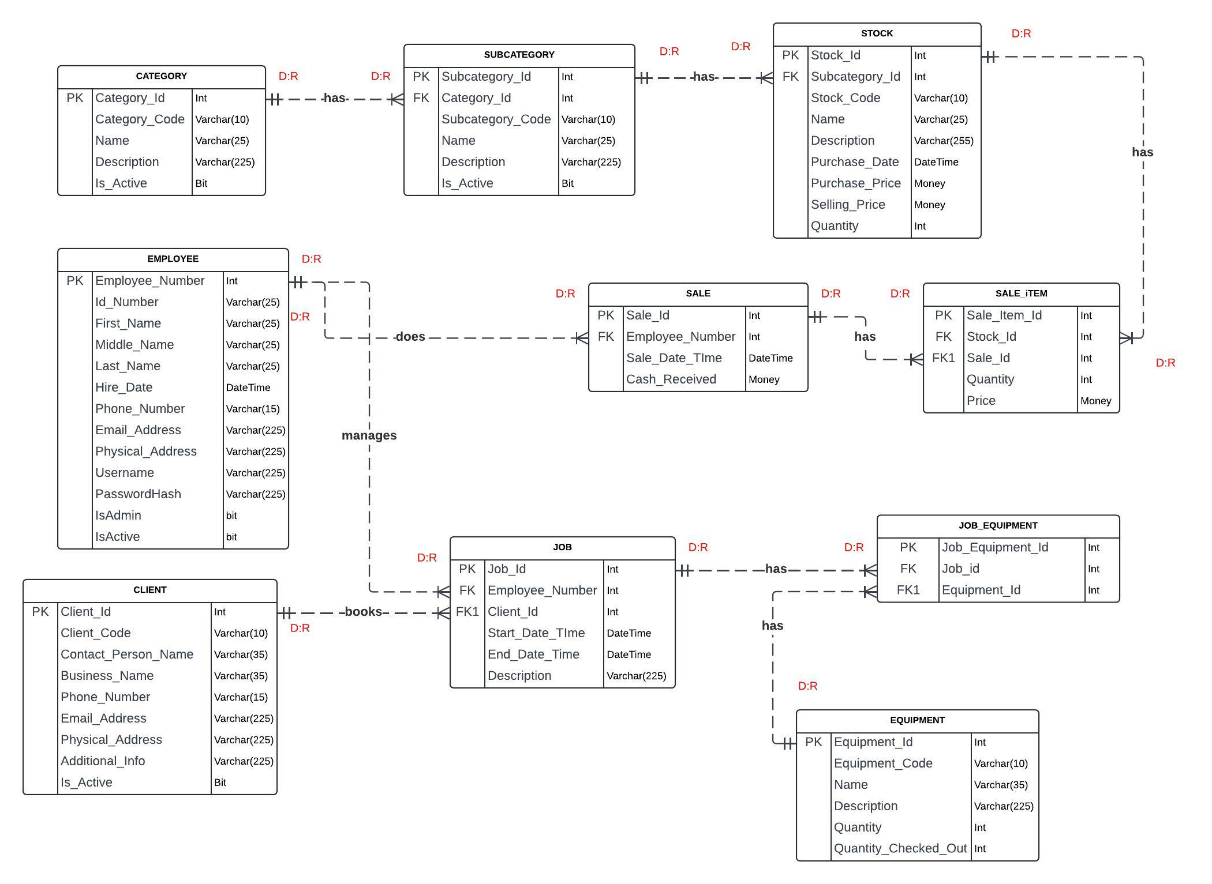

# **Physical Process Model**

## Shop Assistant Process Flow

## Job Process Flow

## Employee Process Flow

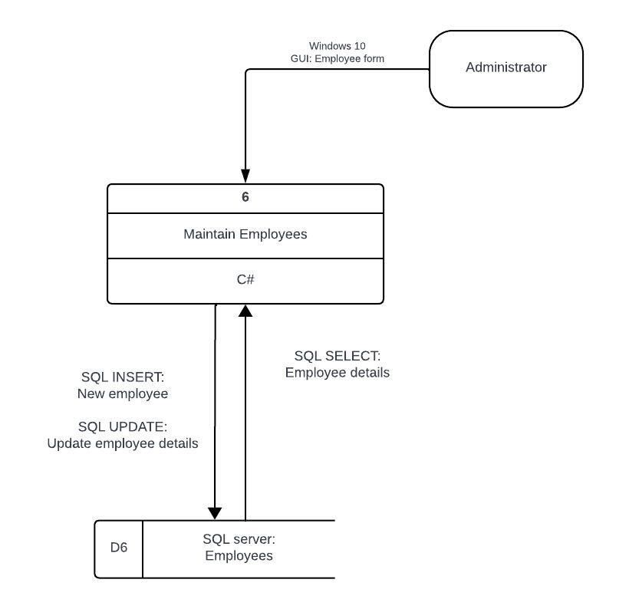

## Sales Process Flow

ToDo

# **Programming Code**

## Maintain Entity

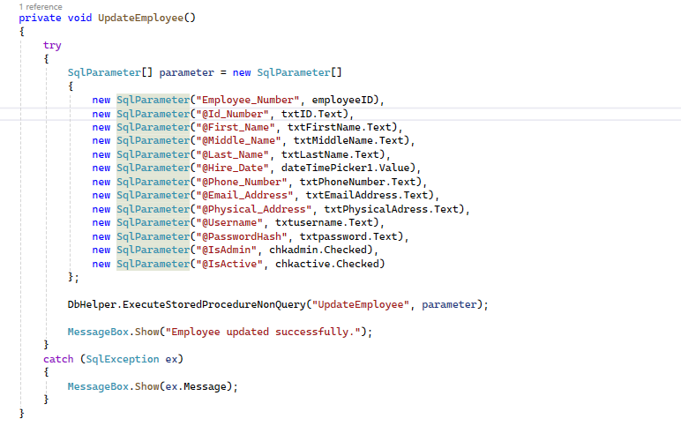

## Code Reusability

# **User Manual**

## ToDo Karina

# **Project Plan**

## Schedule

## GitHub Commits

Get screenshot when Karina is done.