Lab2



**Figure 1** is the time series of EWH at Amazon and Greenland from 2003 to 2015. The blue line is Amazon. An annual period is obvious but no long-term trend, which is proved by **Figure 2** and **Figure 3**. In **Figure 2**, the blue line is the raw EWH and the red one is detrended pattern. They match well, so there is not trend at Amazon. But from **Figure 3**, after the FFT process, we can find a period close to one year- 0.98077 year. This fits to its wet season and dry season alternation.

With the same process on Greenland, a large long-term trend is derived from **Figure 4**. Attention, the y-axis on the left is different from the right, which represent for ‘raw’ and ‘detrend’ data, respectively. This can be explained by the ice melting and global warming. The periodical signal of Greenland is much more complicated. The seasonal signal is not obvious but will three more periodical signal around 11.7, 3.7 and 0.97 year respectively.

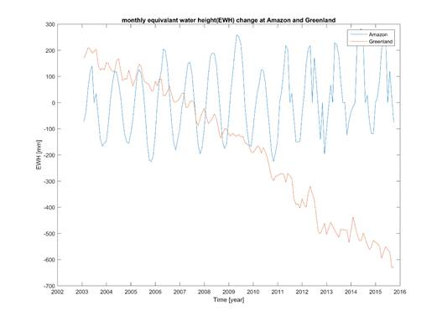

***Figure 1***

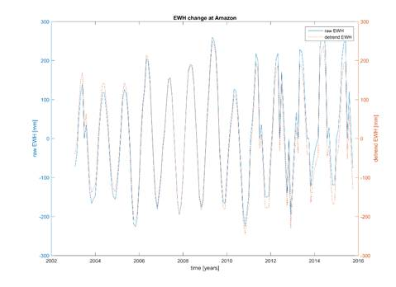

***Figure 2***

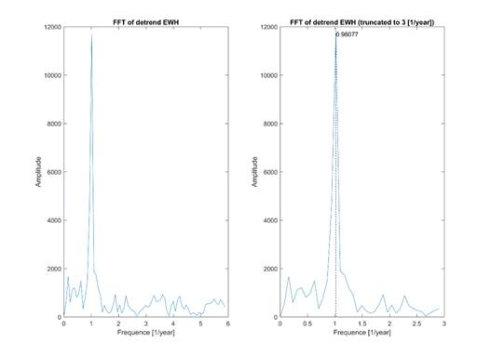

***Figure 3***

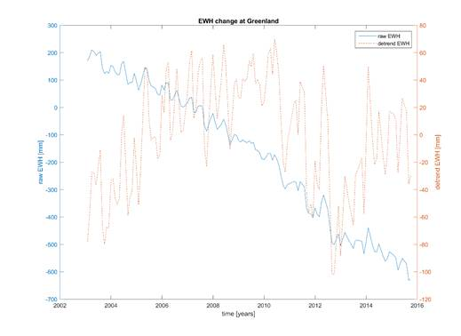

***Figure 4***

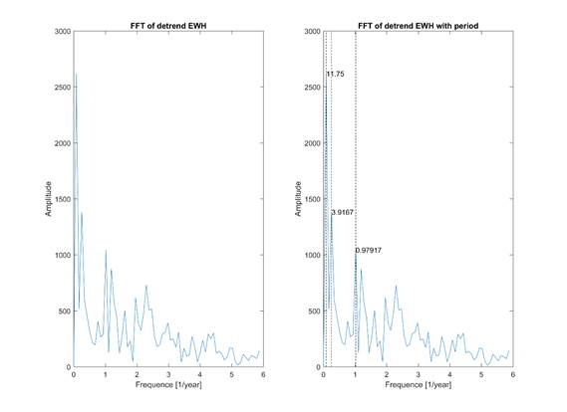

***Figure 5***



**Figure 6**  the left three are the raw EWH change, with de-correlation and with smoothing, respectively, on Jan. 2003. The right three are on Jul. 2003. We can see the raw pattern is a mess and full of strips. But after the de-correlation the change of the EWH become clearer and the strips are only around the equator. Finally after the smoothing, the strips almost gone.

Comparing the patterns of summer (Jul.) and winter (Jan.) ,the bottom two, we can see, most place can be explained by the seasonal change. The Bangladesh and Amazon (red case) get more rainfall from Jan.(dry season) to Jul.(wet season). Similar at Antarctic (black case), on the southern hemisphere, the weather changes from summer to winter and more ice is generated, which cause the mass increase. But it is wired on Greenland (yellow case). As the temperature grows from winter to summer, the mass grows. This is contrary to what we know—the ice will melt during the summer.

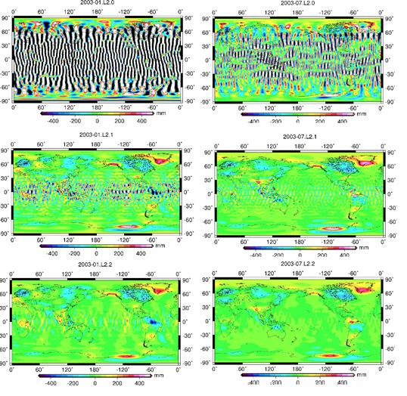

***Figure 6***



**Figure 7** shows the results after smoothing with different radius on the Jul. 2003. The pattern without smoothing still has a lot strips around the equator. With the grows of the radius, the strips become less and less and disappear after 300km. But at the same time the signal is also smoothed. The bright spots on Greenland, Amazon, Bangladesh and Antarctic become gloomy. So a radius from 200 to 300 is recommended, which is close to the altitude of the GRACE and the distance between the two GRACE satellites.

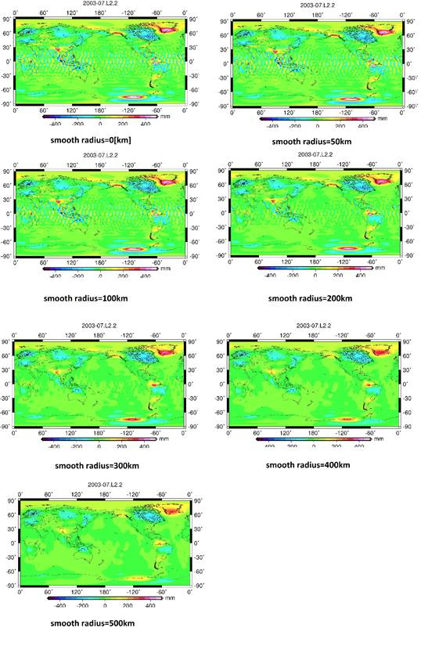

***Figure 7***

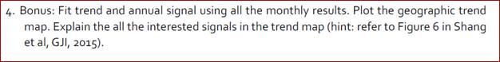

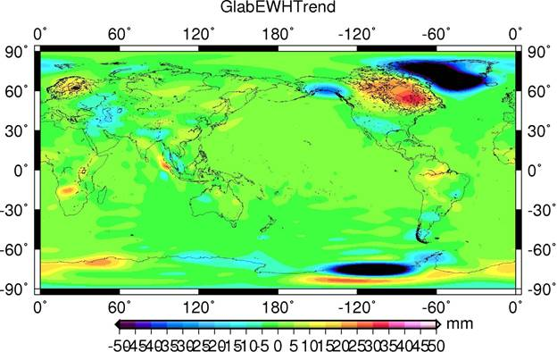

***Figure 8***

Here I give some guesses and explanations without proof

1. Greenland has a decrease trend which can be explained by the loss of the ice shell.
2. The earthquake happened on Sumatra on 2004 cause the contrary trends on two sides of the island.
3. A decrease trend on North China may be due to the over use of the underground water
4. The decrease trend of Tibet Plateau may come from the glacier melting
5. It is interesting that the Antarctica has the contrary trends, the inner with an increase trend and the boundary with a decrease trend.
6. Amazon has an increase trend I do not know how to explain.
7. Also the trend on South part of Africa, Alaska, west Europe and middle east cannot be explained by me