Project Proposal
Beeverse
Lawrence Milne and Brittany Mueller
Overall game idea

Our game is a city builder style game in which you have to build and sustain a bee colony.

Our game is a city builder style games in which you have to build and sustain a bee colony. The game has 4 main goals, keeping the colony alive growing new bees as other die passively with age. Expand the colony by building new honeycombs which will allow you to hold a higher population of bees, grow a new queen bee before the queen dies from age. The game will end if your queen bee dies or if your colony dies out from old age.

- survival city builder
- bee colony simulator
- real time strategy
main goals
- The main goals are
  - expand the colony
  - keep the colony alive (bees passively die of age)
  - grow a new queen before old dies
- The game ends if
  - queen dies without a new queen

Game level layout
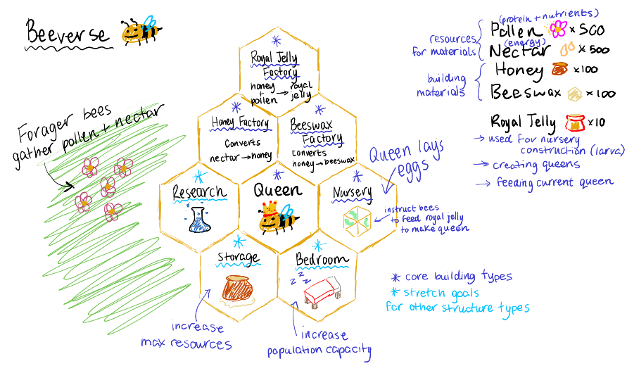

The game will be a top down view of a field which has a bee colony in the center. When the game starts are you will have single honeycomb in the center which holds your queen bee. You can then build 4 types of honeycombs structures
- Honey Factory
  - Used to convert nector into honey
- Beeswax factory
  - Used to convert honey into beeswax
- Royal jelly factory
  - converts honey + pollen into royal jelly

Player
- responsible for managing the bee colony, assigning tasks to bees
- UI for selecting different honeycomb structures

NPC

Other game entities

Responsibilities of group members

Lawrence Milne
-
Brittany
- Game programmer
- Game design

