DM6101 Assignment Document
Matriculation number: G1402663L Name: Zhou Guoyan
I. Content of the submission folder
1. The source code is in the folder “Source code”.
2. The VS 2010 project files are in the folder “Project File”.
3. The .m format 3D models are in the folder “meshes”.
4. The executable file is in the folder “Executable File”. (I generated two version of executable file, one is built under debug mode and one is built under release mode. The one I put in this folder is the latter one.)
5. The document is “Readme.doc”.
II.Compiling instruction:
1. This project is done under Visual Studio 2010 in windows 8. So the compiling environment should be VS 2010, windows 8;
2. I use GLUI to create the user friendly interface and the model example is example 5;
3. Before you compile the program, you must make sure you have configured the corresponding .h files, .lib files and .dll files for OpenGL and make sure the glui lib is collocated correctly. To open the project, you enter the folder “Project File->3d mesh” and open “3d mesh.sln” with Visual Studio 2010, and then you will see the following:
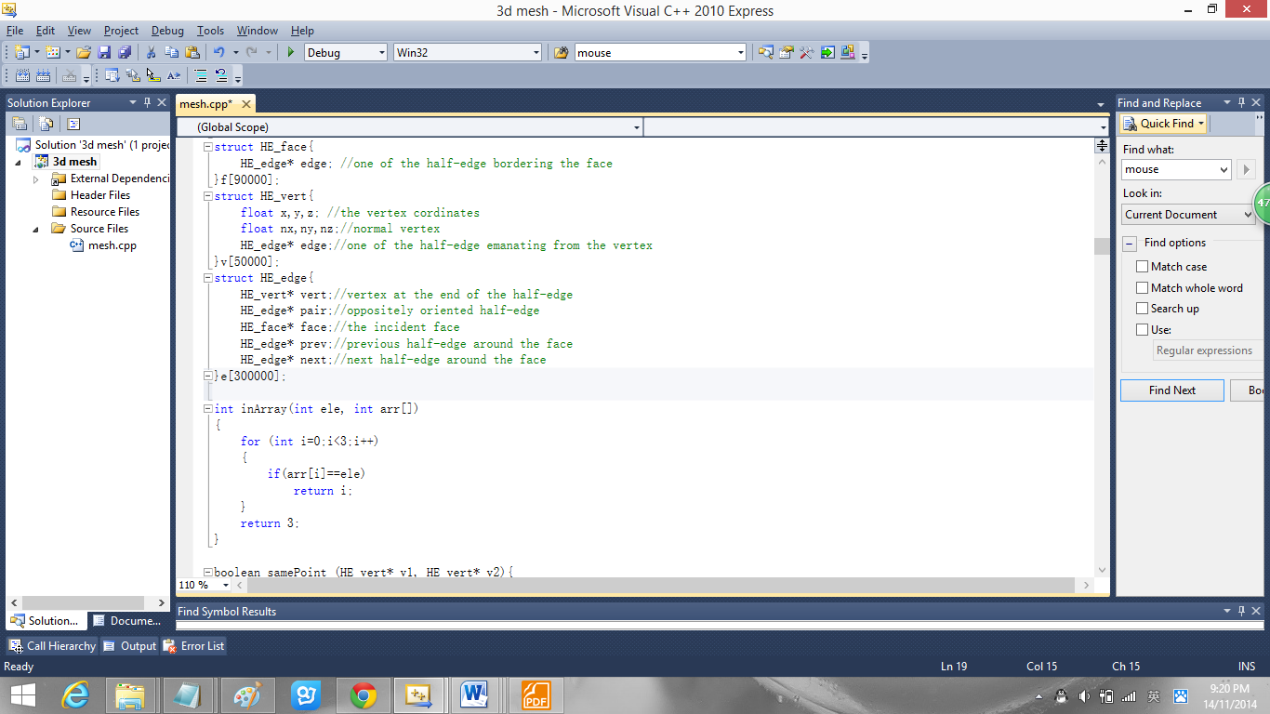
Then you can press ctrl+F7 or choose Build->Compile to compile the source code.
To build the executable file, you can choose Build->Project Only->Build Only Mesh Viewer. There are two versions of executable file you can build, one is debug version and another is release version. To get the release version, you change the configuration here:

The release version is an optimized version which will be smaller and faster than the debug version.
An easy way to both compile and run the program is to press F5 or choose Debug-> Start Debugging.

.Program Manual:
1. Importing a 3D mode, after run the program, the user should click on the “Import” button and choose an m file to open; I have put 5 model files in m format in the folder “meshes”.
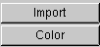 Click on “Import” button, you will proceed to this:
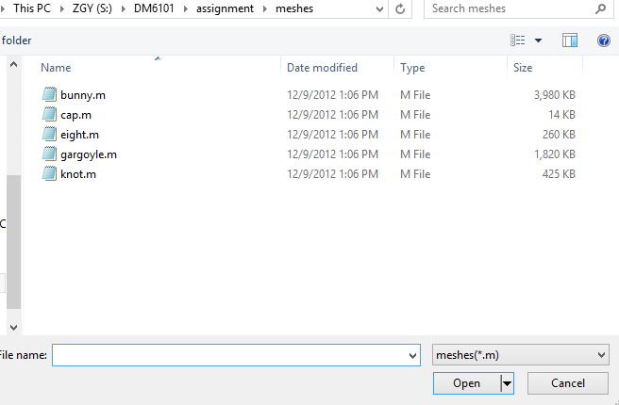Choose “eight.m” to open, then this 3D model will be loaded and shown in the window:
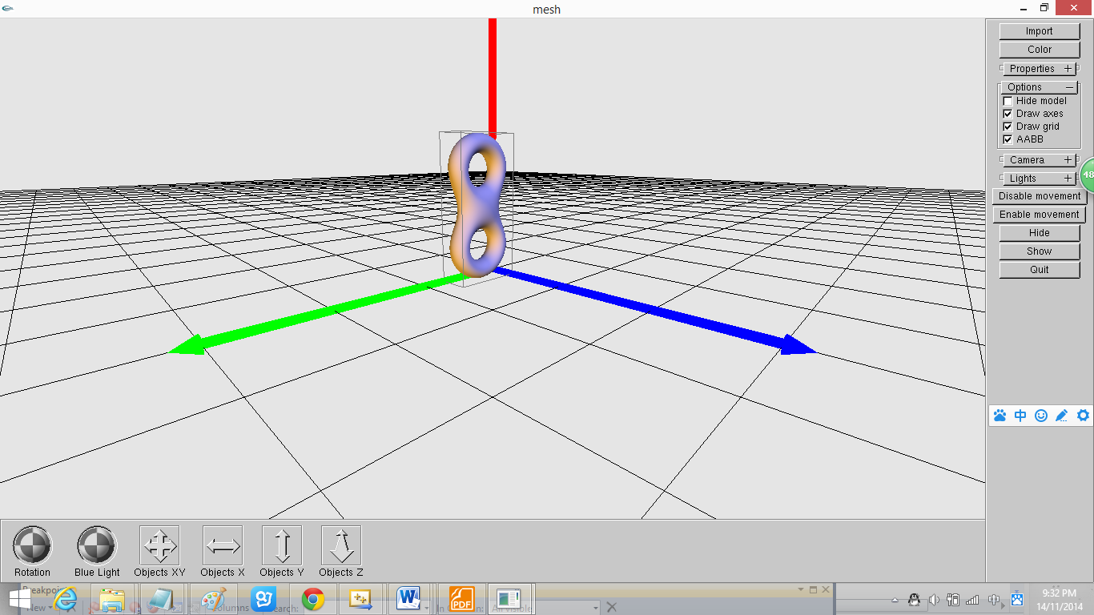
when loading this model, the sub window will reveal the pairing half-edge processing and point normal computing processing, when it stopped, then the demo will revel in the window.
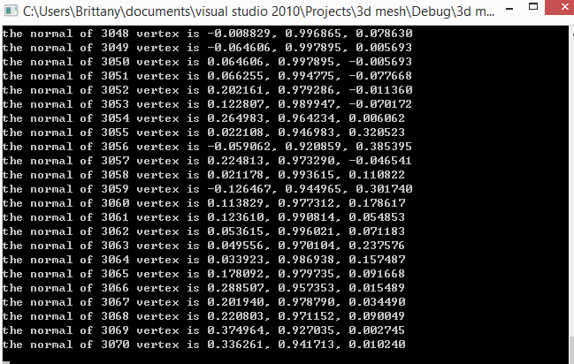
2. Changing the Object property by clicking on “property” panel.
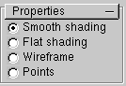 Click on “smooth shading”

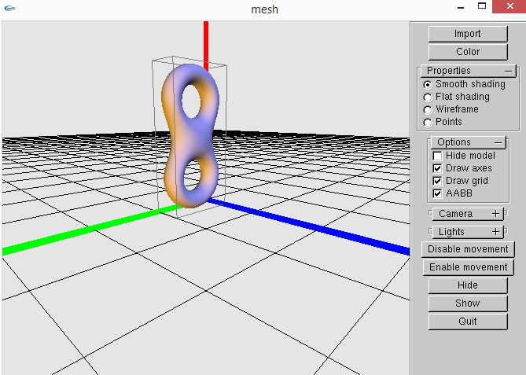
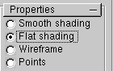
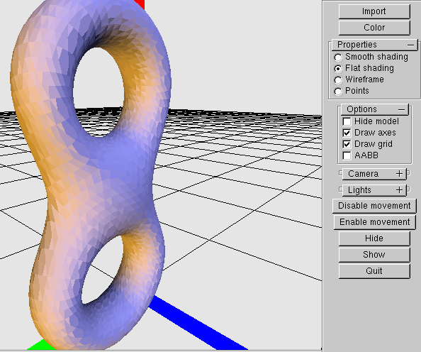
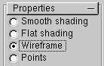
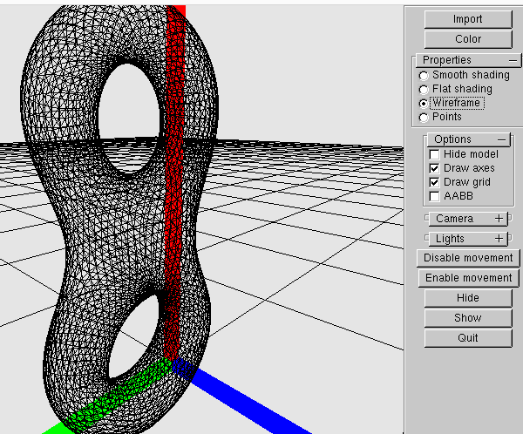
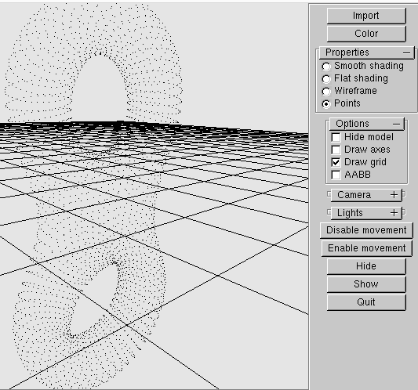
3. Choosing a projection mode, you can choose Orthogonal projection or Perspective projection by clicking on the corresponding radio button.
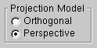
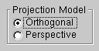
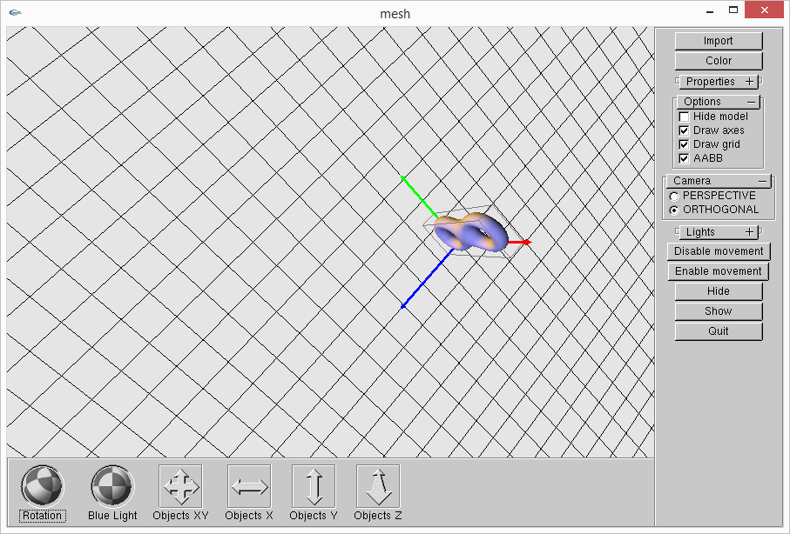
4. Deciding to draw axe, grid and bounding box or not by the checkboxes.
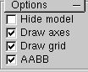
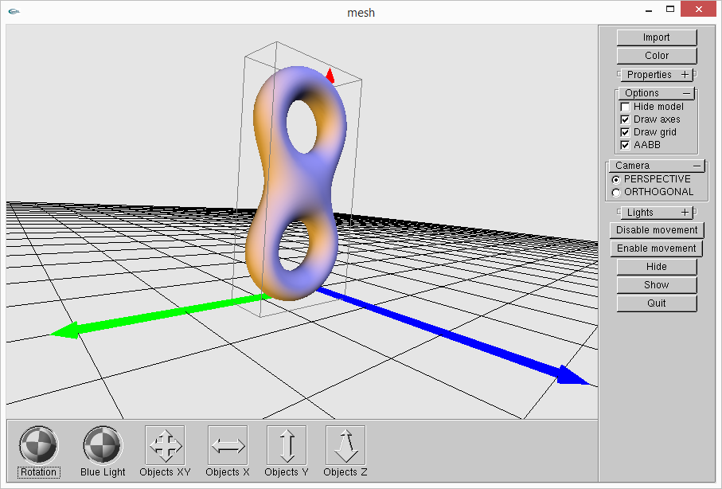
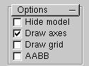
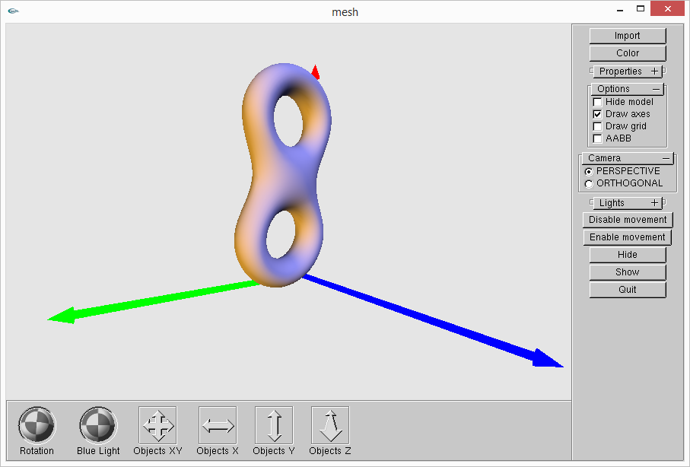

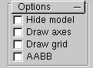
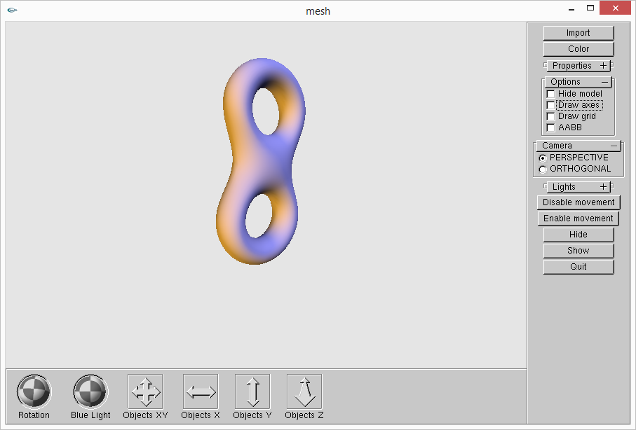
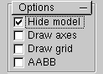
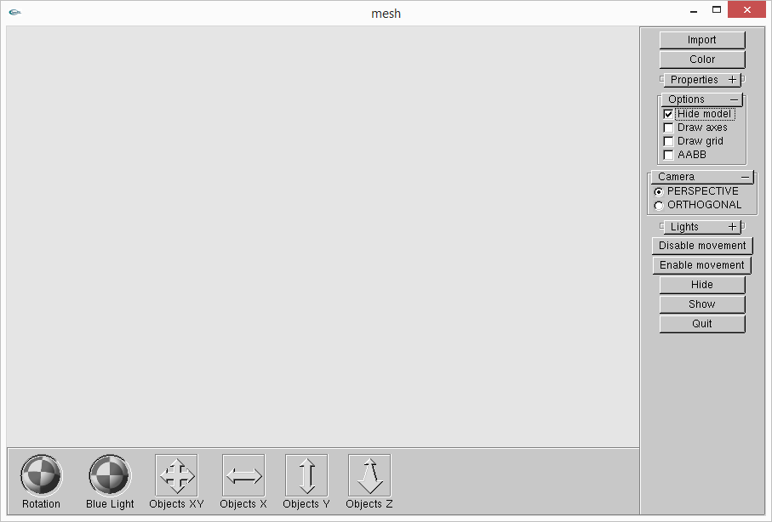
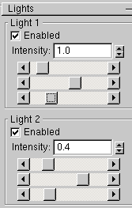

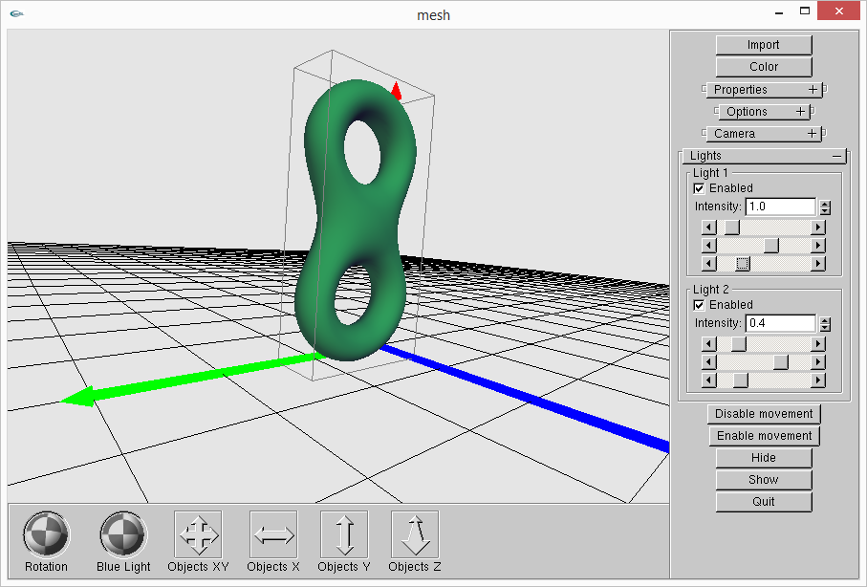
5. Transform these buttons like following shows, then can change the camera station.
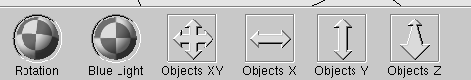
Object z:
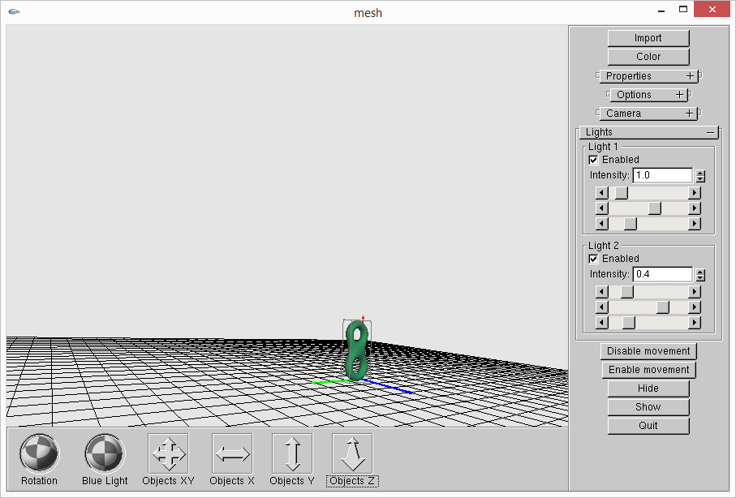
object y means transform camer follow y axis
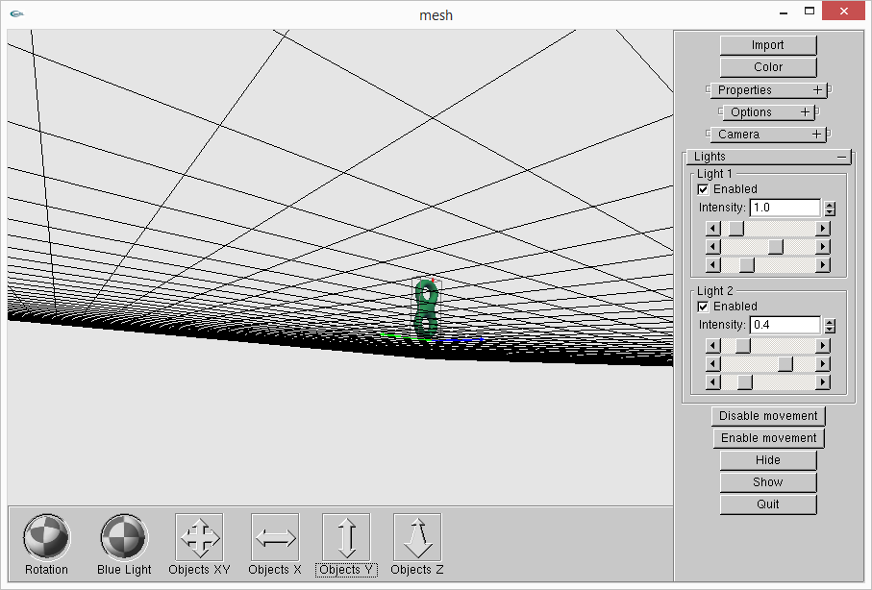
object xy ,just transform camer in xy plane:
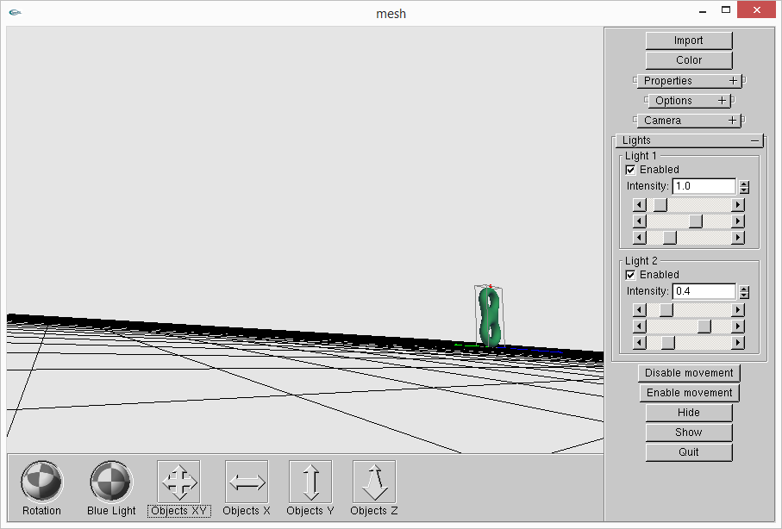
Rotation just rotate the camera:
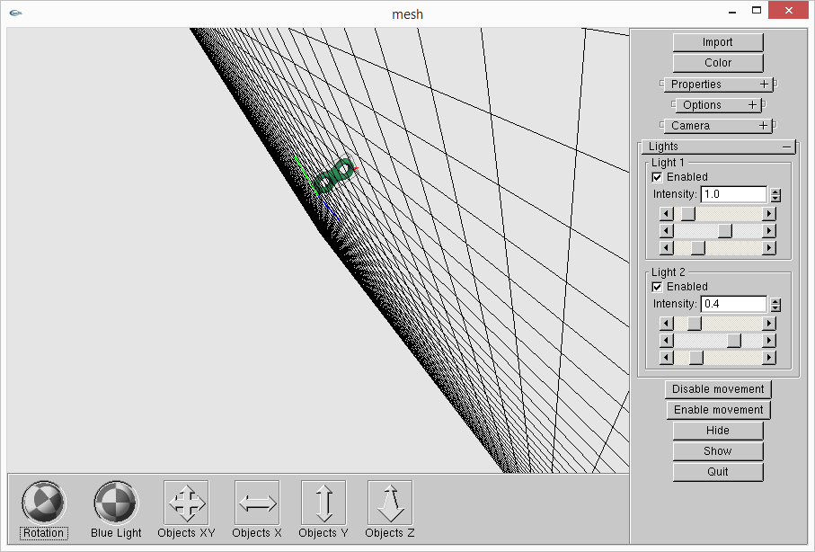
6. Transforming the model using mouse buttons, you can press left button to rotate the model, press middle button to translate the model and press right button to zoom in/out the model.
Rotate model:
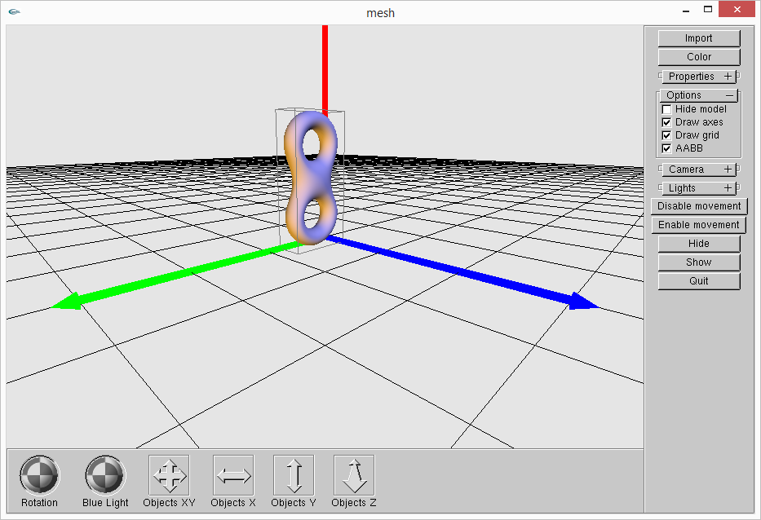

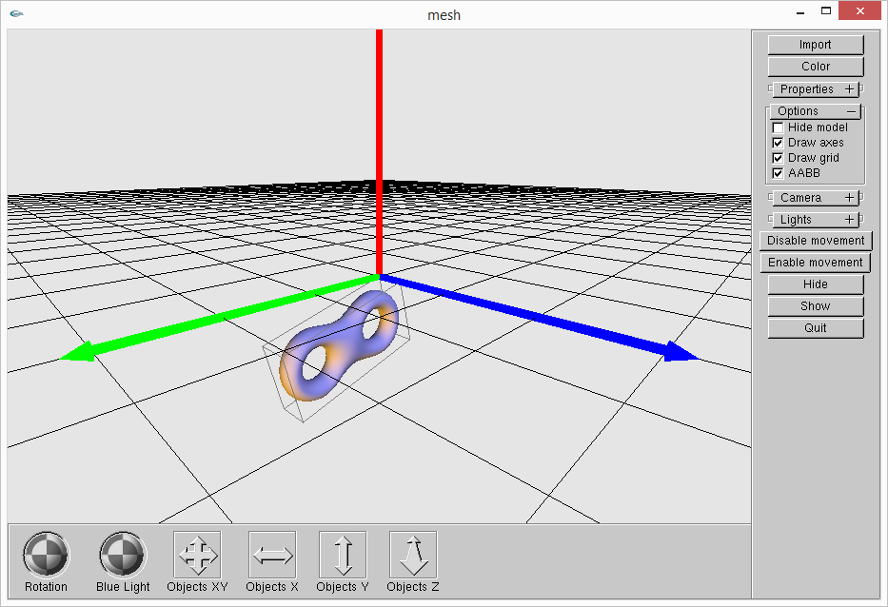
Zoom in/out the model :
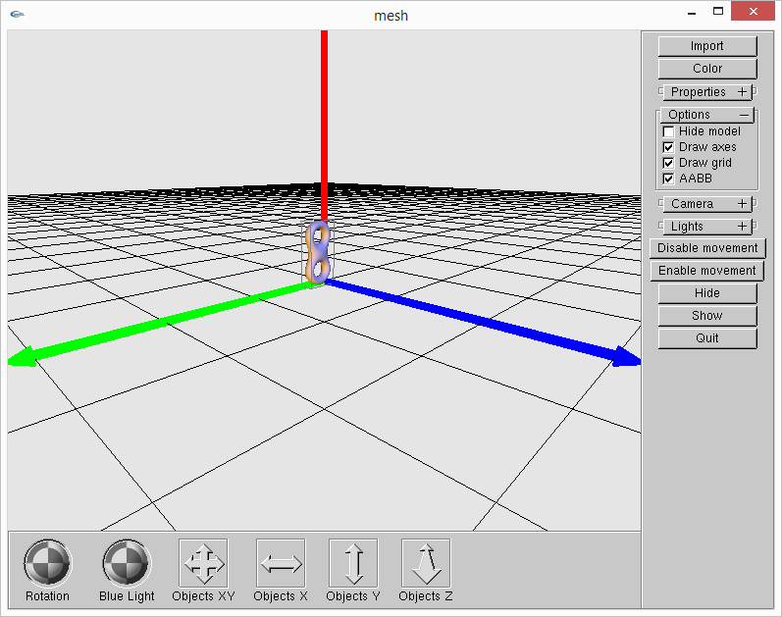

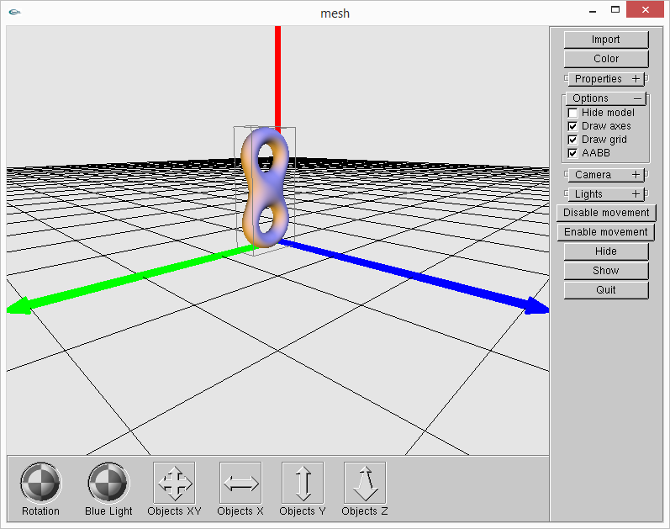
Translate the model only:

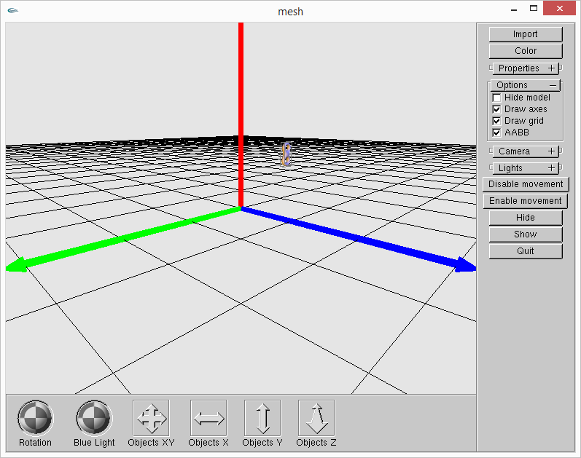
7. Click exit button to exit the program.
Notation:
the imput button just only load once, if you want to load another model, please click the exit button to exit and rebuild this program.

