Brittni Ray

2024.04.13

Module 4.2 Assignment

CSD 310-J308

**First contact:**

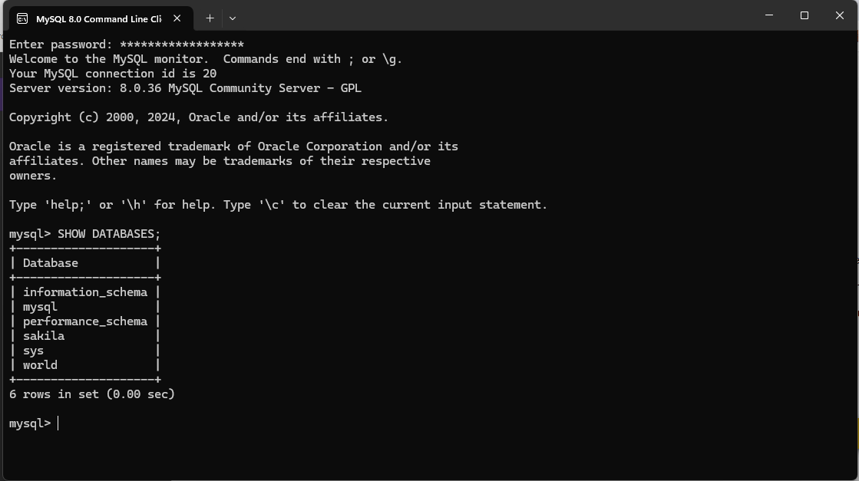

**After adding ‘movies’ database:**

