Brittni Ray

2024.04.13

Module 5.2 Assignment

CSD 310-J308

**CURRENT_TIMESTAMP()**:

The CURRENT_TIMESTAMP() function in MySQL can be used for many reasons, the obvious one being that it can retrieve the current date and time that the function was run. This can be especially useful in the case of auditing so that an auditor can survey the specific time and date that an action was taken. The alias that I gave this function was “Current Date and Time” since those will be the two items reflected—in that respective order—below when this function is called.

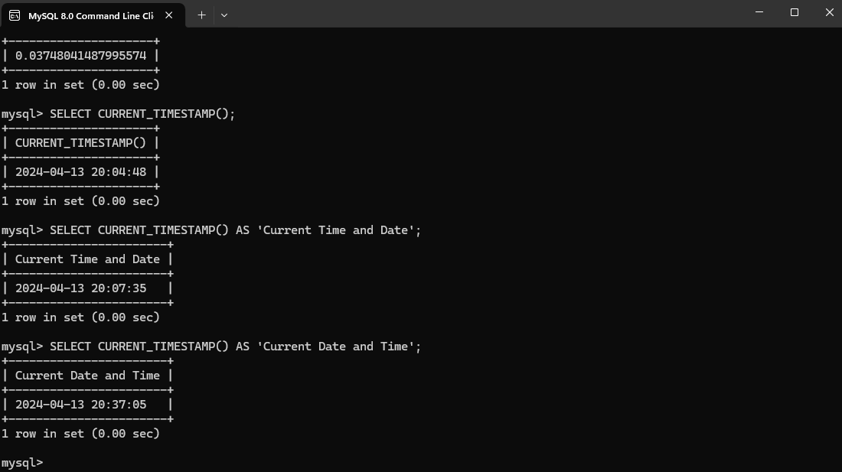

**DAYOFMONTH(‘date’)**:

The DAYOFMONTH() function in MySQL can be used to pull a specific day of a specified date/month into a number that represents that day only. This function is useful when one desires to filter or query data based on specific days of any given month, making it useful for analyzing trends or events that happen to occur on certain days. I, therefore, chose to give this function the alias of ‘Specified Day of the Month’, since that seemed to represent exactly what this function was doing. Even with the whole date given in the body of the function, the only item that will be returned is the *day* of the month and nothing else.

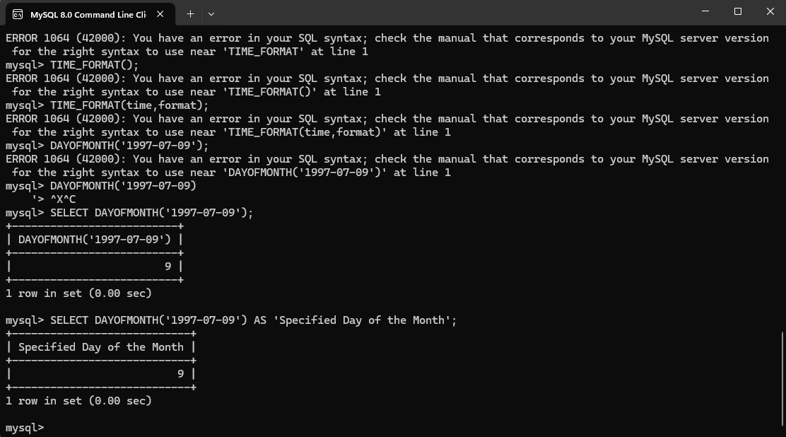

**DAYNAME(‘date’)**:

The DAYNAME() function in MySQL can be used to return the name of the day of the week for any given date specified within the function’s body. It is useful when visualizing or analyzing data for a specific day of the week and can even be used in reservation systems by having the ability to display the day of the week that a customer makes a reservation, which can influence booking decisions. I chose to give this function the alias of ‘Day of Week for Specified Date’ because I thought it better reflected exactly what this function is doing. It is taking any date that is input into it, and returning the name of the day of the week for that specific date value.

