Brittni Ray

Module 1.2

CSD-340

2024.06.01

Link to repository:

<https://github.com/BrittleBunny/csd-340>

Screenshot of ‘dir’:

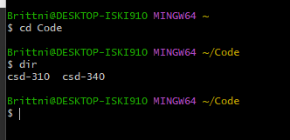

Local directory:

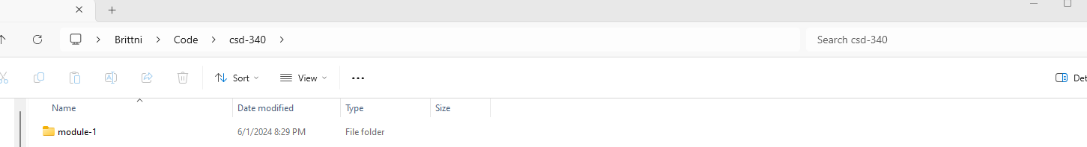

Git hub repository landing page:

