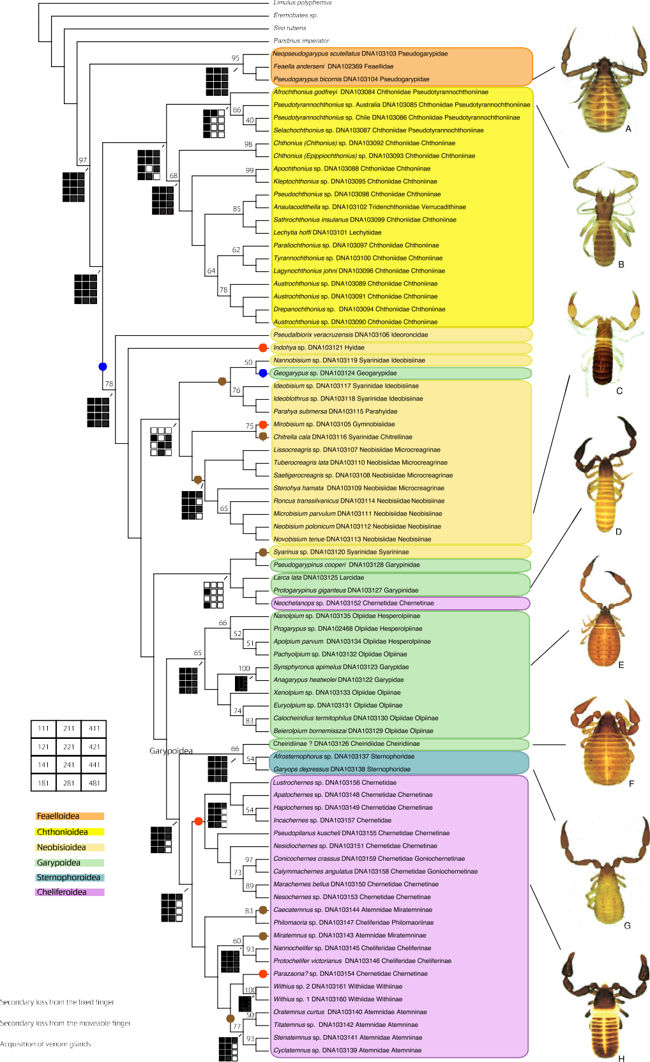*J. Murienne et al. / Molecular Phylogenetics and Evolution 49 (2008) 170–184* 177

Fig. 3. Phylogeny of Pseudoscorpiones based on the direct optimization combined analysis of 18S rRNA, 28S rRNA and COI data under the parameter set that minimizes incongruence. Support values on branches indicate jackknife frequencies. Each weighting scheme is named by a three-digit code corresponding to the ratio of indel/ transversion, transversion/transition and transition values. Black indicates that the monophyly of the group is retrieved under the particular parameter set. Representative pseudoscorpions of all recognized superfamilies are illustrated: (A) *Pseudogarypus bicornis* (Banks) (Pseudogarypidae) from CA, USA; (B) *Pseudotyrannochthonius* sp. (Chthoniidae), from Western Australia; (C) *Neobisium carcinoides* (Leach) (Neobisiidae), from Scotland; (D) *Protogarypinus giganteus* Beier (Garypinidae), from Western Australia; (E) *Synsphyronus* sp. (Garypidae), from Western Australia; (F) unidentiﬁed Cheiridiinae (Cheiridiidae), from Western Australia; (G) *Garyops depressus* Banks (Sternophoridae), from FL, USA; (H) *Marachernes bellus* Harvey (Chernetidae), from Victoria. All images by M.S. Harvey.