HW2

Overview:

For this project I tried to implement a Brand value prediction using twitter sentiments as a source to show trends in popularity. In essence, the popularity of a brand is based on the current tweets on the topic. IBM’s natural language understanding to extrapolate sentiments and associating those sentiments into personality insights using machine learning I followed the processes mentioned in this [tutorial](https://www.ibm.com/developerworks/library/cc-cognitive-watson-extract-insights-spark-dsx/cc-cognitive-watson-extract-insights-spark-dsx-pdf.pdf) as a guide to implement the rest of the features

Tools used

**Node Red**

I used Node Red in IBM Bluemix as a tool to generate tweets and fill a database to analyze data. This was the IOT Portion of the Homework. Although, it’s a service, its behavior was like a separate device whose role was to solely provide twitter data to the system.

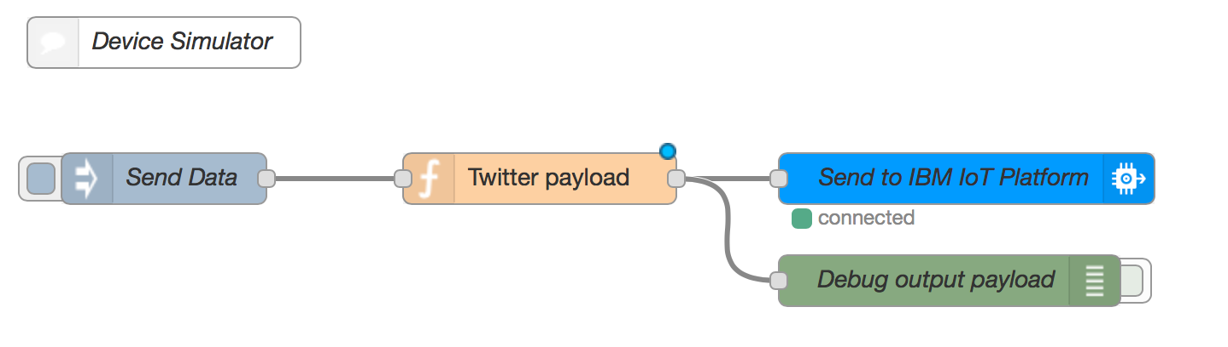

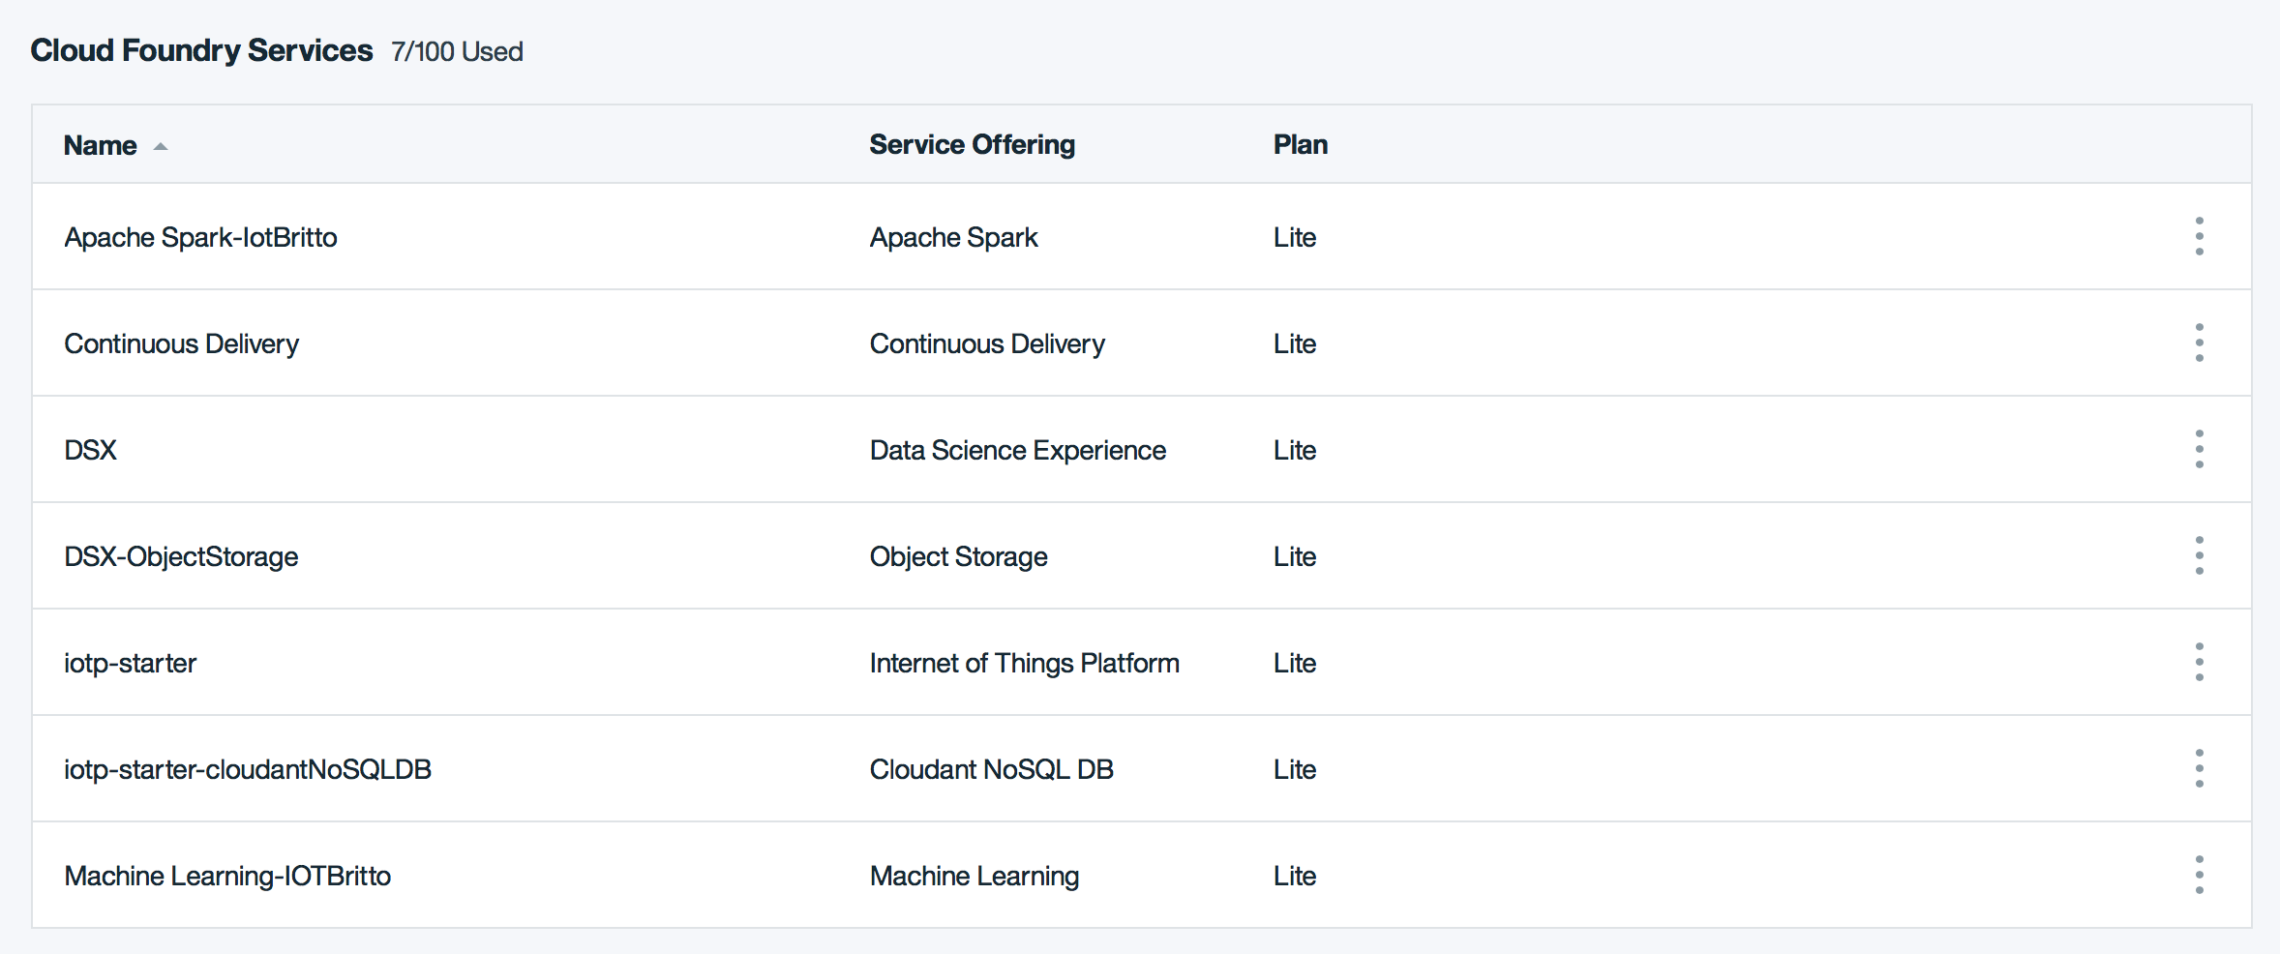

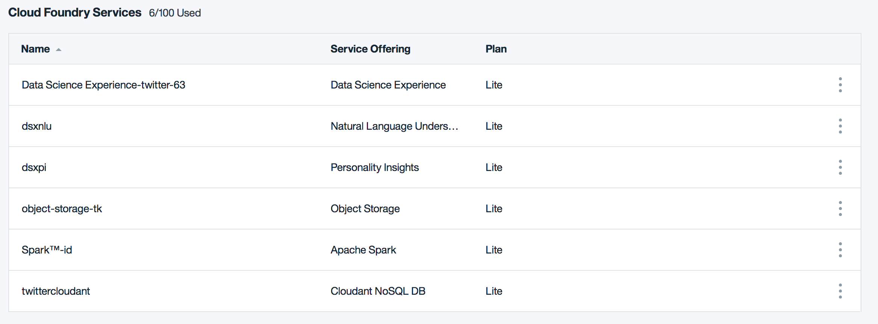

**Cloudant noSQL DB**

This Data was then stored to the IBM Cloudant Database. Then I was supposed to use this data to run the natural language and personality insights with machine learning (in **Apache Spark**) to show patterns and associations between certain brands and related personalities. However, there were several issues I faced while sharing that data, it gave me several bad gateway errors, which is related to not establishing client connections successfully.

Install Instructions:

Follow the [tutorial](https://www.ibm.com/developerworks/library/cc-cognitive-watson-extract-insights-spark-dsx/cc-cognitive-watson-extract-insights-spark-dsx-pdf.pdf) and it outlines all steps required to run the program.

Conclusion

This project has a lot of opportunity for improvement and learning. IBM’s platform has so many options that I was enamored by all the different options they provided. I had never heard of many of the services they offered, so I spent a lot of time playing around with the different services to see how I could leverage them for this homework. One of the key issues I had early on was I deleted an instance accidentally because the lite version only allows one instance. This deleted instance housed about 10-15 hours worth of time spent for this homework. When I tried rebuilding my project, I got several more errors saying that I could only still have one instance even though I deleted the instance. After spending another 8-10 hours or so I was able to reach the Cloudant step but could not continue the steps further to completion. All though I might get a bad grade on this homework, I’m really happy that I got to play around with IBM’s resources. I might spend some money next time so I can really make fun project without much restrictions.