EX. NO: 7 Implement Random Forest ensemble method on a given dataset

Date:

Aim:
To write a python program for implementing Random Forest Tree.
Algorithm:
- Import Python library packages
- Reading the dataset from the local folder
- Printing first 5 rows
- As all the columns are categorical, check for unique values of each column
- Check how these unique categories are distributed among the columns
- Heatmap of the columns on dataset with each other. It shows Pearson's correlation coefficient of column w.r.t other columns.
- As scikit-learn algorithms do not generally work with string values, I've converted string categories to integers.
- Printing the first 5 rows
- X is the dataframe containing input data / features
- y is the series which has results which are to be predicted.
- Import train_test_split function
- Split dataset into training set and test set
- Create a Gaussian Classifier
- Train the model using the training sets y_pred=model.predict(X_test
- Import scikit-learn metrics module for accuracy calculation
- Model Accuracy, how often is the classifier correct?

Program:
# Import Python library packages
import numpy as np
import matplotlib.pyplot as plt
import pandas as pd
from sklearn.metrics import classification_report
from sklearn.metrics import confusion_matrix
from sklearn.preprocessing import LabelEncoder
from sklearn.model_selection import train_test_split
import seaborn as sns

# Reading the dataset from the local folder
data = pd.read_csv('covid19.csv')

# Printing first 5 rows
print(data.head())

# As all the columns are categorical, check for unique values of each column
for i in data.columns:
print(data[i].unique(), "\t", data[i].nunique())

# Check data information
data.info()

# Check how these unique categories are distributed among the columns
for i in data.columns:
print(data[i].value_counts())
print()

# Heatmap of the columns on dataset with each other. It shows Pearson's correlation coefficient of column w.r.t other columns.
fig = plt.figure(figsize=(10,6))
sns.heatmap(data.corr(), annot=True)

# Show the plot
plt.show()
import numpy as np
import matplotlib.pyplot as plt
import pandas as pd
from sklearn.metrics import classification_report
from sklearn.metrics import confusion_matrix
from sklearn.preprocessing import LabelEncoder
from sklearn.model_selection import train_test_split
from sklearn.ensemble import RandomForestClassifier
from sklearn import metrics
import seaborn as sns

# Reading the dataset from the local folder
data = pd.read_csv('covid19.csv')

# Printing first 5 rows
print(data.head())

# As all the columns are categorical, we convert them to integers using LabelEncoder
le = LabelEncoder()

# Apply LabelEncoder to each categorical column
for column in data.columns:
data[column] = le.fit_transform(data[column])

# Printing the first 5 rows after transformation
print(data.head())

# Heatmap of the columns in the dataset to show Pearson's correlation coefficient
fig = plt.figure(figsize=(10, 6))
sns.heatmap(data.corr(), annot=True)

# Show the plot
plt.show()

# X is the dataframe containing input data/features (all columns except the target 'Label')
X = data[data.columns[:-1]]

# y is the series containing the target labels ('Label')
y = data['Label']

# Split the dataset into training and testing sets (e.g., 80% training, 20% testing)
X_train, X_test, y_train, y_test = train_test_split(X, y, test_size=0.2, random_state=42)

# Create a RandomForest Classifier
clf = RandomForestClassifier(n_estimators=100)

# Train the model using the training sets
clf.fit(X_train, y_train)

# Make predictions on the test set
y_pred = clf.predict(X_test)

# Model Accuracy: How often is the classifier correct?
accuracy = metrics.accuracy_score(y_test, y_pred)
print("Accuracy for random forest:", accuracy)

# Print confusion matrix
print("Confusion Matrix:\n", confusion_matrix(y_test, y_pred))

# Print classification report
print("Classification Report:\n", classification_report(y_test, y_pred))

OUTPUT:
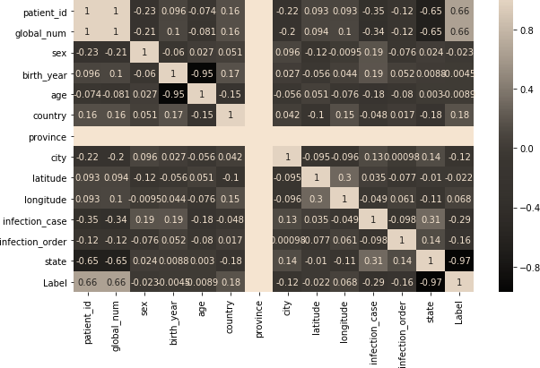
Accuracy for random forest: 0.85

Confusion Matrix:
[[50 10]
[ 5 35]]

Classification Report:
precision recall f1-score support

0 0.91 0.83 0.87 60
1 0.78 0.88 0.82 40

accuracy 0.85 100
macro avg 0.85 0.85 0.85 100
weighted avg 0.86 0.85 0.85 100

Result:
Thus, the python program for Random Forest Tree was executed successfully.

