



操作系统实验报告

学 号： | 20188068
姓 名： | 孔天欣
提交日期： | 2020-12-27
成 绩：

东北大学秦皇岛分校 计算机与通信工程学院

实验一 请求调页存储管理方式的模拟
【实验内容】
（1）用C语言来实现对N个进程采用动态优先权优先算法的进程调度。
（2）每个用来标识进程的进程控制块PCB用结构来描述，包括以下字段：
•••• 进程标识数 ID。
•••• 进程优先数 PRIORITY，并规定优先数越大的进程，其优先权越高。
•••• 进程已占用的CPU时间CPUTIME。
•••• 进程还需占用的CPU时间ALLTIME。当进程运行完毕时，ALLTIME变为0。•••• 进程的阻塞时间STARTBLOCK，表示当进程再运行STARTBLOCK个时间片后，将进入阻塞状态。
•••• 进程被阻塞的时间BLOCKTIME，表示已足赛的进程再等待BLOCKTIME个时间片后，将转换成就绪状态。
•••• 进程状态START。
•••• 队列指针NEXT，用来将PCB排成队列。
（3）优先数改变的原则：
•••进程在就绪队列中呆一个时间片，优先数加1。
•••进程每运行一个时间片，优先数减3。
（4）假设在调度前，系统中有5个进程，它们的初始状态如下：
ID | 0 | 1 | 2 | 3 | 4
PRIORITY | 9 | 38 | 30 | 29 | 0
CPUTIME | 0 | 0 | 0 | 0 | 0
ALLTIME | 3 | 3 | 6 | 3 | 4
STARTBLOCK | 2 | -1 | -1 | -1 | -1
BLOCKTIME | 3 | 0 | 0 | 0 | 0
STATE | READY | READY | READY | READY | READY
- 为了清楚的观察各进程的调度过程，程序应将每个时间片内的情况显示出来，参照的具体格式如下：

RUNNING PROG：i
READY-QUEUE：-〉id1-〉id2
BLOCK-QUEUE：-〉id3-〉id4
= = = = = = = = = = = = = = = = = = = = = = = = = = = = = = = = = = = == = =
ID 0 1 2 3 4
PRIORITY P0 P1 P2 P3 P4
CUPTIME C0 C1 C2 C3 C4
ALLTIME A0 A1 A2 A3 A4
STARTBLOCK T0 T1 T2 T3 T4
BLOCKTIME B0 B1 B2 B3 B4
STATE S0 S1 S2 S3 S4

【实验代码】
1. PCB
- package com.strutnut.lab1;

- public class PCB {

- int id;
- int priority;
- int cpuTime;
- int allTime;
- int startBlock;
- int blockTime;
- State state;
- PCB next;

- public PCB(int id, int priority, int cpuTime, int allTime, int startBlock, int blockTime, State state, PCB next) {
- this.id = id;
- this.priority = priority;
- this.cpuTime = cpuTime;
- this.allTime = allTime;
- this.startBlock = startBlock;
- this.blockTime = blockTime;
- this.state = state;
- this.next = next;
- }
- }
2. 进程状态State
- package com.strutnut.lab1;

- enum State {
- READY,
- BLOCK,
- DONE
- }
3. 调度核心类Schedule
- package com.strutnut.lab1;

- import java.util.*;

- public class Schedule {

- // 进程完成数
- private int countDone = 0;
- private int len;

- private PCB head;

- public Schedule(int len, PCB head) {
- this.len = len;
- this.head = head;
- }

- // 存放阻塞前的进程优先级
- Map<Integer, Integer> prePriority = new HashMap<>();

- Deque<Integer> blockedQueue = new LinkedList<>();

- public void start() {
- while (countDone < len) {
- PCB p = head;
- while (p != null) {
- if (p.state == State.READY && p.priority == getMax(head)) {

- p.priority -= 3;
- p.cpuTime += 1;
- p.allTime -= 1;

- // 未执行且就绪进程 优先级 +1
- PCB q = head;
- while (q != null) {
- if (q != p) {
- if (q.allTime > 0 && q.state == State.READY) {
- q.priority += 1;
- }
- }
- q = q.next;
- }

- // 进程执行完毕
- if (p.allTime == 0) {
- p.state = State.DONE;
- p.priority = -1;
- countDone++;
- }

- // 所有阻塞进程的阻塞时间片减少
- q = head;
- while (q != null) {
- if (q.state == State.BLOCK && q.blockTime > 0) {
- if (--q.blockTime == 0) {
- q.state = State.READY;
- q.priority = prePriority.get(q.id);
- }
- }
- q = q.next;
- }

- // 快进入阻塞的进程 statblock倒计时时间片减少
- if (p.startBlock > 0) {
- if (--p.startBlock == 0) {
- p.state = State.BLOCK;
- prePriority.put(p.id, p.priority);
- p.priority = -1;
- }
- }

- output(p);
- }

- p = p.next;
- }
- }
- }

- private void output(PCB p) {
- System.out.println("RUNNING PROG：" + p.id);

- System.out.println("READY_QUEUE：");
- List<PCB> readyProcess = new ArrayList<>();
- PCB q = head;
- while (q != null) {
- if (q.state == State.READY) {
- readyProcess.add(q);
- }
- q = q.next;
- }
- readyProcess.sort((o1, o2) -> o2.priority - o1.priority);
- if (readyProcess.size() == 0) {
- System.out.print("EMPTY");
- } else {
- for (PCB process : readyProcess) {
- System.out.print("->" + process.id);
- }
- }
- System.out.print("\n");

- System.out.println("BLOCK_QUEUE：");
- List<PCB> blockProcess = new ArrayList<>();
- q = head;
- while (q != null) {
- if (q.state == State.BLOCK) {
- blockProcess.add(q);
- }
- q = q.next;
- }
- blockProcess.sort((o1, o2) -> o2.priority - o1.priority);
- if (blockProcess.size() == 0) {
- System.out.print("EMPTY");
- } else {
- for (PCB process : blockProcess) {
- System.out.print("->" + process.id);
- }
- }
- System.out.print("\n");

- System.out.print("ID：");
- q = head;
- while (q != null) {
- System.out.print(q.id + " ");
- q = q.next;
- }
- System.out.print("\n");
- System.out.print("CPUTIME：");
- q = head;
- while (q != null) {
- System.out.print(q.cpuTime + " ");
- q = q.next;
- }
- System.out.print("\n");
- System.out.print("ALLTIME：");
- q = head;
- while (q != null) {
- System.out.print(q.allTime + " ");
- q = q.next;
- }
- System.out.print("\n");
- System.out.print("STARTBLOCK：");
- q = head;
- while (q != null) {
- System.out.print(q.startBlock + " ");
- q = q.next;
- }
- System.out.print("\n");
- System.out.print("STATE：");
- q = head;
- while (q != null) {
- System.out.print(q.state + " ");
- q = q.next;
- }
- System.out.print("\n");
- System.out.print("PRIORITY：");
- q = head;
- while (q != null) {
- System.out.print(q.priority + " ");
- q = q.next;
- }
- System.out.print("\n");
- System.out.println("===================");
- }

- private int getMax(PCB head) {
- PCB p = head;
- int max = Integer.MIN_VALUE;
- while (p != null) {
- max = Math.max(p.priority, max);
- p = p.next;
- }
- return max;
- }

- public static void main(String[] args) {
- PCB pcb1 = new PCB(0, 9, 0, 3, 2, 3, State.READY, null);
- PCB pcb2 = new PCB(1, 38, 0, 3, -1, 0, State.READY, null);
- PCB pcb3 = new PCB(2, 30, 0, 6, -1, 0, State.READY, null);
- PCB pcb4 = new PCB(3, 29, 0, 3, -1, 0, State.READY, null);
- PCB pcb5 = new PCB(4, 0, 0, 4, -1, 0, State.READY, null);

- pcb4.next = pcb5;
- pcb3.next = pcb4;
- pcb2.next = pcb3;
- pcb1.next = pcb2;

- Schedule schedule = new Schedule(5, pcb1);
- schedule.start();

- }
- }
【实验结果】

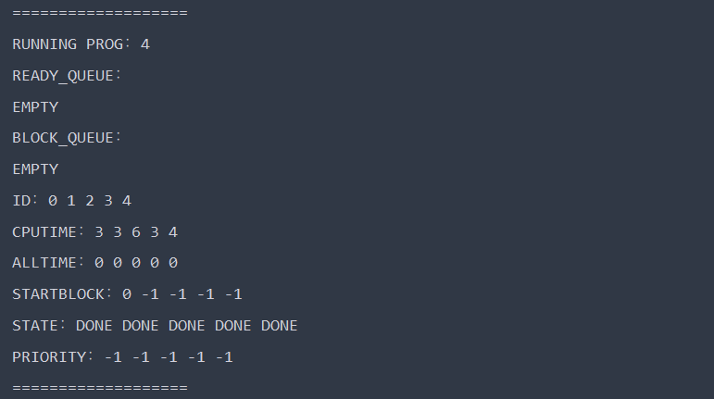

实验二 使用动态分区分配方式的模拟
【实验内容】
（1）用C语言分别实现采用首次适应算法和最佳适应算法的动态分区分配过程alloc( )和回收过程free( )。其中，空闲分区通过空闲分区链来管理：在进行内存分配时，系统优先使用空闲区低端的空间。
（2）假设初始状态下，可用的内存空间为640KB，并有下列的请求序列：
•作业1申请130KB。
•作业2申请60KB。
•作业3申请100KB。
•作业2释放60KB。
•作业4申请200KB。
•作业3释放100KB。
•作业1释放130KB。
•作业5申请140KB。
•作业6申请60KB。
•作业7申请50KB。
•作业6释放60KB。
请分别采用首次适应算法和最佳适应算法，对内存块进行分配和回收，要求每次分配和回收后显示出空闲分区链的情况。
【实验代码】
1. 内存块Block
- package com.strutnut.lab2;

- public class Block {

- int id;
- int startAddress;
- int size;
- boolean isFree;

- public Block(int id, int startAddress, int size, boolean isFree) {
- this.id = id;
- this.startAddress = startAddress;
- this.size = size;
- this.isFree = isFree;
- }

- @Override
- public String toString() {
- return " " + (id == -1 ? " " : id) +
- " " + startAddress +
- " " + size +
- " " + (isFree ? "√" : "×");
- }
- }
2. 最佳适应算法BestFitStrategy
- package com.strutnut.lab2;

- import java.util.Iterator;
- import java.util.LinkedList;
- import java.util.List;

- public class BestFitStrategy implements Strategy {

- private int idCounter = 1;

- private List<Block> blockList = new LinkedList<>();

- public BestFitStrategy() {
- Block initBlock = new Block(-1, 0, INITIAL_SIZE, true);
- blockList.add(initBlock);
- log();
- }

- @Override
- public Block alloc(int size) {
- int maxSize = Integer.MIN_VALUE;
- Block maxBlock = null;
- int maxIndex = -1;
- for (int i = 0; i < blockList.size(); i++) {
- Block block = blockList.get(i);
- if (block.isFree && block.size >= size) {
- if (maxSize == Integer.MIN_VALUE || block.size <= maxSize) {
- maxSize = block.size;
- maxBlock = block;
- maxIndex = i;
- }
- }
- }

- Block newBlock = null;
- if (maxIndex != -1) {
- newBlock = new Block(idCounter++, maxBlock.startAddress, size, false);
- maxBlock.startAddress += size;
- maxBlock.size -= size;
- if (maxBlock.size == 0) {
- blockList.remove(maxIndex);
- }
- blockList.add(maxIndex, newBlock);
- }

- System.out.println(">>> task" + (idCounter - 1) + " alloc " + size + "KB. ....OK");
- log();
- return newBlock;
- }

- private void log() {
- System.out.println("| id startAddress size isFree |");
- for (Block b : blockList) {
- System.out.println(b.toString());
- }
- System.out.println("=========================\n");
- }

- @Override
- public void free(Block block) {
- int blockSize = block.size;
- int taskId = block.id;
- boolean flag = false;
- for (Block b : blockList) {
- if (b.id == block.id && !b.isFree) {
- b.isFree = true;
- b.id = -1;
- flag = true;
- Iterator<Block> it = blockList.iterator();
- while (it.hasNext()) {
- Block bl = it.next();
- if (bl.isFree && b.startAddress + b.size == bl.startAddress) {
- b.size += bl.size;
- it.remove();
- } else if (bl.isFree && bl.startAddress + bl.size == b.startAddress) {
- b.startAddress = bl.startAddress;
- b.size += bl.size;
- it.remove();
- }
- }
- break;
- }
- }
- if (flag) {
- System.out.println(">>> task" + taskId + " free " + blockSize + "KB. ....OK");
- log();
- } else {
- throw new RuntimeException("FAILED");
- }
- }

- @Override
- public void clearList() {
- this.blockList.clear();
- }
- }
3. 首次适应算法FirstFitStrategy
- package com.strutnut.lab2;

- import java.util.ArrayList;
- import java.util.Iterator;
- import java.util.List;

- public class FirstFitStrategy implements Strategy {

- private int idCounter = 1;

- private List<Block> blockList = new ArrayList<>();

- public FirstFitStrategy() {
- Block initBlock = new Block(-1, 0, INITIAL_SIZE, true);
- blockList.add(initBlock);
- log();
- }
- @Override
- public Block alloc(int size) {
- Block block = null;
- if (!blockList.isEmpty()) {
- Iterator<Block> iterator = blockList.iterator();
- int i = 0;
- while (iterator.hasNext()) {
- Block b = iterator.next();
- if (b.size >= size && b.isFree) {
- block = new Block(idCounter++, b.startAddress, size, false);
- b.startAddress += size;
- b.size -= size;
- if (b.size == 0) {
- iterator.remove();
- }
- blockList.add(i, block);
- break;
- }
- i++;
- }
- }
- if (block != null) {
- System.out.println(">>> task" + (idCounter - 1) + " alloc " + size + "KB. ....OK");
- log();
- }
- return block;
- }

- private void log() {
- System.out.println("| id startAddress size isFree |");
- for (Block b : blockList) {
- System.out.println(b.toString());
- }
- System.out.println("==============================\n");
- }

- @Override
- public void free(Block block) {
- int taskId = block.id;
- int blockSize = block.size;
- boolean flag = false;
- for (int i = 0; i < blockList.size(); i++) {
- Block b = blockList.get(i);
- if (b.id == block.id && !b.isFree) {
- b.isFree = true;
- b.id = -1;
- flag = true;
- Iterator<Block> it = blockList.iterator();
- while (it.hasNext()) {
- Block bl = it.next();
- if (bl.isFree && b.startAddress + b.size == bl.startAddress) {
- b.size += bl.size;
- it.remove();
- } else if (bl.isFree && bl.startAddress + bl.size == b.startAddress) {
- b.startAddress = bl.startAddress;
- b.size += bl.size;
- it.remove();
- }
- }
- break;
- }
- }
- if (flag) {
- System.out.println(">>> task" + taskId + " free " + blockSize + "KB. ....OK");
- log();
- }
- }

- @Override
- public void clearList() {
- this.blockList.clear();
- }
- }
4. 主类Main
- package com.strutnut.lab2;

- public class Main {

- public void work(Strategy strategy) {
- Block block1 = strategy.alloc(130);
- Block block2 = strategy.alloc(60);
- Block block3 = strategy.alloc(100);
- strategy.free(block2);
- Block block4 = strategy.alloc(200);
- strategy.free(block3);
- strategy.free(block1);
- Block block5 = strategy.alloc(140);
- Block block6 = strategy.alloc(60);
- Block block7 = strategy.alloc(50);
- strategy.free(block6);
- strategy.clearList();
- }

- public static void main(String[] args) {

- Main main = new Main();

- System.out.println("************** 最佳适应算法 **************");
- main.work(new BestFitStrategy());
- System.out.println("\n************** 首次适应算法 **************");
- main.work(new FirstFitStrategy());
- }
- }

【实验结果】

1. 最佳适应算法

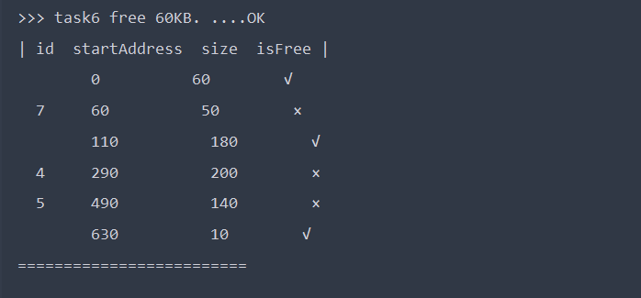
2. 首次适应算法
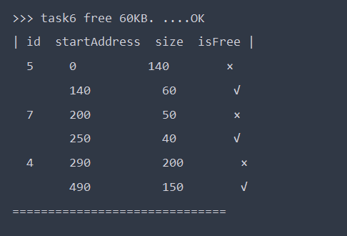

实验三 请求调页存储管理方式的模拟
【实验内容】
（1）假设每个页面中可存放10条指令，分配给一作业的内存块数为4。
（2）用C语言模拟一作业的执行过程。该作业共有320条指令，即它的地址空间为32页，目前它的所有页都还未调入内存。在模拟过程中，如果所访问的指令已经在内存中，则显示其物理地址，并转下一条指令。如果所访问的指令还未装入内存，则发生缺页，此时需记录缺页的次数，并将相应页调入内存。如果4个内存块中均已装入该作业，则需进行页面置换。最后显示其物理地址，并转下一条指令。在所有320条指令执行完毕后，请计算并显示作业运行过程中发生的缺页率。
（3）置换算法：请分别考虑OPT、FIFO和LRU算法。
（4）作业中指令的访问次序按下述原则生成：
•50%的指令是顺序执行的。
•25%的指令是均匀分布在前地址部分。
•25%的指令时均匀分布在后地址部分。
具体的实施办法是：
- 在[0，319]之间随机选取一条起始执行指令，其序号为m；
- 顺序执行下一条指令，即序号为m+1的指令；
- 通过随机数，跳转到前地址部分[0，m-1]中的某条指令处，其序号为m1；
- 顺序执行下一条指令，即序号为m1+1的指令；
- 通过随机数，跳转到后地址部分[m1+2，319]中的某条指令处，其序号为m2；
- 顺序执行下一条指令，即序号为m2+1的指令；
- 重复跳转到前地址部分、顺序执行、跳转到后地址部分、顺序执行的过程，直至执行320条指令。
【实验代码】
1. 物理块 Block
- package com.strutnut.lab3;

- public class Block {

- int pageNum;
- int lastVisit;

- public Block(int pageNum) {
- this.pageNum = pageNum;
- }

- public Block(int pageNum, int lastVisit) {
- this.pageNum = pageNum;
- this.lastVisit = lastVisit;
- }
- }
2. 指令生成器 InstructionBuilder
- package com.strutnut.lab3;

- import java.util.Random;

- public class InstructionBuilder {

- private static int rightBound;

- public static int[][] build(int pageNum, int size) {
- rightBound = pageNum * size;
- int[][] pages = new int[pageNum][size];
- randomBulid(pages);
- return pages;
- }

- private static void randomBulid(int[][] instructions) {
- Random random = new Random();
- int status = 0;
- int m, m1, m2;
- m = m1 = m2 = -1;
- boolean next = false;
- for (int i = 0; i < instructions.length; i++) {
- for (int j = 0; j < instructions[i].length; j = j + 2) {
- if (status == 0 || status == 3) {
- if (!next) {
- m = random.nextInt(rightBound);
- } else {
- status = 1;
- }
- m1 = random.nextInt(m);
- m2 = m1 + 2 + random.nextInt(rightBound - 1 - m1 - 1);
- }
- assert m != -1 && m1 != -1 && m2 != -1;
- instructions[i][j] = status == 0 ? m : status == 1 ? m1 : m2;
- instructions[i][j + 1] = status == 0 ? m + 1 : status == 1 ? m1 + 1 : m2 + 1;
- status++;
- next = true;
- }
- }
- }

- }
3. 先进先出算法FIFO
- package com.strutnut.lab3;

- import java.util.*;

- public class FIFOStrategy implements Replacement {

- private List<Block> memoryPagesList = new ArrayList<>();

- private HashSet<Integer> existedPages = new HashSet<>();

- public int discardCount = 0;

- private int last = 0;

- private int[][] instructions;

- public FIFOStrategy(int[][] instructions) {
- this.instructions = Arrays.copyOf(instructions, instructions.length);
- }

- @Override
- public void run() {
- for (int i = 0; i < instructions.length; i++) {
- for (int j = 0; j < instructions[i].length; j++) {
- int pageNum = instructions[i][j] / 10;
- if (existedPages.contains(pageNum)) {
- printBlockList(memoryPagesList, instructions[i][j], true);
- } else {
- if (memoryPagesList.size() >= MAX_PAGE_SIZE) {
- Block discard = memoryPagesList.get(last);
- existedPages.remove(discard.pageNum);
- discard.pageNum = pageNum;
- last = (last + 1) % MAX_PAGE_SIZE;
- printBlockList(memoryPagesList, instructions[i][j], false);
- } else {

- memoryPagesList.add(new Block(pageNum));
- printBlockList(memoryPagesList, instructions[i][j], false);
- }
- existedPages.add(pageNum);
- discardCount++;
- }
- }
- }
- System.out.println("====================================");
- System.out.println("FIFO 缺页次数是 " + discardCount);
- System.out.println("FIFO 缺页率是 " + (double) discardCount * 100 / (instructions.length * instructions[0].length) + " %");
- System.out.println("====================================");
- }

- private void printBlockList(List<Block> blockList, int inst, boolean hit) {
- System.out.print((hit ? " " : "未") + "命中, ");
- System.out.print("当前指令： " + inst + " , 物理内存块： ");
- for (int i = 0; i < blockList.size(); i++) {
- Block block = blockList.get(i);
- if (i == blockList.size() - 1) {
- System.out.println(block.pageNum);
- } else {
- System.out.print(block.pageNum + "->");
- }
- }
- }

- }
4. 最近最少使用算法LRU
- package com.strutnut.lab3;

- import java.util.*;

- public class LRUStrategy implements Replacement {

- private int[][] instructions;

- private List<Block> memoryPagesList = new ArrayList<>();

- private HashSet<Integer> existedPages = new HashSet<>();

- private int discardCount = 0;

- public LRUStrategy(int[][] instructions) {
- this.instructions = Arrays.copyOf(instructions, instructions.length);
- }

- @Override
- public void run() {
- for (int i = 0; i < instructions.length; i++) {
- for (int j = 0; j < instructions[i].length; j++) {
- int pageNum = instructions[i][j] / 10;
- if (existedPages.contains(pageNum)) {
- for (Block b : memoryPagesList) {
- if (b.pageNum == pageNum) {
- b.lastVisit = -1;
- }
- b.lastVisit++;
- }
- printBlockList(memoryPagesList, instructions[i][j], true);
- } else {
- if (memoryPagesList.size() >= MAX_PAGE_SIZE) {
- int max = Integer.MIN_VALUE;
- int index = -1;
- for (int k = 0; k < memoryPagesList.size(); k++) {
- Block b = memoryPagesList.get(k);
- if (max < b.lastVisit) {
- max = b.lastVisit;
- index = k;
- }
- }
- assert index != -1;
- Block discard = memoryPagesList.get(index);
- existedPages.remove(discard.pageNum);
- discard.pageNum = pageNum;
- discard.lastVisit = 0;
- printBlockList(memoryPagesList, instructions[i][j], false);
- } else {
- memoryPagesList.add(new Block(pageNum, 0));
- printBlockList(memoryPagesList, instructions[i][j], false);
- }
- existedPages.add(pageNum);
- discardCount++;
- }
- }
- }
- System.out.println("====================================");
- System.out.println("LRU 缺页次数是 " + discardCount);
- System.out.println("LRU 缺页率是 " + (double) discardCount * 100 / (instructions.length * instructions[0].length) + " %");
- System.out.println("====================================");
- }

- private void printBlockList(List<Block> blockList, int inst, boolean hit) {
- System.out.print((hit ? " " : "未") + "命中, ");
- System.out.print("当前指令： " + inst + " , 物理内存块： ");
- for (int i = 0; i < blockList.size(); i++) {
- Block block = blockList.get(i);
- if (i == blockList.size() - 1) {
- System.out.println(block.pageNum);
- } else {
- System.out.print(block.pageNum + "->");
- }
- }
- }
- }
5. 最佳页面替换算法OPT
- package com.strutnut.lab3;

- import java.util.ArrayList;
- import java.util.Arrays;
- import java.util.HashSet;
- import java.util.List;

- public class OPTStrategy implements Replacement {

- private int[][] instructions;

- private List<Block> memoryPagesList = new ArrayList<>();

- private HashSet<Integer> existedPages = new HashSet<>();

- private int discardCount = 0;

- public OPTStrategy(int[][] instructions) {
- this.instructions = Arrays.copyOf(instructions, instructions.length);
- }

- @Override
- public void run() {
- for (int i = 0; i < instructions.length; i++) {
- for (int j = 0; j < instructions[i].length; j++) {
- int pageNum = instructions[i][j] / 10;
- if (existedPages.contains(pageNum)) {
- printBlockList(memoryPagesList, instructions[i][j], true);
- } else {
- int discardPageNum = -1;
- if (memoryPagesList.size() >= MAX_PAGE_SIZE) {
- int fari = -1;
- int farj = -1;

- for (Block block : memoryPagesList) {
- int currentPageNum = block.pageNum;
- boolean findit = false;
- for (int m = i; m < instructions.length; m++) {
- if (findit) {
- break;
- }
- for (int n = m == i ? j + 1 : 0; n < instructions[m].length; n++) {
- if (currentPageNum == instructions[m][n] / 10) {
- findit = true;
- if (m * 10 + n > fari * 10 + farj) {
- fari = m;
- farj = n;
- }
- break;
- }
- }
- }
- discardPageNum = findit ? instructions[fari][farj] / 10 : currentPageNum;
- if (!findit) {
- break;
- }
- }
- assert fari != -1 && farj != -1 && discardPageNum != -1;
- for (Block b : memoryPagesList) {
- if (b.pageNum == discardPageNum) {
- b.pageNum = pageNum;
- }
- }
- printBlockList(memoryPagesList, instructions[i][j], false);
- existedPages.remove(discardPageNum);
- } else {
- memoryPagesList.add(new Block(pageNum));
- printBlockList(memoryPagesList, instructions[i][j], false);
- }
- existedPages.add(pageNum);
- discardCount++;
- }
- }
- }
- System.out.println("====================================");
- System.out.println("OPT 缺页次数是 " + discardCount);
- System.out.println("OPT 缺页率是 " + (double) discardCount * 100 / (instructions.length * instructions[0].length) + " %");
- System.out.println("====================================");
- }

- private void printBlockList(List<Block> blockList, int inst, boolean hit) {
- System.out.print((hit ? " " : "未") + "命中, ");
- System.out.print("当前指令： " + inst + " , 物理内存块： ");
- for (int i = 0; i < blockList.size(); i++) {
- Block block = blockList.get(i);
- if (i == blockList.size() - 1) {
- System.out.println(block.pageNum);
- } else {
- System.out.print(block.pageNum + "->");
- }
- }
- }

- }
6. 主类 Main
- package com.strutnut.lab3;

- public class Main {

- public static void main(String[] args) {

- int[][] instructions = InstructionBuilder.build(32, 10);
- printInstructions(instructions);

- System.out.println("============== FIFO ==============");
- Replacement stg;
- stg = new FIFOStrategy(instructions);
- stg.run();
- System.out.println("============== LRU ==============");
- stg = new LRUStrategy(instructions);
- stg.run();
- System.out.println("============== OPT ==============");
- stg = new OPTStrategy(instructions);
- stg.run();

- }

- private static void printInstructions(int[][] instructions) {
- System.out.println("============指令============");
- int count = 0;
- for (int i = 0; i < instructions.length; i++) {
- for (int j = 0; j < instructions[i].length; j++) {
- System.out.print(instructions[i][j] + ",");
- count = (count + 1) % 10;
- if (count == 0) {
- System.out.print("\n");
- }
- }
- }
- }
- }
【实验结果】

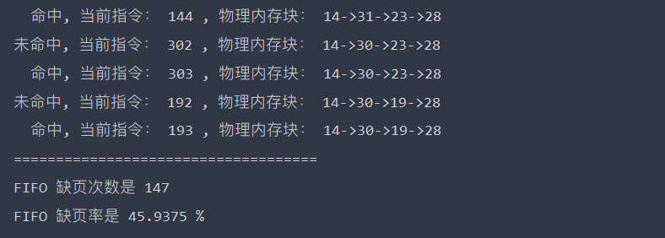

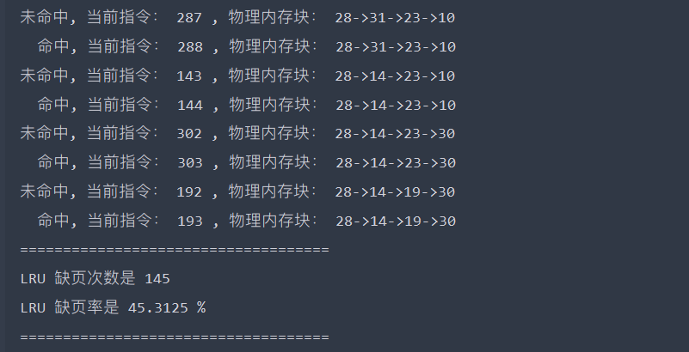

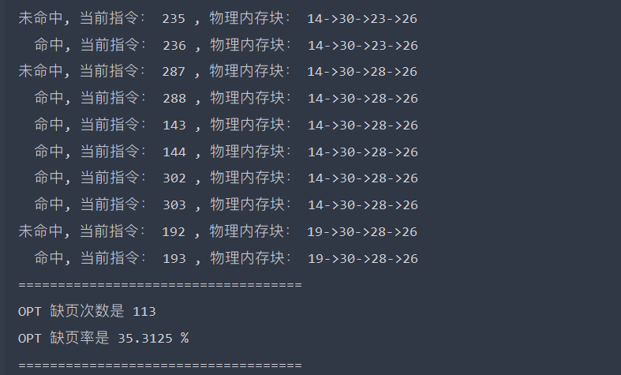

实验四 简单文件系统的实现
【实验内容】
（1）在内存中开辟一个虚拟磁盘空间作为文件存储器，在上面实现一个简单单用户文件系统。退出时应该将该虚拟文件系统保存到磁盘上，以便下次可以再将它恢复到内存对虚拟磁盘空间中。
（2）文件存储空间对分配可以采用显式链接分配或者其他的办法。
（3）空闲空间的管理可以选择位示图或者其他的办法。如果采用位示图来管理文件存储空间，并采用显式链接分配方式，那么可以将位示图合并到FAT中。
（4）文件目录结构采用多级目录结构。为了简单起见，可以不使用索引结点，其中的每个目录项应包含文件名、物理地址、长度等信息，还可以通过目录项实现对文件对读和写的保护。
（5）要求提供以下有关的操作：
√ format：对文件存储器进行格式化，即按照文件系统对结构对虚拟磁盘空间进行布局，并在其上创建根目录以及用于管理文件存储空间等的数据结构。
√mkdir：用于创建子目录；
√rmdir：用于删除目录；
√ls：用于显示目录；
√cd：用于更改当前目录；
√create：用于创建文件；
√open：用于打开文件；
√close：用于关闭文件；
√write：用于写文件；
√read：用于读文件
√rm：用于删除文件。
【实验代码】
1. 文件控制块 FCB
- package com.strutnut.lab4;

- import java.io.Serializable;
- import java.util.HashMap;

- import java.util.Map;

- public class FCB implements Serializable {

- public Map<String, FCB> filesOrDirsList = new HashMap<>();
- private String name;
- private int attribute;
- private int startNum; //在FAT表中起始位置
- private int size;
- private FCB father = null;
- private String content = "";

- public FCB(String name, int attribute, int startNum, int size) {
- this.name = name;
- this.attribute = attribute;
- this.startNum = startNum;
- this.size = size;
- }

- public String getName() {
- return name;
- }

- public void setName(String name) {
- this.name = name;
- }

- public int getAttribute() {
- return attribute;
- }

- public void setAttribute(int attribute) {
- this.attribute = attribute;
- }

- public int getStartNum() {
- return startNum;
- }

- public void setStartNum(int startNum) {
- this.startNum = startNum;
- }

- public int getSize() {
- return size;
- }

- public void setSize(int size) {
- this.size = size;
- }

- public FCB getFather() {
- return father;
- }

- public void setFather(FCB father) {
- this.father = father;
- }

- public String getContent() {
- return content;
- }

- public void setContent(String content) {
- this.content = content;
- }
- }
2. 文件管理系统 FileSystemManagement
- package com.strutnut.lab4;

- import java.io.*;
- import java.util.*;

- public class FileSystemManagement {

- // 是目录
- private static final int IS_DIR = 3;
- // 是文件
- private static final int IS_FILE = 2;

- /**
- * 当前目录
- */
- private FCB currentDir;

- private Map<String, FCB> totalFiles = new HashMap<>();

- private static class FATManageMent {

- // FAT 终结符
- static final int FAT_END = 255;

- // FAT表的盘块个数
- static final int BLOCK_SIZE = 128;

- // 剩余盘块
- static int available;

- static int[] FAT = new int[BLOCK_SIZE];

- static void initFAT() {
- // FAT表初始化，FAT[0]为根目录
- Arrays.fill(FAT, 0);
- FAT[0] = FAT_END;
- // 剩余块数
- available = BLOCK_SIZE - 1;
- }

- static int allocFAT(int size) {
- int[] startNum = new int[128];
- int i = 1; //纪录fat循环定位
- for (int j = 0; j < size; i++) {
- if (FAT[i] == 0) {
- startNum[j] = i; //纪录该文件所有磁盘块
- if (j > 0) {
- FAT[startNum[j - 1]] = i; //fat上一磁盘块指向下一磁盘块地址
- }
- j++;
- }
- }
- FAT[i - 1] = FAT_END;
- return startNum[0];
- }

- /*
- *
- * 释放文件对应的FAT表占用空间
- */
- static void delFAT(int startNum) {
- int nextBlock;
- int currentBlock = startNum;
- int freeSize = 0;
- while (FAT[currentBlock] != FAT_END) {
- nextBlock = FAT[currentBlock];
- FAT[currentBlock] = 0;
- currentBlock = nextBlock;
- freeSize++;
- }
- FAT[currentBlock] = 0;
- available += freeSize + 1;
- }

- static void FATlist() {
- System.out.println(Arrays.toString(FAT));
- }
- }

- public FileSystemManagement() {
- FATManageMent.initFAT();
- //创建根目录 使用fat表的第一项
- FCB root = new FCB("root", 0, 0, 1);
- root.setFather(root);
- currentDir = root;
- }

- /**
- * 1. 格式化
- */
- public void format() {
- String path = "./fs.txt";
- File file = new File(path);
- if (file.exists()) {
- file.delete();
- }
- try {
- FileOutputStream fs = new FileOutputStream(file);
- ObjectOutputStream oos = new ObjectOutputStream(fs);
- for (FCB fcb : totalFiles.values()) {
- oos.writeObject(fcb);
- }
- } catch (IOException e) {
- e.printStackTrace();
- }
- }

- /**
- * 2. 创建目录
- */
- public void mkdir(String name) {

- if (FATManageMent.available >= 1) {
- FCB value = currentDir.filesOrDirsList.get(name);
- if (value != null && value.getAttribute() == IS_DIR) {
- System.out.println("该目录下存在重名目录。不可创建");
- } else {
- int startNum = FATManageMent.allocFAT(1);
- FCB catalog = new FCB(name, IS_DIR, startNum, 1);
- catalog.setFather(currentDir);
- currentDir.filesOrDirsList.put(name, catalog);
- FATManageMent.available--;

- System.out.println("成功创建目录");
- }
- } else {
- System.out.println("创建目录失败，磁盘空间不足");
- }
- }

- /*
- *
- * 9. 删除文件 / 3. 删除目录
- *
- */
- public void rm(String name) {

- FCB value = currentDir.filesOrDirsList.get(name);
- if (value == null) {
- System.out.println("删除失败，目标不存在");
- } else if (value.getAttribute() == IS_DIR && !value.filesOrDirsList.isEmpty()) {
- System.out.println("删除失败，对应目录不为空");
- } else {
- currentDir.filesOrDirsList.remove(name);
- totalFiles.remove(name);
- FATManageMent.delFAT(value.getStartNum());
- System.out.println((value.getAttribute() == IS_DIR ? "目录 " : "文件 ") + value.getName() + " 已成功删除");
- }
- }

- /**
- * 4. 显示目录下所有项
- */
- public void ls() {
- if (!currentDir.filesOrDirsList.isEmpty()) {
- System.out.println("文件名 类型 起始盘块 大小");
- for (FCB value : currentDir.filesOrDirsList.values()) {
- String type = value.getAttribute() == IS_DIR ? "目录" : "文件";
- System.out.println(value.getName() + " " + type + " "
- + value.getStartNum() + " " + value.getSize());
- }
- }
- }

- public void showPath() {
- System.out.print(currentDir.getName() + ">>");
- }

- /**
- * 5. 用于更改当前目录
- */
- public void cd(String name) {
- if ("../".equals(name)) {
- cdpp();
- return;
- }
- FCB value = currentDir.filesOrDirsList.get(name);
- if (value == null) {
- System.out.println("切换失败，目录不存在");
- } else if (value.getAttribute() == IS_FILE) {
- System.out.println("打开文件可使用 open 命令");
- } else {
- currentDir = value;
- }
- }

- /*
- * 6. 创建文件
- */
- public void create(String name, int size) {

- if (FATManageMent.available >= size) {
- // 查找目录下有无同名项
- FCB value = currentDir.filesOrDirsList.get(name);
- if (value != null && value.getAttribute() == IS_FILE) {
- System.out.println("该目录下存在重名文件。不可创建");
- } else {
- int startBlockNum = FATManageMent.allocFAT(size);
- FCB file = new FCB(name, IS_FILE, startBlockNum, size);
- file.setFather(currentDir);
- // 当前目录添加该文件
- currentDir.filesOrDirsList.put(name, file);
- FATManageMent.available -= size;
- totalFiles.put(name, file);
- System.out.println("成功创建文件");
- }
- } else {
- System.out.println("创建文件失败，磁盘空间不足");
- }

- }

- /*
- * 7. 打开文件
- */
- public void open(String name) {
- FCB value = currentDir.filesOrDirsList.get(name);
- if (value == null) {
- System.out.println("打开失败，文件不存在");
- } else if (value.getAttribute() == IS_DIR) {
- System.out.println("打开目录可使用 cd 命令");
- } else {
- System.out.println("打开成功");
- currentDir = value;
- }
- }

- /**
- * 8. 关闭文件
- */
- public void close() {
- if (currentDir.getAttribute() == IS_FILE) {
- System.out.println("文件已关闭");
- cdpp();
- } else {
- System.out.println("并没有打开文件");
- }
- }

- /*
- *
- * 以下为返回上一层目录
- *
- */
- public void cdpp() {
- if (currentDir.getFather() == null) {
- System.out.println("返回上一层目录失败");
- } else {
- currentDir = currentDir.getFather();
- }
- }

- public void read() {
- if (currentDir.getAttribute() == IS_FILE) {
- System.out.println(currentDir.getContent());
- } else {
- System.out.println("当前未打开文件");
- }
- }

- public void write(String content, int offset) {
- if (offset < 0) {
- System.out.println("偏移量不可小于 0");
- }
- if (currentDir.getAttribute() == IS_FILE) {
- StringBuilder builder = new StringBuilder();
- builder.append(currentDir.getContent());
- builder.insert(offset, content);
- currentDir.setContent(builder.toString());
- } else {
- System.out.println("当前未打开文件");
- }
- }

- public void FAT() {
- FATManageMent.FATlist();
- }

- public void exit() {
- System.exit(1);
- }
- }
3. 入口类 Main
- package com.strutnut.lab4;

- import java.util.Scanner;

- public class Main {

- public static void main(String[] args) {
- FileSystemManagement management = new FileSystemManagement();
- run(management);
- }

- private static void run(FileSystemManagement manager) {
- Scanner s = new Scanner(System.in);
- String str;
- manager.showPath();
- while ((str = s.nextLine()) != null) {
- String[] strs = str.split(" ");
- switch (strs[0]) {
- case "format":
- manager.format();
- break;
- case "mkdir":
- manager.mkdir(strs[1]);
- //manager.FAT();
- break;
- case "rmdir":
- case "rm":
- manager.rm(strs[1]);
- //manager.FAT();
- break;
- case "ls":
- manager.ls();
- break;
- case "cd":
- manager.cd(strs[1]);
- break;
- case "create":
- manager.create(strs[1], Integer.parseInt(strs[2]));
- //manager.FAT();
- break;
- case "open":
- manager.open(strs[1]);
- break;
- case "close":
- manager.close();
- break;
- case "read":
- manager.read();
- break;
- case "write":
- manager.write(strs[1], Integer.parseInt(strs[2]));
- break;
- case "FAT":
- manager.FAT();
- break;
- case "exit":
- manager.exit();
- break;
- default:
- System.out.println("未知的命令.");
- }
- manager.showPath();
- }
- }

- }

