
数据结构
实验报告

学 号： | 20188068
姓 名： | 孔天欣
提交日期： | 2019-12-01
成 绩：

东北大学秦皇岛分校
计算机与通信工程学院

【实验内容】
1.线性表-约瑟夫环
- LinkList ListBuild()
- {
- LinkList head = (LinkList)malloc(sizeof(LNode));
- LinkList p = head;
- cout << "有多少人（n值) ?" << endl;
- int n;
- cin >> n;
- cout << "输入每个人的密码：" << endl;
- for (int i = 1; i <= n; i++)
- {
- p->next = (LinkList)malloc(sizeof(LNode));
- p = p->next;
- cin >> p->data;
- p->num = i;
- }
- p->next = head->next;
- p = p->next;
- free(head);
- return p;
- }

- void Joseph(LinkList p)
- {
- cout << "请输入m值 ：" << endl;
- int num;
- cin >> num;
- LinkList q = p;
- while (p)
- {
- for (int i = 1; i < num; i++)
- {
- q = p;
- p = p->next;
- }
- cout << p->num << " ";
- if (p->next == p) //就剩一个人没出列
- {
- free(p);
- break;
- }
- q->next = p->next;
- num = p->data;
- free(p);
- p = q->next;
- }
- }
- int main()

- {
- LinkList p = ListBuild();
- Joseph(p);
- }
运行结果：
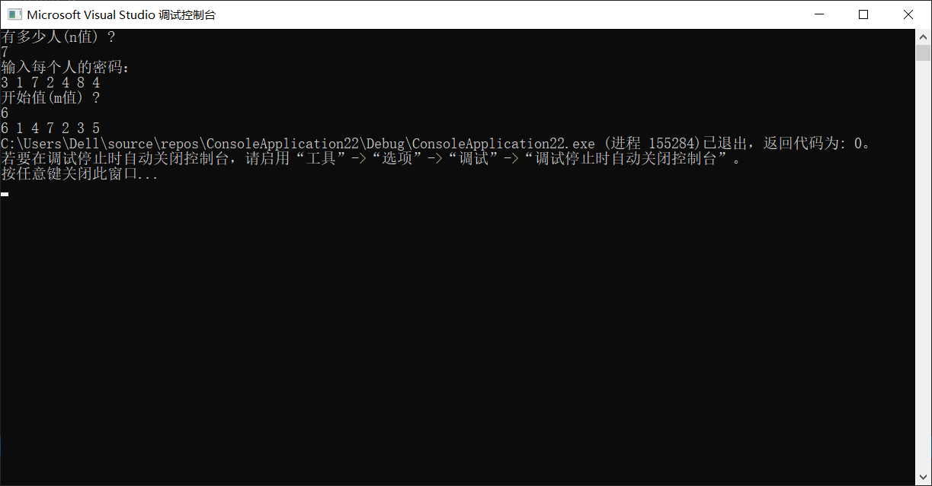

2.栈-表达式求值
- #include <Stack.h>

- int char_to_int(char s) //转int
- {
- return int(s) - 48;
- }

- char PriorityComparison(Stack *S, char c) //运算符优先级比较
- {
- char *p = S->top - 1;
- char prior[7][7] =
- { {'>','>','<','<','<','>','>'},
- {'>','>','<','<','<','>','>'},
- {'>','>','>','>','<','>','>'},
- {'>','>','>','>','<','>','>'},
- {'<','<','<','<','<','=',' '},
- {'>','>','>','>',' ','>','>'},
- {'<','<','<','<','<',' ','='} };

- char Operator[7] = { '+','-','*','/','(',')','#' };
- int m = 0; int n = 0;
- while (Operator[n] != c) { n++; }
- while (Operator[m] != *p) { m++; };
- return prior[m][n];
- }

- int Operate(int num1,char s,int num2) //计算
- {
- switch (s)
- {
- case '+':return num1 + num2; break;
- case'-':return num1 - num2; break;
- case'*':return num1 * num2; break;
- case'/':return num1 / num2; break;
- }
- }

- int main()
- {
- Stack OPND, OPTR;
- string s;
- while (1)
- {
- cout << "输入表达式：" << endl;
- cin >> s;
- InitStack(&OPND); InitStack(&OPTR);
- StackPush(&OPTR, '#', 0);
- for (int i = 0; i < s.length(); i++)
- {
- if (s[i] >= '0'&&s[i] <= '9')
- {
- StackPush(&OPND, s[i], 0);
- }
- else if (PriorityComparison(&OPTR, s[i]) == '<') //优先度低的存入
- {
- StackPush(&OPTR, s[i], 0);
- }
- else if (PriorityComparison(&OPTR, s[i]) == '=')
- {
- StackPop(&OPTR);
- }
- else if (PriorityComparison(&OPTR, s[i]) == '>') //优先度高的立刻运算（这里指去括号的运算）
- {
- if (OPND.top - 2)
- {
- char num1 = *(OPND.top - 2);
- char num2 = *(OPND.top - 1);
- StackPush(&OPND, '0' + char(Operate(char_to_int(num1), *(OPTR.top - 1), char_to_int(num2))), 1);
- StackPop(&OPTR);
- if (s[i] == ')') //括号多删一次，因为多了个符号。(+)
- {
- StackPop(&OPTR);
- }
- else
- {
- StackPush(&OPTR, s[i], 0);
- }
- }

- }
- }
- //完毕后计算剩下的值
- while (*(OPTR.top) != '#' &&*(OPTR.top - 1) != '#')
- {
- if (OPND.top - 2)
- {
- char num1 = *(OPND.top - 2);
- char num2 = *(OPND.top - 1);
- StackPush(&OPND, '0' + (Operate(char_to_int(num1), *(OPTR.top - 1), char_to_int(num2))), 1);
- // int to char
- StackPop(&OPTR);
- }
- }
- //char to int
- cout << int(*(OPND.top - 1)) - 48 << endl;
- StackDestory(&OPND,&OPTR);

- }

- }
运行结果：
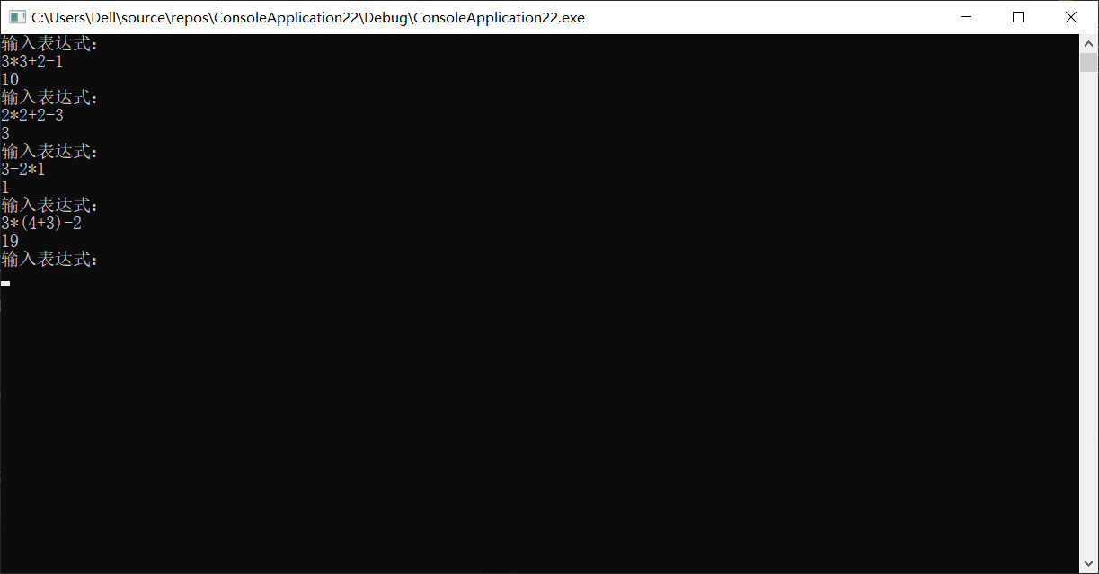

3.队列-猴子分桃
- void QueneBuild(Quene *Q)
- {
- cout << "有多少只猴子？" << endl;
- int n;
- cin >> n;
- Q->num = (int*)malloc(100 * sizeof(int));
- Q->Pch = (int*)malloc(100 * sizeof(int));
- Q->isfull = (bool*)malloc(100 * sizeof(bool));
- Q->front = Q->rear = 0;
- for (int i = 0; i < n; i++)
- {
- Q->num[i] = i + 1;
- Q->Pch[i] = 0;
- Q->isfull[i] = false;
- Q->rear++;
- }
- }

- void DividePeach(Quene *Q)
- {
- cout << "每只猴子可以分到多少桃？" << endl;
- int m;
- cin >> m;
- cout << "筐里最大的桃子数是？ " << endl;
- int k;
- cin >> k;
- int elemnum = Q->rear;
- int b = 0; //从0开始
- int isfullnum = 0;
- int BOXnum = 0;
- while (isfullnum != Q->rear)
- {
- for (int n = 1; n <= k; n++)
- {
- BOXnum += n;
- if (b == Q->rear)
- {
- b = 0;
- }
- if (!(Q->Pch[b] + BOXnum >= m) && !(Q->isfull[b]))
- {
- Q->Pch[b] += n;
- BOXnum = 0;
- }
- else if (!(Q->isfull[b]))
- {
- BOXnum -= m - Q->Pch[b];
- Q->Pch[b] = m;
- cout << Q->num[b] << " ";
- Q->isfull[b] = true;
- isfullnum++;
- }
- b++;
- }
- }
- }
- void QueneShow(Quene *Q)
- {
- for (int i = 0; i < Q->rear; i++)
- {
- cout << "Q.num: " << Q->num[i] << " Q.Pch: " << Q->Pch[i] << " ";
- cout << endl;
- }
- }
- int main()
- {
- Quene Q;
- QueneBuild(&Q);
- DividePeach(&Q);
- }
运行结果：
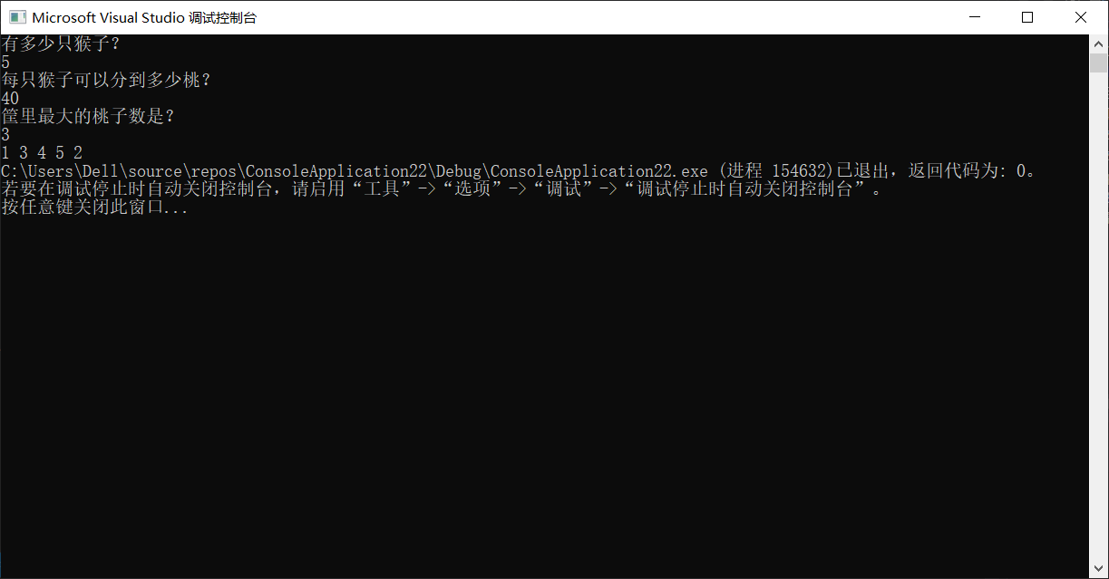

4.字符串和数组-三元组表稀疏矩阵
- typedef struct {
- int row, col; //该数据所在 row 行 col 列
- int elem; //存储的数据
- }Triple;

- typedef struct {
- Triple data[100]; //非零元的数据构成的数组
- int rows, cols, num; //该压缩前矩阵的行数，列数，非零元个数
- }TSMatrix, *TSM;

- void TSMatrixInit(TSMatrix *M, int a[100][100])
- {
- cout << "输入矩阵的行和列 ：" << endl;
- int m, n, i, j;
- cin >> m;
- cin >> n;
- cout << "输入 " << m << "行 " << n << "列的矩阵" << endl;
- for (i = 0; i < m; i++)
- {
- for (j = 0; j < n; j++)
- {
- cin >> a[i][j];
- }
- }
- M->rows = i;
- M->cols = j;
- int k = 0; //计数器
- for (i = 0; i < M->rows; i++)
- {
- for (j = 0; j < M->cols; j++)
- {
- if (a[i][j]) //如果非0
- {
- M->data[k].elem = a[i][j];
- M->data[k].row = i;
- M->data[k].col = j;
- k++;
- }
- }
- }
- M->num = k;

- }

- void TSMatrixAdd(TSMatrix *M, TSMatrix *T,TSMatrix *S) //矩阵相加
- {
- int k = M->num;
- S->num = M->num; S->rows = M->rows; S->cols = M->cols;
- for (int i = 0; i < M->num; i++)
- {
- S->data[i].elem = M->data[i].elem;
- S->data[i].row = M->data[i].row;
- S->data[i].col = M->data[i].col;
- }
- bool flag = 1;
- for (int i = 0; i < M->num; i++)
- {
- flag = 1;
- for (int j = 0; j < k; j++)
- {
- if (T->data[i].row == S->data[j].row&&T->data[i].col==S->data[j].col)
- {
- S->data[j].elem += T->data[i].elem;
- flag = 0;
- break;
- }
- }
- if (flag)
- {
- S->data[k].elem = T->data[i].elem;
- S->data[k].col = T->data[i].col;
- S->data[k].row = T->data[i].row;
- k++;
- S->num++;
- }

- }
- }

- void TSMatrixShow(TSMatrix *T)
- {
- cout << "相加后为 ：" << endl;
- bool sign = 1;
- for (int i = 0; i < T->rows; i++)
- {
- for (int j = 0; j < T->cols; j++)
- {
- sign = 1;
- for (int k = 0; k < T->num; k++)
- {
- if (T->data[k].row == i && T->data[k].col == j)
- {
- cout << T->data[k].elem << " ";
- sign = 0;
- }
- }
- if (sign)
- {
- cout << int(0) << " ";
- }

- }
- cout << endl;
- }
- }

- int main()
- {
- int a[100][100];
- TSM M, T,S;
- M = new TSMatrix;
- T = new TSMatrix;
- S = new TSMatrix;
- TSMatrixInit(M, a);
- TSMatrixInit(T, a);
- TSMatrixAdd(M, T, S);
- TSMatrixShow(S);

- }

运行结果：
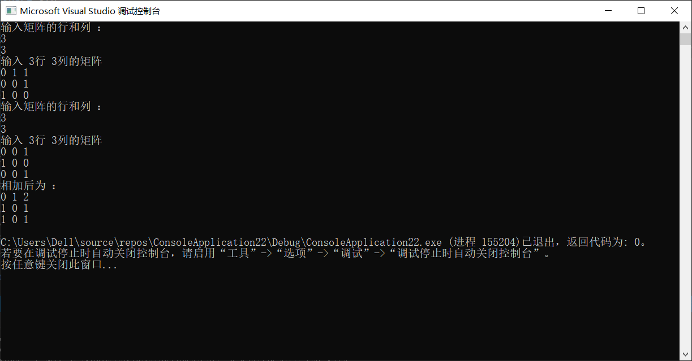
5.树-层序遍历
- void LevelOrderTraverse(BTreeNode *&T)
- {
- BTreeNode* s[100];
- int front=0;
- int rear=0;
- s[rear++]=T;
- while(front<rear)
- {
- cout<<s[front]->data<<” “;
- if(s[front]->lchild)
- {
- s[rear++]=s[front]->lchild;
- }
- if(s[front]->rchild)
- {
- s[rear++]=s[front]->rchild;
- }
- front++;
- }
运行结果：
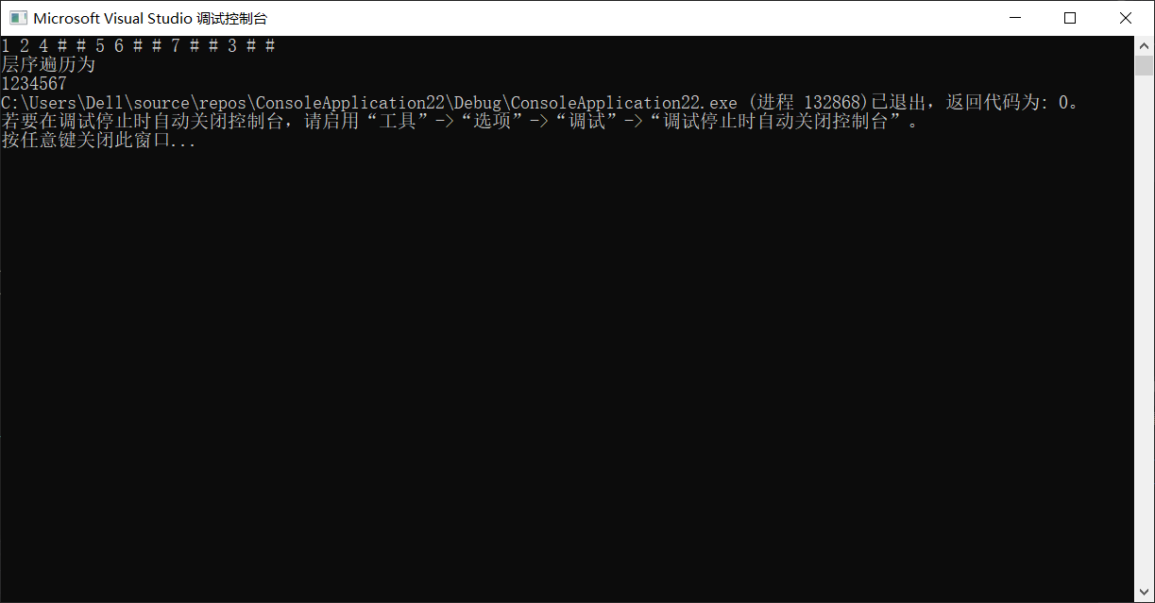

6.图-深度优先搜索
- void DFS(Graph &G, int visited[100], int i)
- {
- if (!visited[i])
- {
- visited[i] = 1;
- cout << G.vertices[i].data << " ";
- ArcNode *p = G.vertices[i].firstout;
- while (p)
- {
- if (!visited[p->adj])
- {
- DFS(G, visited, p->adj);
- }
- p = p->next;
- }
- }
- }

- void showDFS(Graph &G)
- {
- int visited[100];
- for (int i = G.vexnum - 1; i >= 0; i--)
- {
- visited[i] = 0;
- }
- for (int i = 0; i < G.vexnum; i++)
- {
- if (!visited[i])
- {
- DFS(G, visited, i);
- }
- }
- }

运行结果：
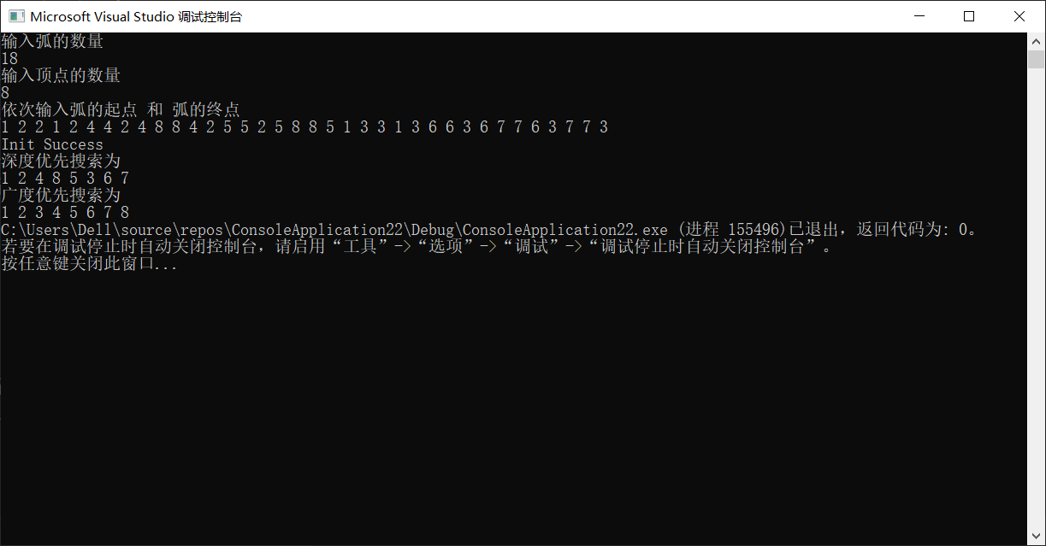

7. 查找-二叉排序树
- bool SearchBTreeNode(BTreeNode *T, int num,BTreeNode *&q,BTreeNode *&cur) //q:双亲结点
- {
- if (T)
- {
- if (T->data == num)
- {
- cur = T; //cur:该数据结点
- return true;
- }
- if (T->data > num)
- {
- q = T;
- return SearchBTreeNode(T->lchild, num, q,cur);
- }
- else
- {
- q = T;
- return SearchBTreeNode(T->rchild, num, q,cur);
- }
- }
- else
- {
- return false;
- }
- }

- void BTreeNodeInsert(BTreeNode *&q,int num)
- {
- if (q->data > num)
- {
- q->lchild = new BTreeNode;
- q->lchild->data = num;
- q->lchild->lchild = q->lchild->rchild = NULL;
- }
- else
- {
- q->rchild = new BTreeNode;
- q->rchild->data = num;
- q->rchild->lchild = q->rchild->rchild = NULL;
- }
- }

- void BTreeNodeDelete(BTreeNode *&p,BTreeNode *&cur, int num) //删除节点
- {
- if (!cur->lchild)//左子树不在就接右子树
- {
- p->rchild = cur->rchild;
- }
- else if (!cur->rchild)//右子树不在就接左子树
- {
- p->lchild = cur->lchild;
- }
- else if (cur->lchild && cur->rchild)//左右子树都有
- {
- BTreeNode *pre = cur->lchild; //找cur的中序前驱
- //如果这个前驱的右子树存在
- if (pre->rchild)
- {
- BTreeNode *ppre = pre;
- while (pre->rchild)
- {
- ppre = pre;
- pre = pre->rchild;
- }
- cur->data = pre->data; //前驱替换该点
- if (pre->lchild) //如果这个前驱也有前驱
- {
- ppre->rchild = pre->lchild; //这个点的前驱作为它下面的一系列前驱的前驱的后继，这样就不会丢失这个点下面的所有数据。
- }
- pre = NULL;
- }
- //如果不存在,也就是这个前驱就是该点的左子树根结点
- else
- {
- p->lchild = pre->lchild;
- free(pre);
- }
- }

- }
- int main()
- {
- BTreeNode *T;
- T = new BTreeNode;
- BTN ptr = T;
- BTN q = T;
- BTN cur = NULL;
- BTreeBuild(ptr);
- BTreeShow(ptr);
- int num;
- cout << "输入你要插入的数据" << endl;
- cin >> num;
- if (!SearchBTreeNode(ptr, num,q,cur))
- {
- cout << "未能找到该数据，现进行插入操作：" << endl;
- BTreeNodeInsert(q, num);
- cout << "插入完毕" << endl;
- }
- BTreeShow(ptr);
- cout << endl;
- for (int i = 0; i < 3; i++)
- {
- q = ptr; //重置
- cout << "请输入要删除的数据" << endl;
- int delnum;
- cin >> delnum;
- if (!SearchBTreeNode(ptr, delnum, q, cur))
- {
- cout << "该数据不存在，无法删除" << endl;
- }
- else
- {
- cout << "删除结果为" << endl;
- BTreeNodeDelete(q, cur, delnum);
- BTreeShow(ptr);
- cout << endl;
- }
- }
- }
- //45 12 3 -1 -1 37 24 -1 -1 -1 53 -1 100 61 -1 90 78 -1 -1 -1 -1
运行结果：
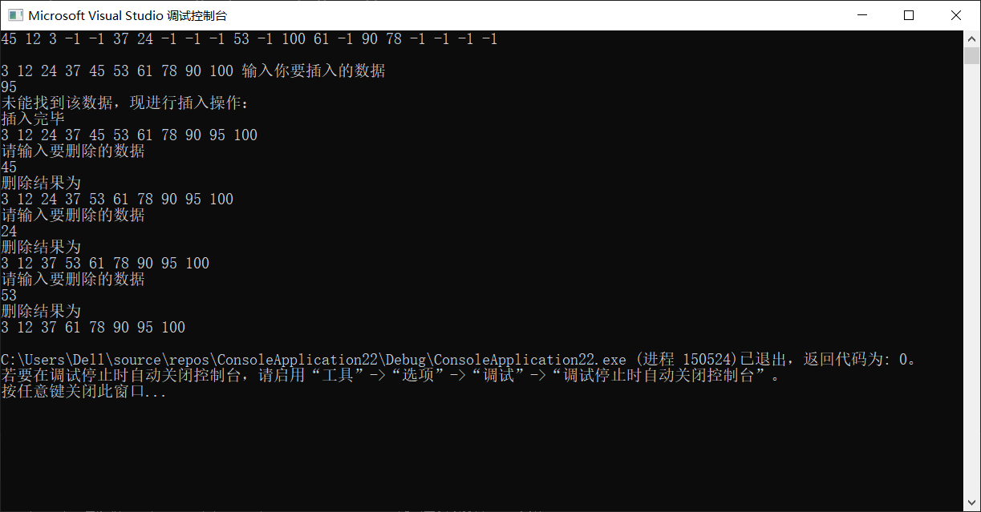

8.排序-快速排序算法
- void QuickSort(SqList &L,int low,int high) //快排
- {
- if(low<high)
- {
- int m;
- L.r[0].key=L.r[low].key;
- m=L.r[0].key;
- int i=low;
- int j=high;
- while(i<j)
- {
- while(i<j&&L.r[j].key>=m)
- {
- j--;
- }
- while(i<j&&L.r[i].key<=m)
- {
- i++;
- }
- if(i<j)
- {
- int temp;
- temp=L.r[i].key;
- L.r[i].key=L.r[j].key;
- L.r[j].key=temp;
- }
- }
- //此时low=high,调换中枢和第一个
- L.r[low].key=L.r[i].key;
- L.r[i].key=L.r[0].key;

- QuickSort(L,i+1,high);
- QuickSort(L,low,i-1);
- }
- }
运行结果：
