DELHI UNIVERSITY,

RAMANUJAN COLLEGE

PRACTICAL FILE

INFORMATION SECURITY

NAME : AKSHIT
ROLL NO: 20232702
SEM: 6

Practical 1
q) Demonstrate the use of Network tools: ping, ipconfig, ifconfig, tracert, arp, netstat, whois.

- ping: Checks connectivity between two systems

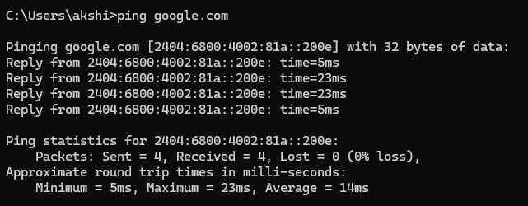

- ipconfig(windows): Shows IP address details

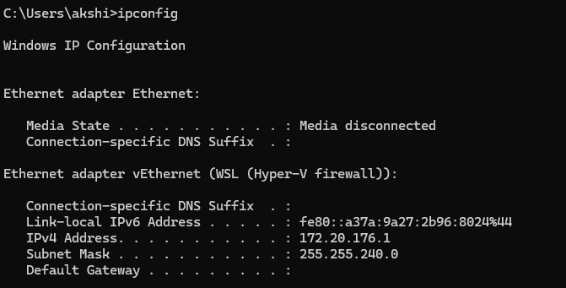

- ifconfig(linux): Shows IP address details
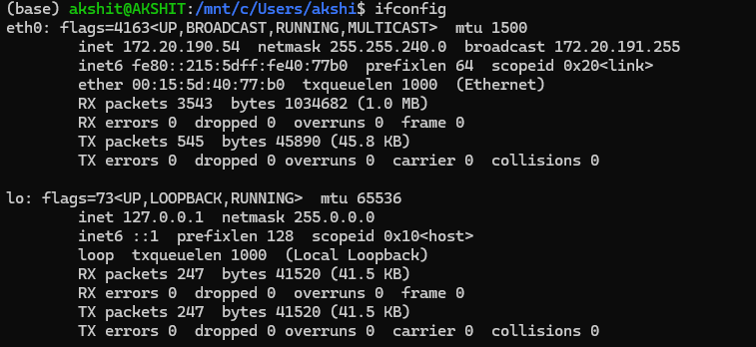

- tracert: Shows path packets take

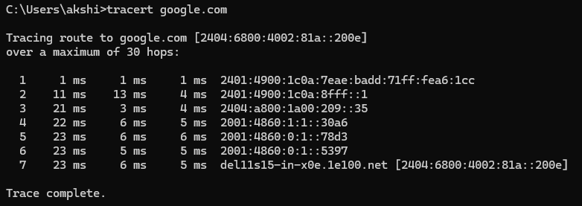

- arp: Displays IP ↔ MAC address mapping
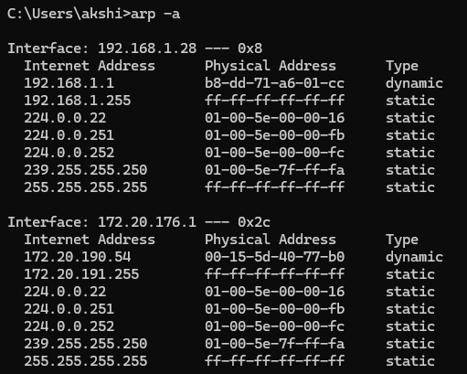
- netstat: Shows active connections & ports

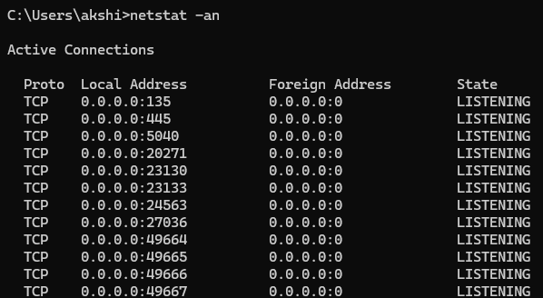

- whois: Gives domain registration details

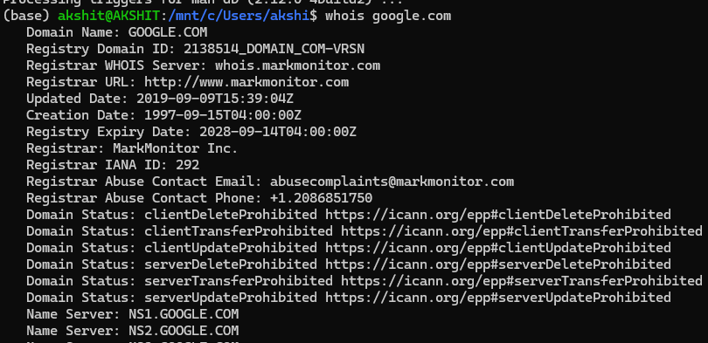

PRACTICAL 2

q) Use of Password cracking tools : John the Ripper, Ophcrack. Verify the strength of passwords using these tools.

- John the Ripper:
- In wsl(windows subsystem for linux or other linux machine):

- Create a hash file(password.txt):

- Create a wordlist(wordlist.txt):
nano wordlist.txt
add:
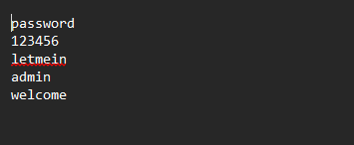

- Run john the ripper:
john --wordlist=wordlist.txt passwords.txt

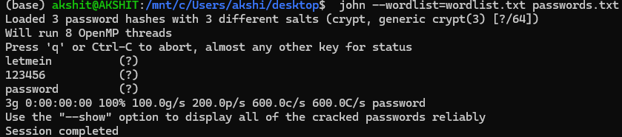

- View cracked passwords:
john --show passwords.txt

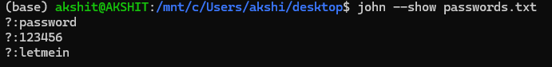

Note: as ripper was able to easily crack these passwords they are weak in strength.

2)Ophcrack :
Step 1: Install and Open Tool
- Install Ophcrack on the system
- Launch the application

Step 2: Load Rainbow Tables
- Go to: Tables → Install
- Load XP free tables
- Wait until tables are loaded into memory

Step 3: Create PWDUMP File
- Create a file pwdump.txt with format:
username:UID:LM_hash:NTLM_hash:::

Step 4: Load Hash File
- Click: Load → PWDUMP file
- Select pwdump.txt

Step 5: Start Cracking
- Click on Crack
- Wait for the process to complete

Step 6: Observe Results
Check:
- LM Password columns
- NT Password column

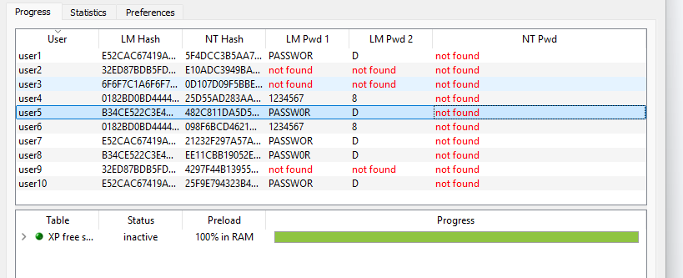

Note: we can conclude that the passwords that were not cracked are more secure

PRACTICAL 3

q) Use nmap/zenmap to analyse a remote machine.

Step1 : download zenmap from https://nmap.org/download
Step 2: discover your network ip-
- Use: ipconfig or ifconfig
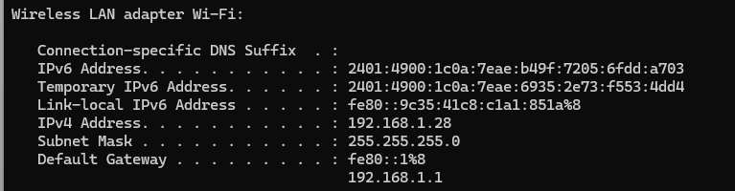
Step 3: run intense scan on 192.168.1.0/24 to detect active host present on the network

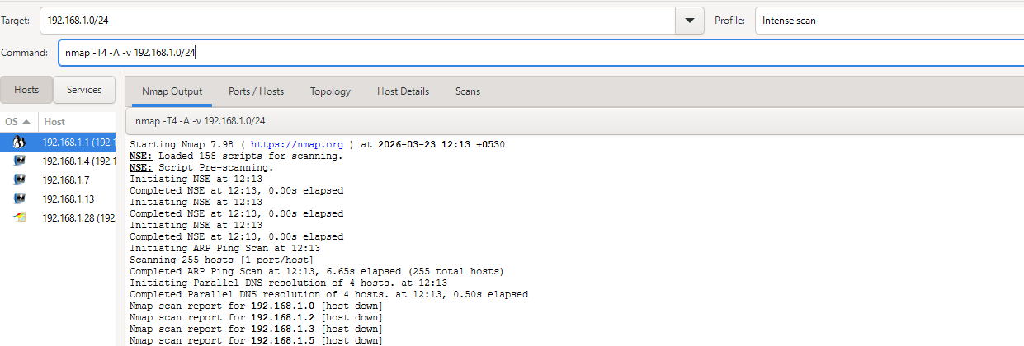

Step 4: analyse remote machine :
- Run scan on detected machines:

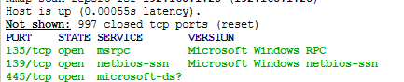

Note: we identified that 192.168.1.28 on the wifi network is likely a windows device and tcp 135, 139 and 445 ports are running on it.

PRACTICAL 4
q) Use Burp proxy to capture and modify the message.

Step 1: Run Juice Shop(OWASP Juice Shop is a deliberately insecure web application developed under the OWASP Foundation. Designed for security education)
- Install Docker
- Run :
docker pull bkimminich/juice-shop
- Run :
docker run --rm -p 127.0.0.1:3000:3000 bkimminich/juice-shop

Step 2: Open Burp Suite
- Launch Burp Suite
- Select:
Temporary Project → Next → Start Burp

Step 3: Enable Intercept
- Go to: Proxy → Intercept
- Click:
Intercept ON

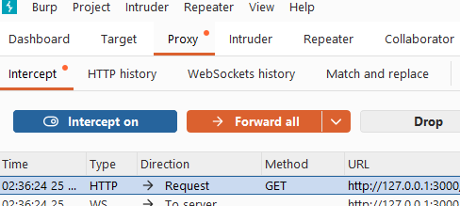

Step 4: Configure Browser Proxy
- Proxy → Open Browser
- Open http://127.0.0.1:3000
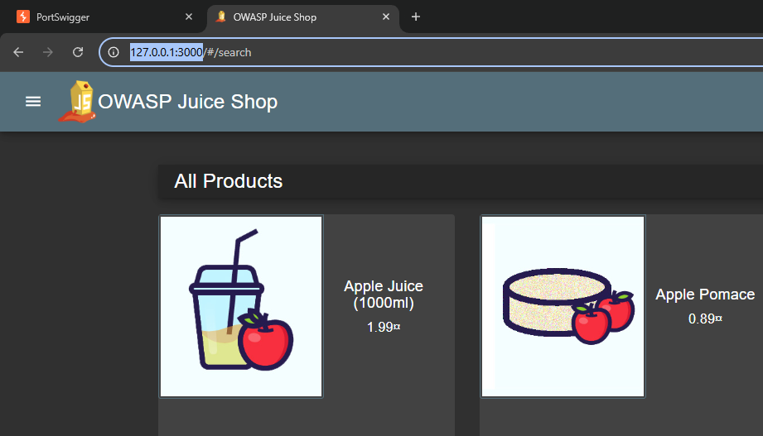

Step 6: Capture Login Request
- Open Juice Shop(localhost:3000)
- Click Login > User registration
- Click login
Enter:(login details)
email: test@test.com
password: 1234
- Click login:
Burp will intercept request like:

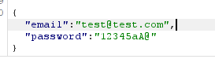

Step 7 : Modify request
- Change password
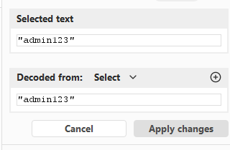

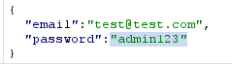

Step 8: Forward Request

- Click Forward

Request goes to server
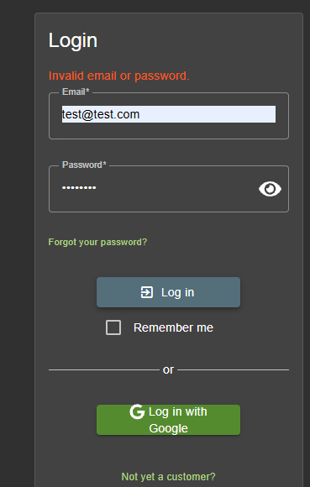

Note: we have managed to capture and modify the user login password request.

PRACTICAL 5

Q) Demonstrate sending of a protected word document.

Step 1: Create Document
- Open Microsoft Word
- Type sample content
- Save file

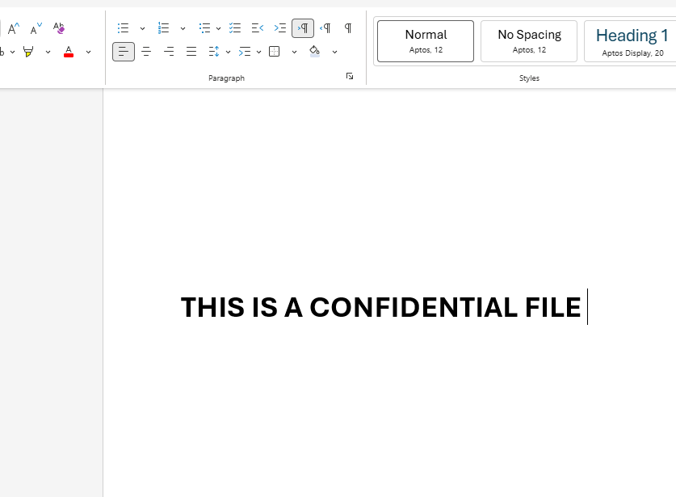

Step 2: Protect the Document
- Go to:
File → Info
- Click:
Protect Document → Encrypt Document

- Enter password
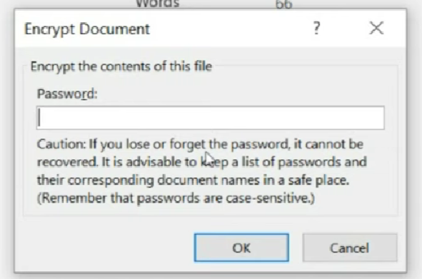
- Confirm password
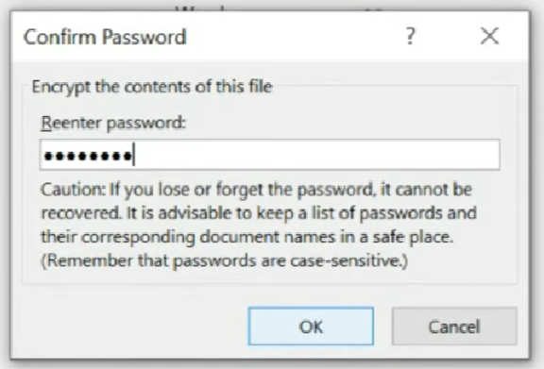
- Save the document

Step 3: Verify Protection
- Close and reopen file
- Enter password
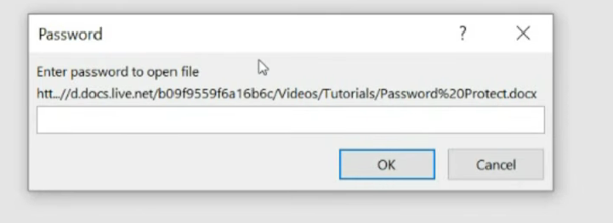

Step 4: Send the Document
- Send the document via email, instant messaging etc.

Step 5: Share Password Securely
- In person
- Over phone call

PRACTICAL 6

Q) Demonstrate sending of a digitally signed document.

Step 1: Create Document
- Open Microsoft Word
- Type sample content

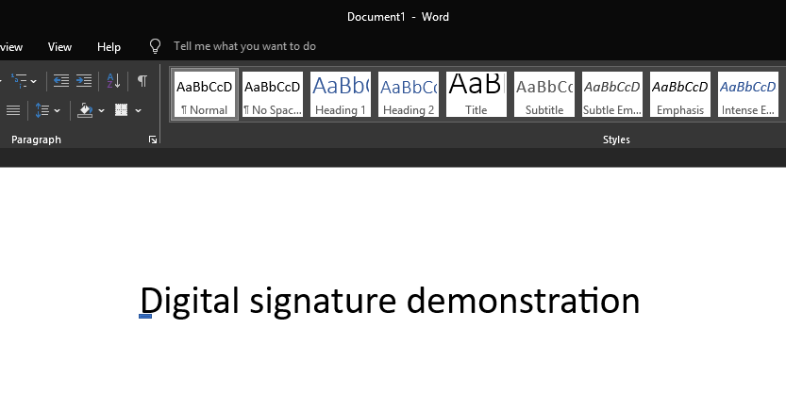

Step 2: Add digital signature:
Go to:
- File → Info → Protect Document → Add a Digital Signature

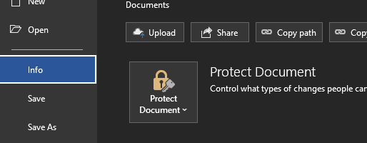

Fill:
- Name
- Purpose (e.g., “Official Submission”)
Click Sign

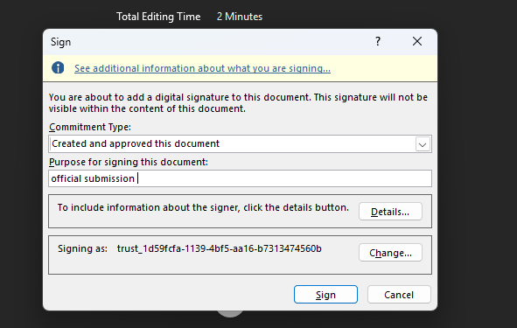

Step 3: Send the Document
- Send the document via email, instant messaging etc.

PRACTICAL 7

Q) Demonstrate sending of a protected worksheet.

Step 1: Create worksheet
- Open excel create worksheet
- Home blank workbook
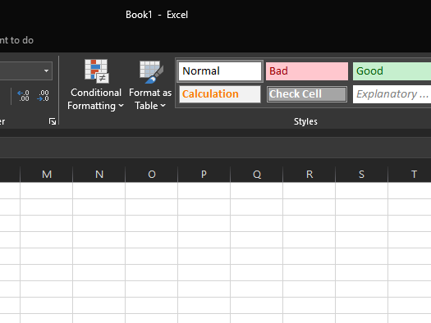

Step 2: Protect sheet
Go to:
- Review → Protect Sheet
Set:
- Password (e.g., 1234)

Choose permissions:
- Allow select cells
- Allow select unlocked cells
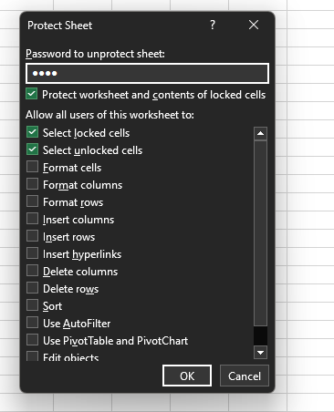

Step 3: Send the Document
- Send the document via email, instant messaging etc.

Step 4: Share Password Securely
- In person
- Over phone call

PRACTICAL 8

Q) Demonstrate use of gpg utility for signing and encrypting purposes.

Step 1: Install GPG
Linux(wsl):
- Bash:
sudo apt install gnupg

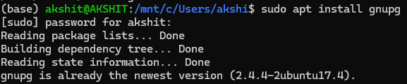

Step 2: Generate Key Pair
gpg --full-generate-key

Choose:
- RSA & RSA
- Key size: 2048
- Enter name, email, password
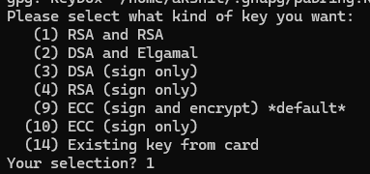

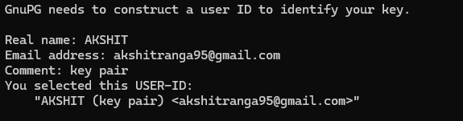

You will also be asked to assign a passphrase:
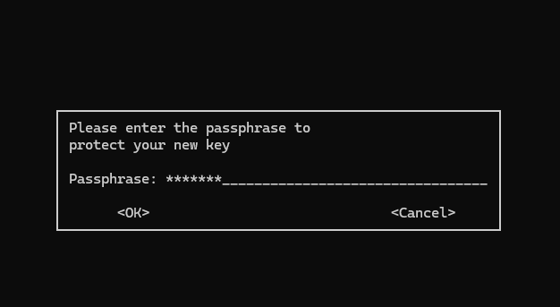

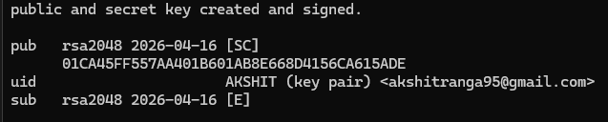

Step 3: List Keys
gpg --list-keys

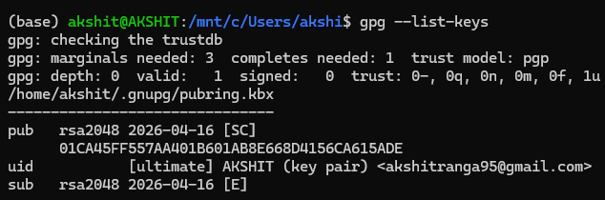

Step 4: Signing a File
Create file:
echo "Hello Secure World" > file.txt

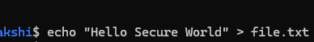

Sign file:
gpg --sign file.txt

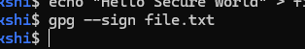

You will be asked for the passphrase:

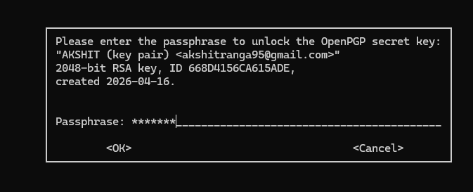
Step 5: Verify Signature
gpg --verify file.txt.gpg

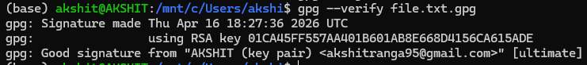

Step 6: Encrypt a File
gpg --encrypt --recipient "user@email.com" file.txt

Step 7: Decrypt File
gpg --decrypt file.txt.gpg

You will be asked for the passphrase: once you enter it

You have decrypted the file

