Facebook

Web Monitoring Group

# Preliminaries

Load and attach packages, as well as custom functions

suppressPackageStartupMessages(  
 invisible(  
 lapply(c("DBI", "RSQLite", "Rfacebook", "dplyr", "ggplot2", "tidyr"),  
 library,  
 character.only = TRUE)  
 )  
)

## Warning: package 'dplyr' was built under R version 3.4.3

source("fb-functions.R")

# Data collection

Fetch the Page’s Newsfeed from the local database. A summary of the available data is displayed.

## Observations: 108  
## Variables: 11  
## $ from_id <chr> "145175075891647", "145175075891647", "14517507...  
## $ from_name <chr> "National Environmental Standards & Regulations...  
## $ message <chr> "THROUGH THE LENS!\n\nThe 11th National Stakeho...  
## $ created_time <chr> "2017-12-15T15:55:38+0000", "2017-12-14T12:02:0...  
## $ type <chr> "photo", "video", "photo", "link", "video", "vi...  
## $ link <chr> "https://www.facebook.com/NESREANigeria/photos/...  
## $ id <chr> "145175075891647_340028919739594", "14517507589...  
## $ story <chr> "National Environmental Standards & Regulations...  
## $ likes_count <dbl> 555, 14, 13, 28, 60, 16, 231, 19, 17, 19, 51, 2...  
## $ comments_count <dbl> 4, 0, 0, 2, 0, 3, 0, 0, 0, 1, 2, 0, 0, 0, 0, 7,...  
## $ shares_count <dbl> 9, 2, 1, 11, 8, 4, 14, 4, 5, 9, 0, 8, 9, 7, 0, ...

## Observations: 2,763  
## Variables: 3  
## $ from_name <chr> "Udoka Ezeudembah", "Martin Enenwaene", "Miranda Ama...  
## $ from_id <chr> "1472314569516878", "146500446103605", "184660826226...  
## $ post_id <chr> "145175075891647_324562367952916", "145175075891647_...

## Observations: 139  
## Variables: 8  
## $ from_id <dbl> 5.638983e-308, 3.398606e-309, 1.071436e-309, 5....  
## $ from_name <chr> "Haruna Adokwe", "Mohammed Adamu Saleh", "Umar ...  
## $ message <chr> "Our Amiable CEO/DG", "Yes! This is my DG/CEO, ...  
## $ created_time <chr> "2017-10-27T07:53:43+0000", "2017-10-27T09:12:1...  
## $ likes_count <int> 1, 1, 2, 1, 1, 1, 0, 0, 2, 1, 1, 1, 1, 1, 1, 1,...  
## $ comments_count <int> 0, 0, 0, 0, 0, 0, 0, 0, 0, 0, 0, 0, 0, 0, 0, 0,...  
## $ id <chr> "324562367952916_324577607951392", "32456236795...  
## $ post_id <chr> "145175075891647_324562367952916", "14517507589...

Note that the function getPage() is used to collect these posts through the Facebook API/Rfacebook package. It can equally be used to harvest data from others’ public posts via the page argument.

# Data cleaning

We have a user-defined function we have called prepare_data() that lives in the file *fb-functions* that was sourced earlier and it will help us do some data cleaning very quickly.

The function:

* takes a data frame as an argument
* checks that the column names match those of typical Facebook post data
* removes non-human readable characters from the ‘message’ variable
* changes ‘type’ from a character to a categorical variable
* converts ‘time’ into a Date-Time object (POSIX standard)
* returns the modified data frame

This is what the function definition looks like:

## function (df = data.frame())   
## {  
## cnames <- c("from_id", "from_name", "message", "created_time",   
## "type", "link", "id", "story", "likes_count", "comments_count",   
## "shares_count")  
## if (!identical(colnames(df), cnames))   
## stop("Loaded data are not compatible with this function")  
## df$type <- as.factor(df$type)  
## df$created_time <- df$created_time %>% gsub("T", " ", .) %>%   
## gsub("\\+", " \\+", .) %>% as.POSIXct(.)  
## df  
## }

Also columns 1 and 2 are redundant for the purpose of these particular analyses and will be removed. This is how it’s done and the data now look like this

posts <- posts %>%  
 prepare_data() %>%  
 select(message:shares_count)  
  
glimpse(posts)

## Observations: 108  
## Variables: 9  
## $ message <chr> "THROUGH THE LENS!\n\nThe 11th National Stakeho...  
## $ created_time <dttm> 2017-12-15 15:55:38, 2017-12-14 12:02:07, 2017...  
## $ type <fctr> photo, video, photo, link, video, video, photo...  
## $ link <chr> "https://www.facebook.com/NESREANigeria/photos/...  
## $ id <chr> "145175075891647_340028919739594", "14517507589...  
## $ story <chr> "National Environmental Standards & Regulations...  
## $ likes_count <dbl> 555, 14, 13, 28, 60, 16, 231, 19, 17, 19, 51, 2...  
## $ comments_count <dbl> 4, 0, 0, 2, 0, 3, 0, 0, 0, 1, 2, 0, 0, 0, 0, 7,...  
## $ shares_count <dbl> 9, 2, 1, 11, 8, 4, 14, 4, 5, 9, 0, 8, 9, 7, 0, ...

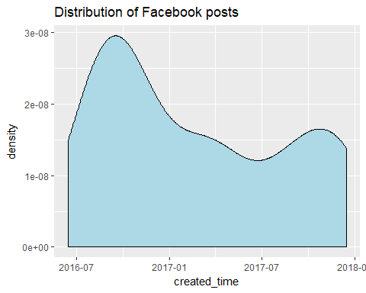

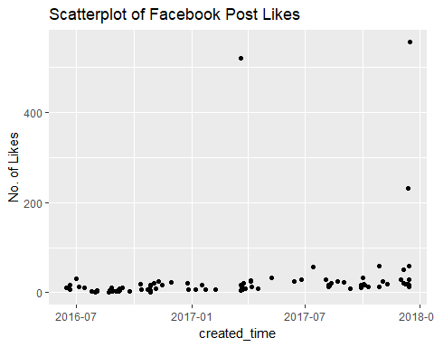

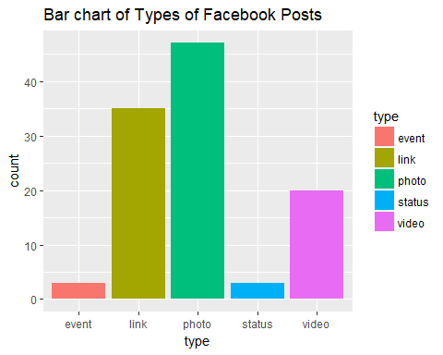

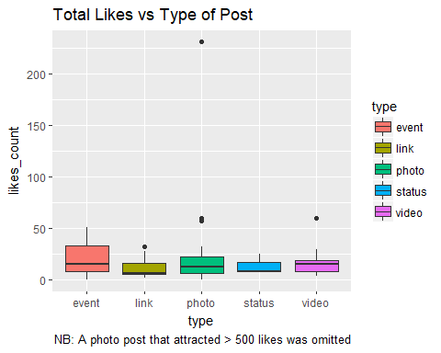

## `stat_bin()` using `bins = 30`. Pick better value with `binwidth`.

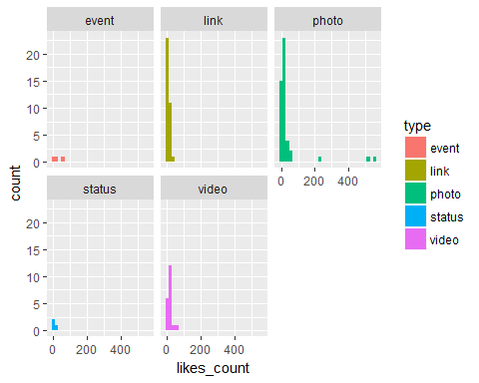

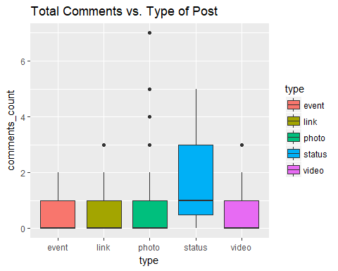

## `stat_bin()` using `bins = 30`. Pick better value with `binwidth`.

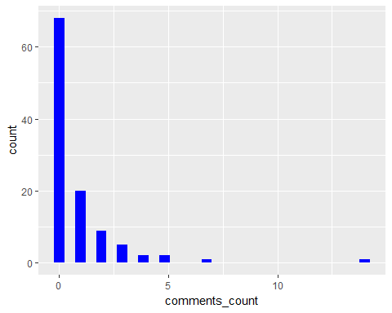

## `stat_bin()` using `bins = 30`. Pick better value with `binwidth`.

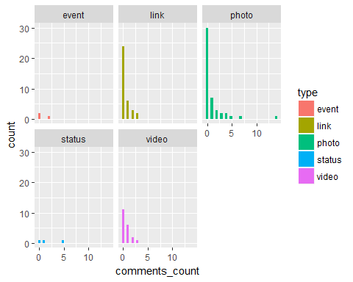

## `stat_bin()` using `bins = 30`. Pick better value with `binwidth`.

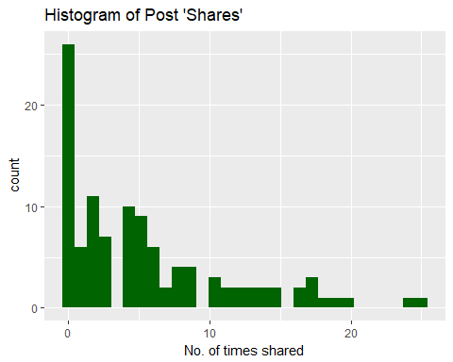

## `stat_bin()` using `bins = 30`. Pick better value with `binwidth`.

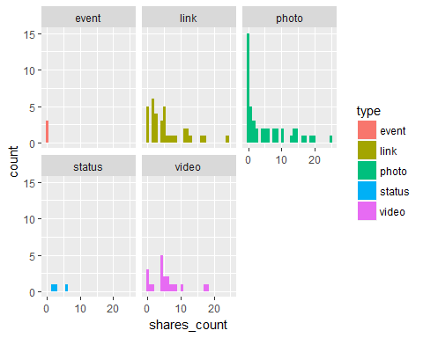

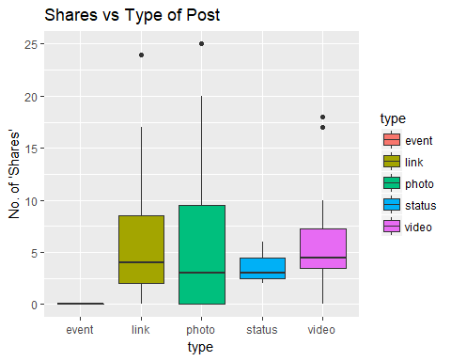

Like details

## Name Freq  
## 1 Saidu Gaji 50  
## 2 Miranda Amachree 47  
## 3 Matthias Nggwa Bwala 40  
## 4 Nath Doeko'os 38  
## 5 Olaniyi Musibau 28  
## 6 Dauda Adedamola Abiodun 27  
## 7 Tukur A Musa 24  
## 8 Kabiru Babayo 23  
## 9 Vincent Emenyonu 23  
## 10 Bola Braimoh-Tokura 21

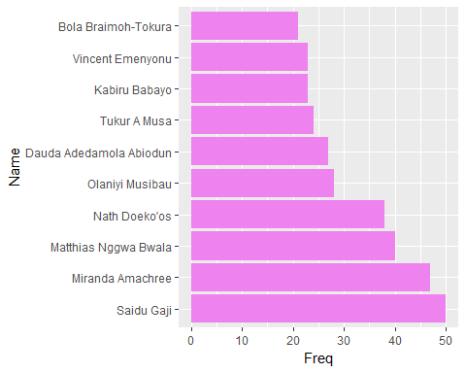

## # A tibble: 10 x 2  
## Name Freq  
## <fctr> <int>  
## 1 Chukwudi Nwabuisiaku 16  
## 2 Rey Bruno Igbadumhe 8  
## 3 Christian Nwaeseni 4  
## 4 Christopher Onotu 4  
## 5 Maiwada Omar 4  
## 6 Matthias Nggwa Bwala 4  
## 7 Ola Abd'Raheem Amode 4  
## 8 Theresa Iwenofu 4  
## 9 Umar Suleiman 4  
## 10 Haruna Adokwe 3

