Selected Formatted Output
These are just a few of the outputs I thought needed to be clarified a little. If any other clarification is needed, kindly request.

1. Multi-way tabulation of the variable set, reformatted as a data frame (outcome variable is spread out and shaded)
risks time | risks communication | risks lackemployeecontrol | risks unclearPolicy | risks workinghours | No concern | Some concern | Major concern
Yes | Yes | Yes | Yes | Yes | 1 | 241 | 259
Yes | Yes | Yes | Yes | No | 0 | 140 | 73
Yes | Yes | Yes | No | Yes | 2 | 49 | 41
Yes | Yes | Yes | No | No | 0 | 38 | 35
Yes | Yes | No | Yes | Yes | 0 | 89 | 60
Yes | Yes | No | Yes | No | 0 | 108 | 52
Yes | Yes | No | No | Yes | 1 | 32 | 24
Yes | Yes | No | No | No | 1 | 84 | 26
Yes | No | Yes | Yes | Yes | 2 | 70 | 51
Yes | No | Yes | Yes | No | 1 | 47 | 34
Yes | No | Yes | No | Yes | 0 | 11 | 19
Yes | No | Yes | No | No | 0 | 18 | 21
Yes | No | No | Yes | Yes | 0 | 47 | 35
Yes | No | No | Yes | No | 1 | 61 | 45
Yes | No | No | No | Yes | 0 | 19 | 9
Yes | No | No | No | No | 0 | 55 | 29
No | Yes | Yes | Yes | Yes | 1 | 236 | 106
No | Yes | Yes | Yes | No | 1 | 129 | 60
No | Yes | Yes | No | Yes | 4 | 132 | 62
No | Yes | Yes | No | No | 4 | 148 | 53
No | Yes | No | Yes | Yes | 1 | 89 | 39
No | Yes | No | Yes | No | 1 | 114 | 51
No | Yes | No | No | Yes | 0 | 71 | 38
No | Yes | No | No | No | 0 | 158 | 56
No | No | Yes | Yes | Yes | 1 | 239 | 139
No | No | Yes | Yes | No | 1 | 220 | 85
No | No | Yes | No | Yes | 1 | 91 | 52
No | No | Yes | No | No | 1 | 135 | 57
No | No | No | Yes | Yes | 4 | 206 | 72
No | No | No | Yes | No | 1 | 332 | 114
No | No | No | No | Yes | 0 | 134 | 60
No | No | No | No | No | 2 | 616 | 171

2. This plot is a visual representation of the table above – apologies for the labelling; will be adjusted if plot is eventually used
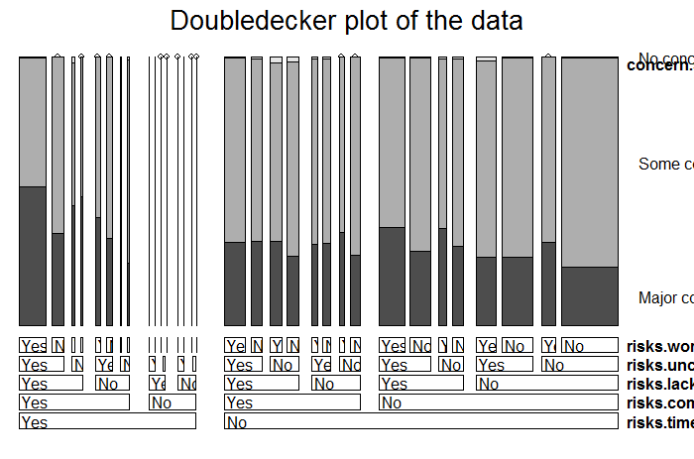
3. This plot represents the validity of the assumption of proportional odds, as explained in the interim report. The model we are using for these data is deemed appropriate.

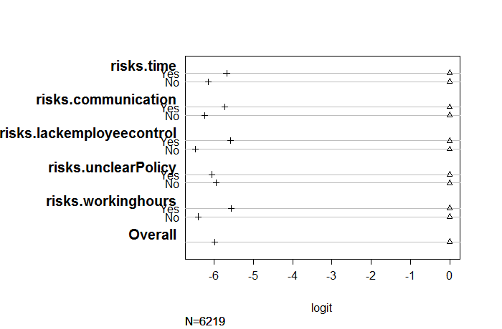

4. This chart displays the predicted probabilities for each response of the outcome variable given the response from the predictor variable. For prediction was done using a simulated dataset in which the conditional probability of the predictor’s response is 0.5, and this was the same for each predictor. Thus the predicted probability in this chart is representative of all the predictors.

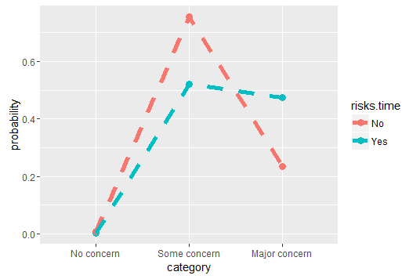

It should be interesting to see how this chart would look amongst the different variable pairs. If you’re happy with the direction this thing is going, let me know and I will proceed to do that.

