GardenSewa
Projects
S.N. | Name | Category | Location
1 | Solatee Westend | Hotel/Resort | Kathmandu
2 | Bajeko Sekuwa | Restaurant | Kathmandu
3 | Sudarshan Resort | Resort | Belbari
4 | Pokhara Airport | Airport | Pokhara
5 | Gokarna Forest Resort | Resort | Kathmandu
6 | Ncell | Telecom | Nationwide
7 | Dusit Thani Himalaya Resort | Hotel/Resort | Kathmandu
8 | Club Himalaya | Hotel/Resort | Nagarkot
9 | Hotel Bhadgaon Bhaktapur | Hotel | Bhaktapur
10 | Kavya Himalayas | Hotel/Resort | Nagarkot
11 | Mercure Kathmandu Sukedhara Heights | Hotel | Kathmandu
12 | Kathmandu Guest House | Hotel/Guest House | Kathmandu
13 | Sankha Park | Park | Kathmandu
14 | Hotel Aikawa, Sauraha | Hotel | Sauraha, Chitwan
15 | The British School | School | Kathmandu
16 | Ramesh Corp | Corporate/Business | Kathmandu
17 | Nabil Bank | Bank | Nationwide
18 | Budhanilkantha School | School | Kathmandu
19 | Shankhamul Park | Park | Kathmandu
20 | Ullens School | School | Lalitpur
21 | Alice Receptions | Banquet/Event | Kathmandu
22 | Grande International Hospital | Hospital | Kathmandu
23 | Silver Oak Banquet | Banquet/Event | Kathmandu
24 | The British College | College | Kathmandu
25 | Rani Mahal Banquet | Banquet/Event | Kathmandu
26 | Nepal Mediciti Hospital | Hospital | Lalitpur
27 | Frontline Hospital | Hospital | Kathmandu
28 | Waterfront Resort by KGH Group | Resort | Pokhara
29 | Rupy’s International School | School | Kathmandu
30 | Norvic Hospital | Hospital | Kathmandu
31 | Fortune Resort | Resort | Pokhara
32 | Ramada By Wyndham Kathmandu Dhumbarahi | Hotel | Kathmandu
33 | Tribhuwan Park | Park | Kathmandu
34 | Basundhara Park | Park | Kathmandu
35 | Garden of Dreams | Heritage Garden | Kathmandu

Website Page Format
Few of our Projects

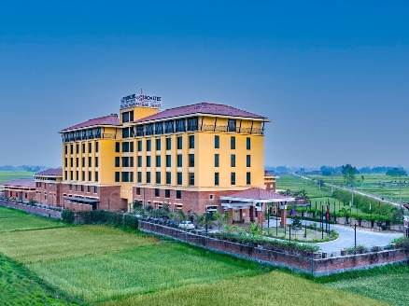  Solatee Westend  Kathmandu | 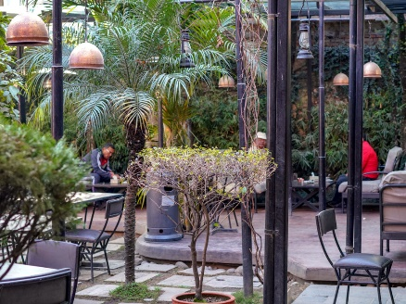  Bajeko Sekuwa  Kathmandu | 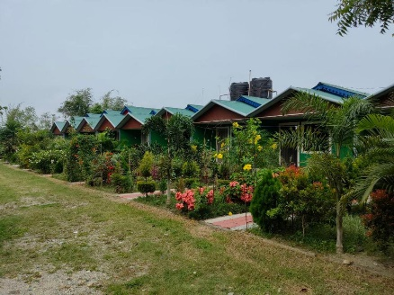  Sudarshan Resort  Belbari
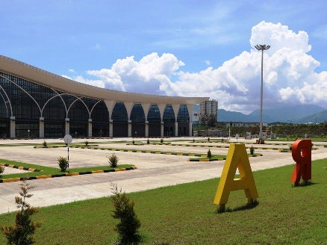  Name of Business  Location | 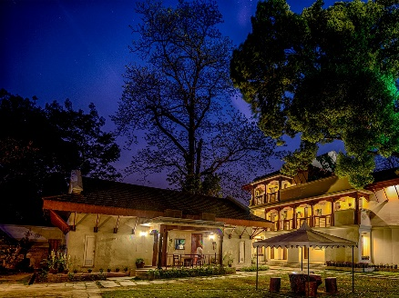  Name of Business  Location | 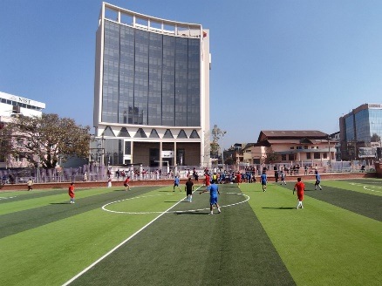  Name of Business  Location
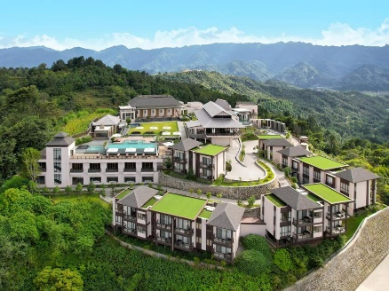  Name of Business  Location | 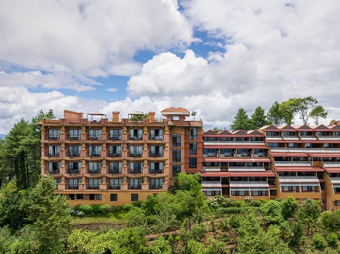  Name of Business  Location | 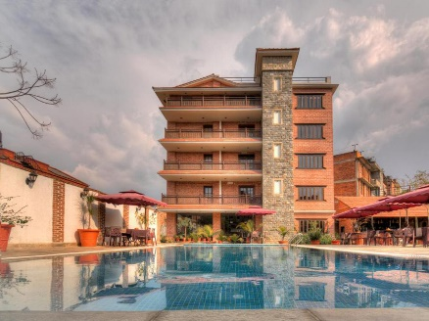  Name of Business  Location

