MS of Marketing course description analysis

Jonathan Broadbridge

# Course description text Analysis

## Marketing program research

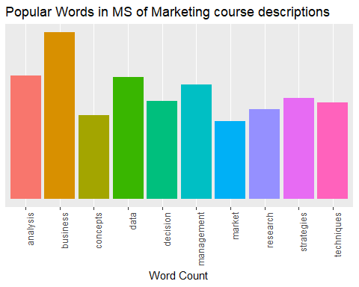

### Common words analysis 1

In this plot we can see represented the most common words used across all MS in marketing programs from the selected schools. Generalize themes around business and basic business concepts dominate this selection.

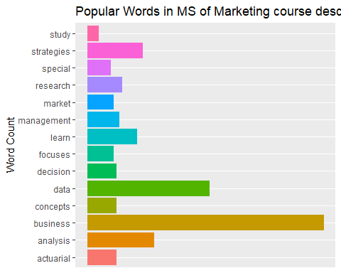

### Common words analysis 2

In this plot we get to see the top 2 most common words per university masters program, this selection is then aggregated into a single plot. This shows a slight difference as terms such as Actuarial appear in this section. This means it is a highly used word in a single university but has a lower representation than the above graph which takes it selection from the entire dataset.

### Wordcloud

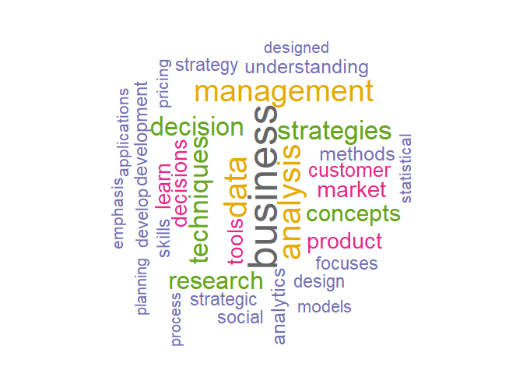

In this graph we can see the top 34 words used overall in the Dataset. From this we can start to interpret trends in current MS of Marketing programs. For example analytics, analysis, and statistical all make an appearance in this wordcloud. This may indicate that current MS of Marketing programs have aspects of marketing and data analytics heavily involved in them.

### TF-IDF analysis 1

Term Frequency and Inter- document frequency can be used to determine which words are most important for each subset of data. In this analysis I chose to interpret the most important words per university program. From this we get much more interesting results that show what each school has a focus or specialization in. This information should be useful to decision makers when evaluating the direction and flavor of the MS of marketing programs that may be proposed in the future. Directly following this paragraph is a list of the top ten words based on TF- IDF analysis.

## # A tibble: 10 x 6  
## school_ab word n tf idf tf_idf  
## <chr> <chr> <int> <dbl> <dbl> <dbl>  
## 1 MSU classroom 3 0.0155 2.83 0.0438  
## 2 MSU special 8 0.0412 0.887 0.0366  
## 3 TEM actuarial 10 0.0114 2.83 0.0324  
## 4 UH credit 2 0.00823 2.83 0.0233  
## 5 UH entrepreneurial 2 0.00823 2.83 0.0233  
## 6 UH repeated 2 0.00823 2.83 0.0233  
## 7 USF buyer 2 0.0124 1.73 0.0215  
## 8 TEM insurance 8 0.00914 2.14 0.0196  
## 9 UMCP conflicting 2 0.00669 2.83 0.0190  
## 10 UMCP morals 2 0.00669 2.83 0.0190

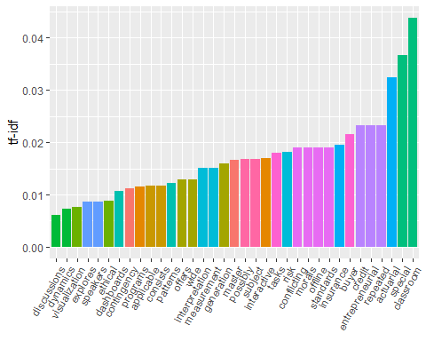 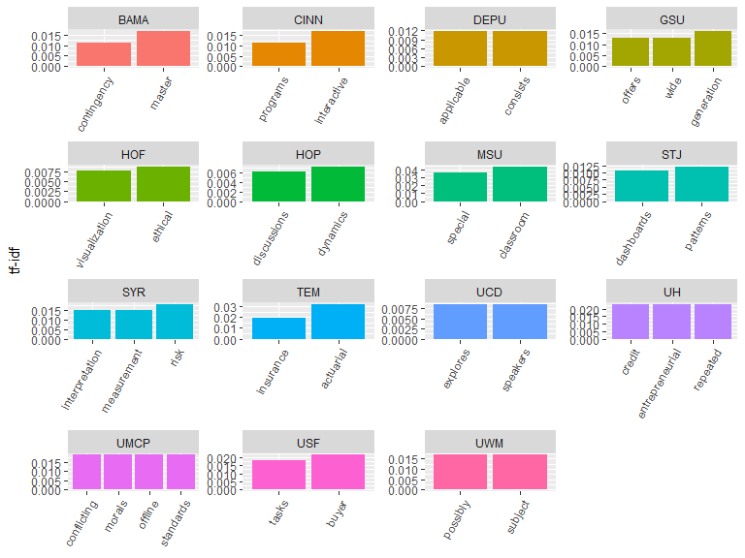

### TF-IDF analysis 2

From these plots we can see a variety of unique words that each school seems to have a focus on. For example Temple university has a focus on actuarial studies as well as insurance based marketing. When looking at the aggregated list we can see some interesting topics being focused on. Classroom is the top word for TF-IDF analysis, this may be because of the current online school format or this may have been previously used course descriptions, more analysis is needed for this. Some of the other top terms do not appear on the most commonly used list such as actuarial, entrepreneurial, credit and buyer. As we continue examining the graph we see that some schools focused more heavily than others on areas such as morals and risk.

### Conclusion

From this preliminary analysis we have asserted what the top words used in course descriptions are for 18 top MS in marketing programs from across the country, we have assembled a more select list in the form of top words per school, created a word cloud of some of the top words and then completed a TF-IDF analysis. Although the results seem to be somewhat expected with the majority of selected words being highly business and marketing related we were able to see some trends that emerged in which certain schools had a much more distinct focus than others. Areas such as morals and risk may provide an opportunity for the proposed programs to offer a unique and useful skillset. I would like to continue analyzing this dataset and begin to introduce some machine learning techniques to identify sentiments and rate words based on either their positive or negative ratings or by grouping them into select topics. Doing this may allow for more nuanced and interesting trends to be discovered.