CTA WAVE Conformance

Instructions to add new Media Profile

Nomor Research GmbH

Munich, Germany

[info@nomor.de](mailto:info@nomor.de)

22 January 2018

Table of Contents

1 Introduction 2

2 Identification of the Media Profile 3

3 Addition of new media profile 5

4 Unit testing 5

Table of Figures

Figure 1 A sample atom-xml file for a video track 3

Figure 2 Atom list showing video media profile parameters 4

# Introduction

This document discusses on the implementation of media profile validation as required for the CTA-WAVE content conformance according to the WAVE content specification [1]. The document can be referred to add the identification of any new media profile to the conformance software.

# Identification of the Media Profile

The following steps gives the flow of the program from beginning of the conformance test until the media profile identification.

1. The Conformance testing is initiated by either providing the MPD URL or uploading the MPD file on the conformance page (conformance.dashif.org)
2. The provided MPD is processed which involves extracting the segment URLs of each Representation/Track and downloading them.
3. Each Representation/Track is validated using *ISOSegmentValidator* and an xml file is created which dumps all the boxes/atoms with their attributes present in the Track. A sample atom-xml file is shown in Figure 1.

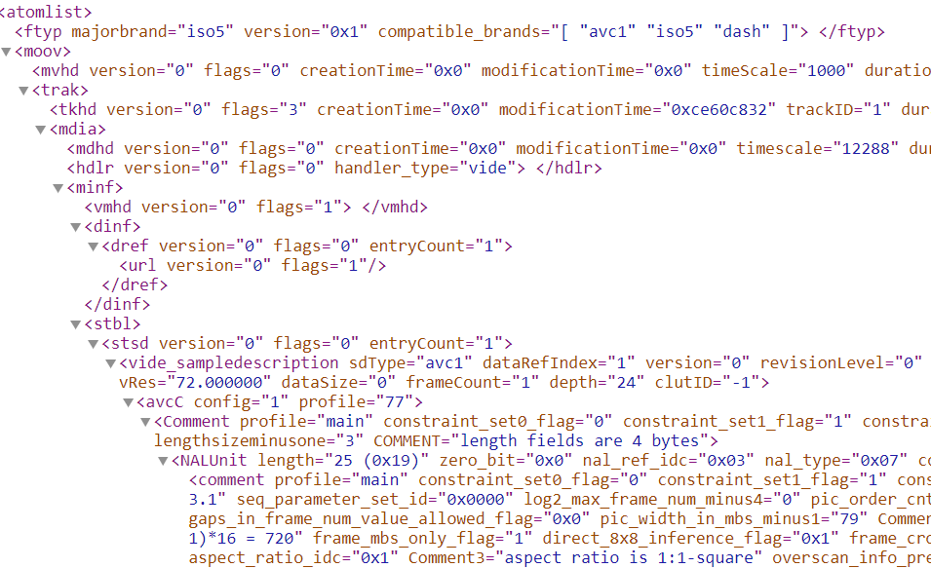

Figure 1 A sample atom-xml file for a video track

The atom-xml files are located in */DASH-IF-Conformance/Conformance-Frontend/temp/<session_folder>/Adaptx/*

The parameters required for the media profile identification are present in the sample entry in *stsd* box as shown for video example track in Figure 2.

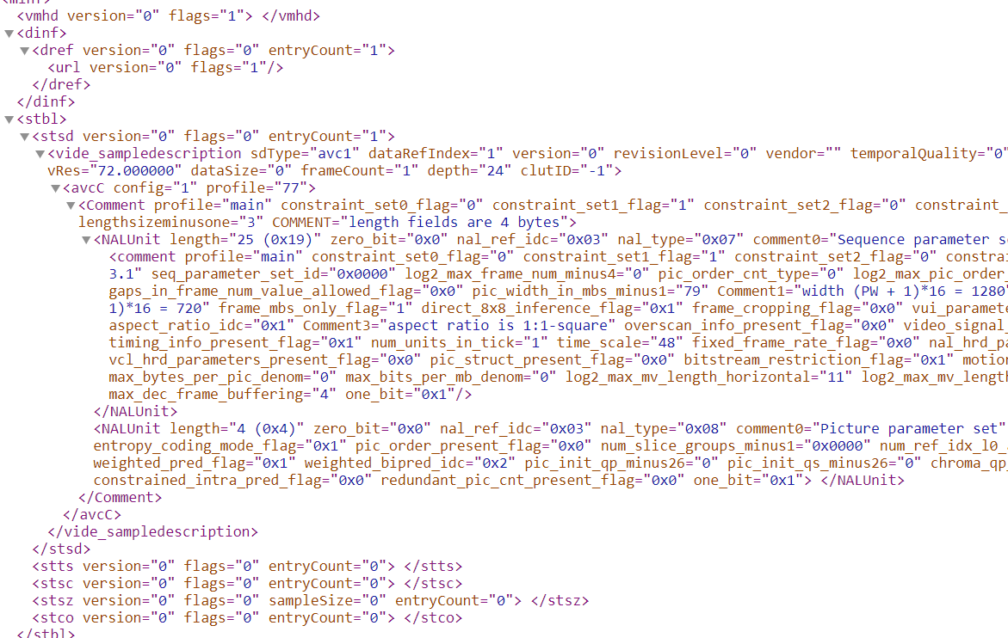

Figure 2 Atom list showing video media profile parameters

1. CTAWAVE sub-module contains the file CTAWAVE_SelectionSet.php which contains function *getMediaProfile().*

The structure of the source files-

*DASH-IF-Conformance*

* *CTAWAVE*
  + *CTAWAVE_Handle.php*
  + *CTAWAVE_Initialization.php*
  + *CTAWAVE_PresentationProfile.php*
  + *CTAWAVE_SelectionSet.php*

The function *getMediaProfile()* has three parts , each for video, audio and subtitle tracks. This function extracts the parameters from the atom-xml file and identifies the media profile of the track.

*getMediaProfile()*

{

if (track type is video)

//collect the video parameters- codec, profile, level, resolution, color, //transfer and matrix coefficients, framerate.

//then call function

checkAndGetConformingVideoProfile(parameters)

If(track type is audio)

//collect the audio parameters- codec, profile, channels, sampleRate.

//then call function

checkAndGetConformingAudioProfile(parameters)

if(track type is subtitle)

//collect the subtitle parameters- codec, content_type, mimetype, //mimeSubtype

//then call function

checkAndGetConformingSubtitleProfile(parameters)

}

The function *checkAndGetConformingVideoProfile()* compares the extracted parameters of the input track with the parameters from the Table 1 to check which media profile the track conforms to. Similarly audio and subtitle media profile check happens.

# Addition of new media profile

The new media profile can be added in the respective functions for example- for video – *checkAndGetConformingVideoProfile()* or a new function similar to this can be written and called from *getMediaProfile()*.

# Unit testing

Unit tests for the media profile checks are under */CTAWAVE/UnitTests/MediaProfilesTest.php*

After implementing new media profile, unit test can be added to the test file *MediaProfileTest.php*.

Instructions to create and run unit tests can be found in */CTAWAVE/UnitTests/Doc/UnitTesting_Doc.pdf*

# Reference

[1] - WAVE Content Specification, April 2018