HLS Content Validation

Nomor Research GmbH

Munich, Germany

[info@nomor.de](mailto:info@nomor.de)

31 October 2018

Table of Contents

1 Introduction 3

2 Design 3

2.1 Architecture 3

2.2 Conformance-Frontend-HLS 4

2.3 HLS 6

2.3.1 Design Approach 6

Table of Figures

Figure 1: New submodules in the hierarchy. 3

Figure 2: Web browser UI for HLS. 4

Figure 3: Example UI visual after HLS content validation. 5

Figure 4: Closer look on the report tree on UI. 5

Figure 5: Example HLS manifest with optional tags present (marked in red rectangle). 6

# Introduction

In the current Integrated Conformance Software, only DASH manifests are supported. As part of CTA WAVE conformance, Integrated Conformance Software is extended to provide content validation support for HLS manifests.

Section 2 provides information on how HLS support for content validation is provided in Integrated Conformance Software, specifically Section 2.1 explains the additional submodules for such support whereas Section 2.2 and Section 2.3 explains in more detail what each submodule is responsible for and how they interact with each other.

# Design

## Architecture

For HLS support, two additional submodules have been introduced: 1) HLS and 2) Conformance-Frontend-HLS. The folder structure of these submodules in overall Integrated Conformance hierarchy is as shown in Figure 1.

HLS submodule performs the processing of HLS manifests. It supports both master playlist and media playlist m3u8 manifests. Conformance-Frontend-HLS submodule, on the other hand, has been added for providing web browser UI specific for HLS and separate from web browser UI for DASH. Detailed information on each submodule along with the design idea is provided in following subsections.

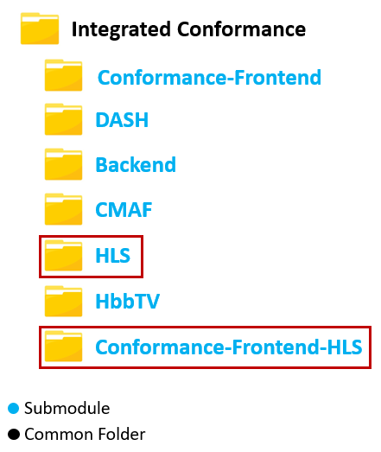

Figure 1: New submodules in the hierarchy.

## Conformance-Frontend-HLS

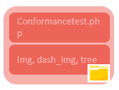

As mentioned, a separate web browser UI has been provided for HLS. The UI is depicted in Figure 2. This submodule is responsible for initiating the conformance server processes and updating the client about the overall progress as well as the conformance results.

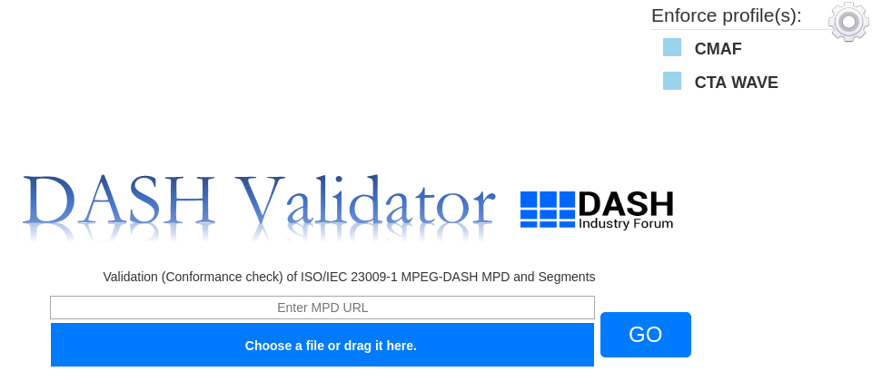

Figure 2: Web browser UI for HLS.

The UI is quite similar to the UI used for DASH manifests (Conformance-Frontend) except the following:

* ***Profile enforcement:*** Only CMAF and CTA WAVE profiles enforcement is allowed.
* ***UI tree update:*** UI tree providing the validation reports is visible only after all the tracks are downloaded. This is because of the design choice selected for HLS support, which is explained in Section 2.3.1.
* ***Validation scope:*** Only HLS content pointed to by HLS manifest is validated. HLS manifest conformance is out of scope of this requirement.

As for the process, just as in Conformance-Frontend, it initially interacts with “Process.php” in “Utils” block as soon as Submit button is clicked on or local HLS file is provided. After the conformance check process starts, the final results are sent to this submodule for display. These results contain:

* Representation checks
* Cross-representation checks

An example UI visual after HLS content validation is complete is provided in Figure 3. A closer snapshot of the report tree is provided in Figure 4.

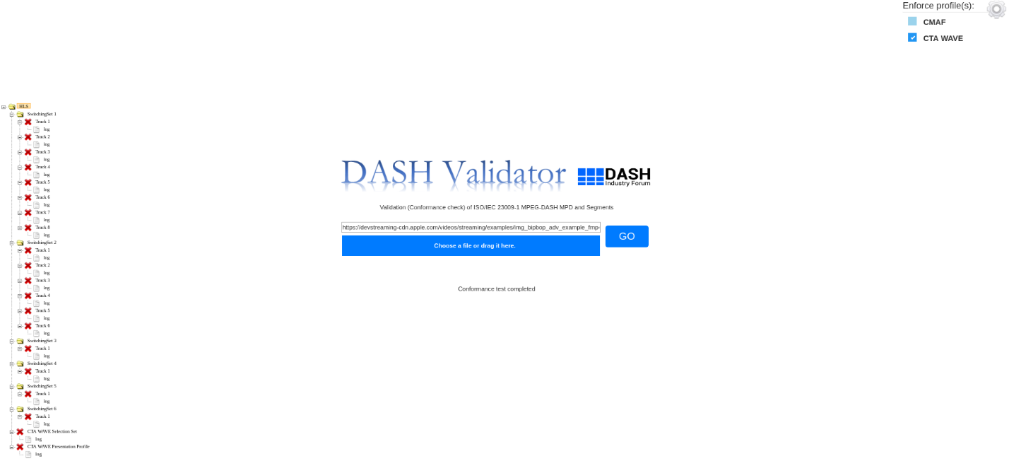

Figure 3: Example UI visual after HLS content validation.

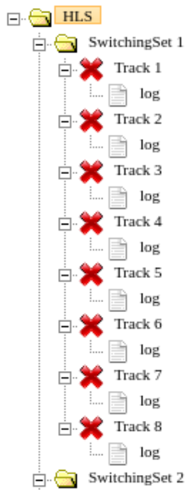

Figure 4: Closer look on the report tree on UI.

## HLS

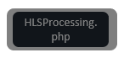This submodule is responsible for parsing the provided HLS manifest and validating the content in the manifest against ISO BMFF and optionally CMAF and CTA WAVE. Generated reports for each track in the manifest are sent to the frontend block for display.

### Design Approach

In conformance software, the validation checks are dependent on classification of the tracks, such as track/representation media type, switching sets/adaptation sets. In DASH, this is quite intuitive as the classification itself is already provided via MPD. However, from HLS manifest specification, it is observed that almost all tags in a manifest are optional to be included, such as “CODEC”, “AUDIO”, “VIDEO”, etc., which makes this type of classification difficult to be performed. An example of an HLS manifest is provided in Figure 5.

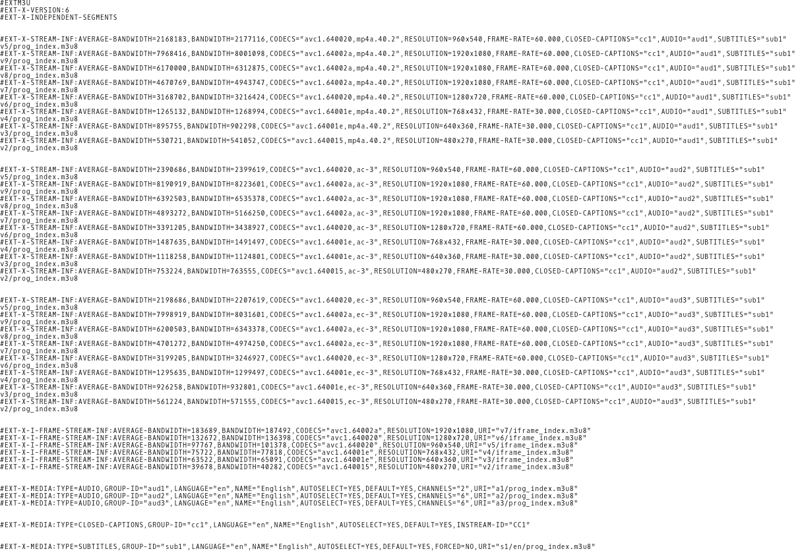

Figure 5: Example HLS manifest with optional tags present (marked in red rectangle).

Therefore, for HLS content validation support, for robustness purposes, it was decided to perform such classification without relying on the HLS manifest tags but rather by analyzing the track headers (hdlr and sample description boxes). The complete algorithm for HLS processing is as follows:

1. Derive if the manifest is master playlist or media playlist. If it is a media playlist, skip to step 3.
2. Extract all the media playlist URL(s) provided in the master playlist and group them according to their pointers (“EXT-X-STREAM-INF”, “EXT-X-I-FRAME-STREAM-INF”, and “EXT-X-MEDIA”).
3. For each media playlist pointer
   1. Create media playlist pointer directory.
   2. For each extracted media playlist URL in pointer directory
      1. Create media playlist directory inside media playlist pointer directory.
      2. Extract segment URL(s) provided in the media playlist.
      3. Download the segment(s).
      4. Store them in media playlist directory.
   3. For each extracted media playlist URL in pointer directory
      1. Assemble the segment(s) together into one media file.
      2. Perform segment validation via “ISOSegmentValidator” submodule.
      3. Determine the media type based on the output of segment validation (by looking at hdlr and sample description boxes)
4. Group the tracks into Switching Sets, using the media type information.
   1. Create a new Switching Set directory.
   2. Move all tracks associated with this Switching Set in this directory.
   3. Example
5. Perform cross validation checks between all tracks in a Switching Set.

This approach is robust as it does not use optional HLS manifest tags for processing. Since the classification can be done after all tracks are downloaded, the validation reports can only be displayed on the UI after all the validation checks are complete as opposed to providing the report after each media playlist (Representation as in the case of DASH support).