

440.729.8350

Attention Property Managers

Imagine what you could do with an extra $16,512 in your annual operating budget. Picture your boss raving about how you save money for the property and keep your residents happy.

Sometimes it’s easy to determine if the carpet in your recently vacated apartment will need to be replaced. And other times you think there might be hope.

When you prevent a new carpet installation by having Carpet Advantage work for you, just how much of a savings is it?

If you save one carpet per month for an entire year, your savings is

$16,512

Example vacant apartment.

It’s a 2 bedroom suite, heavily soiled in the living room and it’s rippled across the hallway in a couple of spots. There are bleach drops by the entry and kitchen and matted down carpet.

It’s right on the fence and you think that you ***might*** have to replace it.

**Is it worth $140 versus $1516 to find out?**

$1516.00 2 bd average install

- 140.00 Carpet Advantage clean/repair

$1376.00 Savings

x 12 1 year

**$16,512.00**

**One carpet saved per month for a year**

The Rotovac Powerwand

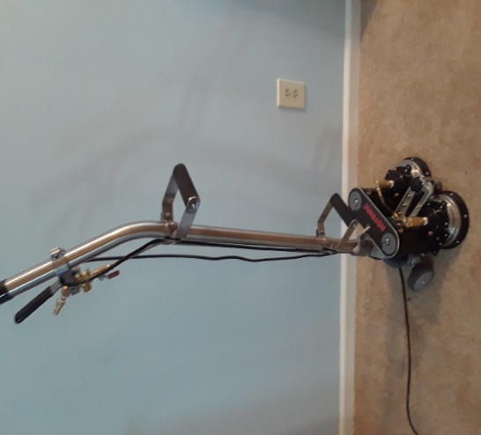

The Rotovac Powerwand

2 oscillating scrubbing heads

6 vacuum slots

6 spray jets

Rotation at 250rpm

Major multi-directional cleaning

Carpet Cleaning and repairs

by Carpet Advantage $140

Rotovac Powerwand with proprietary solutions $75

Carpet stretch $35

Spot dying a couple of bleach stains $30

OR

New carpet installation $1516