# Conceptual Classes

|  |  |  |  |
| --- | --- | --- | --- |
| **Class** | **Description** | **Attribute** | **Method** |
| OrderType | This is a super class, which represents what kind of order the user has paid. |  |  |
| MobileMovieStreaming | This is a subclass of the “OrderType” class, which represents that the user has paid an order of the type “Mobile Movie Streaming”. | 1. int premium 2. int ultimate |  |
| HighDefinitionBox | This is a subclass of the “OrderType” class, which represents that the user has paid an order of the type “High Definition Box”. | 1. String definition |  |
| OnlineGameRental | This is a subclass of the “OrderType” class, which represents that the user has paid an order of the type “Online Game Rental”. | 1. int hardCode |  |
| PPVMovies | This is a subclass of the “OrderType” class, which represents that the user has paid an order of the type “PPV Movies”. | 1. int hardCode |  |
| PPVLiveSportsEvents | This is a subclass of the “OrderType” class, which represents that the user has paid an order of the type “PPV Live Sports Events”. | 1. int hardCode |  |
| Plan | This is a super class, which represents what kind of plan the user has paid. |  |  |
| TVPlan | This is a subclass of the “Plan” class, which represents that the user has paid an plan of the type “TV Plan”. | 1. int basic 2. int basicPlus 3. int ultimate |  |
| InternetPlan | This is a subclass of the “Plan” class, which represents that the user has paid an plan of the type “Internet Plan”. | 1. int speedLane 2. int lightLane |  |
| Manager | This class contains information about the role Manager. | 1. List<Order> orderList | 1. cancelOrder(Order) : String 2. updateOrder(Order) : String 3. deleteOrder(Order) : String |
| Order | This class contains the details of order. | 1. OrderType orderType 2. Customer user 3. Plan orderPlan 4. Date createTime |  |
| Customer | This class contains information about the role Customer. | 1. Account record 2. List<Plan> planList 3. List<Order> orderList | 1. enrollInPlan(Plan): void 2. updateRecord(Account): String 3. payMonthlyBill(Order): void 4. rentOnlineGame(Order): void 5. orderPPVEvent(Order): void 6. cancelPPVEvent(Order): void 7. changePlan(Plan): void 8. cancelPlan(Plan): void 9. addPlan(Plan): void 10. rateAndSubmitReview(Review): void 11. shareOrderLink(Order): void 12. scheduleIncidentTicket(IncidentTicket): void 13. agreePlacePPVOrder(): boolean |
| Account | This class contains information about the role Account. | 1. String creditCard 2. String userName 3. String userTel 4. String zipCodes 5. String email |  |
| SalesTeam | This class contains information about the role SalesTeam. | 1. Manager manager | 1. forecastSalesRevenue() : String 2. forecastDemand() : String 3. analyzeDemand() : void |
| DataScientist | This class contains information about the role DataScientist. | 1. List<Order> orderList | 1. analyzeWellConnectedCustomer(Customer): void |
| CustomerSupport | This class contains information about the role CustomerSupport. | 1. List<Customer> enrolledCustomerList 2. List<IncidentTicket> incidentTicketList | 1. createNewAccount(Account, Plan): String 2. updateAccount(Customer): void 3. createIncidentTicket(): void 4. placePPVOrder(): void 5. checkAccountExist(Account): boolean |
| Review | This class contains the customer's evaluation of the service. | 1. String content 2. int stars 3. Date createTime |  |
| Technician | This class contains information about the role Technician. | 1. List<IncidentTicket> incidentTicketList | 1. scheduleIncidentTicket(IncidentTicket): void 2. closeIncidentTicket(IncidentTicket): void 3. cancleIncident(IncidentTicket): void |
| IncidentTicket | This class represents information about the incident ticket created for customer. | 1. Date createTime 2. String createBy 3. String reason |  |

# Analysis class diagram

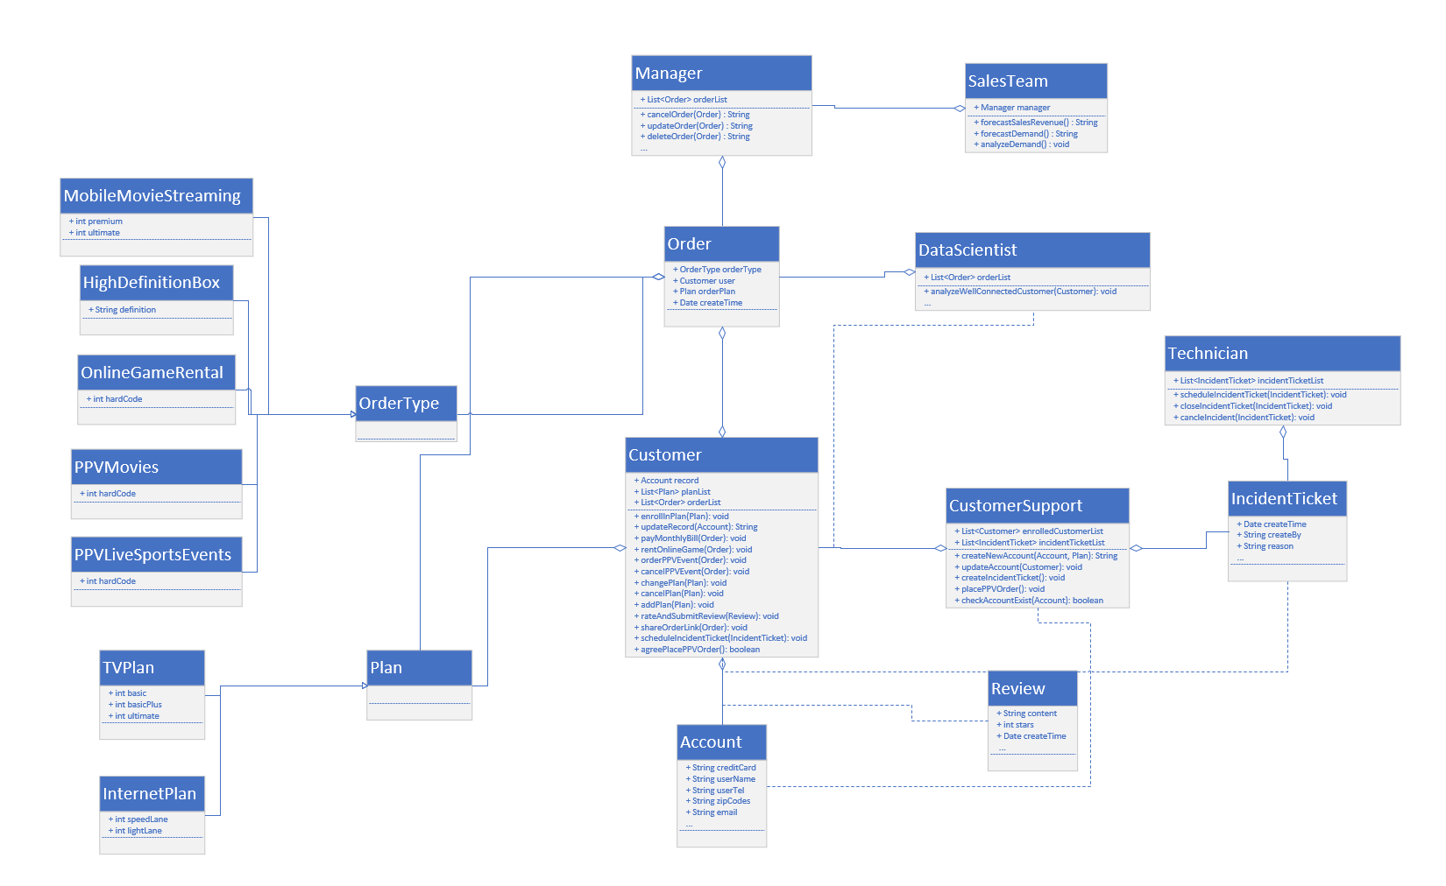

# Sequence Interaction Diagrams

1. Use Case “Create Customer Account” at role “CustomerSupport”.

Note: “account_1” contains the basic information for the customer that needs to be created, such as creditCard, userName, userTel, and so on.

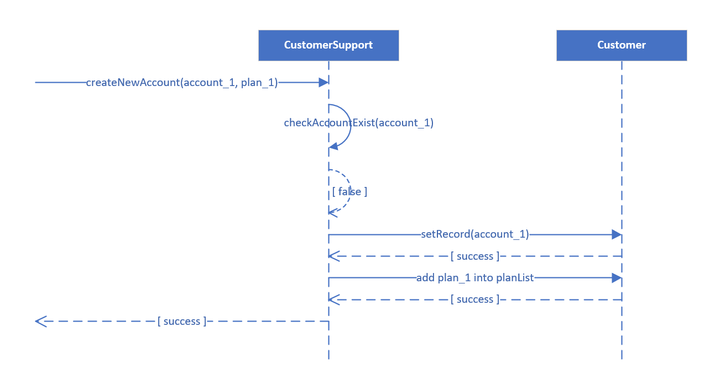

1. Use Case “Update Record” at role “Customer”.

Note: “account_1” contains the basic information for the customer that needs to be updated, such as creditCard, userName, userTel, and so on.

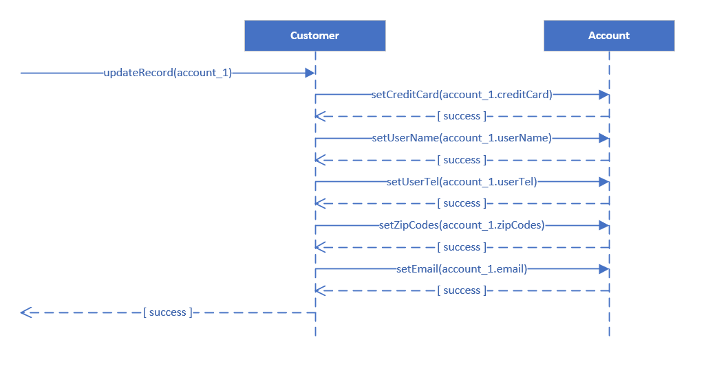

1. Use Case “Delete Order” at role “Manager”.

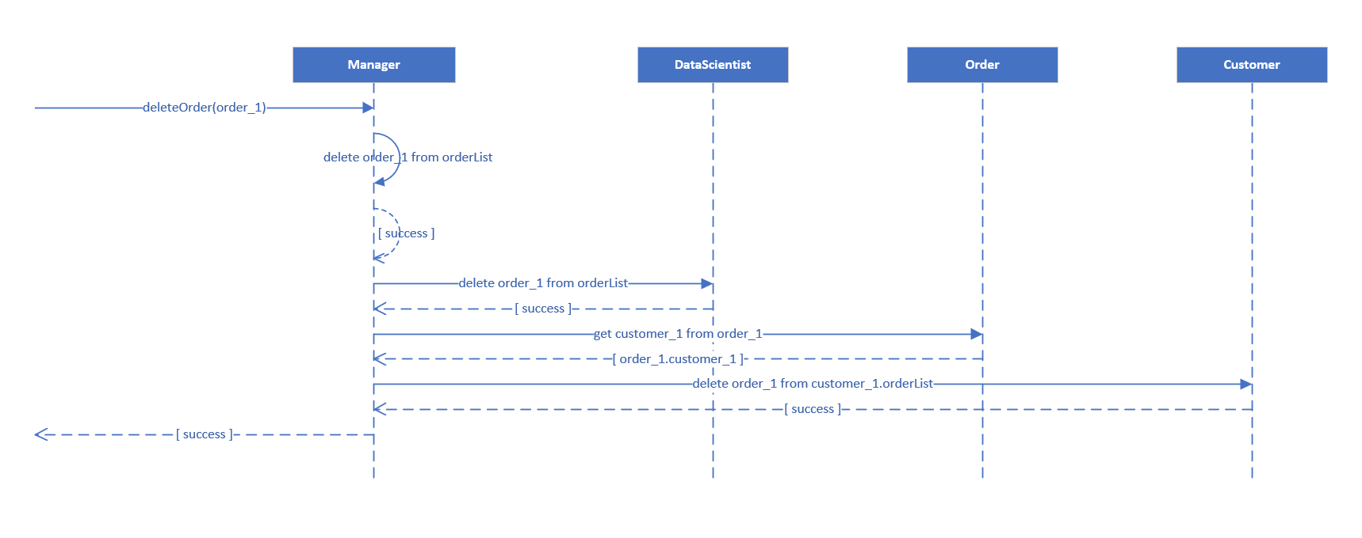

# Communication Interaction Diagrams

1. Use Case “Create Customer Account” at role “Customer Support”.

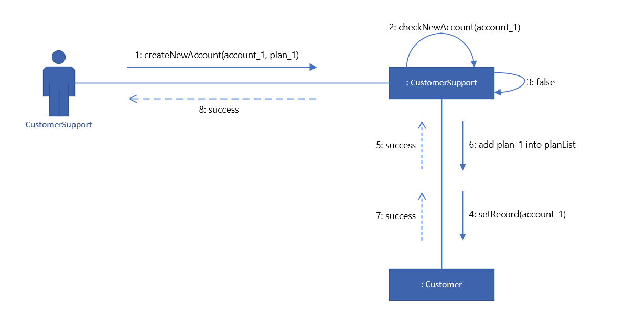

1. Use Case “Update Record” at role “Customer”.

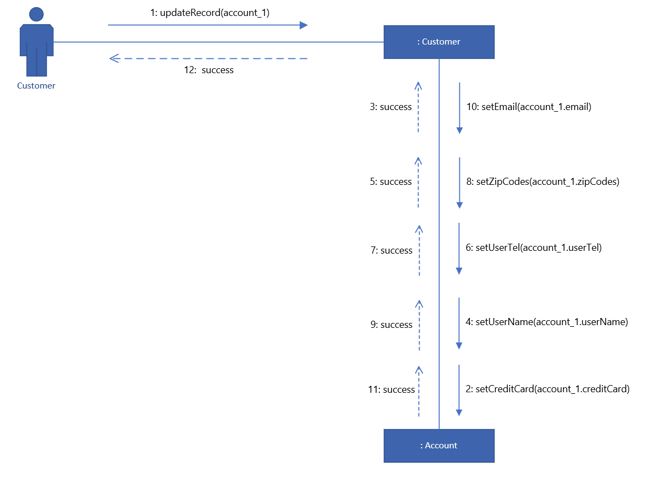

1. Use Case “Delete Order” at role “Manager”.

