# Conceptual Classes

|  |  |
| --- | --- |
| **Class** | **Description** |
| OrderType | This is a super class, which represents what kind of order the user has paid. |
| MobileMovieStreaming | This is a subclass of the “OrderType” class, which represents that the user has paid an order of the type “Mobile Movie Streaming”. |
| HighDefinitionBox | This is a subclass of the “OrderType” class, which represents that the user has paid an order of the type “High Definition Box”. |
| OnlineGameRental | This is a subclass of the “OrderType” class, which represents that the user has paid an order of the type “Online Game Rental”. |
| PPVMovies | This is a subclass of the “OrderType” class, which represents that the user has paid an order of the type “PPV Movies”. |
| PPVLiveSportsEvents | This is a subclass of the “OrderType” class, which represents that the user has paid an order of the type “PPV Live Sports Events”. |
| Plan | This is a super class, which represents what kind of plan the user has paid. |
| TVPlan | This is a subclass of the “Plan” class, which represents that the user has paid an plan of the type “TV Plan”. |
| InternetPlan | This is a subclass of the “Plan” class, which represents that the user has paid an plan of the type “Internet Plan”. |
| Manager | This class contains information about the role Manager. |
| Order |  |
| Customer | This class contains information about the role Customer. |
| Account | This class contains information about the role Account. |
| SalesTeam | This class contains information about the role SalesTeam. |
| DataScientist | This class contains information about the role DataScientist. |
| CustomerSupport | This class contains information about the role CustomerSupport. |
| Review | This class contains the customer's evaluation of the service. |
| Technician | This class contains information about the role Technician. |
| IncidentTicket | This class represents information about the incident ticket created for customer. |

# Analysis class diagram

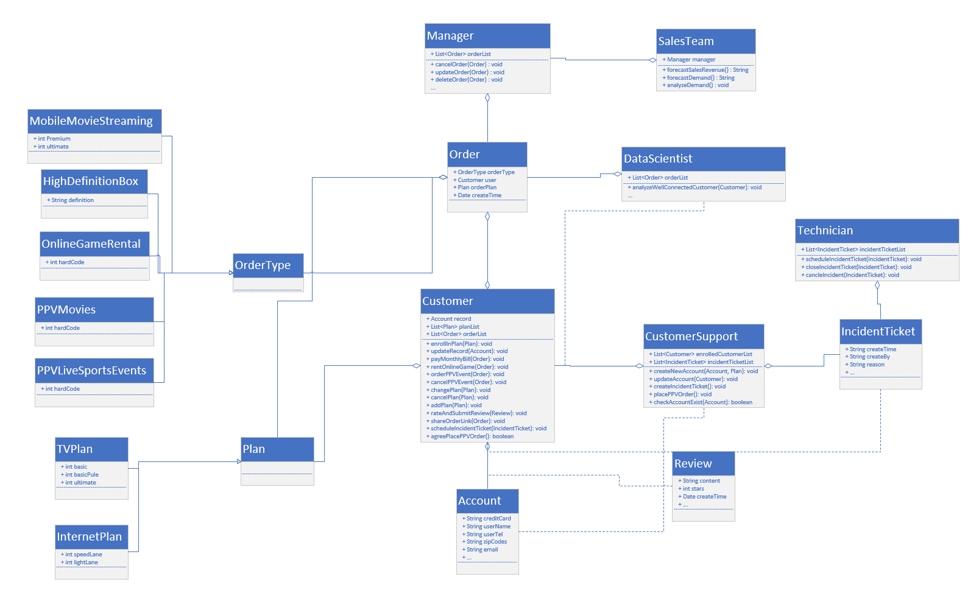

# Sequence Interaction Diagrams

1. Use Case “Create Customer Account” at role “Customer Support”.

Note: “account_1” contains the basic information for the customer that needs to be created, such as creditCard, userName, userTel, and so on.

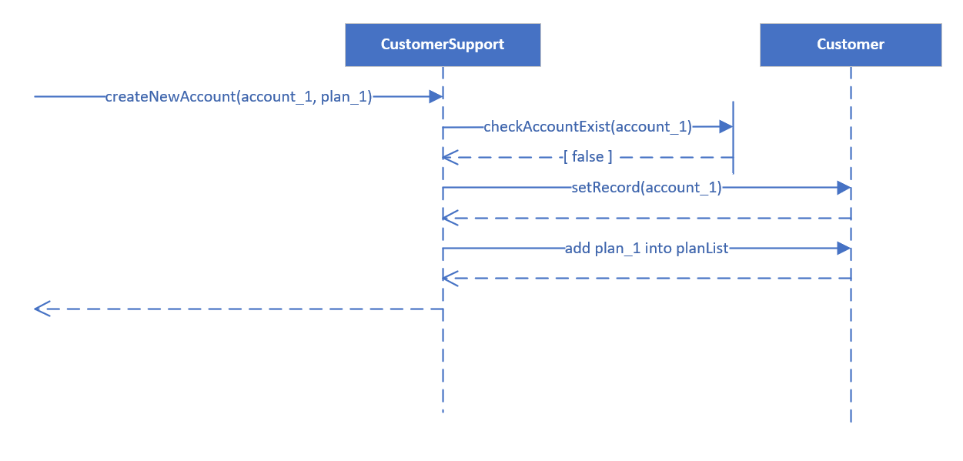

1. Use Case “Update Record” at role “Customer”.

Note: “account_1” contains the basic information for the customer that needs to be updated, such as creditCard, userName, userTel, and so on.

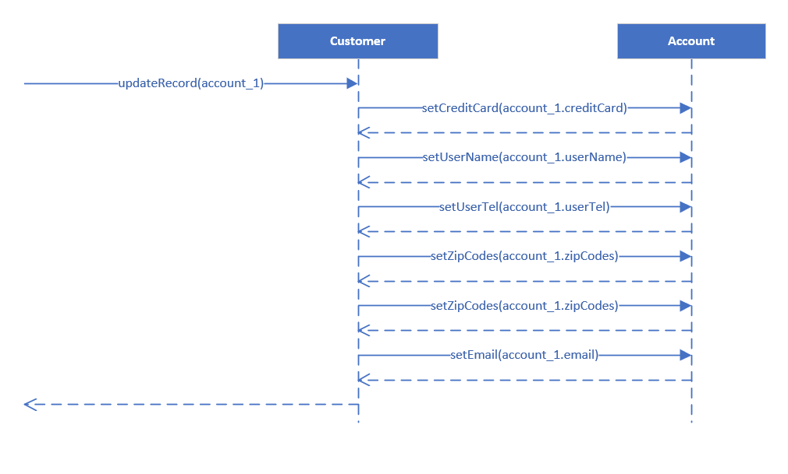

1. Use Case “Delete Order” at role “Manager”.

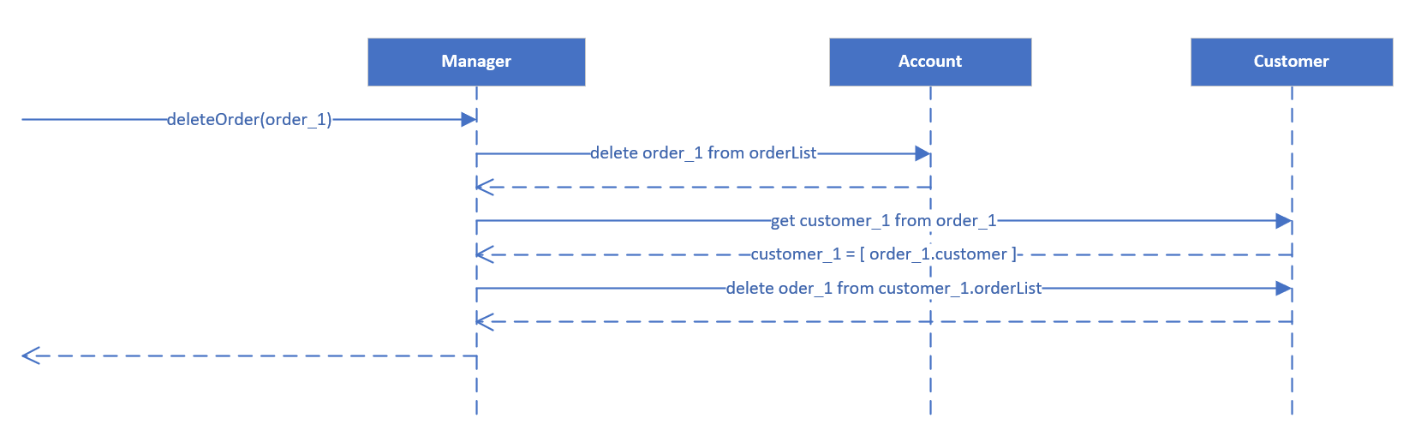

# Communication Interaction Diagrams