#### Texas Tech University

#### Department of Electrical and Computer Engineering

#### ECE 4264 / 5364 Digital Signal Processing

#### Fall 2019 Group D1

# Homework 7

Due November 1st before midnight CDT.

Please submit to Blackboard exactly two files:

1. A single ZIP file with all your MATLAB programs, along with any data files necessary to run your programs.
2. A single report document in Word or PDF. Your report should include procedures and solutions to analytical problems, screenshots of results and graphs from programs, and discussions. Please do not include copies of your code in the report.

Submit your solutions to Blackboard by the date and time listed to avoid penalties. This homework is individual. You are welcome to discuss your approach with others, but your answers need to be unique. If your answers are found to be highly similar to others’ or to some material published, you may be subject to a review of academic integrity.

Undergraduate students only need to complete Part 1. Graduate students should complete both Part 1 and Part 2.

## Part 1 (Both ECE 4364 & 5364 students)

### Problem 1 (20 points)

Design a two-stage solution to decimate audio files from 48000 samples/second to 8000 samples/second. Your first stage should decimate by a factor of 2, and your second stage by a factor of 3.

Remember that in a two-stage solution, each filter will introduce distortion to the passband, so you need to design each stage with smaller passband ripple, so that the total distortion remains within desired limits.

1. Design an anti-aliasing filter for the first stage, as a half-band filter to minimize the number of non-zero coefficients

* Explain your filter design choices: filter order, passband ripple, stopband attenuation, fc, fs, design method.

**This filter was designed with .005 passband ripple, filter order of 30, a stop-band attenuation of 70 dB and a passband frequency from 3500 to 4000.**

* Plot the frequency response of your filter

* Estimate the number of multiplications and additions per second that this filter will need to perform

**30 coefficients * 48000 samples per second is 1,440,000 multiplications and additions per second.**

1. Complete the decimation by a factor of 2 and apply it to the test file toneramp.wav.

* Your output signal at this stage should be sampled at 24000 samples/second
* Plot the amplitude of the test signal at this stage. Explain the behavior observed

**The amplitude is unaffected by the half-band filter considering most of the signal is under the 12 kHz frequency range.**

1. Design an anti-aliasing filter for the second stage.

* Explain your filter design choices: passband ripple, stopband attenuation, fc, fs, design method.

**Passband ripple is the same at around 1 dB. Fs is the same as problem a) and the design method is done the same way using firpm.**

* Plot the frequency response of your filter

1. Complete the decimation by a factor of 3. Apply it to the output of step b).

* Your output signal should be sampled at 8000 samples/second at this stage
* Plot the amplitude of the test signal at this stage. Explain the behavior observed

**This behavior is accurate and is showing the proper amp response after the final stage of the filter.**

* Estimate the number of multiplications and additions per second that this filter will need to perform

**108 coefficients * 24000 = 2,592,000 Multiplications and additions per second.**

1. Compare the total number of multiplications per second that your two-stage solution will need to perform

* Contrast this with your single-stage solution from homework 6, problem 1
* Comment as to the advantages and disadvantages of multi-stage decimation

**Total of 4.03 million multiplications and additions per second. My original filter from homework 6 had 115 coefficients. 115 coefficients * 48000 = 5.525 million multiplications and additions per second. The advantages of using multiple stages allows for less coefficients to be used between multiple filter stages. This also is a disadvantage because more time is allotted to design that second filter. Another big disadvantage is the amount of passband ripple that is caused by the multiple stages.**

### Problem 2 (15 points)

Replace the first stage of your solution to problem 1, with an Nth order CIC filter. Please note that an efficient structure for CIC filters in decimation places the comb filter after the downsampler, like this:

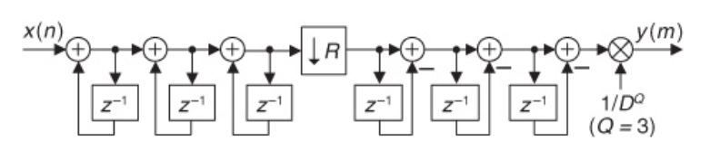

1. Select the order of the CIC filter that meets your needs

* Explain your choice

**I used 8 coefficients for the CIC filter. This allows for a quick decrease in the original gain at the beginning of the response.**

* Show the frequency response of this filter
* Estimate the number of multiplications and additions per second that this filter will need to perform, and contrast with what you got for this stage in problem 1. **8 * 48000 = 384000 multiplications and additions per second.**

1. Complete the decimation by a factor of 2 and apply it to the test file toneramp.wav.

* Plot the amplitude of the test signal at this stage.

* Compare the result with what you had at this stage in problem 1

**There is a huge increase at the beginning in gain compared to the original amplitude response. Overall, the response is drastically different because the CIC filter itself is a cascaded filter.**

1. Apply the second stage of your decimation as in problem 1

* Plot the amplitude of the test signal at this stage.
* Compare the result with what you had at this stage in problem 1

**The grooves of the amplitude here are somewhat similar to the second stage filtering design. The only big difference is the massive increase in gain at the beginning of the filter.**

1. Comment to the advantages and disadvantages of using CIC filters for decimation

**CIC filters call for an advantage with a minimum amount of coefficients but a disadvantage with a maximum amount of gain to make up.**

### Problem 3 (20 points)

Design a polyphase filter structure to decimate audio files from 48000 samples/second to 8000 samples/second. The structure should be similar to the following, but for a factor of 6:

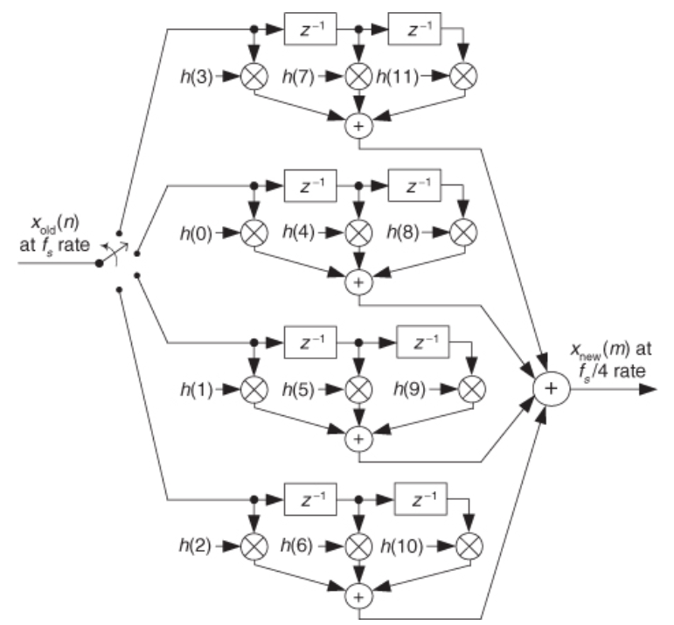

1. Design your prototype anti-aliasing filter.

* Make sure that the filter length is a multiple of 6
* Plot the frequency response of your filter (magnitude and phase)

**For the filter, I used a similar FIR implementation like in Homework 6. I had a total of 119 coefficients used with a passband frequency of 0.16π normalized frequency.**

1. Divide your prototype filter coefficients into a bank of 6 sub-filters f0, f1, …, f5

* f0 should have coefficients h(0), h(6), …, h(6n)
* f1 should have coefficients h(1), h(7), …, h(6n+1)
* :
* f5 should have coefficents h(5), h(11), …, h(6n+5)
* Plot the frequency response of each of your sub-filters (magnitude and phase)

* Explain what you see, and why it makes sense

**This makes sense because the entire lowpass filter has been spread into 6 different lowpass filters with a variety of magnitudes. When these are summed together, the final filter from part a) is created.**

1. Read the audio signal from the test file toneramp.wav, and separate it into 6 sub-sequences as follows:

* x0 should have samples 0, 6, …, 6n
* x1 should have samples 1, 7, …, 6n+1
* :
* x5 should have samples 5, 11, …, 6n+5
* Note that each of these sub-sequences are downsampled versions of the input, with different phases.
* Show the spectrum of each of the test sub-signals. Explain what you see and why it makes sense.

**This makes sense in comparison to the frequency spectrum gathered from HWK 6. All of the proper frequency information is reflected in the graph.**

1. Apply each of the subfilters to the corresponding input sequence: f0 to x5, f1 to x4, etc.

* Show the spectrum of each of the filtered sub-signals. Explain what you see and why it makes sense.

**The Frequency Spectrum is around the same range for each of the varied sequences. This is similar to the sub-band sampling we did a while back.**

1. Add all the filtered sub-signals (adding the corresponding samples) to obtain the final filtered signal

* Show the spectrum of final filtered signal. Explain what you see and why it makes sense.

**The Frequency spectrum shape is the same, but the magnitude has gone down significantly. This accurately represents the filtering being applied properly.**

1. Estimate the total number of multiplications and additions that this polyphase filter will need to compute per second

* Contrast this to the previous solutions from problems 1 and 2, and from problem 1 in homework 5
* Comment about the advantages and disadvantages of performing decimation with polyphase filter banks.

**119 * 48000 = 5.712 million multiplications and additions per second. This is more multiplications than problem 1 and 2 but there is a smaller amount of multiplication of 0 being done. Other disadvantages involve splitting the frequency into six different sequences. Overall, it does save on ‘zero multiplication’ but at an increased complexity in programming.**