#### Texas Tech University

#### Department of Electrical and Computer Engineering

#### ECE 4364 Digital Signal Processing

#### Fall 2019 Group D1

# Project 1

Due October 25th before midnight CDT.

This is a group project. Each group should submit to Blackboard exactly two files:

1. A single ZIP file with all the MATLAB programs and data files.
2. A single report document in Word or PDF. Expectations for the report are detailed below.

Submit your solutions to Blackboard by the date and time listed to avoid penalties.

## Project Description

A secret message has been encoded into the audio file “secret_message_4364.wav”. The message is human-readable, and it will become evident if you decode it successfully. No further information is given about the message, the file or the method used to encode the information in it.

## Project Members

* Cole Lewis
* Macky Brock McWhirter
* Braydon Westmoreland

## Part 1

Your task is to decode the message using any means you can devise. The only limitation is that you are not allowed to ask for help from people outside your team.

If you are completely stuck, you may ask for a hint from your instructors, but doing so will result in a deduction of 5 points on your final score.

Please keep a record of the ideas and experiments you try, as this will be part of your report grade.

Write a decoder in MATLAB that can take audio files encoded with the same method as the secret message, and print the messages encoded within them.

For this part, you should submit:

1. The decoded secret message

**‘So long, and thanks for all the fish’ was the decoded message.**

1. An explanation of the algorithm you are using to decode it

**The algorithm takes the FFT of one second of data. The peaks of the FFT are taken and compared with a bit range to determine whether a specific frequency is present. These frequencies represent ASCII in the form of an 8-bit number. From there, the 8-bit number is converted to a character using an ASCII table.**

1. A narrative explaining your thought process and experiments leading to your solution

**After listening to the wav file, we determined that there were multiple tones in each second of audio. This was confirmed after running the signal through a spectrograph. From the spectrograph, we could tell there was 8-bits being represented and ASCII is made up of 8-bits. From there, we began the process of decoding the signal by hand and then eventually implemented this in our MATLAB solution.**

1. The MATLAB code for your decoder
2. Screen-shots, graphics and visualizations of intermediate results that illustrate the operation of your decoder

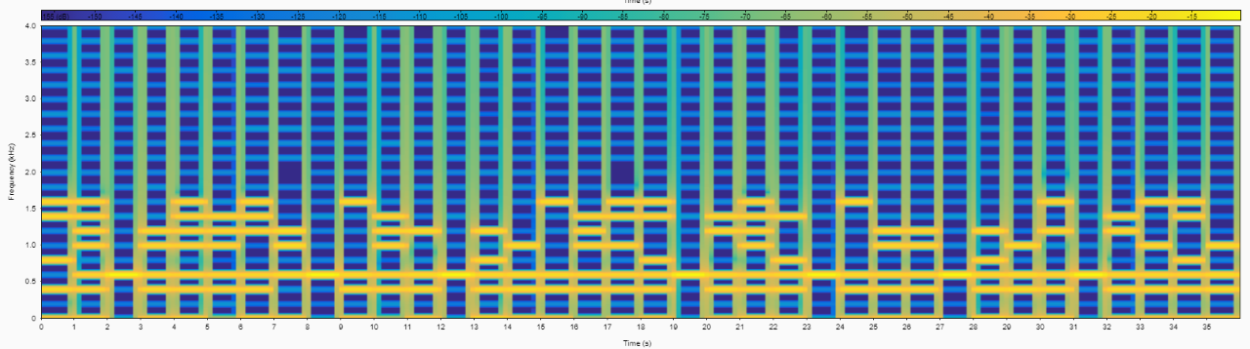

## Part 2

For this part, you are tasked with writing a message encoder in MATLAB that can construct audio files using the same encoding method as in the secret message you decoded in part 1.

Please submit the following items:

1. The MATLAB code for your encoder
2. An explanation of the operation of your encoder

**The message is converted to ASCII. Then by using the bits of ASCII, we determine what frequencies are added into that portion of the signal by summing up multiple sine waves with various frequencies. This signal is then normalized to a value of 0.5. Zeroes are then added to the end of the signal to separate the end of that portion of the signal. This is then done for each letter of the message and concatenated to the rest of the signal. The output is then read and saved to a wave file. We then took the spectrograph of the new wave file, compared it with the original and both matched.**

1. Screen-shots, graphics and visualizations of intermediate results that illustrate the operation of your encoder.

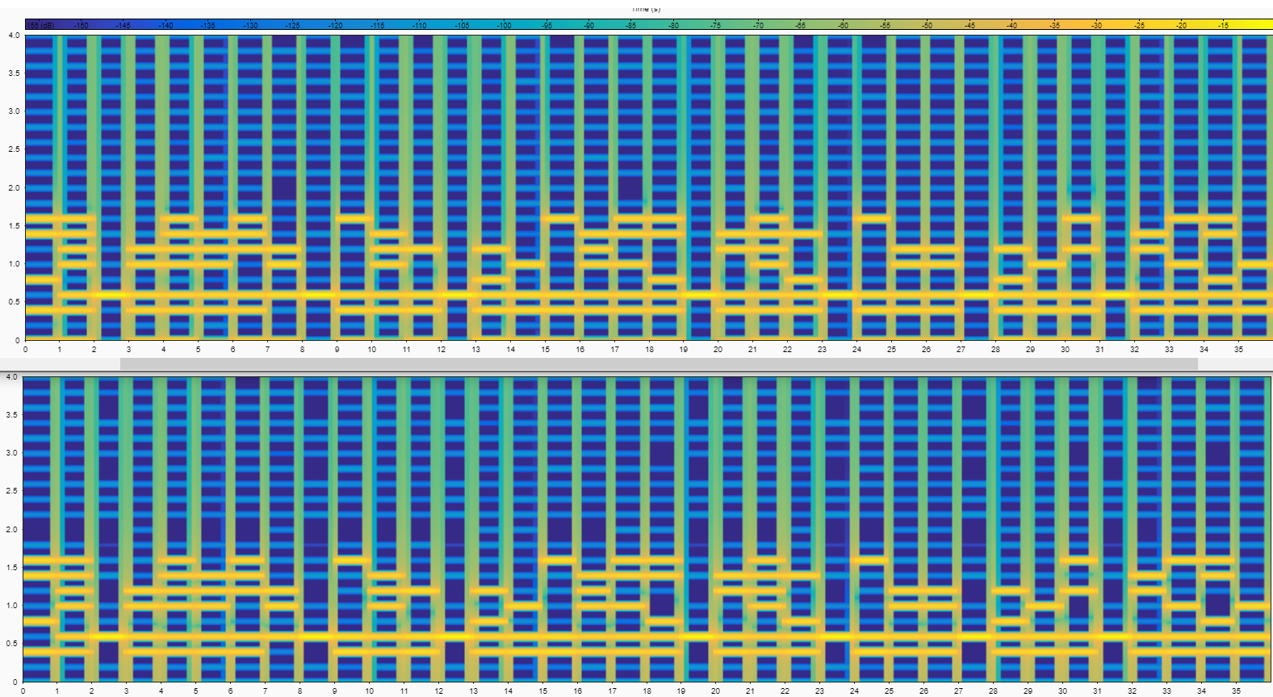

**The Top spectrograph is the original signal. The Bottom spectrograph is the signal created from our encoder.**

1. One example of an encoded audio file using your encoder

## Part 3 (Just for Fun)

* Post a secret message encoded with your encoder from Part 2 to the class discussion forum.
* Decode the secret messages that other teams posted to the forum.
  + Please note that graduate students are using a different encoding scheme than undergraduate students
* Respond to the teams using your encoder.

## Evaluation:

|  |  |
| --- | --- |
| **Item** | **Points** |
| Successfully decoded the secret message | 10 |
| Explanation of the discovery process for part 1 | 10 |
| MATLAB code for part 1 (correct, clean, easy to read) | 15 |
| Explanation of algorithm for part 1, along with documentation of intermediate results | 20 |
| MATLAB code for part 2 (correct, clean, easy to read) | 15 |
| Explanation of algorithm for part 2, along with documentation of intermediate results | 20 |
| Encoded audio file from part 2 | 10 |
| Total | 100 |