Hypothesis Testing for the difference in means using the p-value and confidence interval methods of evaluation of a t-test
Brock Akerman and Hanan Ali
ST502 - Spring 2022
A sample of data is extracted from the Framingham Heart Study which includes the systolic blood pressure of participants who are identified as either smokers or non-smokers. Smokers in this study are defined as participants who have smoked cigarettes anytime the year preceding the physical examination while non-smokers are those who have abstained from smoking during that same period of time. (SOURCE: https://www.ncbi.nlm.nih.gov/pmc/articles/PMC6541867/). The data contains a column of qualitative binary values characterizing the subjects smoking habit and a second column pairing it with a single measurement of systolic blood pressure measured in millimeters of mercury (mmHg).
We are interested in examining the difference in blood pressure means between smokers and non-smokers. To test whether a difference between means exists, we will use the t-test (pooled) the Welch-Satterthwaite t-test. Random sampling and a normal distribution are assumed for each of the sample; however let us examine some plots to better understand the data visually and reinforce the normality assumption.
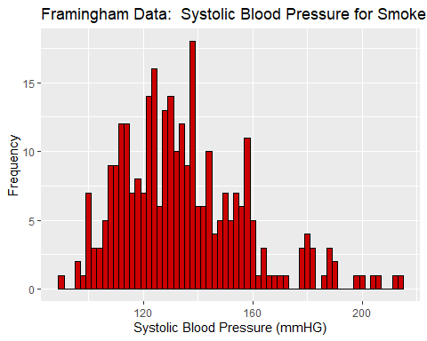 From the sample of systolic blood pressures we can see a skew toward the right. There is concern for outliers influencing this skew. Of particular concern is the systolic blood pressure for the observations where the subject had a 200 mmHg reading. A pressure observed above 180mmHg is consider a medical emergency and requires urgent care and hospitalization. A test for outliers is recommended. Should there be justification for removing the observations above 180mmHg, this distribution would appear to closely resemble a normal.
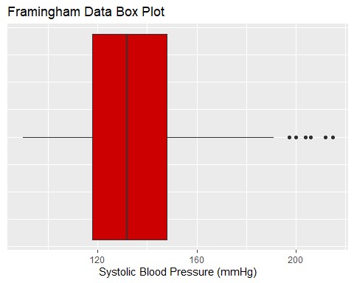
A generated boxplot of the sampled data shows six outliers which aligns with analysis of the histogram and the skew. These data points should be removed since they deviate from the remaining data points; in reality these are subjects that either should be hospitalized or the testing methods should be reevaluated in case this is a user generated error by the clinician administering the test.
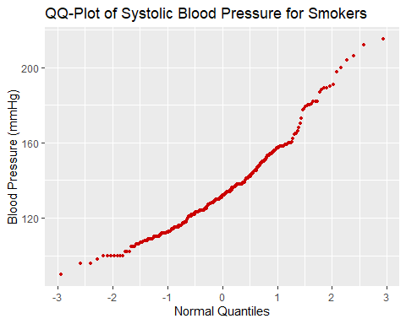 Our Quantile-Quantile plot illustrates a linear arrangement. Both tails deviate from that line but not so close to the center of the data that I would be concerned in rejecting the normality assumption. Potential outliers are present in the upper blood pressure range. The same six data points observed in the histogram are causing the upper tail of the distribution to deviate from this line. Positively identifying and removing outliers in the upper tail will result in a better normality shape.

t-test (pooled)

P-Value method
Are the mean systolic blood pressures different between smokers and non-smokers? We will use the t-test in our hypothesis test to answer that question. First, we will consider the case of equal variance. The status quo is that the mean systolic blood pressures are equal between smokers and non-smokers. We would like to test whether there is evidence to support the claim against the status quo–that there does exist a difference between means.
, There is no difference between means of smokers and non-smokers.
, There is a difference between means of smokers and non-smokers.
Y1 = framingham_data[currentSmoker==0,2] #Groups non-smokers
Y2 = framingham_data[currentSmoker==1,2] #Groups smokers

Y1 = unlist(framingham_data[currentSmoker==0,2])
barY1 = mean(Y1) #R code for computing systolic blood pressure mean for non-smokers

Y2 = unlist(framingham_data[currentSmoker==1,2])
barY2 = mean(Y2) #R code for computing systolic blood pressure mean for smokers

S1 = sd(Y1) #computing systolic blood pressure standard deviation for non smokers
S2 = sd(Y2) #computing systolic blood pressure standard deviation for smokers

n1= length(Y1) #number of non smokers
n2= length(Y2) #number of smokers

Sp2 = ((n1-1)*S1^2 + (n2-1)*S2^2)/(n1+n2-2)

T1 = (barY1-barY2)/(sqrt(Sp2)*sqrt(1/n1 + 1/n2))
#p-value 2*(1-pt(3.04,298)) qt(0.025,298)
We reject H0. There is sufficient evidence to support the claim that mean systolic blood pressure between smokers and non-smokers differs at a significant level of 0.05.

###### Confidence Interval method

```r
#Computing confidence interval
(barY1 - barY2) - (qt(0.025,298))*(sqrt(Sp2)*sqrt(1/n1 + 1/n2))
## [1] 15.08355
#0.025 = alpha/2 and df=298
(barY1 - barY2) + (qt(0.025,298))*(sqrt(Sp2)*sqrt(1/n1 + 1/n2))
## [1] 3.232003

t-test (Welch-Satterthwaite)

P-Value method
For the Welch-Satterthwaite t-test we will test using the same hypothesis as in the t-test pooled; however, with the assumption about the variance removed, the test statistic formula.
H0:μ1-μ2=0, There is no difference between means of smokers and non-smokers.
H1:μ1-μ2≠0, There is a difference between means of smokers and non-smokers.
<INSERT CODE CHUNK OF RESULTS FROM THE SATTERTHWAITE T-TEST>
We reject H0. There is sufficient evidence to support the claim that mean systolic blood pressure between smokers and non-smokers differs at a significant level of 0.05.

Confidence Interval method

comparison of tests
Both test rejected the null hypothesis.

concluding remarks

